Lab 12: Topological Sort

In this lab, we will implement an algorithm for topological sorting. When a graph structure (i.e. a set of nodes and edges) is given, your program prints a list of nodes as a result of topological sort. As we have discussed in class, topological sorting needs queue ADT in order to save the nodes that do not have any in-degree during the sorting process.

1. Input and Output

Read a set of vertices in the first line and a set of edges in the second line from the given input file. Each line is described below. You may assume that the node is represented by an integer.

* Vertices are given in the first line. Each vertex is separated by a space.
* Edges are given in the second line. Each edge is represented by a pair of vertices. For example, “1-3” represents an edge from the vertex 1 to 3.

An exemplary input file is given below; the corresponding graph is provided on the right.

Input.txt

|  |
| --- |
| 1 2 3 4 5 6  1-2 1-4 2-5 2-4- 2-3 3-4 5-3 6-3 6-5 |

Expected output (should be printed in standard output):

1 6 2 5 3 4

2. Data Structure for Topological Sorting

You can use an adjacency matrix to store your graph information as we have discussed in class. An example is shown below.

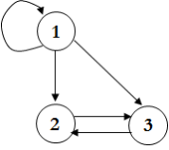 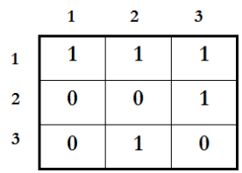

3. Program Description

* name : p12.c
* input : an input file name is given as a command line argument. See the example in “1. input”
* output : the corresponding result in the standard output

Submit to the course git your source code. (~2020/6/11 23:59)