Assignment 2

Lior Kotlar – lior.kotlar

# TTC

We manually select two points on the pen in two successive video frames. The distance between these points on the image (i.e., the apparent size of the pen) changes due to motion toward the camera.

Using these measurements:

1. Let $L_{1}$ be the pixel length between two points on the object in frame 1, and $L_{2}$ ​ in frame 2.
2. The rate of change of this length is used to compute an apparent velocity:
$$v= \frac{L_{2}-L_{1}}{Δt}$$

3. Assuming constant velocity, $TTC$ is estimated as:

$TTC=\frac{L_{2}}{v}$

​​

This method assumes that the object is rigid, and the motion is directly toward the camera. It works because as the object approaches, its image gets larger — and the rate of this growth informs how close it is to "contact."

The steps taken:

1. We extracted two frames from the video
2. Manually selected two corresponding points on the pen in both frames
3. Measured the pixel distance between the points
4. Used the change in size to estimate $TTC$.

Here are the two frames:

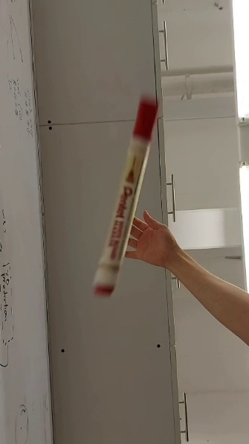 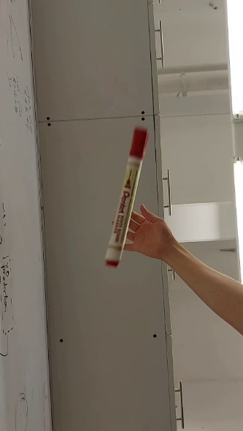

# Stereo

The algorithm used here is built according to the algorithm described in Hartley and Zisserman’s book – algorithm $11.6$, (page 291).

We begin by identifying corresponding points between two images using local descriptors.

The fundamental matrix $F$ encapsulates the intrinsic projective geometry between two views. It satisfies the epipolar constraint:

$$x_{2}^{T}Fx_{1}=0$$

for all corresponding points $x_{1}$ ​ and $x_{2}$ ​ (in homogeneous coordinates).

We use a normalized 7-point algorithm on randomly sampled matches to estimate $F$. Normalization improves numerical stability by translating and scaling the points so that their mean is at the origin and average distance from the origin is $√2$ ​.

To mitigate the influence of outliers in the point correspondences, we apply RANSAC. We use the open-cv function $findFundamentalMat$, to compute the fundamental matrix in each iteration of the RANSAC.

