**MS WORD - How to create Table of contents**

**Concepts for best practice:**

Active Tab = Current Home Tab

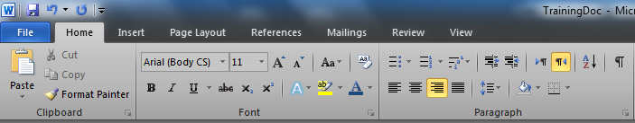

Items inside our Column

Column Font

Column Paragraph

**Quick Start Guide:**

(Not Current) Tab Home

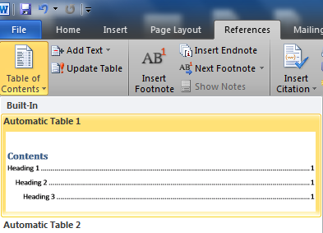

By choosing the first option: Automatic Table 1. It will add our contact list item to our document. (Without entries)

First of all we will choose the References Tab, by doing so we will open the current tab References characteristics. The next step is to locate the Button Located below the File tab. By pressing this button we will be allowed to choose a few options.

Table of Contents Button

Tab References

Now, as mentioned above there in no entries = blank table. To insert our content to the table we will have to write-down our main headlines of our document. Even we could re-arrange and plan again the sequence our writing. Get back to home tab and then we will define every sentence (each headline) the following design option: **Heading 1:**

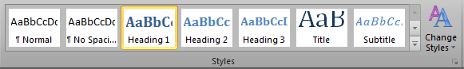

# 

We denote our headlines and then press on Heading1 Button on the Styles row. We will make sure that we actually see the style of our text changing

Original Text Example Designed Text as "Heading 1"

Right after we've done with the main headlines, we would like to update them on our blank-previous made contact list table.

By clicking on our document element (our blank contact list) and choosing Update Table. Alternatively, Click Update Table on the element itself.

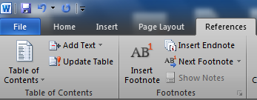

Right after we've done all that, congrats! Our fields are not empty anymore. In addition we could update the headlines during our writing of the document. In the most cases, the headlines changes usually during our writing process. Two update options:

1) Only page numbers

2) All the table (page numbers of each headline + Headlines text itself.)

To add sub headlines, simply we will write them below our main headline, but this time we will define the style of the text as Heading 2. Click Update and the change immediately appear.

**Common answers and questions**

Q- Will the use of automatic table of contacts hurt the design of the document?

1. No, you could change the design anytime just remember to update your current heading style to match the selected text.

Q-What are the advantages of using table of contacts

1. Arrange your document, define well subjects, make reasonable structure for text

Q-I'm regular to create my table of contacts manually, why should I create the automatic anyhow?

1. Actually, you don't have to. But it will help you arrange your writing and be more precise. The main advantage - you could anytime change your text and style, you could re-arrange your headlines, no matter where the headline is you don't have to count pages, or worry about what will happen if you will write a huge bulk of text. Above all mentioned, others could easily click on one of your headlines and read the subject directly.