Project report

**Article name:**

“Arbitrary Order Total Variation for Deformable Image Registration”  
By Jinming Duan, Xi Jia, Joseph Bartlett, Wenqi Lu, Zhaowen Qiu

**Submitters:**

Lior Dvir 207334376  
Neta Becker 209244839

Contents

Main concept 3

Background 4

Summary of the given article 4

Object Tracking 5

Method 6

Experimental results 7

References 8

# Main concept

The paper we have chosen is: “Arbitrary Order Total Variation for Deformable Image Registration”, by Jinming Duan, Xi Jia, Joseph Bartlett, Wenqi Lu and Zhaowen Qiu.

Image registration is the process of creating alignment between two or more images from various imaging equipment or sensors taken at different times and angles, or from the same scene. The alignment between different images could be rigid and non-rigid. Rigid alignment is an alignment that could be defined with an affine transform, whereas non-rigid alignment could not.

The paper presents a new mathematical model which performs non-rigid image registration, meaning the algorithm can handle alignment between deformed images.

We would like to apply the algorithm and its resulting registration map in the field of object tracking, where objects can change shape and form in time. With an initial mask of an object in a time-series video we can calculate the registration map between consecutive frames and warp the mask through time. Theoretically, that would allow us to get a mask of the tracked object throughout the entire input video even if the object’s form changes between frames.

The goal of this project is to tackle challenging scenarios, such as tracking a tennis ball in a video. See selected frames from tennis matches for example:

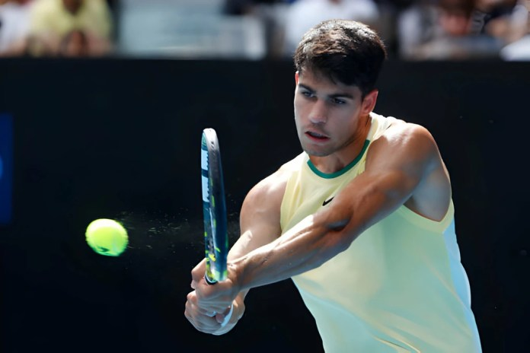 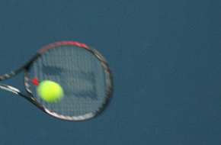 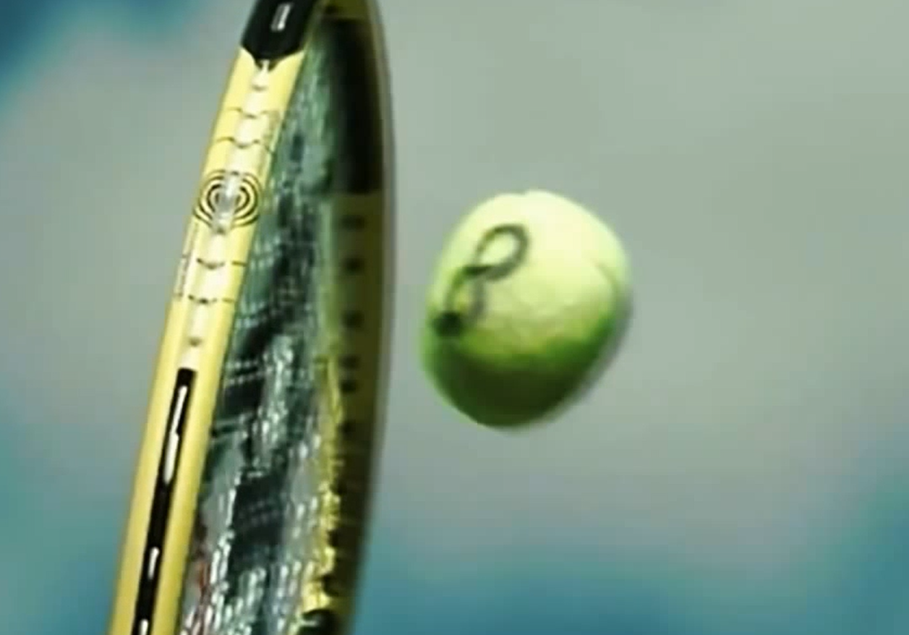

Using a regular fixed mask the shape of a ball would result in “losing” the ball mid-video, since we won’t be able to find that specific shape (as can bee seen in the images above). Using the algorithm presented in the article could act as the solution to that problem.

# Background

## Summary of the given article

In the given article, the authors present a mathematical model which performs image registration. That model uses sum of absolute differences (SAD) with an arbitrary order total variation as a regularization term. The Objective is to find that minimizes the following:

Where:

* u is the 2D displacement field
* are the input images
* is the n’th order distributional derivative of u. n is an arbitrary integer.

Note: The authors use the intensity consistency constraint (the intensity at point x in the target image is the same as that at point in the source image)

Since the optimization of the given term is challenging, The authors propose a to approach it in the following matter:

1. Using linearization to simplify the model.
2. Break down the optimization process to multiple steps using alternating direction method of multipliers (ADMM)(1).

(1) The alternating direction method of multipliers (ADMM) is an algorithm that attempts to solve a convex optimization problem by breaking it into smaller pieces, each of which will be easier to handle.

The model described in the article was proven to be successful, as can be seen in the following results:

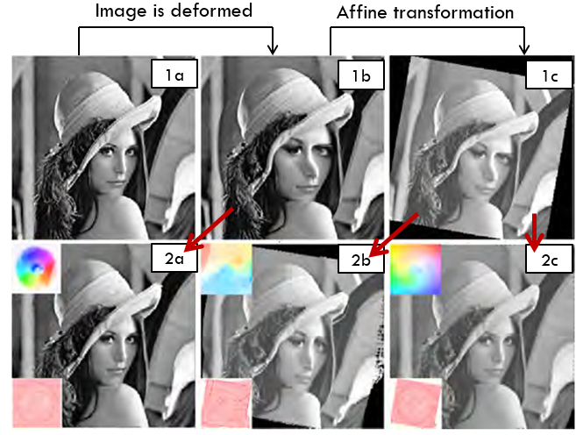

* (1a) Original image
* (1b) The original image after it was deformed
* (1c) The deformed image after an affine transform was applied to it
* (2a) The result of applying a 1st order Total Variation to image (1b)
* (2b) The result of applying 1st order Total Variation to image (1c)
* (2c) The result of applying 3rd order Total Variation to image (1c)

As seen in the results above, 1st order methods rely on the initial alignment of images, making them better suited when an affine linear pre-registration is possible. However, this is not the case for higher-order methods.

## Object Tracking

Object tracking is the process of identifying and tracking objects during a series of frames of a video.

# Method

To achieve the ability to track objects that may change their shapes in between frames, we are planning to implement the following workflow:

For the first frame:

1. Detect the object of interest using object detection algorithm
2. Create a mask of said object

For any frame that follows:

1. Use the algorithm from the given article to shape the mask using the current frame and the previous one as input images
2. Create a mask according to the result of the algorithm

# Experimental results

# References