1) ML eqaulizer performs better than LS equalizer in terms of noise enhancement (flat channel), namely on high SNR

on extermely high SNR it performs less good: EVM~55dB instead of ~75dB, but who cares...

2) on low SNR, coarse frequency synch with preamble_synch harms more than it contributes. netter neutralize it. Not true once extended preamble_synch to 8 symbol lengths

3) on moderate multupath (e.g; Delay_resp_vec=[0 1]; Amp_resp_vec=[1 0.5];) coarse frequency synch harms more than contributes

Average power curve: preamble part "looks better" if there is large number of preamble symbols (4 CE and 8 synch)

•CP  ארוך עלול לגרום לשיא שגוי של המטריקה. בקוד הגבלתי אותו ל-1.4 מאורך ה-FFT

1. ML Equalizer crashes when the ratio between the sc's quantity and CP length (in Tchip terms) is superior to 0.2577. LS equalizer does not depend on LS problem overdetemination, thus has no problem with that; i.e- long CP -> LS equalizer
2. Time synchronization:
   1. the metric's peak is goes from 0.8 to 0.99. it is higher the more the channel is flat
   2. CP too long may cause a wrong metric's peak. I have therefore limited it to 1/4 of the N_FFT length
3. NI9215 is has a narrower band than 6212, hence chirp might be distorted and misinterpreted. Its performance is unstable; sometimes 37dB at N_symbols=50,000 and sometimes 51dB
4. NI9215 needs to "warm up";
   1. In HW mode, the chirp fails to synchronize. Especially in wideband modes (10kHz and above)
   2. provides better results after some time has elapsed from powering ON. If results are mediocre even after warm up: need to reset via NI MAX **when MATLAB is closed!!**
5. PAPR depends on number of subcarriers; thus preambles enhancement is correlated to number of subcarriers and not to bandwidth (Fchip)
6. 256 subcarriers configuration performs better than 64 somehow
7. Despite the inverse sinc, being too close to Freconstruction harms the signal
8. Chirp: D/A deteriorates chirp signal that spans on a wide range of frequencies. E.g: chirp between 5kHz and 15kHz will be transmitted better than 2.5kHz to 17.5kHz. therefore it is preferable to use a 10kHz wide chirp for 20kHz wide signal than 20kHz wide chirp
9. Bad EVM:
   1. Wait for warm up
   2. Lower Fchip to 5kHz; maybe wide chirp is the cause for that
   3. NI max: soft reset. **NI6215** is mostly the problem, not the 9215&9174!
   4. Hard reset
   5. Change equalizer to LS
   6. Disable coarse frequency correction
   7. Shorten N_CP (relevant to ML)
10. HW mode: the reason of major deterioration of EVM, namely on long frames is the ICI and Sinc descent (see Prasad 5.21, 5.23) resulting of wrong frequency offset estimation. To be more precise, the estimation is right but valid only for a short period following the synchronization preamble. The reason is that the frequency offset itself varies with time!

**Figure 1: large frequency variation (ADC =9215)**

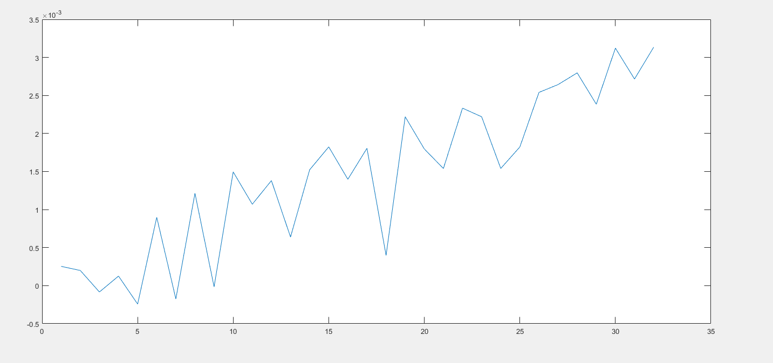

**Figure 2: bad EVM (relating to fig 1)**

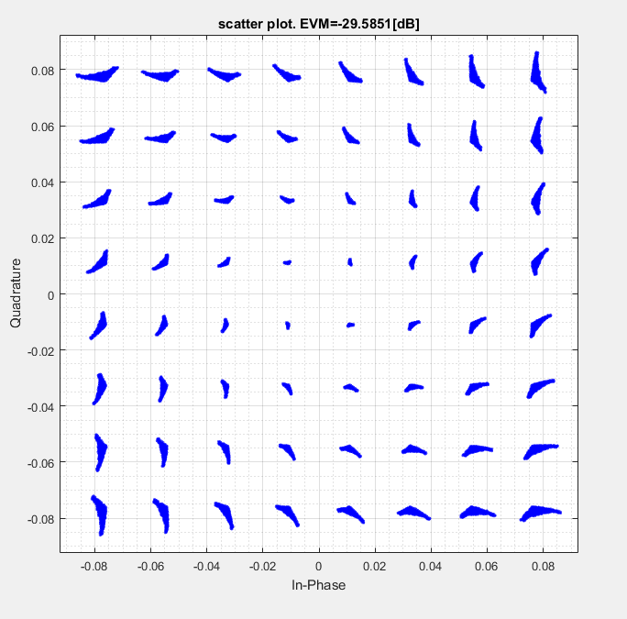

**Figure 3: small frequency variation (ADC =9215)**

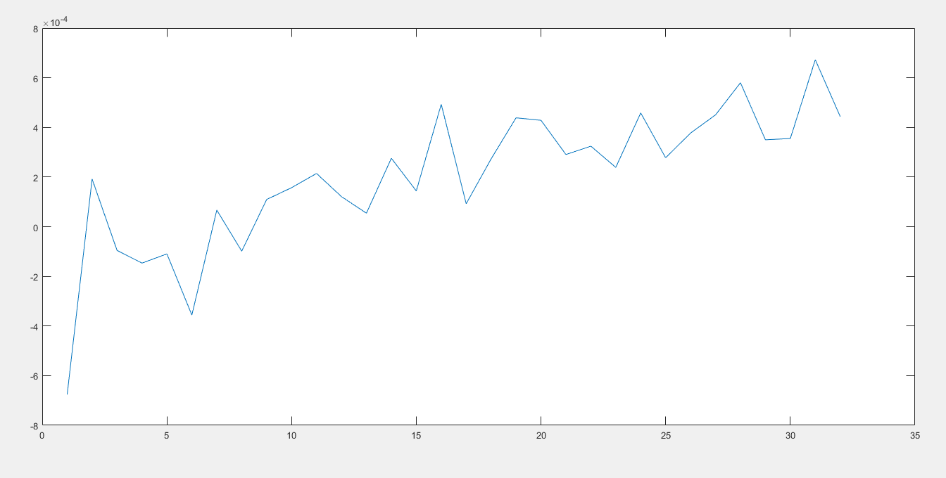

**Figure 4: good EVM (relating to fig3)**

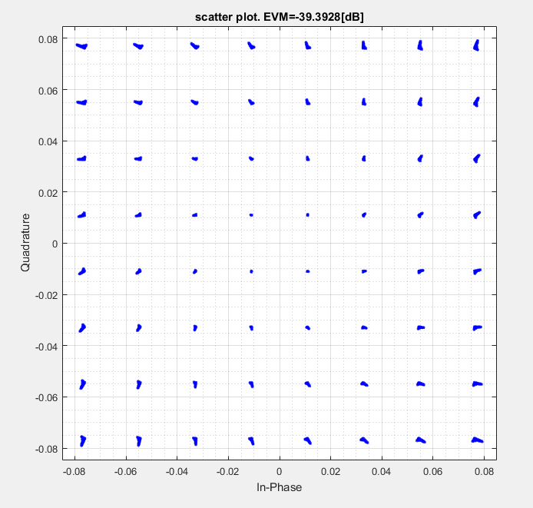The further away from preamble that we are the worse are the consequences. Those consequences cannot be corrected in the frequency domain but only on time domain.

I have implanted an estimator in the receiver, only for testing purposes, to estimate the needed spacing between consecutive midambles. It seems that on every ~0.8sec (16k chips with T_chip=5e-5 sec [F_chip=20kHz]) a re-sync is needed