Semantic Analysis of Dreams Using Text Embeddings & Language Models
Final Project Report - Advanced Models of Language Understanding
Lior Telman Amram, Mor Berger, Linoy Kaufman
Abstract
Semantic analysis of complex narrative structures, such as dream reports, presents a unique challenge in Natural Language Processing (NLP) due to their high degree of subjectivity, emotional nuance, and non-linear storylines. In this project, we explore the semantic organization of dream narratives from the DreamBank corpus by projecting text embeddings into a two-dimensional principal component analysis (PCA) space. Dividing this space by the signs of the two components yields four quadrants, which we initially interpreted along two axes: Emotional Intensity (Dramatic vs. Everyday) and Cognitive Orientation (Experiential vs. Cognitive). To evaluate whether modern language models can capture this structure, we formulate a 4-class classification task. We implement and compare two methodological paradigms: (1) fine-tuning supervised Transformer models (BERT and RoBERTa), and (2) Zero-Shot and Chain-of-Thought prompting of a Large Language Model (GPT-4o). Fine-tuned BERT and RoBERTa reproduce the PCA-derived labels almost perfectly (98–99% accuracy), whereas GPT-4o performs below chance level (19–20%, compared with 25% for four balanced classes). An orientation check revealed that the second PCA axis is reversed relative to our semantic labels and strongly correlated with report length, indicating that the PCA-based labels capture surface features in addition to semantic content.

Introduction & Background

Motivation & Dataset
Dream reports are rich personal narratives containing complex cognitive patterns, recurring images, and emotional trajectories. Traditional psychological text analysis relied heavily on manual coding frameworks (such as the Hall/Van de Castle system). With the advent of deep contextual embeddings, NLP methods offer scalable, systematic ways to map the semantic topology of large narrative corpora.
In this study, we utilize data from DreamBank, a widely referenced repository established at UCSC containing over 20,000 digitized dream reports from many dreamers and series. The combined corpus used in this project contains 38,223 reports. Pre-processing removed DreamBank identifier and date tags and normalized whitespace; we then discarded reports shorter than 10 words and removed 10,132 exact duplicates (the same dream appearing in several source files), leaving 27,695 unique dreams that were used in all experiments.

Semantic Mapping via PCA Quadrants
To map dreams into a continuous vector space, each dream text is passed through a pre-trained Sentence Transformer model (all-MiniLM-L6-v2) to extract 384-dimensional sentence embeddings. To visualize and interpret this high-dimensional space, Principal Component Analysis (PCA) is applied to reduce the embeddings to two orthogonal dimensions, which together explain about 9% of the embedding variance (5.1% and 4.3%). Based on a qualitative reading of dreams along each component, we interpreted them as follows:
- PCA Component 1 (Emotional Intensity): Interpreted as the spectrum from Everyday/Mundane narratives (work, routines, shopping) on the left to High Emotional/Dramatic events (accidents, nightmares, life-or-death scenarios) on the right.
- PCA Component 2 (Cognitive vs. Experiential Orientation): Interpreted as differentiating between direct sensory/bodily experiences (Experiential) and objective, detached or procedural recollections (Cognitive).
As illustrated in Figure 1, crossing these two axes defines 4 Semantic Quadrants:
- Top-Right (Dramatic + Experiential): Nightmares, fear, physical sensations, violence, and intense emotional trauma.
- Top-Left (Everyday + Experiential): Personal emotional tension, minor discomfort, and interpersonal awkwardness in daily settings.
- Bottom-Right (Dramatic + Cognitive): Major high-stakes events described from a distance, objectively, or observationally.
- Bottom-Left (Everyday + Cognitive): Work, organizational routines, administrative tasks, and mundane daily logistics.
These axis labels reflect our initial qualitative interpretation. A later orientation check (Results, item 5) showed that PCA2 is reversed relative to these labels and strongly associated with report length, so the axis names should be read as tentative.
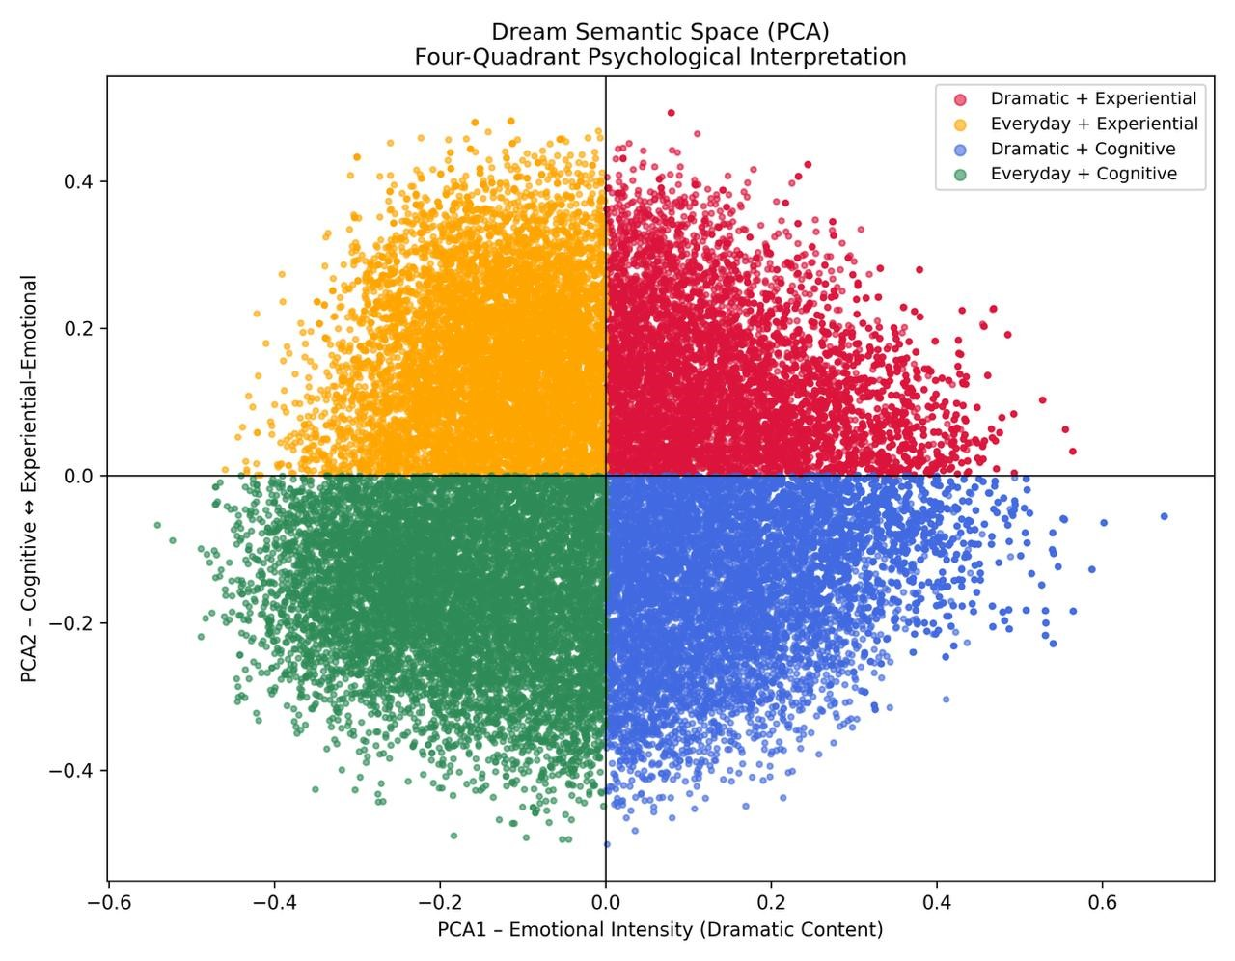
Figure 1: Global PCA projection of DreamBank text embeddings into a 2D semantic space, partitioned into four psychological quadrants.

Related Work
- Sentence Embeddings & Low-Dimensional Projections: Reimers & Gurevych (2019) introduced Sentence-BERT, demonstrating that pooling Transformer outputs yields semantically meaningful sentence embeddings that maintain cosine-similarity relationships suited for dimensionality reduction techniques like PCA and UMAP.
- Interpretability & Probing in LMs: Rogers et al. (2020) (A Primer in BERTology) surveyed methods for analyzing BERT’s internal representations, highlighting how self-attention heads specialize.
In syntactic vs. semantic features, and how probing classifiers reveal what structural information models retain.

Research Questions
Based on the semantic mapping established in the previous section, we formulate three core research questions:
- Classification Performance (RQ1): Can fine-tuned Transformer models (e.g., BERT/RoBERTa) and Zero-Shot Large Language Models (LLMs) accurately predict the semantic quadrant of a dream report solely from its textual content?
- Interpretability & Feature Importance (RQ2): Which specific words, phrases, or structural elements drive the models’ predictions?
- Emotional Alignment (RQ3): How do LLM-extracted emotional attributes correspond to the positions of dream reports along the two PCA axes (Emotional Intensity vs. Cognitive/Experiential orientation)?
In this research, we decided to focus primarily on Classification Performance (RQ1).
RQ2 is addressed only qualitatively through the case studies, and RQ3 is left for future work.

Methodology & Experimental Setup

Ground Truth Construction & Extreme-Case Filtering
A primary challenge in this project is that the four quadrants were derived via unsupervised PCA projection of vector embeddings, rather than explicit human annotations. To construct a reliable test set (Ground Truth) for evaluation:
- Qualitative Inspection: A sample of dream reports from each quadrant was inspected qualitatively; a later orientation check revealed that the PCA2 orientation was reversed relative to our labels
- Filtering for Boundary Cases: To reduce ambiguity near quadrant boundaries, we selected extreme cases using the 50th percentile of the absolute PCA coordinates within each quadrant. Dreams were retained only if both PCA coordinates exceeded their respective thresholds. Each class was then randomly downsampled to the size of the smallest class, yielding 1,439 dreams per class (5,756 in total), and the data were split with stratification into training (4,029), validation (863), and test (864) sets (random seed 42).
To verify that each quadrant represents a rich sub-domain rather than a collapsed cluster, we analyzed the local structure of each quadrant independently (Figure 2) and performed exploratory KMeans clustering (k = 4, Figure 3). The results suggest that semantic variance is preserved locally across all four quadrants.

Experiment 1: Fine-Tuned Transformer (Supervised Approach)
To test whether a supervised model can capture the quadrant boundaries:
- Model Architecture: Pre-trained BERT-base-uncased (and RoBERTa-base) with a classification head added on top of the token output.
- Dataset Split: 70% Train, 15% Validation, 15% Test (filtered extreme cases).
- Hyperparameters: Learning rate = 2 × 10⁻⁵, Batch size = 16, Optimizer = AdamW with linear warmup, trained for 5 epochs using Cross-Entropy Loss. The best checkpoint was selected based on validation Macro F1-score and evaluated on the held-out test set.
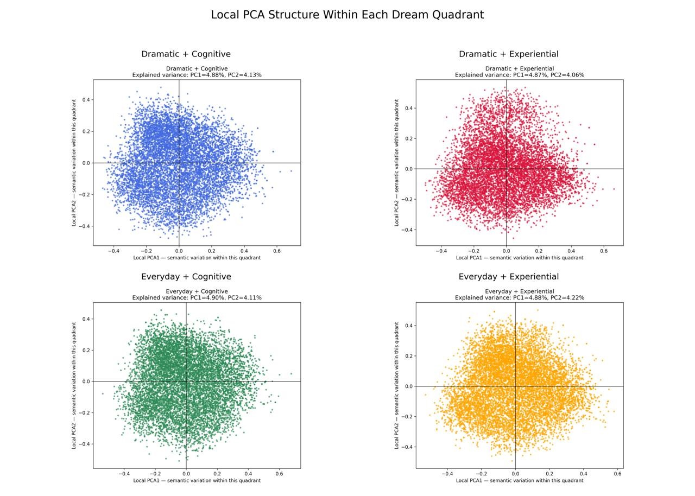
Figure 2: Local PCA projections performed independently within each dream quadrant, showing internal semantic structure and variance distribution.
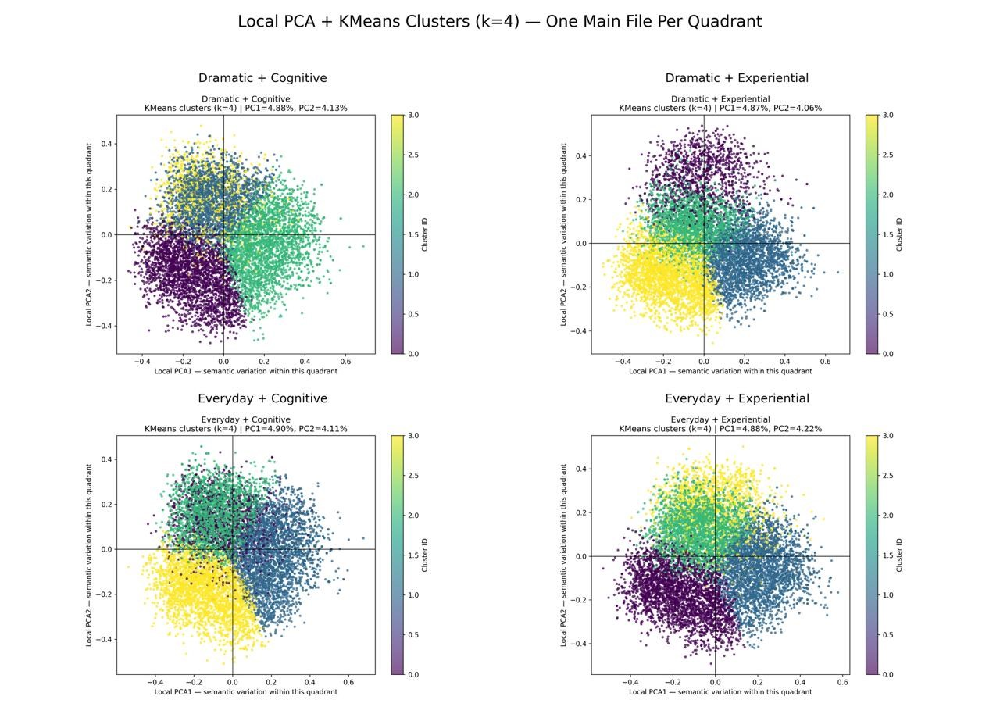
Figure 3: Exploratory KMeans clustering (k = 4) applied within each local PCA space to evaluate subtopological groupings.

Experiment 2: Large Language Model (Zero-Shot & Chain-of-Thought)

To evaluate whether a general-purpose LLM can recover the quadrant structure from natural-language definitions alone, we evaluated GPT-4o (temperature 0, JSON output) on the same 864-dream test set without any task-specific training.

Prompt: The system prompt contains a definition of both axes (Emotional Intensity: Dramatic vs. Everyday; Orientation: Experiential vs. Cognitive) and a short description of each of the four quadrants, as interpreted in the Introduction.

Zero-Shot: The model returns only the quadrant number.

Zero-Shot + Chain-of-Thought (CoT): The model first reasons step by step about each axis, then returns the quadrant and 3–5 verbatim key phrases that influenced its decision.

Scoring: Answers that could not be parsed are counted as errors (in the final run, all 864 answers in both setups were parsed successfully). The exact prompts are defined in experiments.py, and all raw model responses are stored in the repository (table1_outputs).

Results & Findings

Quantitative Classification Performance
Table 1 presents the classification performance of four experimental configurations on the extreme-cases test set, consisting of 864 dream reports. The experiments compare two supervised Transformer-based models, BERT-base-uncased and RoBERTa-base, with GPT-4o evaluated using Zero-Shot Prompting and Zero-Shot with Chain-of-Thought (CoT) prompting.
The dataset was constructed by applying SentenceTransformer embeddings and Principal Component Analysis (PCA) to dream narratives, assigning each dream to one of four semantic quadrants based on its PCA coordinates. To reduce ambiguity near quadrant boundaries, extreme-case filtering was applied, followed by class balancing. The resulting dataset was divided into training (70%), validation (15%), and testing (15%) subsets.
The supervised models were fine-tuned on the PCA-derived quadrant labels, whereas GPT-4o was evaluated without task-specific fine-tuning, using natural-language descriptions of the four semantic categories.
Performance was evaluated using Accuracy, Macro Precision, Macro Recall, and Macro F1-score.
Table 1: Performance metrics for 4-quadrant dream classification on the extreme-cases test set.
Model | Setup | Accuracy | Macro Prec. | Macro Rec. | Macro F1
BERT-base-uncased | Supervised Fine-Tuning | 0.9826 | 0.9828 | 0.9826 | 0.9826
RoBERTa-base | Supervised Fine-Tuning | 0.9896 | 0.9896 | 0.9896 | 0.9896
LLM (GPT-4o) | Zero-Shot Prompting | 0.1944 | 0.1903 | 0.1944 | 0.1786
LLM (GPT-4o) | Zero-Shot + Chain-of-Thought | 0.2037 | 0.1744 | 0.2037 | 0.1608
Key Quantitative Observations:
1. Supervised Model Performance: RoBERTa achieved the highest accuracy (98.96%) and Macro F1 (0.9896), slightly outperforming BERT (98.26%). Both models demonstrated strong agreement with the PCA-derived labels.
2. Zero-Shot Performance: GPT-4o achieved substantially lower accuracy (19.44%), suggesting a mismatch between its semantic interpretation of dream categories and the PCA-generated labels.

3. Chain-of-Thought Impact: CoT prompting slightly improved accuracy from 19.44% to 20.37%, but reduced Macro F1 from 0.1786 to 0.1608, indicating no consistent improvement.

4. Supervised vs. Zero-Shot: Fine-tuned models substantially outperformed Zero-Shot approaches because they were trained directly on PCA-derived labels, while GPT-4o relied solely on natural-language category definitions.
5. PCA axis orientation: PCA signs are arbitrary, so we examined the most extreme training dreams to verify axis orientation. PCA2 was reversed relative to our semantic labels: going over the most extreme dreams showed that positive values corresponded to short, fragmentary reports, while negative values corresponded to longer, emotional, and sensory narratives. PCA2 is strongly correlated with report length (Spearman ρ = −0.75, training set). PCA1 had the expected orientation but appeared to reflect mainly writing style rather than emotional intensity.
GPT-4o agreed with the original PCA2 labels in only 35–36% of test cases. Flipping PCA2 improved accuracy from 0.19 to 0.40 (Zero-Shot) and from 0.20 to 0.37 (CoT), while PCA1 agreement remained at 0.58–0.59 (see Table 2).
Since flipping a PCA axis changes only the label convention, the underlying data structure remains unchanged. For the fine-tuned models, an equivalent relabeling of both true and predicted classes leaves evaluation metrics unchanged; retraining is only necessary if the models must produce predictions using the corrected label convention.

Table 2: GPT-4o accuracy and per-axis agreement under different PCA axis orientations (n = 864)
Orientation | Zero-Shot Acc. | Zero-Shot Axis 1 | Zero-Shot Axis 2 | CoT Acc. | CoT Axis 1 | CoT Axis 2
Original (as in Table 1) | 0.19 | 0.59 | 0.35 | 0.20 | 0.58 | 0.36
PCA2 flipped | 0.40 | 0.59 | 0.65 | 0.37 | 0.58 | 0.64
PCA1 flipped | 0.15 | 0.41 | 0.35 | 0.16 | 0.42 | 0.36
Both flipped | 0.26 | 0.41 | 0.65 | 0.27 | 0.42 | 0.64

Qualitative & Interpretability Analysis
Case Study 1: High Emotional / Experiential (Top-Right Quadrant)
- Text snippet: “I was climbing some high mountain peaks. Other peaks were all around.”
- PCA Coordinates: High positive values on both PCA1 (Intensity) and PCA2 (Experiential).
- Model Classifications: Fine-tuned BERT, RoBERTa and GPT-4o (CoT) correctly assigned this dream to Dramatic + Experiential; GPT-4o Zero-Shot assigned it to Dramatic + Cognitive.
- Key Indicators: GPT-4o highlighted “climbing some high mountain peaks” and “Other peaks were all around”. It placed the dream on the Dramatic side because of “the inherent risk and challenge associated with mountain climbing”, while noting that “the description lacks any emotional intensity or high-stakes events like danger or fear”. It placed it on the Experiential side because it “describes the activity from a first-person perspective”.
Case Study 2: Everyday / Experiential (Top-Left Quadrant)
- Text snippet: “Someone was speaking. I was annoyed because he was using ambiguous terms and otherwise contradicting himself.”
- PCA Coordinates: Negative PCA1 (Mundane setting) and Positive PCA2 (Personal emotional tension).
- Model Classifications: All four configurations (BERT, RoBERTa, GPT-4o Zero-Shot and CoT) correctly assigned this dream to Everyday + Experiential.
- Key Indicators: GPT-4o highlighted “I was annoyed”, “ambiguous terms” and “contradicting himself”. It described the situation as “a mundane interaction with someone speaking ambiguously” (Everyday), in which “the dreamer expresses a personal emotional reaction, feeling annoyed by the speaker’s ambiguity” (Experiential).
Notably, both examples are short reports, consistent with the association between positive PCA2 values and shorter reports.

Discussion, Limitations & Future Work

Discussion of Findings
- The experimental results demonstrate that supervised Transformer models can effectively learn the classification structure derived from PCA projections of dream embeddings.
- RoBERTa-base achieved the highest classification performance, followed closely by BERT-base-uncased. Both models obtained accuracy scores above 98%, indicating strong agreement with the automatically generated quadrant labels.
- In contrast, GPT-4o performed substantially worse under both prompting configurations Zero-Shot configurations. The addition of Chain-of-Thought prompting produced a minor improvement in accuracy but did not improve overall Macro F1 performance.
- These findings suggest that the PCA-derived classification boundaries can be learned effectively through supervised fine-tuning but are not necessarily aligned with the semantic distinctions inferred by a general-purpose language model from natural-language instructions alone.
- Importantly, the high performance of the supervised models should be interpreted within the context of the experimental design. Since the target labels were derived from unsupervised dimensionality reduction rather than comprehensive human annotation, the results primarily demonstrate the models' ability to reproduce the PCA-based classification structure.
- Part of GPT-4o’s low accuracy stems from the PCA2 sign convention: with PCA2 flipped, its accuracy rises to 0.37–0.40 (Table 2), indicating partial agreement with the semantic definitions along that axis, even so, it remains far below the fine-tuned models.

Limitations
- Unsupervised Ground Truth Noise: Because the quadrant labels were derived from PCA coordinates rather than exhaustive manual annotation, boundary cases near the origin (0,0) retain inherent ambiguity.
- Computational Constraints: Fine-tuning was limited to base Transformer models (110M–125M parameters). We did not perform full parameter fine-tuning on multi-billion parameter open-weights models due to GPU memory limits.
- Domain Specificity: Dream reports vary substantially in length and narrative style across different dreamers (e.g., child series vs. adult series).
- Label Semantics: PCA2 is strongly correlated with report length (Spearman ρ = −0.75), so the fine-tuned models’ near-perfect accuracy may partly reflect surface features such as length and writing style rather than the intended psychological dimensions.
- Single Run: Each configuration was run once.

Future Directions
- Parameter-Efficient Fine-Tuning (PEFT/LoRA): Applying LoRA to adapt open LLMs (e.g., Llama3-8B) directly to narrative quadrant classification.
- Multimodal Embeddings: Combining text embeddings with generative image models (Text-to-Image) to visualize the dream landscapes corresponding to each quadrant.

Conclusion
This study explored the semantic organization of dream narratives using contextual text embeddings and unsupervised learning methods. By projecting dream reports into a low-dimensional space using Principal Component Analysis, we qualitatively interpreted two latent dimensions as reflecting emotional intensity and cognitive versus experiential content. These dimensions provided a computational basis for dividing the projected space into four broad semantic quadrants. However, an orientation check showed that the second axis is reversed relative to this interpretation and largely reflects report length, so these labels should be treated as tentative rather than as validated psychological dimensions.
To investigate the internal variation of these regions, we performed local PCA followed by KMeans clustering within each quadrant. The local projections suggested that each quadrant retains semantic variation, while the KMeans analysis produced candidate subdivisions for further investigation. Quantitative modeling showed that supervised language models reproduce this partition almost perfectly, whereas GPT-4o, guided by the semantic definitions, performed below chance level. Correcting the PCA2 orientation raised its accuracy to 37–40%, still far below the fine-tuned models.
Overall, the findings suggest that contextual text embeddings can organize dream reports along interpretable dimensions without manual labels, but our orientation check shows that these dimensions may also reflect surface features such as report length. The proposed framework offers a scalable computational approach to examining subjective texts while highlighting the importance of cautious interpretation and external validation.

Team Contributions & Division of Labor
The workload was equally distributed among all team members:
- Lior Telman Amram: Primary responsibility for dataset preprocessing, Sentence-BERT embedding generation, PCA dimensionality reduction, and vector space visualization.
- Mor Berger: Led the supervised fine-tuning experiments (BERT / RoBERTa models) and the setup of evaluation metrics.
- Linoy Kaufman: Designed the LLM Zero-Shot & Chain-of-Thought prompting framework, conducted case-study qualitative analysis, and led the integration and drafting of the final scientific report.

References
- Reimers, N., & Gurevych, I. (2019). Sentence-BERT: Sentence embeddings using Siamese BERT-networks. Proceedings of the 2019 Conference on Empirical Methods in Natural Language Processing (EMNLP).
- Domhoff, G. W., & Schneider, A. (2008). Studying dream content using the DreamBank website and LIWC. University of California, Santa Cruz. Available at http://dreambank.net.
- Rogers, A., Kovaleva, O., & Rumshisky, A. (2020). A Primer in BERTology: What We Know About How BERT Works. Transactions of the ACL, 8, 842–866.
- Devlin, J., Chang, M.-W., Lee, K., & Toutanova, K. (2019). BERT: Pre-training of Deep Bidirectional Transformers for Language Understanding. NAACL-HLT.
- Liu, Y., et al. (2019). RoBERTa: A Robustly Optimized BERT Pretraining Approach. arXiv:1907.11692.
- OpenAI (2024). GPT-4o System Card. arXiv:2410.21276.
- Hall, C. S., & Van de Castle, R. L. (1966). The Content Analysis of Dreams. New York: Appleton-Century-Crofts.

