**CommIT FED Quiz**

1. Google search tool:  
   the following ‘pseudo’ code represents an input listener for the Google search tool:  
     
   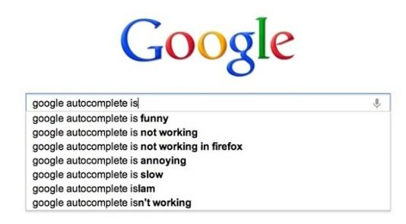  
     
   $(‘#search’).keyup(async function(e){  
    var topFiveSuggestions = await fetchTopFiveSuggestions(e.target.val);  
    showAsAutoComplete(topFiveSuggestions);  
   });  
     
   * what’s the disadvantage of this code ?   
   assuming fetchTopFiveSuggestions returns a promise object, showAsAutoComplete  
   will be called with a promise object as its argument  
   * add your own code that will solve the current issues. added above
2. The next function gets a jQuery element and a Boolean flag.  
   The function should show or hide the element, following the flag.  
   flag==false: hide the element  
   flag==true: show the element  
   the function should contain only a single line that will starts with: ‘$element’. Complete the function, **using ‘show’ and ‘hide’ jQuery functions**.  
     
   function showMe($element, flag){

$element.filter(() => flag ? $element.show() : $element.hide());

}

1. Write a **multiple questions quiz** - angular application (from scratch),  
   the app will show one question at a time and two navigation buttons:   
   next + prev.   
   * The prev. button will be disable on the first question.  
   * The next button will be replaced with ‘done’ button on the last question.  
   * The ‘done’ button should calculate the user’s grade (0-100).  
   * Each question will have a single answer.  
   * On prev. / next navigation the answered questions should keep the state.  
   * the number of questions and answers will be represented by a ‘data’ object (JSON)  
   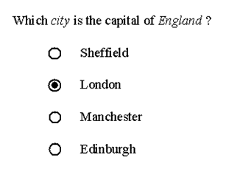

**Good luck ☺**