T91 Basic Idle project for AT91RM9200DK
Introduction
The goal of this demonstration project is to show how to move the AT91RM9200 in IDLE state
This very small application is controlled through the DBGU serial port messages.
User can send ‘p’ or ‘c’ characters to move the core in idle mode. Other characters send while in idle mode will activate the core.
Description
There are 2 ways to go in IDLE mode:
- • • Configuring the processor clock bit in the PMC (power management controller)
- • • Using the CP15 function “Wait for Interrupt” of the ARM920T: MCR p15, 0, Rd, c7, c0,4
While running the application send characters each seconds through the DBGU. An interrupt is triggered when a character is received.
If this character is ‘P’ then the AT91RM9200 goes in idle mode configuring the power management controller. If character sent is ‘C’ then
the AT91RM9200 goes in idle mode using CP15 function.
DBGU Trace and Command
-I- ======================================
-I- AT91RM9200 idle mode example
-I- --------------------------------------
-I- Hit P to enter in idle mode using PMC
-I- Hit C to enter in idle mode using CP15
-I- Hit another key to exit idle mode
-I- ======================================

IDLE模式测试方法
下面来说明用JTAG/ICE的方式来做EBD9200IDLE模式的测试。基本条件如下：
- 9针串口插在底版上标号为“P1”的串口插座上，25针并口线一头插在PC机并口，另一头插在JTAG/ICE转换器上，JTAG/ICE转换器的排线一头插在底版上标号为“J22”的20Pins槽上，另一头插在JTAG/ICE转换器的的右边即靠近SN74HC244 10脚这边；
- 将底版上标号为“J23”的跳线跳到靠近J5这边；
- 核心板上标号“J2”的跳线跳到靠近“C18”的这边；
- 底版上其它跳线配置为：J13，J16要插好，JP1插在靠近C14这边，J12插在靠近C22这边；
- 9V电源线（最好用我公司提供的专用产品）插在标号为“JACK1”的DC插座上。
当您上电后ARM9调试代理软件EBD9200超级终端的现象和电路板的现象如下图所示的话就说明连接正确：
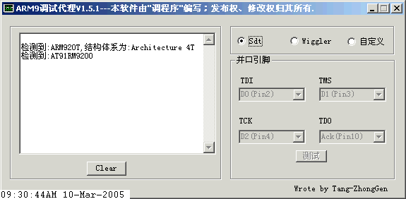
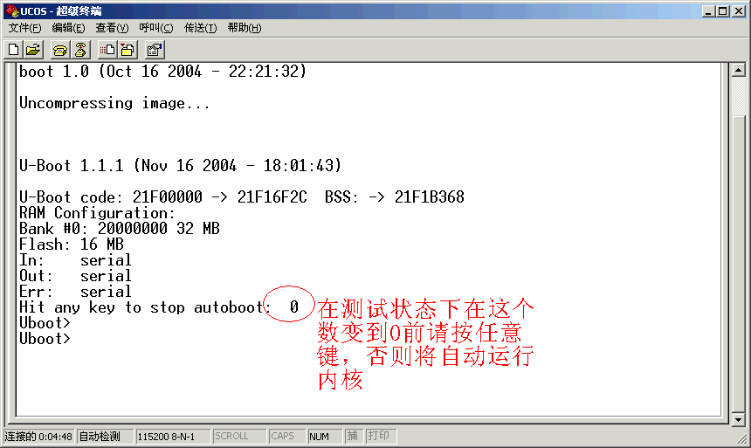

将待测试的文件通过软件汇编和编译在超级终端中刚开始现象如下
参加汇编和文件目录：AT91RM9200-BasicIdle-ARM1_2-2_0/AT91RM9200-BasicIdle/compil/BasicIdle.mcp

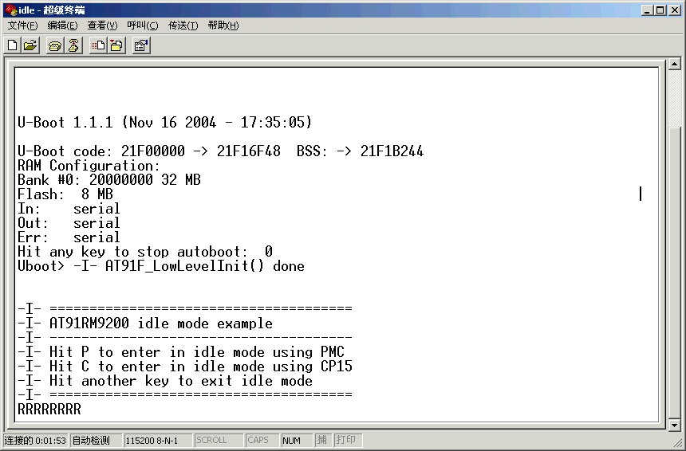
按“P“的现象如下
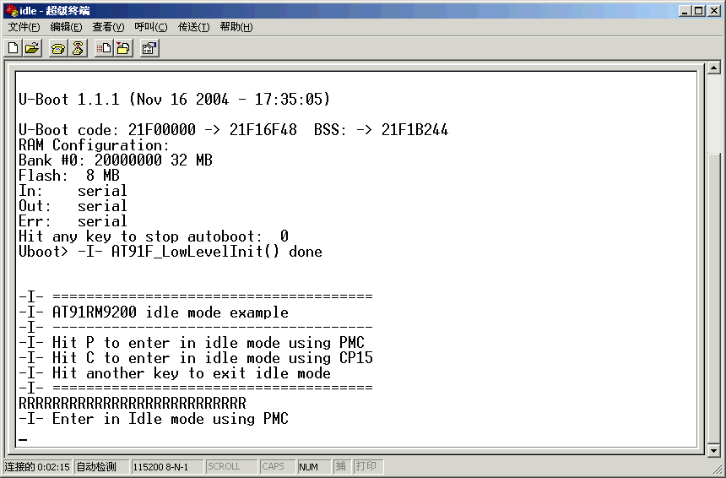

按“C”的现象如下
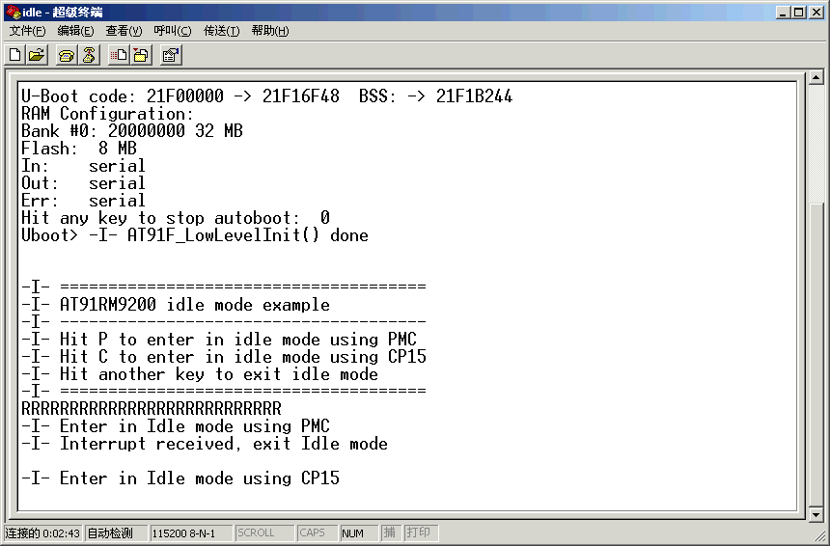

按其它键的现象如下
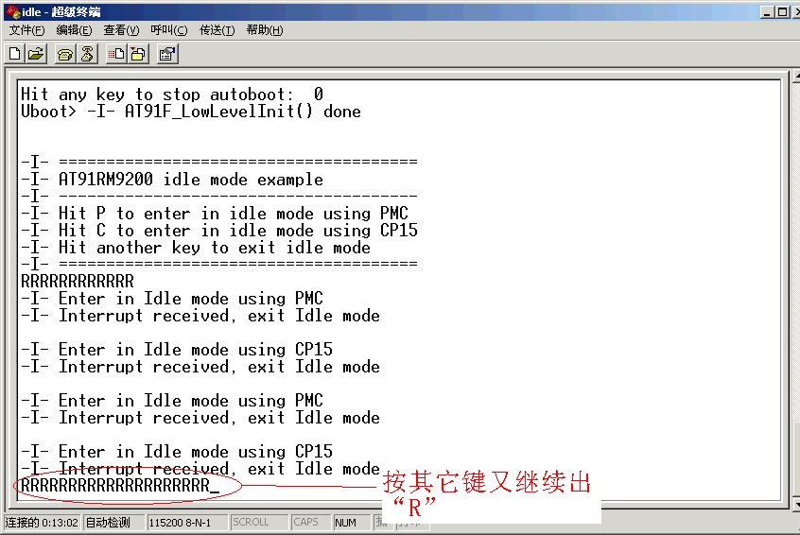
测试完毕。

