Nick Liotti, liotti2
STAT 434 FINAL PROJECT

Instructions

Fill in this document, inserting your answers where appropriate. You are allowed to work with others. Point values are given next to the questions you need to answer. Submit the following to Compass under the Final Project section by December 20 at 11:59 pm.
- This completed document
- The file score.RData, see instructions below

Preprocess data

Load train.RData.
- The expr_train object contains gene expression levels (rows) for each patient (columns) in the training data.
- The outcome_train object contains survival outcomes (columns) for each patient (rows) in the training data.
- The expr_test object contains gene expression levels for each patient in the test data.

Answer the following questions.
- How many patients are there in the training data? (1 point)
Answer: 340 patients

- How many covariates (genes) are there in the training data? (1 point)
Answer: 54675 covariates

- How many patients are there in the test data? (1 point)
Answer: 214 patients

Descriptive statistics

This section assesses some basic features of the training set data.

Answer the following questions.
- Plot the Kaplan-Meier estimate of the survival function for the patients in the training set. Include 95% log-log confidence intervals. (1 point)

Include plot here:
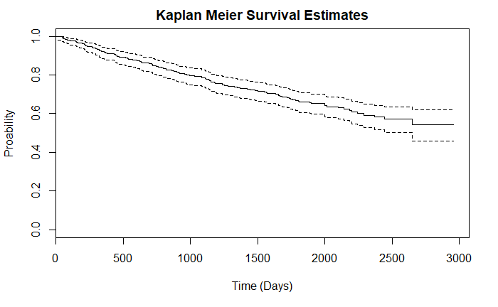

- What is the restricted mean survival time up to 1825 days (1 point)?
Answer: 1498.66642 Days

Important genes

This section tries to identify genes that are highly associated with survival time in the training set.

Answer the following questions:
- For each gene, divide patients into two groups, depending on whether each patient’s gene expression level is higher or lower than the median expression level of that gene. Conduct a logrank test for whether the survival curve is different between the two groups. What are the top 10 genes with the most significant logrank p-values, from most to least significant?
  - (1 point): 1565951_s_at
  - (1 point): 212766_s_at
  - (1 point): 209687_at
  - (1 point): 228191_at
  - (1 point): 209609_s_at
  - (1 point): 1558027_s_at
  - (1 point): 231428_at
  - (1 point): 1553677_a_at
  - (1 point): 206698_at
  - (1 point): 215176_x_at

- For each gene, fit a Cox regression modeling survival time as a function of only that gene. What are the top 10 genes with the most significant Cox Wald test p-values, from most to least significant?
  - (1 point): 225834_at
  - (1 point): 201731_s_at
  - (1 point): 213144_at
  - (1 point): 1565951_s_at
  - (1 point): 226350_at
  - (1 point): 204092_s_at
  - (1 point): 209753_s_at
  - (1 point): 201137_s_at
  - (1 point): 204032_at
  - (1 point): 208965_s_at

- Using the fitted Cox regressions from part 2 above, what are the top 10 genes that give the largest C statistics (up to 1825 days) in the training data, from largest to smallest?
  - (1 point): 226350_at
  - (1 point): 204032_at
  - (1 point): 1565951_s_at
  - (1 point): 208965_s_at
  - (1 point): 209753_s_at
  - (1 point): 225834_at
  - (1 point): 201137_s_at
  - (1 point): 213144_at
  - (1 point): 204092_s_at
  - (1 point): 201731_s_at

Trial design

This section imagines that we want to design a clinical trial for a drug that will be tested on future patients. Our goal is to calculate the number of patients we need to enroll in our trial in order to detect the effect of the drug, subject to the parameters below:
- We want a type I error of 0.05 and 90% power to detect the drug’s effect, if one exists.
- We will assign 50% of the recruited subjects to each arm of the trial.
- We expect that the survival distribution of the patients who do not receive the drug will look like the survival distribution of patients in the training data.
- We expect that the drug will have a hazard rate of 0.5.
- We will enroll patients for 1 year (365 days) assuming uniform accrual.
- We will follow them for 3 years (1095 days).

Answer the following questions:
- Will the drug lead to longer or shorter survival times? (1 point)
Answer: Longer survival times

- How many deaths are needed? (1 point)
Answer: 88 deaths (rounded up)

- What is the total sample size that needs to be accrued? (1 point)
Answer: 256 (rounded up)

Prediction

Use the training data to build an algorithm that, given a future patient’s gene expression values, produces a score that is predictive of that patient’s risk of death. Apply your algorithm to the patients in the test data (expr_test) and save the resulting scores to an R object called score. Save this object to a file called score.RData using the command

save(score, file = “score.RData”)

and submit this score.RData file to Compass under the Final Project section. I will use the actual survival outcomes of the patients in the test data to calculate the C statistic of your score. Grading will be as follows:
- Your score.RData file contains an object called score. (1 point)
- I can calculate a valid C-statistic in the test data using your score object without any errors. (1 point)
- Extra credit: I will round your C-statistic to two decimals and you will get 1 point extra credit ON YOUR FINAL COURSE GRADE for every 0.01 you get over 0.6.

