# ENERGY AUDIT REPORT FOR BUILIDNG COOLING SYSTEM

# FOR

# Raffles City

# North Bridge Road

Submitted By

Registration No.

# Contents

1.0 Executive Summary & Recommendation

2.0 Building Information

3.0 Energy Audit Information For Building Cooling System

3.1 Chilled Water Plant Design information

Table 1: Chiller Information

Table 2: Ancillary equipment Information

3.2 Chilled Water Plant Normal Operating Hours

3.3 Description of Plant Control Strategy

4.0 Instrumentations

Table 3: Instrumentation Table

5.0 Chiller Plant Performance Analysis (1 week data)

Fig 5.1 Super-imposed plot of 24 hr Cooling Load Profile RT

Fig 5.2 Histogram of Cooling Load Occurrences

Fig 5.3 Super-imposed plot of daily chilled water supply/return  
 temperature degC

Fig 5.4 Super-imposed plot of daily chilled water temperature  
 difference degC

Fig 5.5 Super-imposed plot of daily condenser water supply/return  
 temperature degC

Fig 5.6 Super-imposed plot of daily condenser water temperature  
 difference degC

Fig 5.7 Super-imposed plot of daily chilled water GPM/RT

Fig 5.8 Super-imposed plot of daily condenser water GPM/RT

Fig 5.9 Cooling Tower Approach Temperature

Fig 5.10 Super-imposed plot of daily chiller efficiency kW/RT

Fig 5.11 Super-imposed plot of daily chilled water pump efficiency kW/RT

Fig 5.12 Super-imposed plot of daily condenser water pump efficiency kW/RT

Fig 5.13 Super-imposed plot of daily cooling tower efficiency kW/RT

Fig 5.14 Super-imposed plot of daily chiller plant system efficiency kW/RT

Fig 5.15 Scatter plot of chiller plant efficiency over cooling load

Fig 5.16 Scatter plot of chilled water pump efficiency over cooling load

Fig 5.17 Scatter plot of condenser water pump efficiency over cooling load

Fig 5.18 Scatter plot of cooling tower efficiency over cooling load

5.1 Summary of Chilled Water Plant Operating Performance

Table 4: Chilled Water Plant Performance Summary

6.0 Summary of Heat Balance

Fig 6.1 System Level Heat Balance Plot

Table 5: Heat Balance Summary

7.0 Schedule of space operating conditions

Table 6: Space Condition Schedule

APPENDIX

Checklist of Plant Operating Condition (for best practices)

Table 7: Checklist of Plant Operating Condition

# 1.0 Executive Summary & Recommendation

This report highlights the findings and recommendations obtained from the energy audit performed at Raffles City from 2012-06-16 00:00:00 to 2012-06-18 00:00:00 for 24 hrs.

Recommendations for maintenance improvements and low cost energy conservation measures.

Recommendations which would incur capital expenditure.

# 2.0 Building Information

|  |  |
| --- | --- |
| Project Reference Number | 8888 |
| Building Age | 10 years |
| Date of last Energy Audit Submission | 23 Jun 2013 |
| Gross floor area (GFA), m2 | 1000 |
| Air conditioned area, m2 | 600 |
| Number of guest rooms (for hotels/service apartments) | nil |
|  |  |
|  |  |
|  |  |
|  |  |

# 3.0 Energy Audit Information For Building Cooling System

Ong Eng Huat was appointed by CapitaLand, owner of Raffles City to be the Energy Auditor for the 3 yearly submission of the operating system efficiency (OSE) of the centralized Chilled Water Plant. The report will present the performance of centralized Chilled Water Plant efficiency based on the measurements from the permanent instrumentations installed on site.

|  |  |
| --- | --- |
| Location | B1 Plant room |
| Energy Audit Period | 25 May 2017 to 1 Jun 2017 |
| Date of notice served | 2 May 2017 |
| Date of submission in notice | 2 May 2020 |
| Data Logging Interval | 1 minute sampling |
| Trend Logged Parameters |  |
|  |  |

# 5.0 Chiller Plant Performance Analysis (1 week data)

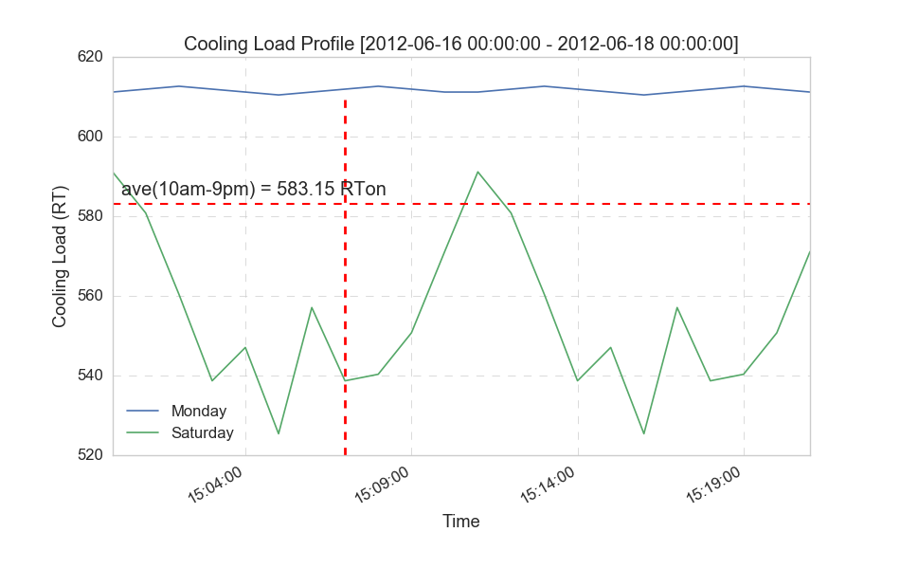

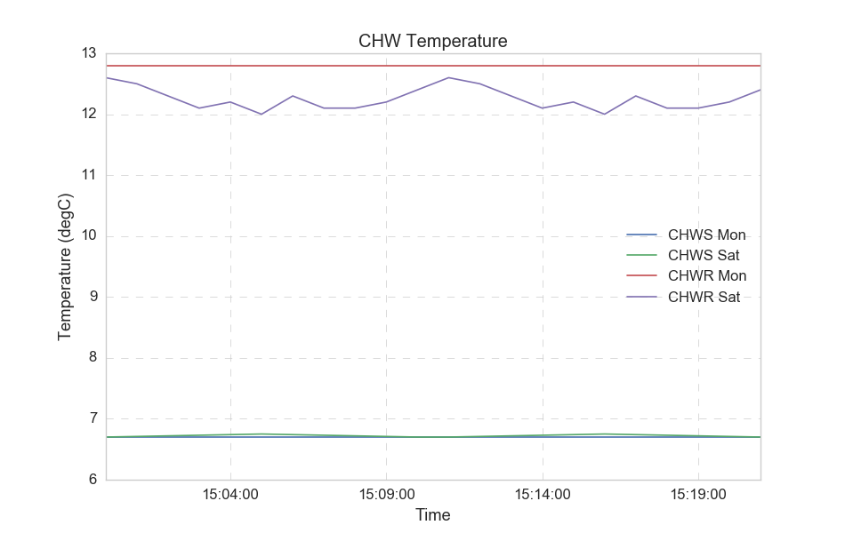

# 6.0 Summary of Heat Balance

|  |  |  |
| --- | --- | --- |
|  | Quantity | Unit |
| Sum of total electrical energy used | 13628 | kWh |
| Sum of total cooling produced | 25658 | RTh |
| Sum of total heat rejected | 28735 | RTh |
| Chiller Plant Efficiency | 25658.78 | kW/RT |
| Total Heat Balance Data Count | 44 | - |
| Data Count > + 5% error | 14 | - |
| Data Count < - 5% error | 4 | - |
| Data Count within +/-5% error | 26 | - |
| % Heat Balance within +/-5% error | 59.0 | % |

# 7.0 Schedule of space operating conditions