CS4433 Software Engineering
Phase 7: Deployment (4 Marks)
Deployment Deliverables and Verification Record

Scope and required deliverables
Phase 7 requires a UML deployment diagram, a technician-followable installation guide, role-specific user manuals and release notes for version v1.0. The approved release should be tagged v1.0. This is a console-based, offline Windows application with SQLite; web/mobile interfaces are out of scope.

Submission inventory
- Deployment_Diagram.png and Deployment_Diagram.dot: static image and editable Graphviz source.
- Technician_Installation_Guide.docx: installation, first-time setup, verification, backup and rollback.
- User_Manual_Administrator.docx, User_Manual_Lecturer.docx, User_Manual_Head_of_Department.docx and User_Manual_Student.docx: role-specific instructions.
- Release_Notes_v1_0_DRAFT.docx: feature summary, dependencies and known release constraints.
- Deployment_Checklist.csv: sign-off and onsite evidence form.

Deployment model
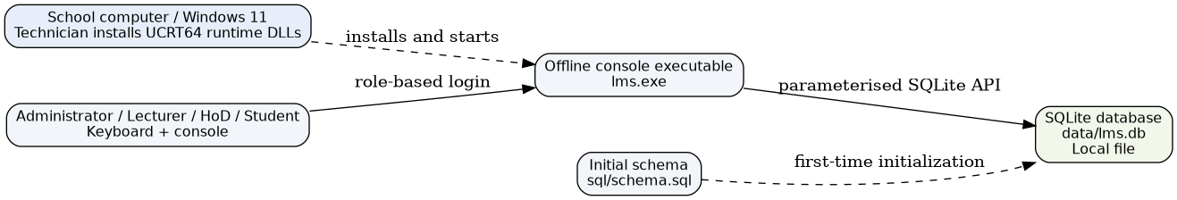

Verification and approval status
Check | Status | Evidence / action
Local Linux Release build and CTest | Passed previously | CMake release and CTest 1/1
GitHub CI Linux and Windows | Passed | Actions run #1, 2 November 2026
Standalone Windows package with runtime DLLs | Not verified | Confirm dependencies and run on target school PC
Technician installation on target machine | Not verified | Complete deployment checklist
Role-based smoke test on target machine | Not verified | Record results and screenshots
v1.0 Git tag and published release | Not verified | Tag approved commit and publish package
Stakeholder acceptance | Pending | Signed approval after on-site validation

Release conditions
Do not mark the deployment accepted until the executable, compatible DLLs, installation path, database initialization, role-based logins, local backup and restart persistence are checked on the actual target computer. Do not upload production lms.db or real student data to GitHub.

Sign-off
Technician: __________________ Date: ______________
School representative: __________________ Date: ______________
Decision: Approved / Approved with conditions / Rejected

