Paperdown: The Future of Writing Papers

lipido

2025-04-25

# 1 The Future of Writing Papers

## 1.1 Abstract

Please note: this document is not for edit its contents! It is only intended to set the fonts of the different elements and serve as a template to the DOCX generation by the paperdown pipeline.

Write your abstract here. [1]

## 1.2 Introduction

Write your introduction here.

## 1.3 Materials and methods

The following equation 1 represents…

$$\int_{a}^{b}{f}\left(x\right)dx=F\left(b\right)−F\left(a\right)\left(1\right)$$

The pseudocode for the Bubble Sort algorithm is shown in Listing 1:

Listing 1: Pseudo code of bubble sort

procedure BubbleSort(A: list of items)  
 n := length(A)  
 for i from 1 to n - 1 do  
 for j from 0 to n - i - 1 do  
 if A[j] > A[j + 1] then  
 swap(A[j], A[j + 1])  
 end if  
 end for  
 end for  
end procedure

## 1.4 Results

As shown in Table 1 (Summary of experimental results), the experimental results demonstrate significant improvements across all metrics.

Tables 1 and 2 summarize the outcomes.

Table 1: Results of the treatment experiment

| Experiment | Metric A | Metric B | Metric C |
| --- | --- | --- | --- |
| Exp 1 | 0.85 | 0.78 | 0.92 |
| Exp 2 | 0.88 | 0.81 | 0.95 |
| Exp 3 | 0.90 | 0.85 | 0.97 |

Table 2: Results of the treatment experiment

| Experiment | Metric W | Metric X | Metric Y | Metric Z |
| --- | --- | --- | --- | --- |
| Exp A | 0.60 | 0.65 | 0.70 | 0.75 |
| Exp B | 0.68 | 0.72 | 0.78 | 0.80 |
| Exp C | 0.75 | 0.78 | 0.82 | 0.85 |

As Figure 1 shows…

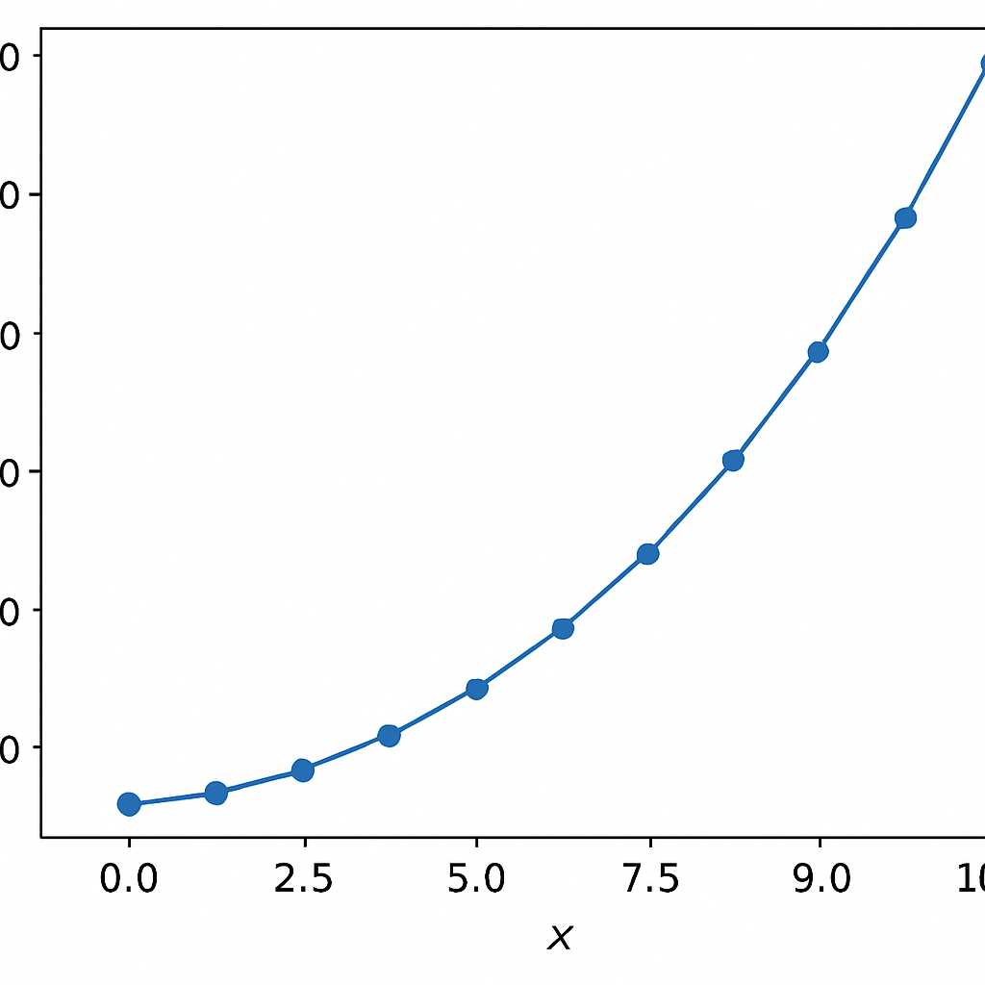

Figure 1: Experimental setup and results visualization.

## 1.5 Conclusion

Write your conclusion here.

## 1.6 References

1. Asgari E, Mofrad MRK. [Continuous Distributed Representation of Biological Sequences for Deep Proteomics and Genomics](https://doi.org/10.1371/journal.pone.0141287). Kobeissy FH, editor. PLOS ONE. 2015 Nov;10(11):e0141287.