DEPARTMENT OF CSE
A
PROJECT REPORT

LEXVIGIL AI LEGAL
INTELLIGENCE PLATFORM

A PROJECT REPORT

Submitted by
240701415 Rakesh H
240701491 Sharweshvar P


Academic Year 2026-27

BONAFIDE CERTIFICATE

Certified that this project report entitled "LexVigil AI Legal Intelligence Platform" is the bonafide work of Rakesh H (240701415) and Sharweshvar P (240701491), who carried out the project work under my supervision.

SIGNATURE OF THE FACULTY INCHARGE

Submitted for the Practical Examination held on _________________

SIGNATURE OF THE INTERNAL EXAMINER

TABLE OF CONTENTS
Chapter | Title | Page
 | Executive abstract | 4
1 | Introduction and context | 5
2 | Problem statement | 6
3 | Literature survey | 7
4 | Research gap and objectives | 8
5 | Proposed work and architecture | 9
6 | Algorithm and workflow | 11
7 | Implementation | 13
8 | Final results and outputs | 15
9 | Conclusion and future work | 17
10 | References | 18
A | Application screenshots | 19

EXECUTIVE ABSTRACT
LexVigil is a web-based contract review and Indian legal research workspace designed to make document analysis traceable. A contract often distributes definitions, payment conditions, exceptions and amendments across numbered clauses. A useful review must show how a proposed issue relates to the actual source text, while making uncertainty and incomplete coverage visible.
The implemented contract workflow extracts text from PDF, DOCX, TXT and Markdown, parses numbered clauses and their original spans, resolves unambiguous numbered references, records definitions and amendments, and applies bounded deterministic rules. Its React and TypeScript interface presents findings with evidence chains. A FastAPI service manages authenticated workflows and SQLAlchemy-backed records. Optional local OCR supports selected languages for scanned PDF pages.
The supplied synthetic agreement demonstrates a 30-day payment definition amended to 45 days while a related late-payment trigger remains 30 days. The sample interface shows six clauses, six resolved references, one definition, one amendment and one potential temporal finding. The candidate links back to four clauses and explicitly requires human review. Thirteen focused contract-engine tests passed in the reviewed session; they check selected behaviours rather than general legal accuracy.
LexVigil is a research and review aid, not a legal decision-maker. Live AI semantic review and legal research are currently disabled by the project policy. Production readiness, broad legal coverage and measured accuracy have not been established. Evaluation on expert-labelled Indian contracts, provider eligibility, operational hardening and legal review remain future work.

1 INTRODUCTION AND CONTEXT

1.1 Background
Contracts are structured legal documents whose meaning may depend on links across clauses. A defined payment period can be changed in an amendment while another clause still uses an earlier deadline. A cross-reference can be missing or ambiguous. A sentence-level search may find the relevant phrases but leave the reviewer to reconstruct their relationships manually.
Legal text adds challenges for information systems: documents may be lengthy, numbering can repeat across schedules, conditions and exceptions change how obligations apply, and scanned pages may lack selectable text. An automated candidate should therefore preserve the source text and its location and communicate uncertainty rather than presenting a bare conclusion.

1.2 Project overview
LexVigil combines document ingestion, structural parsing, relationship extraction and candidate detection in an authenticated web workspace. It gives users a way to inspect clause text, follow references and amendments, view potential findings, and save, export or remove analyses. The Indian legal research section exists in the broader application design, although live research requests are currently blocked and are not included in the verified local contract workflow.

1.3 Scope and intended use
- Primary implemented workflow: analyse structured contracts and review their source-linked findings.
- Supported upload formats: PDF, DOCX, plain text and Markdown, within configured size, page and extraction limits.
- Human reviewer remains responsible for interpreting contract context and deciding what action to take.
- A missing finding does not establish that a contract contains no issues.

2 PROBLEM STATEMENT
Reviewers need to locate potentially important relationships across long contracts. An obligation can reference a defined term elsewhere; a later amendment can change a value without changing every clause that depends on it. Missing targets, repeated numbering, exceptions and conditional wording can make manual checking slow and can also cause simplistic automated comparison to raise misleading conflicts.

2.1 Defined problem
Given a supported contract file and an analysis date, the system must extract the available text, identify numbered clauses, preserve source spans and page provenance where available, connect explicit references and definitions, record relevant amendments, and identify a bounded set of potential inconsistencies. Each finding must point to the clauses that support it, and ambiguity must trigger a warning or human review instead of an unsupported resolution.

2.2 Constraints
- Contract documents can contain scanned pages, unusual layouts, duplicate clause labels or text outside the parser’s supported numbered structure.
- The currently enabled symbolic patterns cover only a subset of legal and semantic issue categories.
- Correct quotation matching verifies that evidence came from the supplied clause; it does not verify that the legal interpretation is correct.
- Document originals, extracted text and reports have distinct retention and deletion behaviour that users need to understand.

2.3 Project question
How can a web-based contract review workflow make selected clause relationships and inconsistency candidates easier to inspect while keeping the original evidence, uncertainty and system coverage limits visible?

3 LITERATURE SURVEY

3.1 Expert-annotated contract understanding
Hendrycks et al. introduced CUAD, a contract-review dataset with expert annotations across 41 clause categories. It frames contract review as finding particular clauses and their text spans, which supports a source-linked approach to reading. Its source contracts and annotation scheme provide a useful research resource, but the dataset does not establish how LexVigil performs on Indian agreements, and this project does not train on or evaluate against CUAD.

3.2 Document-level inference and evidence
Koreeda and Manning introduced ContractNLI, which asks systems to decide whether contract hypotheses are entailed, contradicted or not mentioned and identify evidence. Its study reports 607 annotated contracts and highlights the difficulty of long documents and exception language. This supports treating evidence selection and contextual reading as core parts of contract analysis. LexVigil’s current deterministic engine is narrower than ContractNLI: it parses selected structures and applies explicit patterns rather than implementing a general entailment model.

3.3 Legal reasoning benchmarks
Guha et al.’s LegalBench assembles legal reasoning tasks to encourage systematic evaluation across distinct abilities. Its benchmark perspective is useful because a single aggregate score can obscure failures in extraction, issue classification or evidence grounding. The current project reports selected software checks and a synthetic example rather than benchmark accuracy; a future evaluation should measure each stage independently and include legal expert review.

3.4 Design implications
- Separate document structure from legal interpretation.
- Keep exact source passages available beside each candidate.
- Treat negation, exceptions, scope and effective dates as reasoning conditions.
- Measure error types and coverage on held-out contracts before making accuracy claims.

4 RESEARCH GAP AND OBJECTIVES

4.1 Research gap
Published contract datasets and legal reasoning benchmarks demonstrate the value of structured evaluation and evidence identification. A practical review workspace also needs to connect extracted clauses, definitions, numbered references, amendments and user-visible source passages. LexVigil addresses this workflow through a structural parser and explicit local rules, but the current release documents a narrow implemented coverage and does not supply an expert-labelled Indian contract benchmark, measured precision or recall, independent reviewer agreement, or an approved live AI route. These gaps limit conclusions about general legal effectiveness.

4.2 Aim
To develop an evidence-first workspace that extracts selected contract structure and presents bounded potential inconsistencies with enough source context for a human reviewer to assess them.

4.3 Objectives
- Accept supported contract and text formats within explicit processing limits.
- Parse numbered clauses and preserve exact text spans and available page locations.
- Resolve unambiguous references and capture definitions and amendments as inspectable relationships.
- Identify selected temporal and definition conflicts with deduplicated, clause-linked findings.
- Present analysis, evidence and limitations in an authenticated web workspace with save, export and delete controls.
- Evaluate software behaviour with unit and workflow tests, then identify what remains unmeasured.

4.4 Success criteria and non-goals
The implemented objectives are considered demonstrable when supported sample documents produce structurally valid reports, source IDs resolve to extracted clauses, missing or ambiguous references stay explicit, and authenticated users can inspect the outputs. The project does not claim complete legal review, jurisdiction-specific legal advice, benchmark-level performance, or production approval.

5 PROPOSED WORK AND SYSTEM ARCHITECTURE

5.1 Design principles
- Evidence before conclusion: every finding points to extracted clause IDs and original text spans.
- Bounded reasoning: deterministic rules operate only where their supported conditions are present.
- Visible uncertainty: unresolved references, incomplete text extraction and human-review status remain explicit.
- Controlled handling: authenticate users, isolate document processing and apply distinct report and original retention rules.

5.2 Architecture diagram
Figure 5.1 shows the local development path. The browser communicates with a FastAPI service. Authenticated API workflows hand document bytes to bounded child-process ingestion and analysis. The structural parser provides clauses and source spans to the contract engine; the service persists authorized report state through SQLAlchemy and presents results in the evidence viewer. OCR is optional and local. Live AI provider requests are currently disabled.
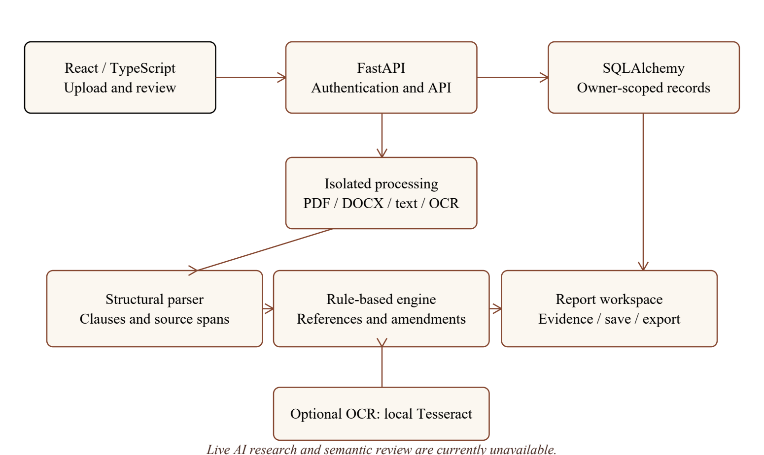
Figure 5.1 LexVigil local contract-analysis architecture

5.3 Component responsibilities
- Presentation layer: React and TypeScript workspace for upload, report navigation, source review, saving and export.
- API and access layer: FastAPI endpoints, account/session handling, owner-scoped analysis operations, input constraints and feature gates.
- Processing layer: PDF/DOCX/text extraction, optional local OCR, structural parsing and deterministic rule evaluation in a supervised child process.
- Persistence layer: SQLAlchemy models and development SQLite records for users, sessions, analyses and consented temporary originals.
- Evidence layer: report schema stores clauses, text spans, reference edges, definitions, amendments, findings and limitations for interactive inspection.

5.4 Main data flow
A user authenticates and uploads a supported file. The API validates the request, hands the file to the isolated processor and receives extracted units with a document hash and extraction warnings. The parser labels numbered clauses and preserves spans. The engine resolves explicit references, captures definitions and amendments, then applies selected consistency rules using the chosen analysis date. The API validates and stores the report under the account. The client renders the finding with its evidence chain. The user can inspect, save, export or delete the report.

6 ALGORITHM AND ANALYSIS WORKFLOW

6.1 Input and output
Input: an authenticated request containing a PDF, DOCX, TXT or Markdown file, optional OCR language for supported scanned PDFs, and an analysis date. Output: a versioned contract report with document metadata, source units, clauses, source spans, references, definitions, amendments, findings, severity, review status, extraction warnings and coverage limitations.

6.2 Numbered procedure
1. Authenticate the requester and confirm permission to start an analysis. Validate file type and enforce byte, page, source-unit and extracted-text limits.
2. Compute a SHA-256 hash from the original bytes. Extract text into ordered units. For eligible scanned PDF pages, run explicitly selected local OCR; retain page provenance and an accuracy warning.
3. Parse numbered clause headings. Assign stable IDs and exact Unicode spans. Preserve text before the first supported clause as unassigned material and record duplicate labels or missing parents as warnings.
4. Build a clause-label index. Resolve a numbered reference only when exactly one target matches within its scope. Otherwise record it as unresolved and, when appropriate, create a low-severity candidate for review.
5. Capture explicit defined terms and values. Find clauses using those terms. Identify amendment text and extract supported duration values and effective dates.
6. Evaluate amendments against the requested as-of date. Do not automatically activate amendments with unresolved dates or conditions; flag precedence issues when several active amendments apply.
7. Apply bounded rules. For payment terms, compare an active amended period with a related late-payment trigger; create a candidate only when the rule conditions match. Compare repeated definitions and flag differing values.
8. Deduplicate findings by category and evidence set. Attach the supporting clause IDs, explanation, severity and review-required status. Leave confidence unset when it has not been measured.
9. Validate the report schema and evidence references, enforce authorization and retention checks, and return the completed report for human inspection.

6.3 Pseudocode
PROCEDURE Analyse(file, as_of_date):
require authenticated user and supported file
units, metadata, warnings <- extract_with_limits(file)
clauses, unassigned <- parse_numbered_structure(units)
references <- resolve_unique_targets(clauses)
definitions <- extract_explicit_definitions(clauses)
amendments <- extract_amendments(definitions, clauses)
activate only amendments whose supported dates and conditions are clear
findings <- unresolved_reference_candidates(references)
findings += bounded_payment_period_checks(definitions, amendments, clauses)
findings += conflicting_definition_checks(definitions)
report <- attach_exact_evidence_and_limitations(findings, clauses, metadata)
validate_schema_and_owner_scope(report)
return report

6.4 Complexity and limitations
The current parser scans text by line and indexes clause labels. Reference lookup is indexed by scope and label, while selected rule comparisons iterate over extracted definitions and clauses. The implementation enforces explicit caps to bound work. Because semantic interpretation is not general-purpose, a report with no finding must never be treated as proof of consistency or completeness.

7 IMPLEMENTATION

7.1 Technology stack
- Frontend: React 19, TypeScript, React Router and Vite.
- Backend: Python FastAPI with Pydantic schema validation.
- Persistence: SQLAlchemy with SQLite in the local development adapter; managed identity can be configured for Supabase.
- Document processing: PyMuPDF for PDF text extraction, python-docx for DOCX, UTF-8 for TXT/Markdown and opt-in local Tesseract OCR.
- Testing: pytest backend tests and Playwright browser workflows for supported local configurations.

7.2 Modules

Document ingestion and provenance
The ingestion module rejects unsupported or malformed files, enforces a 15 MB upload limit and caps PDFs at 200 pages. It extracts PDF text in reading order, reads DOCX paragraphs and table cells, and decodes text files as UTF-8. Extracted material is limited to one million characters and 20,000 source units. Scanned or nearly empty PDF pages require opt-in OCR; at most 20 scanned pages are processed per upload. OCR results carry a warning and source-page label because recognition is not guaranteed.

Structural parser
The structural parser identifies numbered clauses and supported Schedule, Annexure and Appendix sections. It normalizes labels, links subsection parents only when unambiguous, and preserves offsets against exact extracted Unicode text. Duplicate labels and text outside the recognized structure are reported rather than silently discarded.

Contract reasoning engine
The deterministic engine currently handles selected numbered references, explicit definitions, duration amendments, effective dates, multiple-amendment precedence, differing definitions and a payment-period versus late-payment-trigger pattern. It classifies issue candidates and links each result to original clauses. The broader twelve-category taxonomy does not mean that every category is implemented or validated.

Identity, report lifecycle and original files
Users authenticate before accessing account-owned analyses. Reports are temporary by default and unsaved analyses expire after 24 hours; users may explicitly save them. Development original storage requires per-upload consent and has a separate maximum 48-hour lifetime. Stored original payloads use owner/document-bound AES-256-GCM encryption, with the development key protected on Windows by current-user DPAPI. Extracted report text, filenames, historical database pages and backups are not thereby encrypted, and deletion of active rows is not a guarantee of secure erasure.

Bounded background processing
The development durable-job path uses a SQLite-backed queue with two worker loops, lease heartbeats and bounded recovery attempts. Uploaded contract processing runs in a supervised child process with a configured 768 MiB aggregate committed-memory limit, at most four processes, a 660-second deadline and a 32 MiB response limit. Non-consented uploads stay outside the durable original store. Process containment does not constitute an operating-system filesystem or network sandbox; the current database, quota controls and worker design are not a distributed production service.

7.3 Development and verification setup
The project runs as a local React/Vite client and FastAPI API using the documented development launcher. Backend tests use isolated temporary databases; browser workflows create synthetic test accounts. The repository documentation describes production bundle and end-to-end checks, while this report cites only the focused 13-test contract-engine run performed during the reviewed work session. Test results are not substituted for expert legal evaluation.

8 FINAL RESULTS AND OUTPUTS

8.1 Demonstrated report output
The repository’s synthetic services agreement provides a reproducible example. Section 4.2 defines a 30-day payment period. Section 8.1 refers to that term. Section 17.3 amends it to 45 days. Section 12.4 applies a late-payment charge after 30 days. The engine raises a potential temporal inconsistency and links the candidate to clauses 4.2, 8.1, 17.3 and 12.4. The report asks the reviewer to confirm that the deadline and trigger event cover the same invoice scope.
The saved demonstration interface displays six clauses, six resolved references, one defined term, one amendment and one potential finding. This screenshot is a synthetic demonstration, not a measured production outcome.

8.2 Verification evidence
- Thirteen focused contract-engine tests passed in the reviewed work session.
- Tests cover source-linked findings, future-dated amendments, unresolved references, exception handling, duplicate definitions, PDF and DOCX ingestion, invalid file rejection and unstructured input.
- The evidence-viewer browser screenshot shows clause navigation, source passages and a finding linked to its evidence chain.

8.3 Output inventory
Output | Description
Clause map | Numbered clauses with IDs, source text, offsets and available page locations.
Relationship set | Resolved or unresolved numbered references, term use and amendment links.
Finding list | Bounded candidates with category, severity, explanation, evidence IDs and review status.
Evidence view | Side-by-side source clause inspection and navigation to original text.
Report lifecycle | Temporary report, explicit save, export and delete actions with retention controls.

8.4 Interpretation and limitations
These tests establish selected implementation behaviour; they do not provide precision, recall, false-negative rates, review-time savings or legal correctness. No representative Indian contract benchmark or independent legal panel result is supplied. Page-exact OCR alignment, handwriting, complex mixed layouts, cross-document reasoning and broad semantic conflict detection remain outside verified coverage. Live semantic review and legal research requests are blocked by the current AI policy before job creation or external text transmission.

8.5 Sample application result
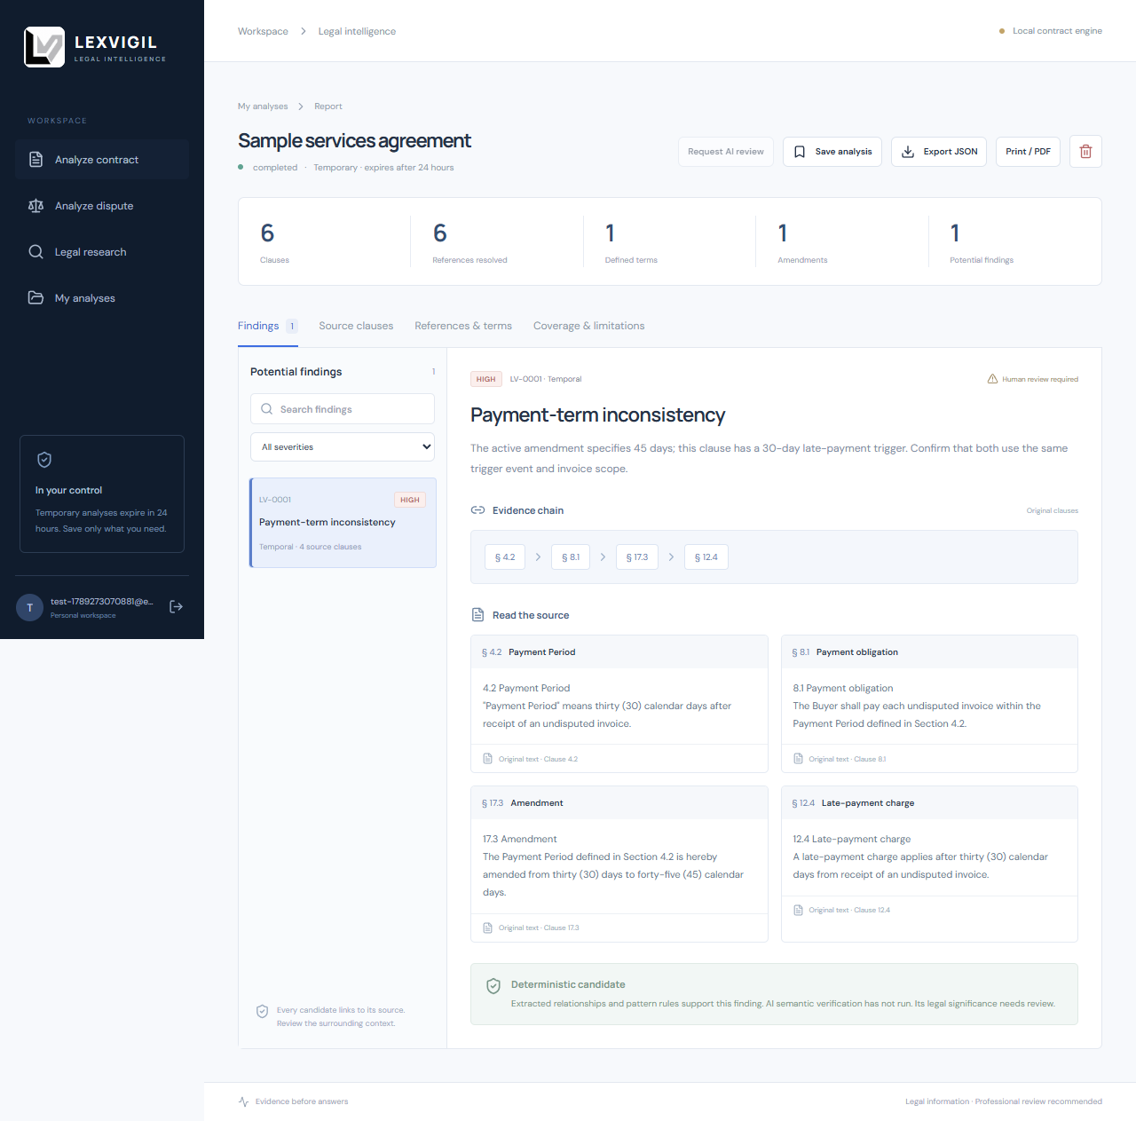
Figure 8.1 Saved synthetic contract report showing one candidate finding and its evidence chain

9 CONCLUSION AND FUTURE WORK
LexVigil implements a useful foundation for evidence-linked contract review: it extracts supported document structures, builds selected clause relationships and presents bounded candidates in an interactive workspace. Its strongest demonstrated result is traceability from a potential payment-term inconsistency back to the definition, usage, amendment and trigger clauses that produced it. Reviewers can inspect the same source material before deciding whether the candidate matters.
The system remains incomplete for general legal reasoning. It does not certify a contract, guarantee issue coverage or replace professional legal judgment. The current live AI policy also leaves semantic review and legal research unavailable, and the local deployment architecture is not production-approved.

9.1 Future work
- Build a de-identified, expert-labelled Indian contract evaluation set with clause spans, issue labels and adjudication notes.
- Measure extraction completeness, reference resolution, finding precision and recall, review time and disagreement by contract type.
- Extend support for layout variation, nested numbering, schedules and multilingual documents while preserving source coordinates.
- Add provider routes only after satisfying the project’s India-only processing and privacy requirements; validate outputs against exact source spans and legal reviewers.
- Complete production storage, migrations, shared job coordination, managed key recovery, backup expiry, monitoring and security review.
- Run accessible user studies to test whether evidence navigation helps reviewers understand and correct candidates.

10 REFERENCES
Guha, N., Nyarko, J., Ho, D.E., Ré, C., Chilton, A., Narayana, A., Choi, E., and others. (2023). LegalBench: A Collaboratively Built Benchmark for Measuring Legal Reasoning in Large Language Models. Advances in Neural Information Processing Systems 36. https://arxiv.org/abs/2308.11462
Hendrycks, D., Burns, C., Chen, A. and Ball, S. (2021). CUAD: An Expert-Annotated NLP Dataset for Legal Contract Review. NeurIPS 2021 Track on Datasets and Benchmarks. https://arxiv.org/abs/2103.06268
Koreeda, Y. and Manning, C. (2021). ContractNLI: A Dataset for Document-level Natural Language Inference for Contracts. Findings of the Association for Computational Linguistics: EMNLP 2021, pp. 1907-1919. https://aclanthology.org/2021.findings-emnlp.164/
LexVigil project documentation (2026). README, BUILD_PLAN, contract engine, structural parser, ingestion, semantic-review policy, lifecycle notes, process-isolation checkpoint and backend tests. Reviewed 26 September 2026.

APPENDIX A APPLICATION SCREENSHOTS
The following saved screenshots show the public introduction page and the authenticated contract-analysis report used as visual output examples. They are demonstration captures and do not serve as accuracy metrics.
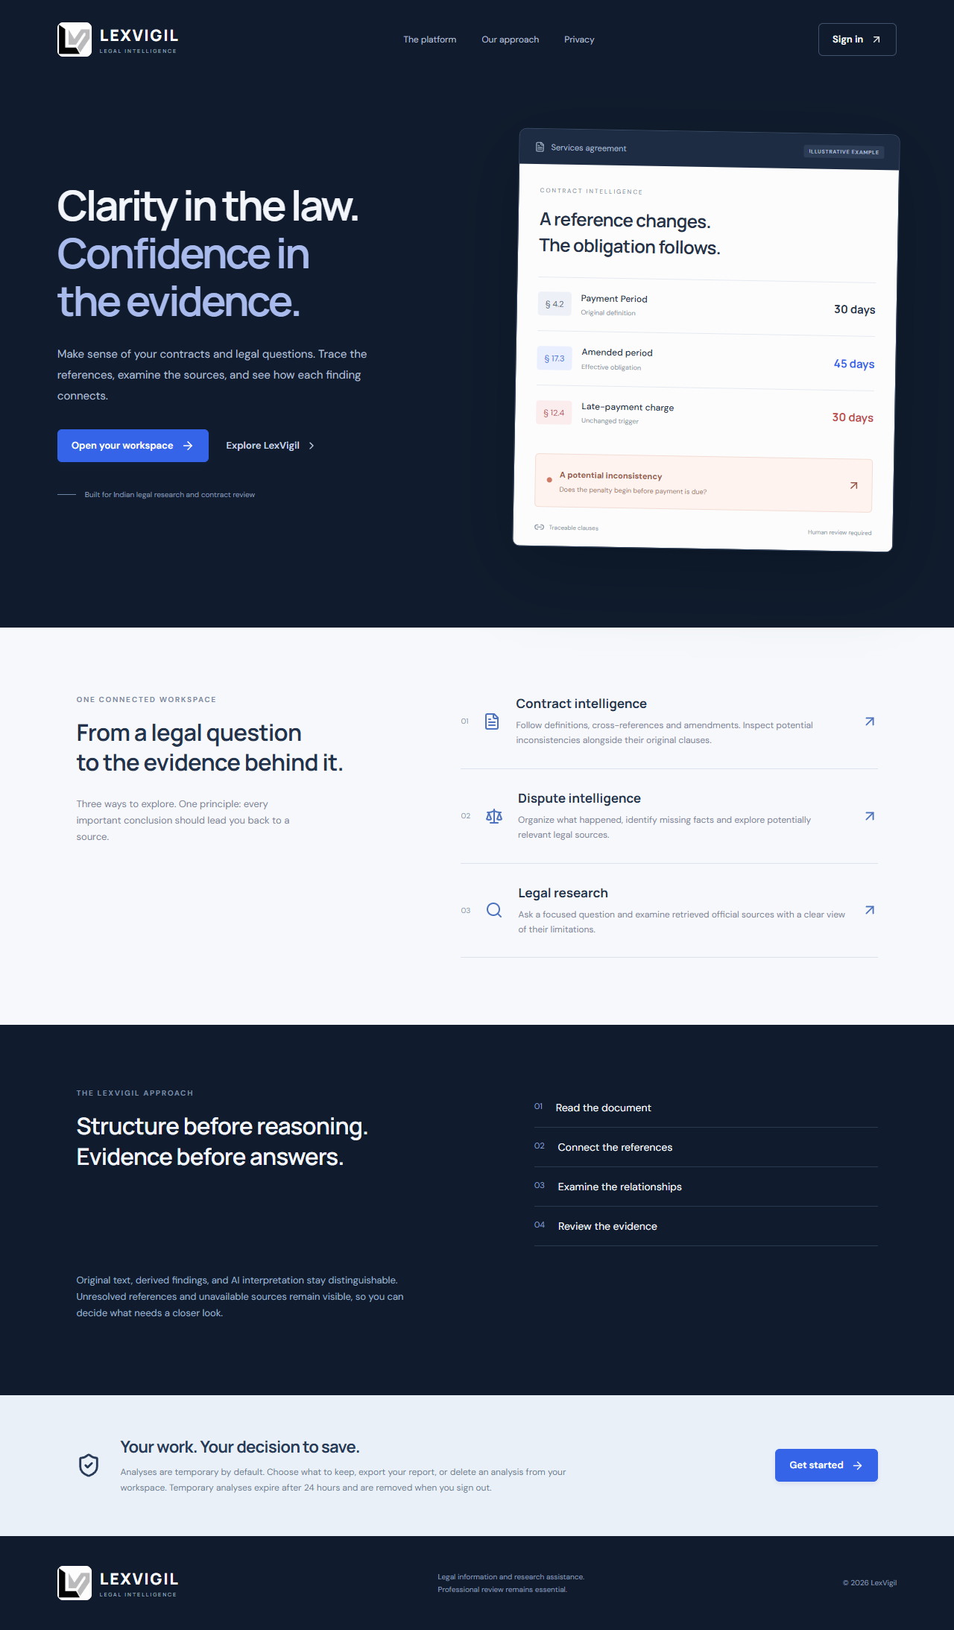
Figure A.1 LexVigil landing page in a saved demonstration capture

