**ABSTRACT**

In this project, we aim to develop an AI-based system that recognizes, categorizes, and personalizes Indian recipes based on user preferences, dietary restrictions, and available ingredients. ChefMate, our proposed solution, integrates image recognition, machine learning, and natural language processing (NLP) techniques. The system utilizes convolutional neural networks (CNNs) for identifying ingredients from images, provides customized recipe recommendations, detects allergens, and even offers alternatives to unavailable ingredients. Python will be used to develop algorithms for ingredient recognition and recipe generation. The goal is to create a dynamic and interactive cooking assistant that enhances culinary experiences while promoting sustainable food management by recommending recipes based on leftovers.

**INTRODUCTION**

The rise of AI and machine learning in the culinary industry has led to innovative solutions that enhance the cooking experience. ChefMate aims to address the gap in personalized cooking assistance by creating an AI-based recipe recommender tailored to Indian cuisine. While existing tools provide general recipe suggestions, there is a lack of systems that focus on cultural food patterns, dietary restrictions, and sustainability in terms of food waste. ChefMate not only recognizes ingredients through image processing but also personalizes recipe suggestions, detects allergens, and helps users create dishes with available ingredients. This project focuses on the development of an intelligent system that caters to the dynamic culinary needs of users, reducing food waste and enhancing meal preparation efficiency.

**LITERATURE SURVEY**

Several research works have been conducted in the fields of image recognition and food recommendation systems. The MNIST dataset is a widely used resource for digit recognition in image processing. However, recognizing and categorizing ingredients from images remains a challenge due to variations in food appearance and quality.

The work presented in "RecipeIS—Recipe Recommendation System Based on Recognition of Food Ingredients" has demonstrated the use of image recognition for food identification. However, many systems lack personalization in recipe recommendations, especially in terms of cultural preferences or dietary restrictions. Recent developments in machine learning, such as convolutional neural networks (CNNs), have significantly improved image recognition accuracy.

A review of "AI-Based Recipe Generator and Cook Assistant" revealed the potential of AI in personalized cooking assistance, but its applicability to Indian cuisine is still underexplored. ChefMate will build on this research by focusing on a more specialized recommendation system that includes Indian food patterns, dietary needs, and allergen detection.

**OBJECTIVE**

The primary objective of ChefMate is to create an intelligent recipe recommender system for Indian cuisine that recognizes ingredients, customizes recipes, and minimizes food waste. The specific objectives of the project include:

1. Develop a convolutional neural network (CNN) model to recognize and categorize ingredients from images.
2. Create a personalized recipe recommendation system based on dietary preferences, ingredient availability, and Indian cuisine patterns.
3. Promote sustainability by recommending recipes using leftover ingredients.
4. Develop a user-friendly interface that integrates image recognition, real-time recipe generation, and an AI chatbot for interaction.

**RESEARCH METHODOLOGY**

1. **Dataset Preparation**

The dataset will be created by combining open-source food image datasets and collecting images specific to Indian ingredients. The dataset will include ingredient images, recipe texts, and product labels, focusing on variations in food appearance. Additionally, user-contributed data will be incorporated to enhance the model’s ability to recognize diverse ingredients.

1. **Image Preprocessing**

Images will be standardized by resizing them to a uniform dimension, ensuring consistent input for the deep learning model. Colour normalization and augmentation techniques will be applied to handle variations in lighting and texture.

1. **Training the Neural Network**

A convolutional neural network (CNN) model will be developed for ingredient recognition. The model will consist of convolutional, pooling, and fully connected layers. Transfer learning will be employed using pre-trained models such as ResNet or Inception to improve accuracy. The dataset will be split into training and testing sets, with the model evaluated on validation data to avoid overfitting.

1. **Text Segmentation for Ingredient Recognition**

The system will use image segmentation techniques to identify individual ingredients in the image. OpenCV will detect and isolate the contours of ingredients, and the segmented portions will be passed through the CNN model to recognize each ingredient. Post-recognition, the system will generate a list of ingredients, which will serve as the input for recipe generation.

1. **Recipe Generation and Personalization**

The recognized ingredients will be matched with a database of Indian recipes. The system will provide personalized suggestions based on user preferences, dietary restrictions, and available ingredients. It will also suggest alternative ingredients for users with allergies and offer recipes that use leftover ingredients.

1. **User Interface and Integration**

The model will be integrated into a web-based user interface, where users can upload images of ingredients, view recipe suggestions, and interact with an AI chatbot. The chatbot will answer cooking-related questions, suggest recipes in real-time, and help users plan meals based on their dietary needs.

**GANTT CHART  
  
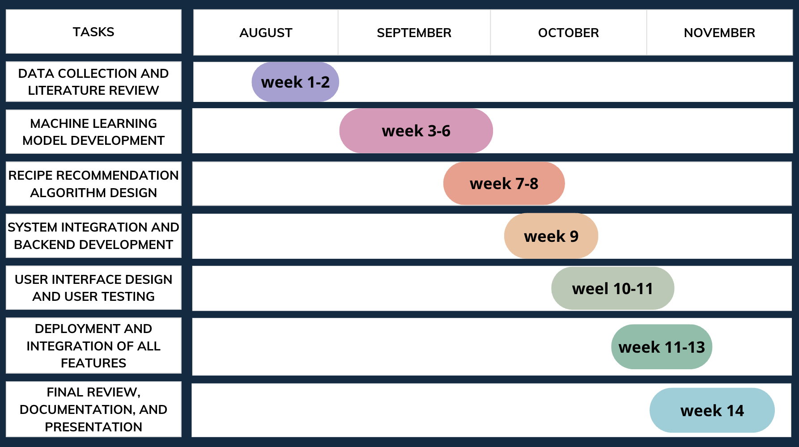**

**REFERENCES**

1. Britto, L. F. S., Pacífico, L. D. S., Oliveira, E., & Ludermir, T. B. (2020). *A cooking recipe multi-label classification approach for food restriction identification*. Anais do Encontro Nacional de Inteligência Artificial e Computacional (ENIAC 2020). <https://api.semanticscholar.org/CorpusID:237431225>.
2. Rodrigues, M. S., Fidalgo, F., & Oliveira, Â. (2023). *RecipeIS—Recipe recommendation system based on recognition of food ingredients*. *Applied Sciences*. <https://api.semanticscholar.org/CorpusID:259534462>.