Agents:
Airlines activated ref Avbis as shown (screen shot provided below for ref)
Library (screenshots have been provided already) Library for Agent will only contain uploaded documents related to travel agent only
Case History
General:
Business Mode in General is Business Model ref. Agency Type in Excel and consider the Dropdown allow to select multiple
GDS Type please consider the Dropdown give Option to select multiple
trying to update Focus Destinations but it's not working

Focus destinations to be renamed to Focused Destinations
Focus destinations to be displayed one under the other same as product type

Address:
Address will can be multiple so we Need address for to fill and save after saving it will Show below in the list
e.g.
Address Type: Chandigarh Branch, Head Office or Delhi Branch, Marketing Department Delhi, Sales Department Mumbai, IT Department Bangalore, Invoice Address
Address:(Ref Excel Provided)
Address required in top to Bottom Format so that multiple address can be added

Contact details:(Ref Excel Provided)
Contact details required in top to Bottom Format so that multiple address can be added
also please Show last updated by column and updated on for Contact Details, address, fares, products, pli

Product Type if submitted blank there is code error
after submitting the product i am diverted to General screen
please provide edit & delete button on Right side of the product names
Product type to be displayed one under the other in bullet points ref screenshot Travel Agent screen Sub 1 (Focus Destinations)

Special Fares:
Private Fare Type | Status | IATA | PCC / Office ID | Account code | Discount | Remarks
VFR | Active | 2328569 | DELVS37QC | 318967 | 15 € per Segment | Valid only ex DE and not valid on Feeder flights

Provide option to add more and display in same row as above left to right
For Private Fare Type and Status: please provide dropdown and option to add the types from backend.

Commission & PLI:
Please add 1 more colum with title Term:
Put all Columns from Left to Right in 1 Link and provide + Option to add a line if required to add more data

Term | Incentive Description | Target | Business Class |  | Premium Class |  | Economy Class |  | Valid From | Valid Till
 |  |  | INTL | DOM | INTL | DOM | INTL | DOM
December 2024 | Deal PLB | Non-Targeted | 1,25% | 1% | 1,25% | 1,00% | 1% | 0,75% | 01.04.2023 | 31.03.2024

Term | Incentive Description | Target | Business Class |  | Premium Class |  | Economy Class |  | Valid From | Vailid Till
 |  |  | INTL | DOM | INTL | DOM | INTL | DOM
Q1 PLI | Marketing Fee | Non-Targeted | 1,25% | 1% | 1,25% | 1,00% | 1% | 0,75% | 01.04.2023 | 31.03.2024
 | Slab 1 | EUR 200000 | 1% | 0% | 1% | 0% | 1,25% | 0%
 | Slab 2 | EUR 250000 | 1,50% | 0% | 1,50% | 0% | 1,50% | 0%
 | Slab 3 | EUR 3000000 | 2% | 0% | 2% | 0% | 1,75% | 0%
Total Max Payout |  |  | 3,25% | 1% | 3,25% | 1% | 2,75% | 0,75%

Airlines Activation Screen for Travel Agent:
Ticketing Authority will be activated from Screen.
Fares can be done from screen as well but please auto activate relevant fare if they are activated in special fare screen. And if the special fare is deactivated in special fare screen also deactivate it here and also the other way around if deactivated here also deactivate it in special fare screen. Airlines to be displayed only if the airlines is in our data base and is active.
Please only copy airline activation section do not copy anything else e.g. modules permissions, roster or office duties
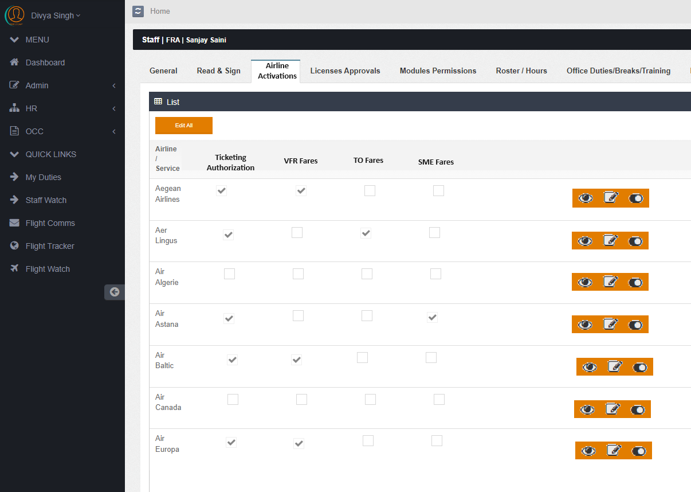

Case History:
Please find below as agreed previously idea how it should be was also provided last time providing again with example. Please provide buttown to view and edit also to close/deactivate on main window
On view only view only
On edit/update please show above the previous conversation and below a dropdown for update or close
the case status should be updated automatically depending on the optioned selected update or close
doesn’t matter what is selected please provide option to write comments. Even to close the case closing comments needs to be entered. If close status is selected the case should be closed and comments updated
Main window:
Case Opening Date | Case ID | Opened by | PNR | Ticket No | Case Status | Case Closed by | Case Closing Date
26.07.2024 | FTM2024072601 | Jhon | Ghs7s | 228-55469875 | Closed | Hubert | 03.08.204
28.07.2024 | FTM2024072805 | Sanjay | Jlsfs87 | 228-554896548 | Open
28.07.2024 | FTM2024072806 | Sanjay | Jlsfs87 | 228-554896548 | Open

View and updation Window
Date | PNR | Ghs7s | Ticket No. | 228-55469875 | Status | User
6.07.2024 | wanted to do date change advised to contact HQ PNR: 4554544 |  |  |  | Opened | Jhon
28.07.2024 | Pax called to know about status |  |  |  | Updated | Sanjay
30.07.2024 | Pax has been informed about the charges PP 140€ Pax will advise by tommorow |  |  |  | Updated | Fani
03.08.2024 | Date Change has been done pax called on 03.03.2024 payment was done to our AC 20€ extra as the fare had changed |  |  |  | Closed | Hubert

