Agent Login
Invoice:
- S.No:
- Invoice Date
- Filters: Date
- Search by: PNR, Booking ID, Passenger Name

Payment History:
- Filters: Date
- Search by: Booking ID (Please Rename Refer to Booking ID)
View Accounts:
- Search by: Booking ID (Please Rename Refer to Booking ID), Amount
Order:
- S.No:
- Order Date
- Filters: Date
- Search by: Booking ID, Passenger Name, PNR No., From City, To City

Ledger:
- S.No:
- Filters: Date
- Search by: Booking ID, Passenger Name, PNR No., From City, To City, Travel Date, Type (Oneway or Return)

Profile:
Please make it view only and give edit button for Editing if editing is required
All editing in Profile details of Agents to be sent to Admin recorded to be kept in Agents KYC (in Admin Panel).
E.g
Profile History:
S.No | Category | Old Details | New Details | Updated on
1. | Fullname | Dipanshu | Manish | 14.06.2024 16:08 hrs
2. | E-Mail | dipanshu@test.com | manish@test.com | 24.04.2024 20:59 hrs
3. | GST | 24AAAFT2820R1Z0 | 98458sdg5246 | 12.02.2024 10:44 hrs

Admin Login
Inventory Listing:
- Display Inventory availability against each PNR please see below the image:
- While adding Inventory Purchase and Sales fares to be added are: Adult, Child, Infant
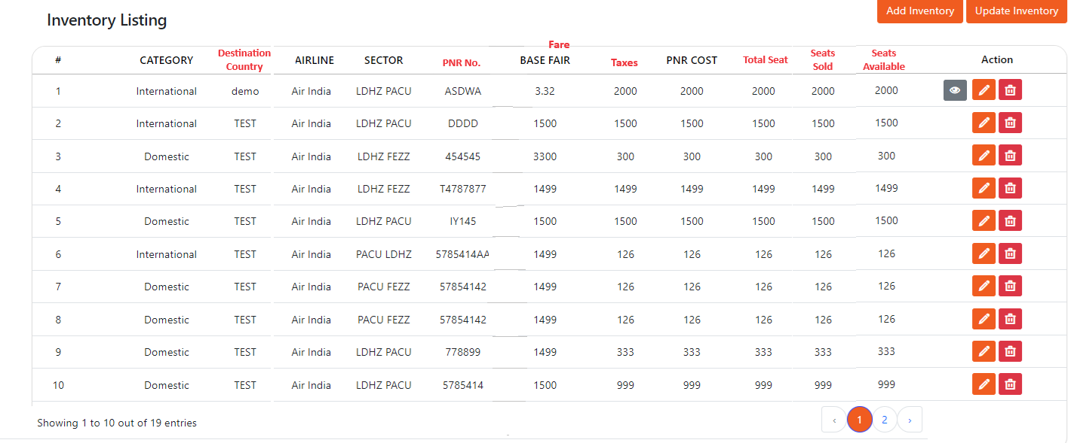

Report:
Please Rename Report as Sales Reports
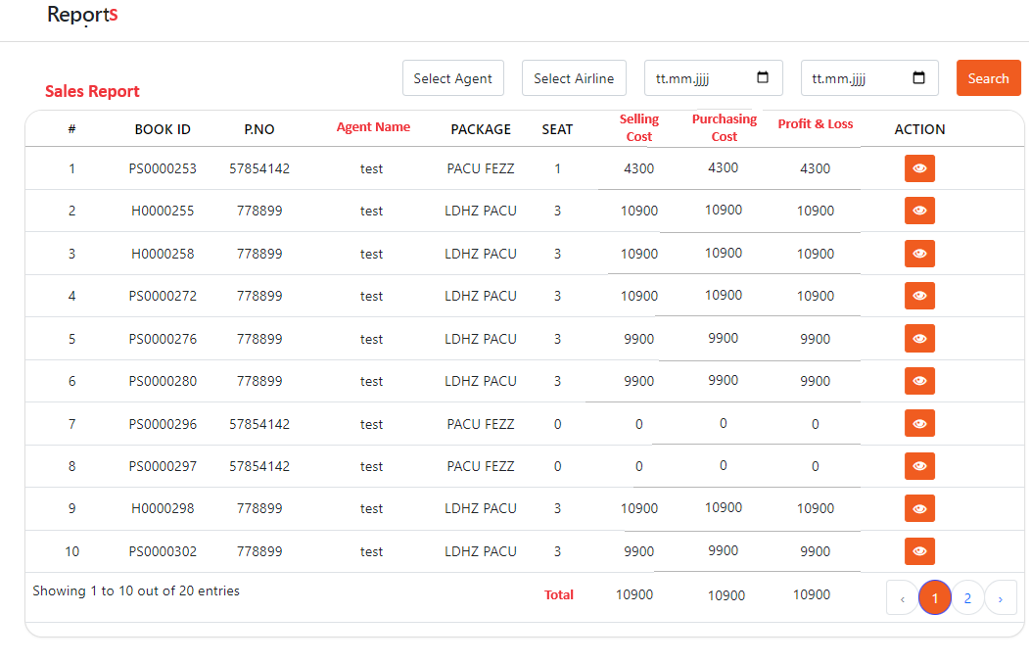
Add Filter: filter as per Departure City, as per Destination City, PNR

