- E-Mail for Account activation:

Subject Line: Welcome to The Trip Guru! Confirm Your Account

Dear [Agent's Name],
Welcome to The Trip Guru family! We're thrilled to have you join our community of passionate travel experts.
Your account registration is almost complete. To activate your account and start exploring the wide range of opportunities we offer, please confirm your email by clicking the link below:
Confirm Your Account
Once your account is activated, you'll gain access to our comprehensive platform.
If you have any questions or need assistance, feel free to reach out to our support team at support@thetripguru.de. We're here to help!
Thank you for choosing The Trip Guru. We look forward to partnering with you to create unforgettable journeys for travelers worldwide.

Warm regards,
The Trip Guru Team
www.thetripguru.de

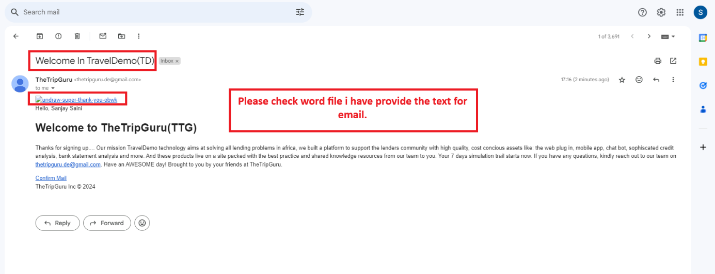

2.) Footer on Landing Page is somewhere between products see image below.

