BCSE203E: Web Programming

NAME: LIPIKA PANDE

REG.NO.: 23BCE0844

QUESTION: Create an HTML document with an unordered list containing at least three grocery items. Use different list item content and styles.

INPUT:

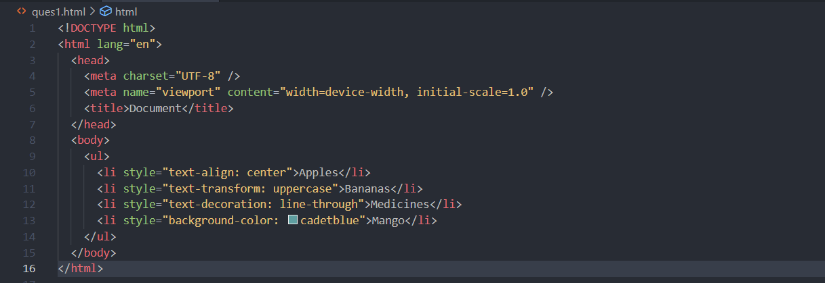

OUTPUT:

