DSC5122C

Quantitative Risk Management

Group Project 3

Risk Aversion Project

CAO CHANG: A0054785U

LI LIPING: A0186040M

ZHANG AO: A0176595L

# Introduction

Fruit has been recognized as a good source of nutrients that are vital for the health, especially vitamin C and vitamin A. Research has shown that a high daily intake of fruits could promotes health and potentially reduce the risk of chronic diseases[1]. However, there are many choices of fruits in the market with different flavors and prices. Our project aims to find a mix of fruits that satisﬁes requirements on the daily amount of nutrition with minimal cost.

# Problem description

The nutrition information of four fruits are gathered along with a minimum required intake of each type of nutrition for an adult. The goal is to ﬁnd the cheapest combination of fruits that will meet nutritional requirements by using 3 different approaches: risk neutral model, CVAR model and worst-case model. By adjusting model parameters, sensitivity analysis is conduced to determine how risk appetite and number of scenarios will impact the final result.

# Mathematical model

Model Risk Neutral

$$Nutrition∈\{Calories,Protein,Fiber,Carbohydrate,Vitamin_{A}, Vitamin_{C}\}$$

$$s: scenario$$

$$f:fruit∈\{Apple, Lemon, Grape, Orange\}$$

$$\operatorname{Minimize}{cost=\sum_{f=1}^{4}{price_mean(f)*x(f)}}$$

s.t

$$\sum_{f=1}^{4}{x\left(f\right)=1}$$

$$\sum_{f=1}^{4}{\sum_{s=1}^{100}{Nutritions\left(s,f\right)*x\left(f\right) /card(s)≥req(Nutritions)}}$$

$$x\left(f\right)≥0$$

Model CVAR

$$\operatorname{Minimize}{cost=\sum_{f=1}^{4}{price_mean(f)*x(f)}}$$

s.t

$$\sum_{f=1}^{4}{x\left(f\right)=1}$$

$$\sum_{f=1}^{4}{\sum_{s=1}^{100}{Nutritions\left(s,f\right)*x\left(f\right) /card(s)≥req(Nutritions)}}$$

$$z\left(s\right)≥\sum_{f=1}^{4}{a\left(f,s\right)*x\left(f\right) - var}$$

$$cvar=\frac{var+1}{\left(\left(1-beta\right)*card\left(s\right)\right)*\sum_{s=1}^{100}{z(s)}}$$

$$x\left(f\right)≥0$$

Model worst case

$$\operatorname{Minimize}{mu}$$

s.t

$$\sum_{f=1}^{4}{x\left(f\right)=1}$$

$$\sum_{f=1}^{4}{\sum_{s=1}^{100}{Nutritions\left(s,f\right)*x\left(f\right) /card(s)≥req(Nutritions)}}$$

$$mu≥\sum_{f=1}^{4}{a\left(f,s\right)*x(f)}$$

$$x\left(f\right)≥0$$

# Model Parameterization

1. f: set of fruits selected - Apple, Lemon, Grape, Orange
2. n: set of nutrients required - Calories, Protein, Fiber, Carbohydrate, Vitamin A, Vitamin C
3. s: number of scenarios
4. req(n): Daily requirement of each nutrient

|  |  |
| --- | --- |
| **Nutrient** | **min required** |
| **Energy (kcal)** | 46.35 |
| **Protein (g)** | 0.87 |
| **Dietary fiber (g)** | 3.23 |
| **Carbohydrate (g)** | 11.28 |
| **Vitamin A (mcg)** | 5.33 |
| **Vitamin C (mg)** | 34 |

Table 1 Minimum daily intake of nutrients required for an adult

1. price_mean(f) and price_SD(f)

|  |  |  |
| --- | --- | --- |
| **Fruit** | **Mean price** | **Standard Deviation** |
| **Apple** | 0.55 | 0.112 |
| **Lemon** | 1.54 | 0.764 |
| **Grape** | 1.3 | 0.396 |
| **Orange** | 0.47 | 0.053 |

Table 2 Mean and SD of fruit prices

1. correlation(f,f): correlation matrix for fruit prices

|  |  |  |  |  |
| --- | --- | --- | --- | --- |
|  | **Apples** | **Lemon** | **Grapes** | **Oranges** |
| **Apples** | 1.000 | 0.784 | 0.052 | 0.346 |
| **Lemon** | 0.784 | 1.000 | 0.079 | -0.061 |
| **Grapes** | 0.052 | 0.079 | 1.000 | -0.383 |
| **Oranges** | 0.346 | -0.061 | -0.383 | 1.000 |

Table 3 correlation matrix for fruit prices

Correlation matrix is calculated based on historical fruits price from 2004-2014. (Source: U.S. Bureau of Labor Statistics)

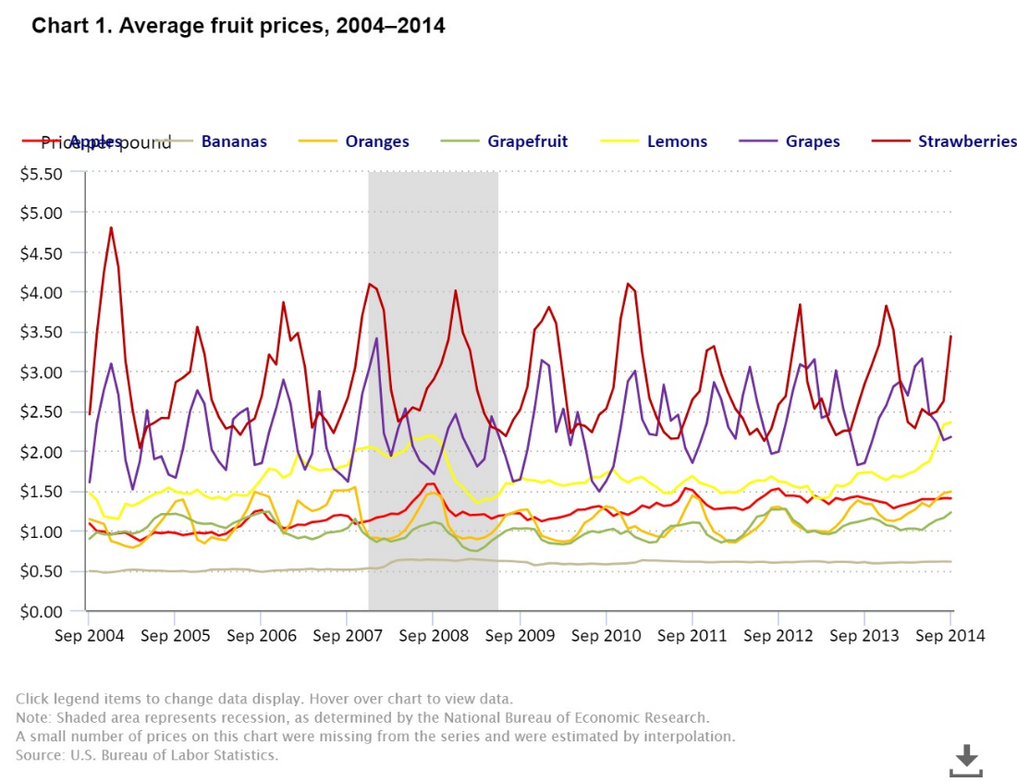

Figure 1 Average fruit prices from 2004 to 2014

1. char(*,n,f): fruit characteristics (pct)

|  |  |  |  |  |  |  |  |  |
| --- | --- | --- | --- | --- | --- | --- | --- | --- |
|  | Apple.Mean | Apple.Variance | Lemon.Mean | Lemon.Variance | Grape.Mean | Grape.Variance | Orange.Mean | Orange.Variance |
| Energy (kcal) | 54.39 | 3.63 | 20.00 | 0.00 | 70.24 | 4.79 | 40.75 | 2.85 |
| Protein (g) | 0.30 | 0.00 | 1.20 | 0.00 | 0.97 | 0.17 | 1.00 | 0.08 |
| Dietary fibre (g) | 2.27 | 0.05 | 4.70 | 0.00 | 3.43 | 0.09 | 2.50 | 0.22 |
| Carbohydrate (g) | 11.90 | 0.88 | 10.70 | 0.00 | 14.90 | 1.00 | 7.63 | 0.52 |
| Vitamin A (mcg) | 1.67 | 0.47 | 2.00 | 0.00 | 5.67 | 4.03 | 12.00 | 1.63 |
| Vitamin C (mg) | 5.33 | 0.47 | 77.00 | 0.00 | 4.00 | 2.94 | 51.67 | 5.79 |

Table 4 Fruit characteristics (pct)

Three different brands of each fruit except lemon are collected to compute the mean and variance of the nutrition composition.

1. create normal distribution of nutrients amount and fruit prices:

cal(s,f) = normal(char('mean','Calories',f),sqrt(char('variance','Calories',f)));

prot(s,f) = normal(char('mean','Protein',f),sqrt(char('variance','Protein',f)));

fiber(s,f) = normal(char('mean','Fiber',f),sqrt(char('variance','Fiber',f)));

carbo(s,f) = normal(char('mean','Carbohydrate',f),sqrt(char('variance','Carbohydrate',f)));

va(s,f) = normal(char('mean','Vitamin_A',f),sqrt(char('variance','Vitamin_A',f)));

vc(s,f) = normal(char('mean','Vitamin_C',f),sqrt(char('variance','Vitamin_C',f)));

price(f,s) = normal(price_mean(f),price_SD(f));

1. variables: cost total cost per 100g

x(f) fruit mix (per 100g)

var value at Risk

cvar conditional value at risk

z(s) tail profit in scenario s

1. equations: equations defined for each nutrient requirement

calc.. sum((f,s), cal(s,f)*x(f))/card(s) =g= req('Calories');

protc.. sum((f,s), prot(s,f)*x(f))/card(s) =g= req('Protein');

fiberc.. sum((f,s), fiber(s,f)*x(f))/card(s) =g= req('Fiber');

carboc.. sum((f,s), carbo(s,f)*x(f))/card(s) =g= req('Carbohydrate');

vac.. sum((f,s), va(s,f)*x(f))/card(s) =g= req('Vitamin_A');

vcc.. sum((f,s), vc(s,f)*x(f))/card(s) =g= req('Vitamin_C');

1. mc: mixed constraint, the percentages of each fruit should add up to 1
2. total cost = sum(f, price_mean(f)*x(f))
3. tails(s): calculate the value of the tail

z(s)=g=-sum(f,a(f,s)*x(f))-var

1. cvar_eq: calculates cvar of model

cvar =e= var+1/((1-beta)*card(s))*sum(s,z(s))

1. objective is to minimizing total cost using linear programming

# Analysis of the optimal policy

**Risk-neutral policy**

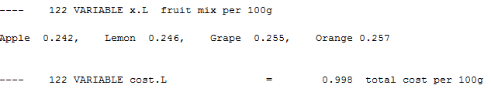

The optimal policy under risk-neutral method is to intake 24.2% apple, 24.6% lemon, 25.5% grape and 25.7% orange. The objective cost is 0.998 on 100g

**CV@R policy**

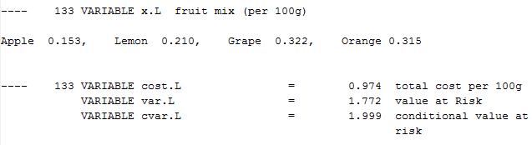

The optimal policy under CV@R method is to intake 15.3% a% apple, 21.0% lemon, 32.2% grape and 31.5% orange. The objective cost is 0.970 on 100g. The V@R is 1.772 and the CV@R is 1.999.

**Worst Case policy**

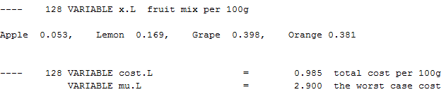

The optimal policy under worst case method is to intake 5.3% apple, 16.9% lemon, 39.8% grape and 38.1% orange. The worst case cost is 2.9 on 100g.

# Sensitivity analysis

1. Scenario = 1000

|  |  |  |  |  |  |  |  |
| --- | --- | --- | --- | --- | --- | --- | --- |
|  | | Risk Neutral | CVAR | CVAR | CVAR | CVAR | Worst Case |
| Scenario | | 1000 | 1000 | 1000 | 1000 | 1000 | 1000 |
| Beta | |  | 0.9 | 0.95 | 0.99 | 0.999 |  |
| Mix | |  |  |  |  |  |  |
|  | Apple | 24.20% | 15.30% | 15.50% | 9.40% | 5.30% | 5.30% |
|  | Lemon | 24.60% | 21.00% | 21.10% | 18.60% | 16.90% | 16.90% |
|  | Grape | 25.50% | 32.20% | 32.10% | 36.70% | 39.80% | 39.80% |
|  | Orange | 25.70% | 31.50% | 31.40% | 35.40% | 38.10% | 38.10% |
| Cost | | 0.998 | 0.974 | 0.974 | 0.980 | 0.985 | 0.985 |
| V@R | |  | 1.772 | 1.919 | 2.265 | 2.900 |  |
| CV@R | |  | 1.999 | 2.158 | 2.482 | 2.900 |  |
| Mu | |  |  |  |  |  | 2.900 |

1. Scenario = 5000

|  |  |  |  |  |  |  |  |
| --- | --- | --- | --- | --- | --- | --- | --- |
|  | | Risk Neutral | CVAR | CVAR | CVAR | CVAR | Worst Case |
| Scenario | | 5000 | 5000 | 5000 | 5000 | 5000 | 5000 |
| Beta | |  | 0.9 | 0.95 | 0.99 | 0.999 |  |
| Mix | |  |  |  |  |  |  |
|  | Apple | 24.20% | 17.10% | 16.80% | 19.00% | 15.10% | 3.50% |
|  | Lemon | 24.90% | 21.90% | 21.80% | 22.70% | 21.10% | 25.40% |
|  | Grape | 25.60% | 31.00% | 31.20% | 29.60% | 32.50% | 37.50% |
|  | Orange | 25.40% | 30.00% | 30.20% | 28.80% | 31.30% | 33.60% |
| Cost | | 1.001 | 0.975 | 0.976 | 0.973 | 0.978 | 1.056 |
| V@R | |  | 1.744 | 1.992 | 2.340 | 2.733 |  |
| CV@R | |  | 2.035 | 2.210 | 2.526 | 2.826 |  |
| Mu | |  |  |  |  |  | 2.894 |

1. Scenario = 10,000

|  |  |  |  |  |  |  |  |
| --- | --- | --- | --- | --- | --- | --- | --- |
|  | | Risk Neutral | CVAR | CVAR | CVAR | CVAR | Worst Case |
| Scenario | | 10000 | 10000 | 10000 | 10000 | 10000 | 10000 |
| Beta | |  | 0.9 | 0.95 | 0.99 | 0.999 |  |
| Mix | |  |  |  |  |  |  |
|  | Apple | 24.50% | 18.60% | 17.90% | 18.40% | 23.40% | 23.90% |
|  | Lemon | 25.10% | 22.80% | 22.50% | 22.70% | 24.80% | 25.00% |
|  | Grape | 25.40% | 29.60% | 30.20% | 29.70% | 25.90% | 25.50% |
|  | Orange | 25.00% | 29.00% | 29.50% | 29.20% | 25.90% | 25.60% |
| Cost | | 1.002 | 0.974 | 0.975 | 0.974 | 0.969 | 0.969 |
| V@R | |  | 1.749 | 1.962 | 2.375 | 2.916 |  |
| CV@R | |  | 2.030 | 2.212 | 2.552 | 2.999 |  |
| Mu | |  |  |  |  |  | 3.219 |

Findings from sensitivity analysis:

* Keeping the scenario still, with the increase of beta, V@R and CV@R will converge to worst case cost. And V@R is always less or equal than CV@R
* V@R and CV@R converge to worst case mu faster when the scenario is less, in other words, the distance between CV@R and worst mu with beta 0.999 under scenario 10,000 is larger than the distance between CV@R and worst mu with beta 0.999 under scenario 1,000.
* The larger the scenarios are, the higher the cost in Risk Neutral method and the higher the worst-case cost.
* The V@R and CV@R increase with the increase of beta.

# Conclusions

This report analysed how to choose the fruit to meet the nutrition requirement and meanwhile minimizing the cost by applying stochastic programming. Three different approaches Risk Neutral, CVAR and Worst Case are used to model different risk appetite. The results of the analysis with different scenarios give different solutions for different degrees of uncertainty. If one has higher risk appetite, he could follow the model result when Beta=90%. Vice versa, for the one is more risk adverse, higher Beta or Worse Case might be a better choice for him. Last but not the least, the result also suggests that diversification of the fruit intake is important to meet different nutrition requirement rather than only eat one kind of fruit.

Reference

Nutrition Composition

<https://focos.hpb.gov.sg/eservices/ENCF/foodsearch.aspx>

Nutrition Requirement

<http://www.mydailyintake.net/daily-intake-levels/>

Price Information

[https://redmart.lazada.sg/#home](https://redmart.lazada.sg/)

Historical Price Information

<https://www.bls.gov/opub/btn/volume-3/slicing-through-fruit-price-volatility.htm>

1. Heiner Boeing, Angela Bechthold, Achim Bub, Sabine Ellinger, Dirk Haller, Anja Kroke, Eva Leschik-Bonnet, Manfred J. Müller, Helmut Oberritter, Matthias Schulze, Peter Stehle, Bernhard Watzl. Eur J Nutr. 2012 Sep; 51(6): 637–663. Published online 2012 Jun 9. doi: 10.1007/s00394-012-0380-y. PMCID: PMC3419346