COMP306 Group Project Proposal

# Information:

* Liping Wu and Xinglong Lu (Group11)
* GitHub Source URL: https://github.com/foxpeer/comp306gr11groupproject

# Background

Many merchants provide a wide range of discounted products and various coupons, but it is difficult for consumers to quickly find the products they need from the dazzling information.The economic downturn makes people more concerned about shopping prices, and consumers naturally pay more attention to discount information. Therefore, we aim to provide a discount information sharing and coupon providing website.

# Project Overview:

-Our website will provide the discount and coupons information to our users. Merchants can access our website, and add the new discount information and coupons. They can also update previous information, and delete them. Users can view all the discount information and write reviews to the information they viewed. All the backend processes will be handled by our REST API. We will use DynamoDB to store the coupon information. For public visit, the coupon REST API will deploy on AWS through Elastic Beanstalk.

The front end, an Asp.net Core MVC application will call the coupon REST API service.

# Deliverables:

-Back End: a CouponREST API Service built based on ASP. NET CORE Framework

-Front End： an Asp.net Core MVC application to Call the CouponRESTAPI

# Project Details:

## Models

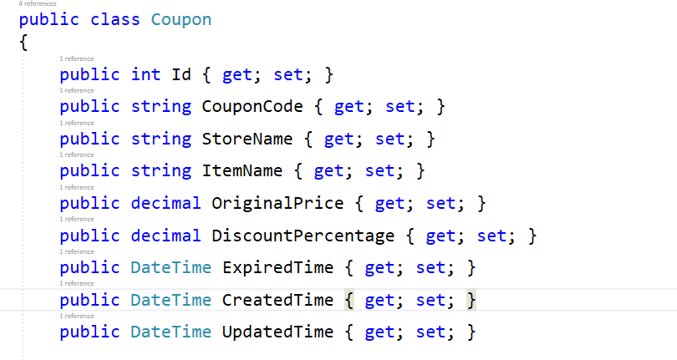

## Database

AWS DynamoDB

## Coupon REST API EndPoint

|  |  |  |  |
| --- | --- | --- | --- |
| **API** | **Description** | **Request body** | **Response body** |
| GET /api/Coupons | Get all Coupons | None | Array of Coupons |
| GET /api/Coupons/{id} | Get a Coupon by ID | None | Coupon |
| POST /api/Coupons | Add a Coupon | Coupon | Coupon |
| PUT /api/Coupon/{id} | Update an existing Coupon | Coupon | None |
| DELETE api/Coupons/{id} | Delete a Coupon | None | None |