COMP303_Assignment3_Screenshots

Liping Wu 300-958-061 3/24/2020

Contents

1. WEB PAGES: 3

Home Page: 3

List of All Jobs 3

Add a new job 4

Add successfully 4

Add a job with duplicated jobId 5

A Job Details 6

Update a job 6

Delete a Job 7

SWAGGER – REST API Testing 8

About page 9

2. Postman Testing 10

2.1 JOBS 10

GET http://localhost:8081/jobs 10

GET http://localhost:8081/jobs/6 which is not existing 11

GET http://localhost:8081/jobs/1 which exists 11

POST http://localhost:8081/jobs 12

Request: 12

Response 12

PUT http://localhost:8081/jobs/6 12

DELETE http://localhost:8081/jobs/6 13

2.2 Category 14

GET http://localhost:8081/cats 14

GET http://localhost:8081/cats/1 which is existing 14

GET http://localhost:8081/cats/1 which is NOT existing 14

POST http://localhost:8081/cats 15

PUT http://localhost:8081/cats/4 16

DELETE http://localhost:8081/cats/4 16

2.3 ORGNIZATION 17

GET http://localhost:8081/orgs 17

GET http://localhost:8081/orgs/1 17

POST http://localhost:8081/orgs 17

PUT http://localhost:8081/orgs/4 18

DELETE http://localhost:8081/orgs/4 18

# WEB PAGES:

## Home Page:

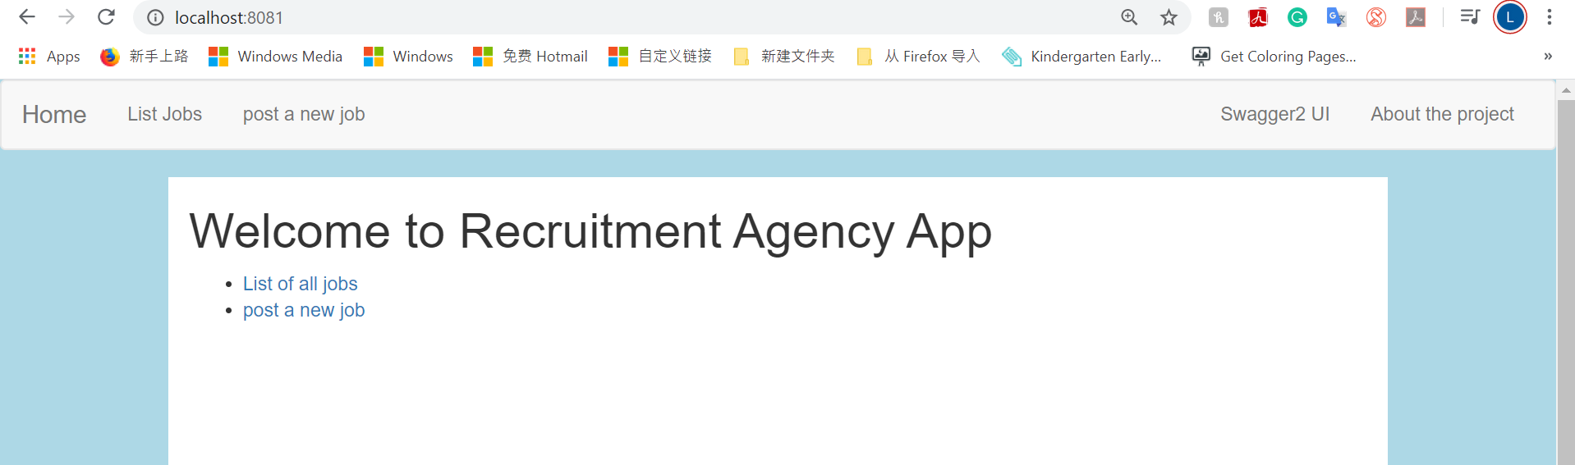

## List of All Jobs

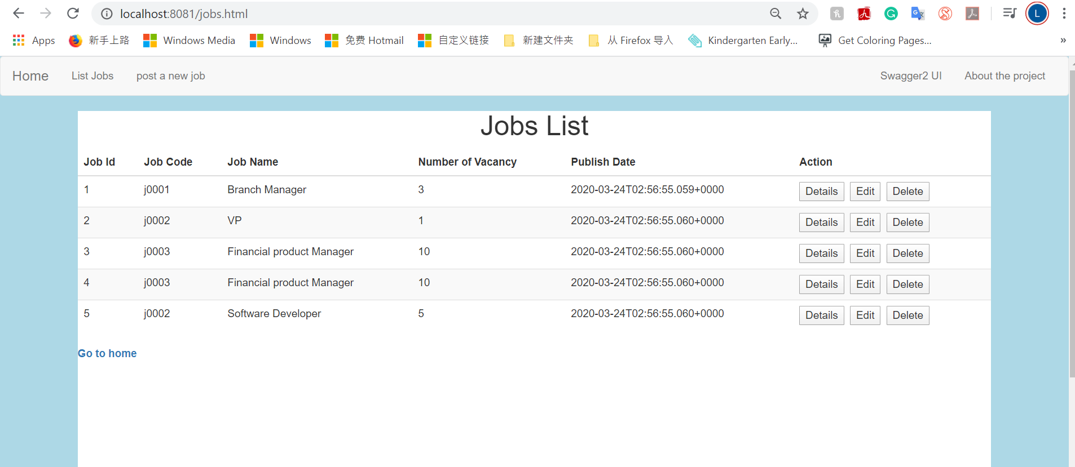

## Add a new job

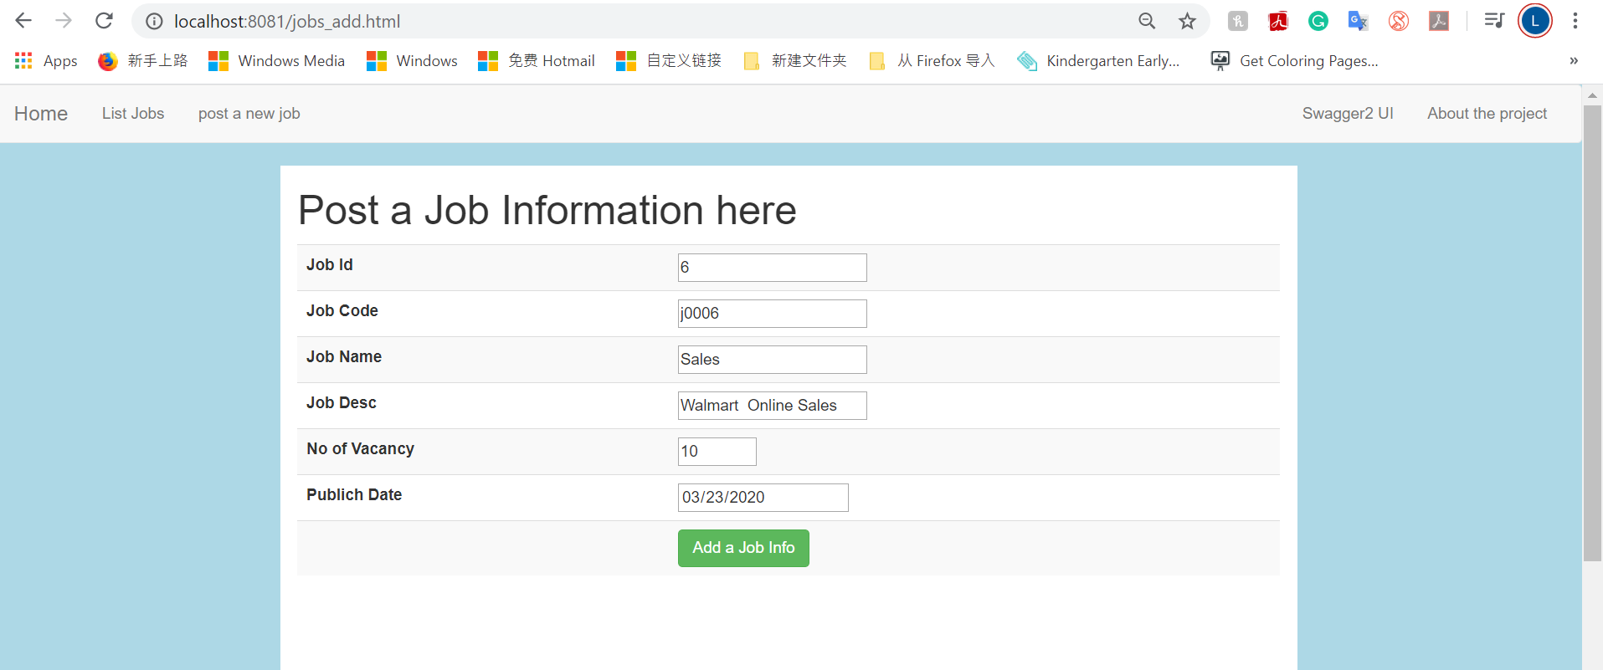

## Add successfully

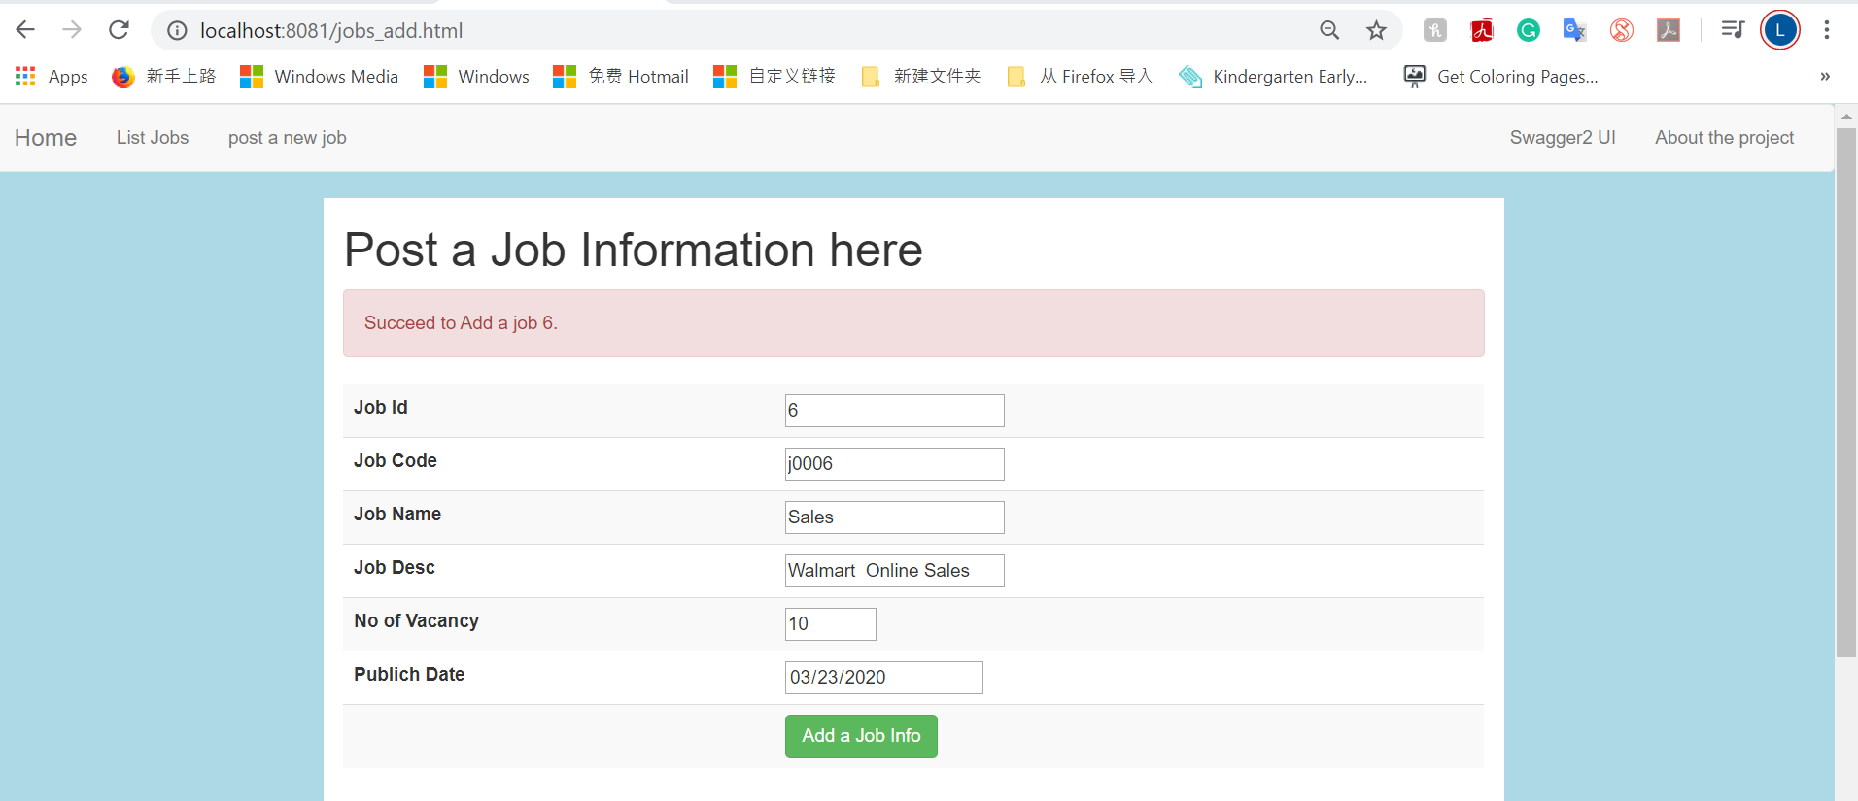

## Add a job with duplicated jobId

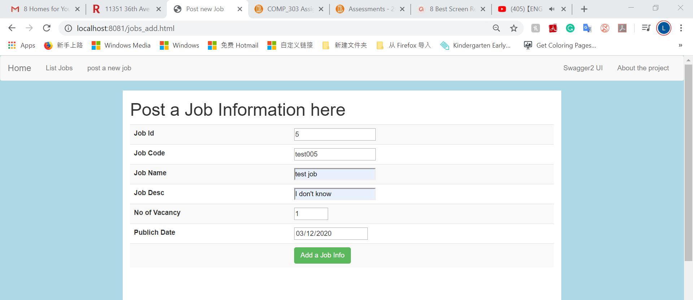

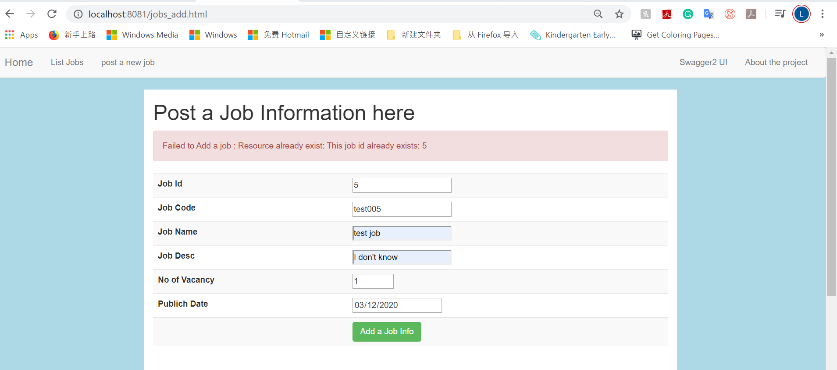

## A Job Details

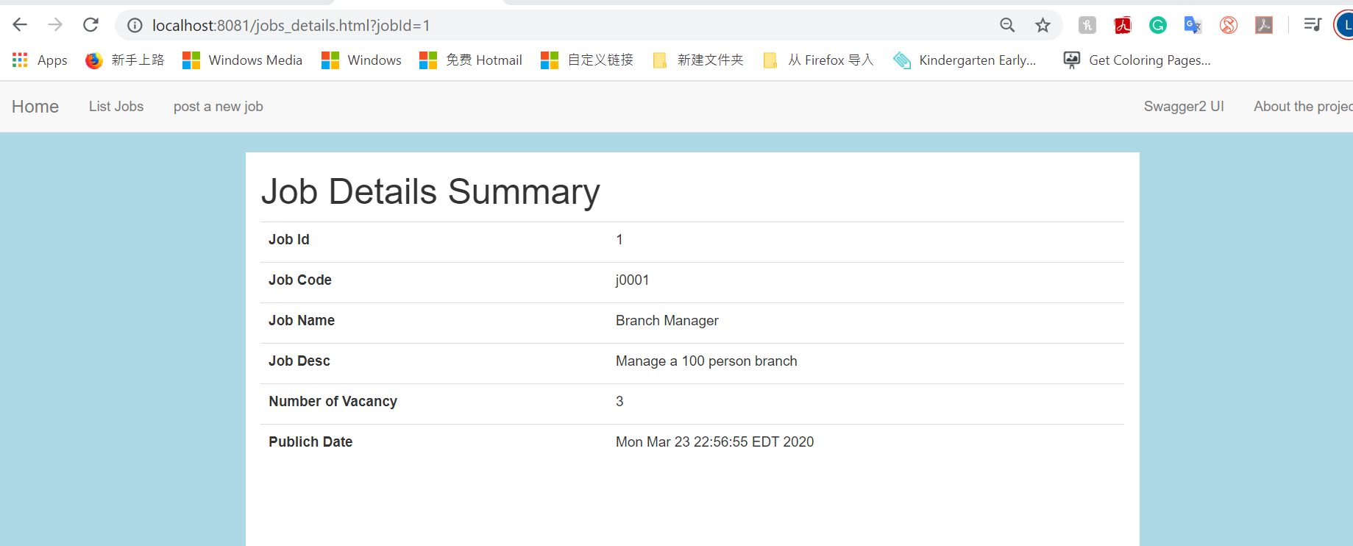

## Update a job

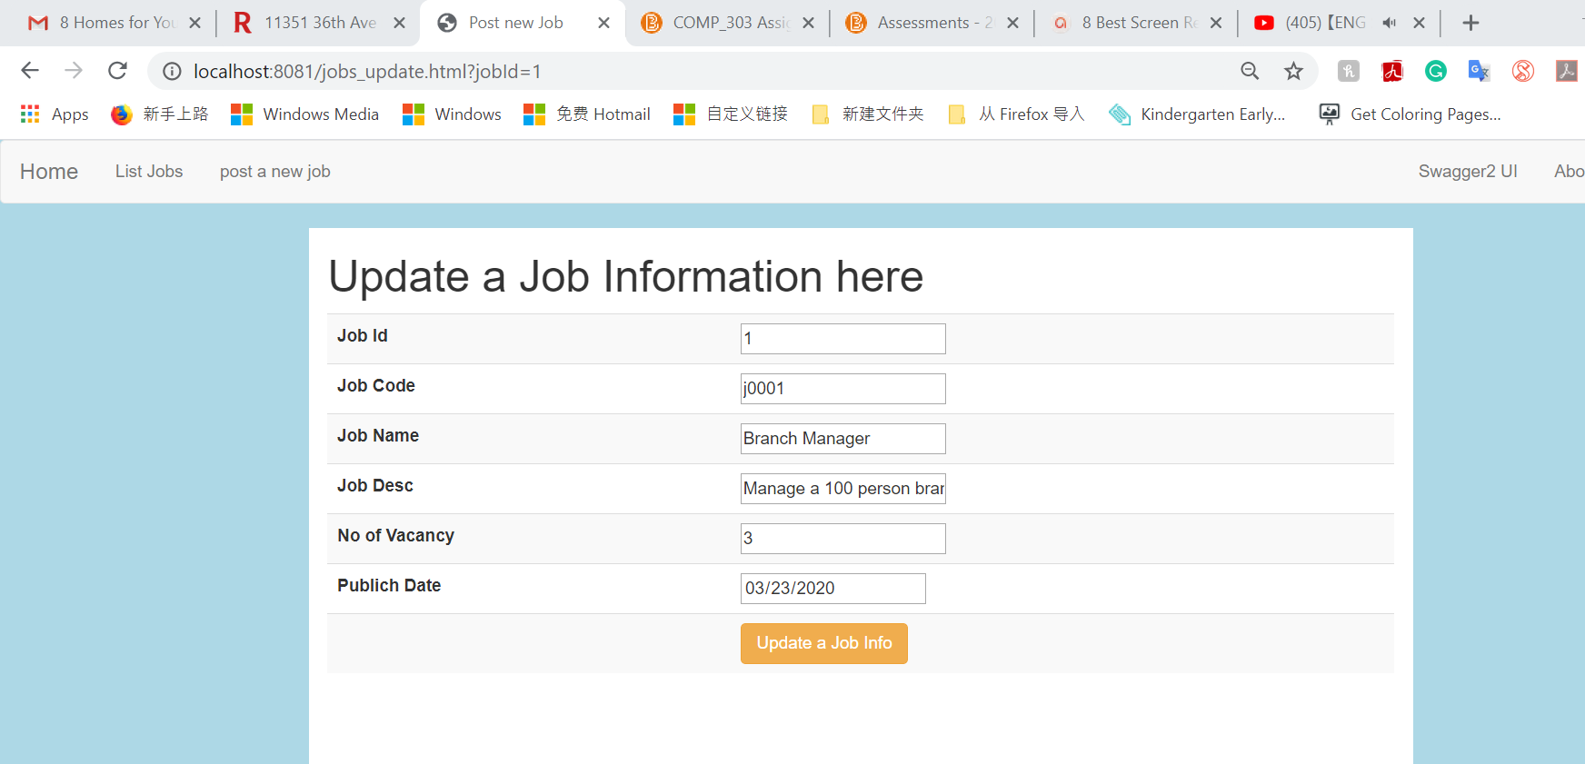

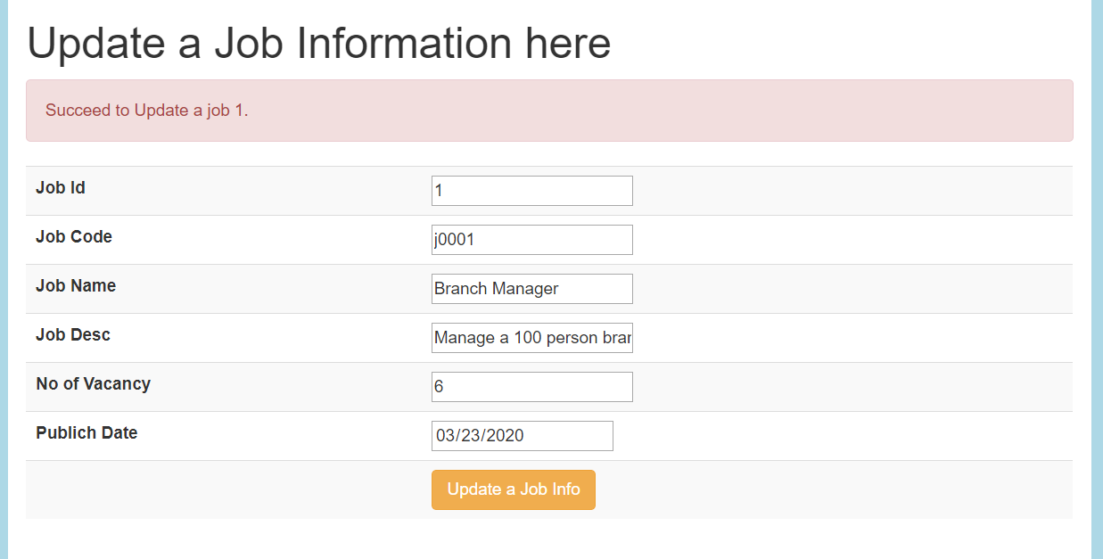

## Delete a Job

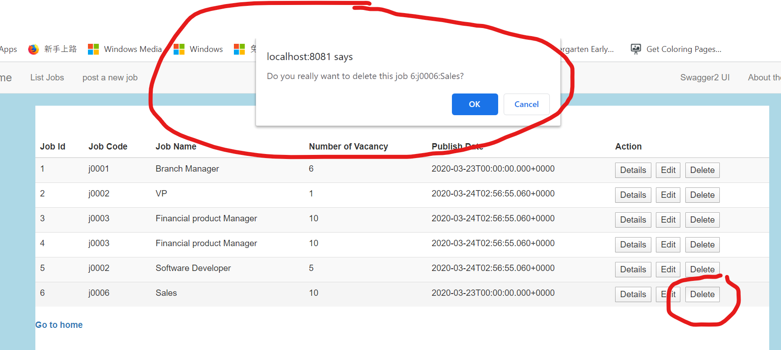

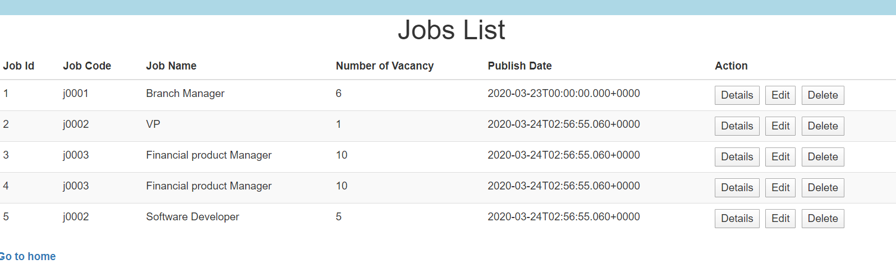

## SWAGGER – REST API Testing

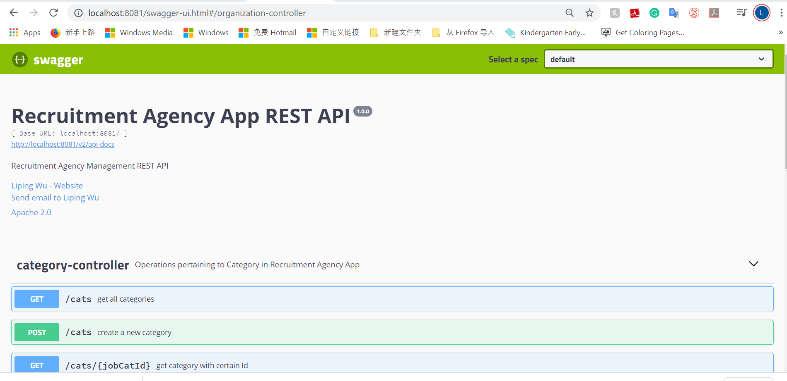

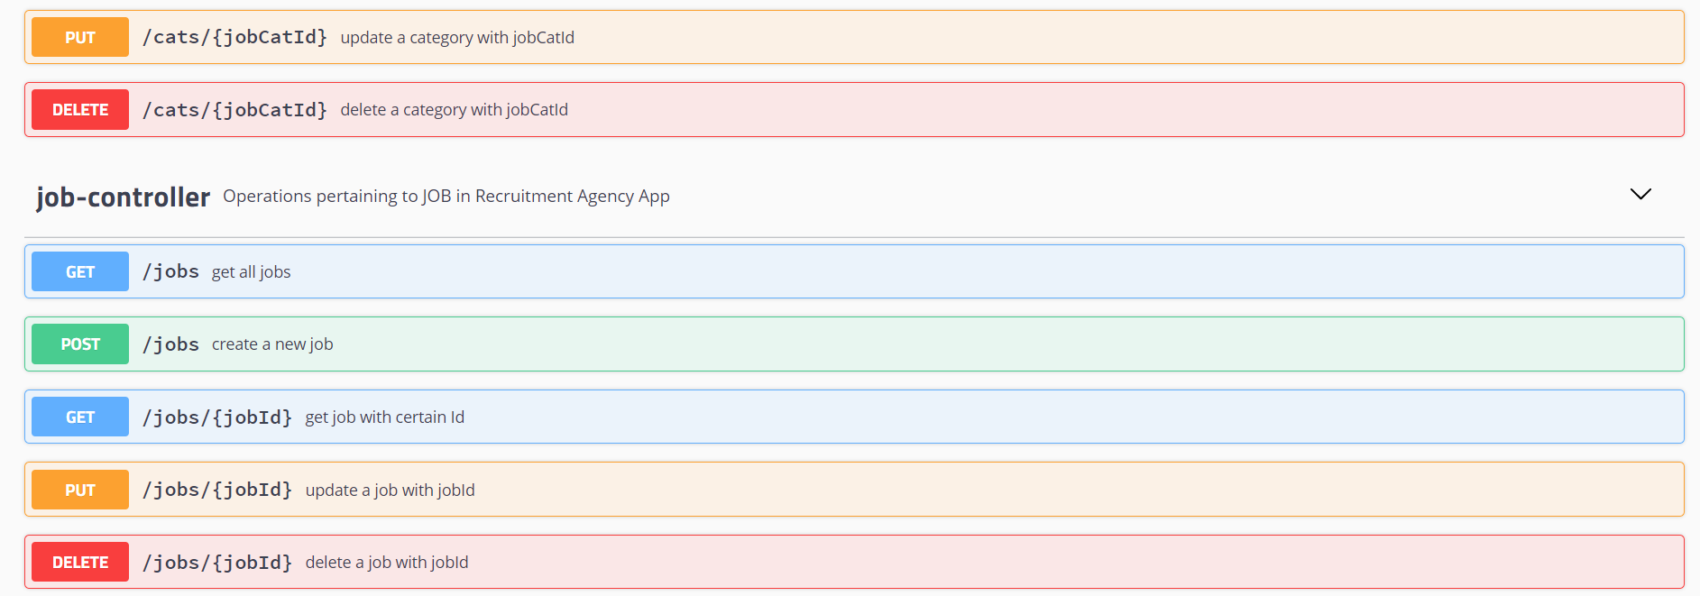

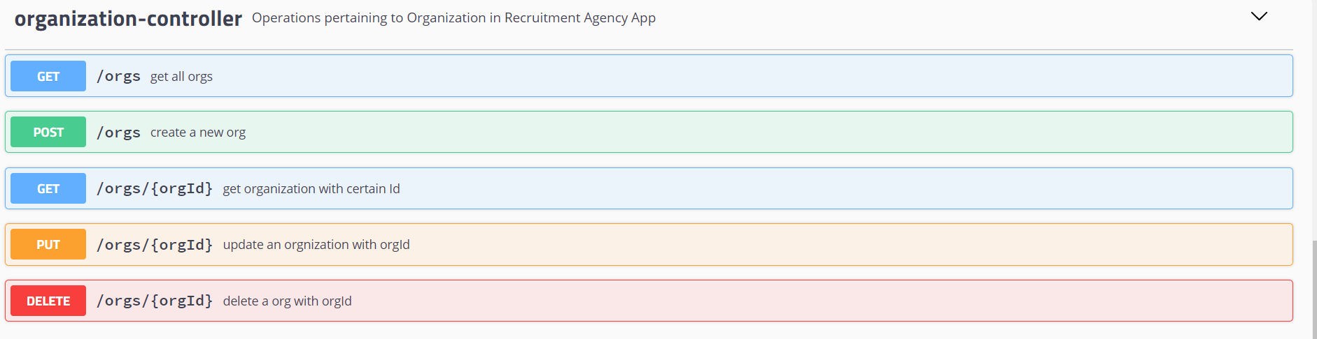

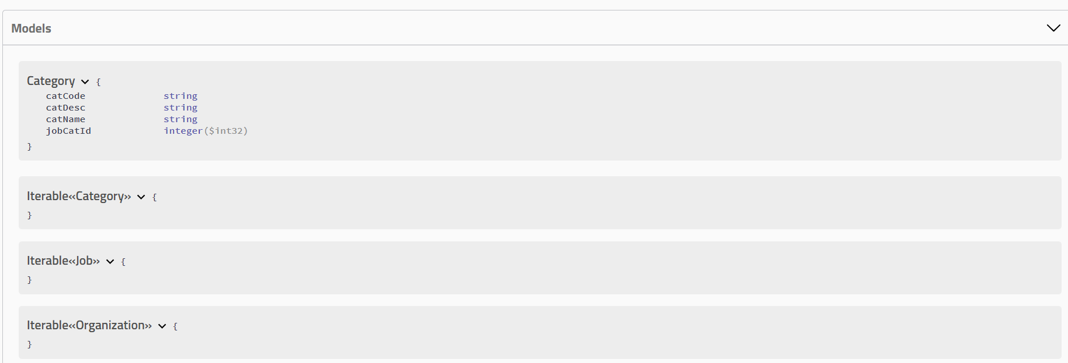

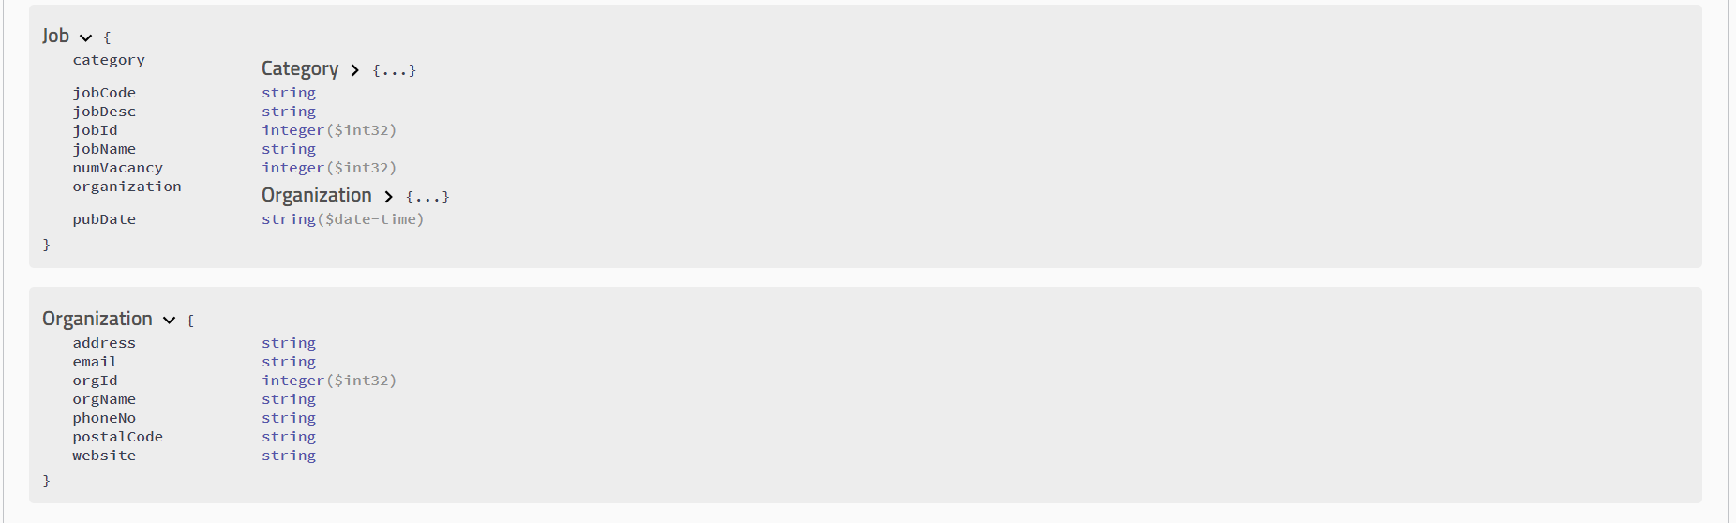

## About page

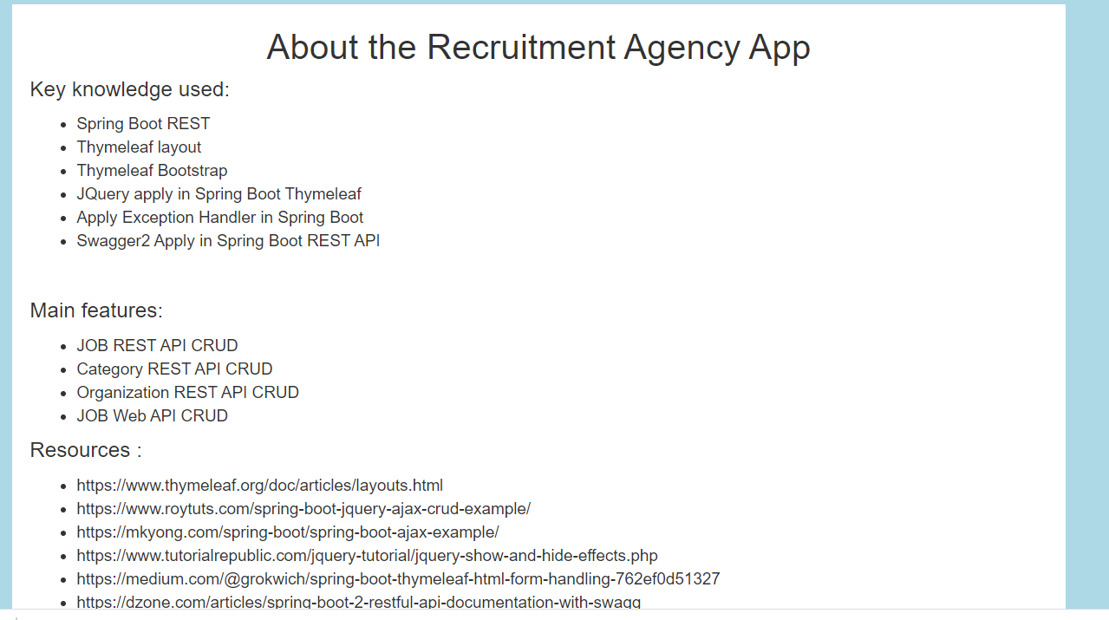

# Postman Testing

## 2.1 JOBS

### GET http://localhost:8081/jobs

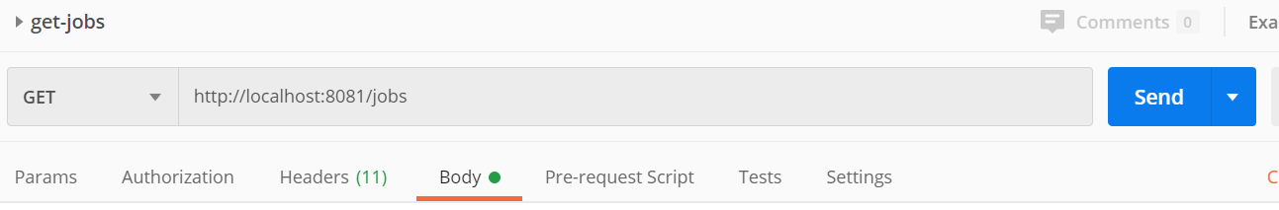

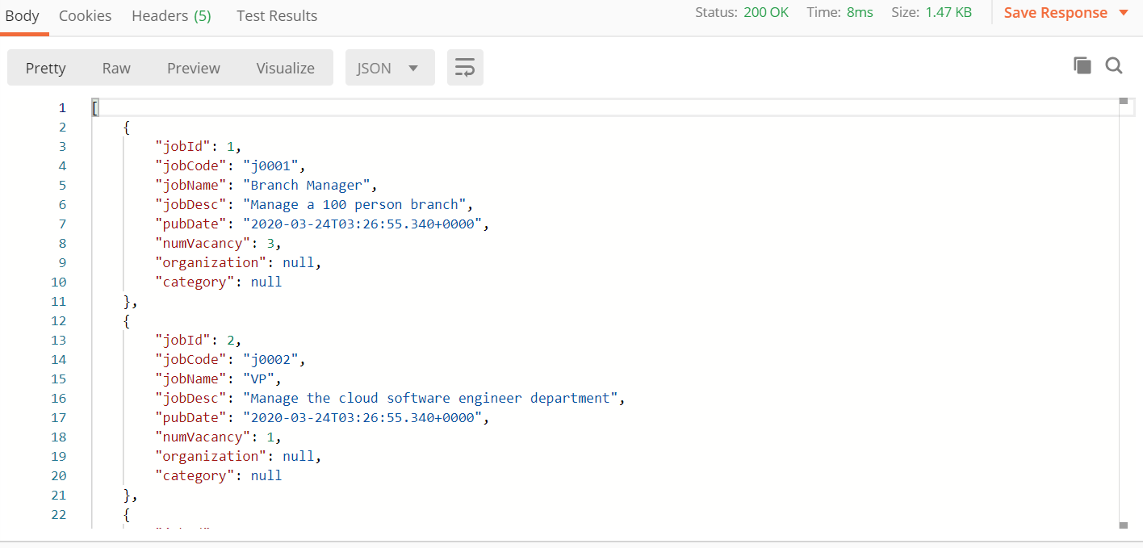

### GET <http://localhost:8081/jobs/6> which is not existing

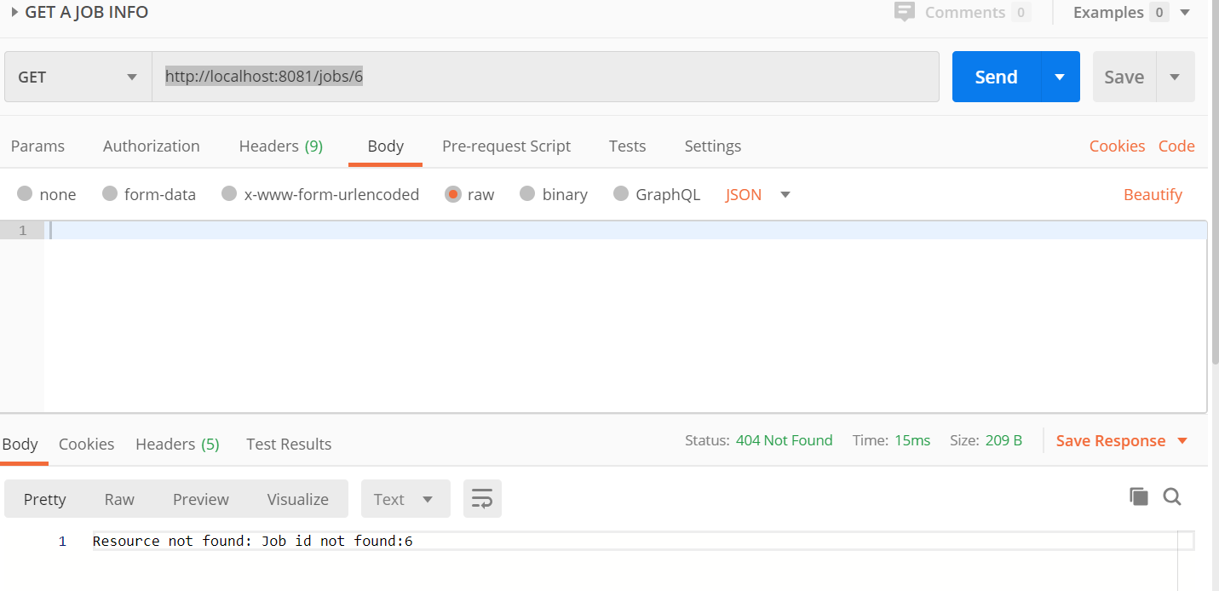

### GET <http://localhost:8081/jobs/1> which exists

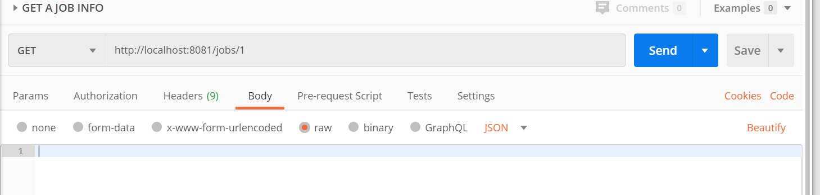

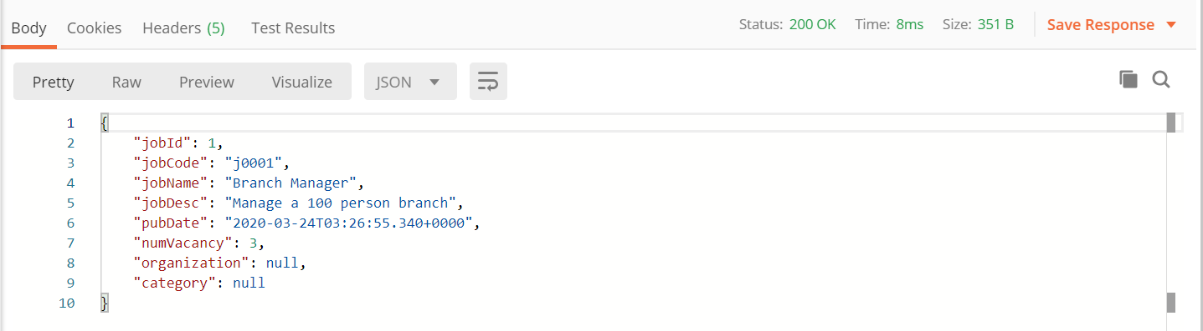

### POST <http://localhost:8081/jobs>

### Request:

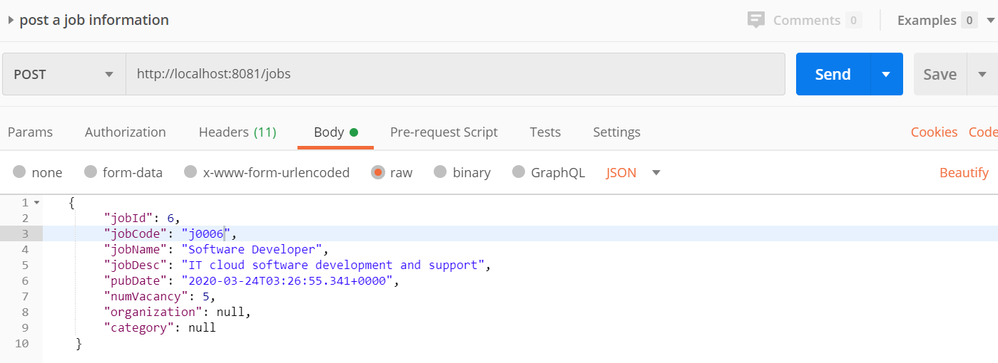

### Response

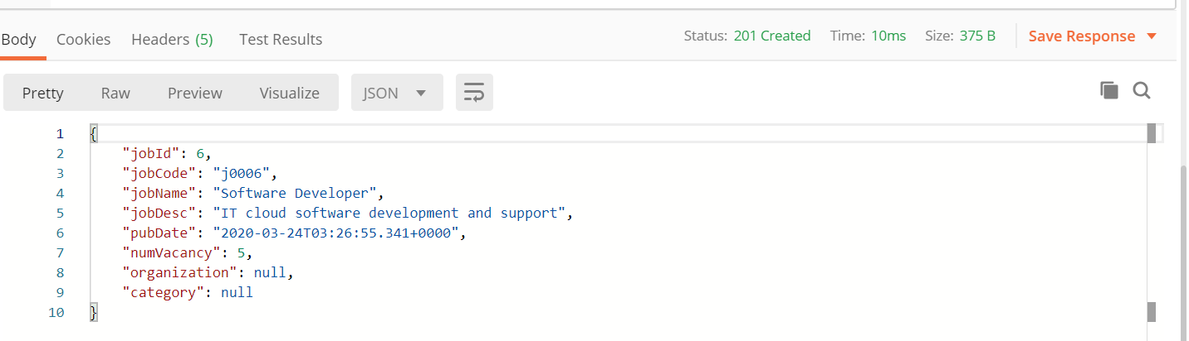

### PUT <http://localhost:8081/jobs/6>

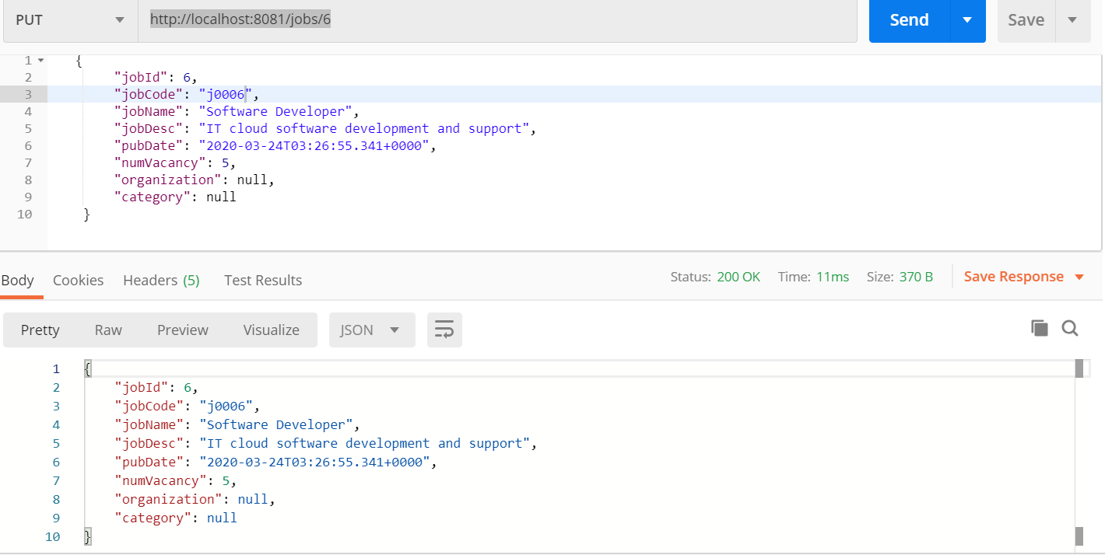

### DELETE <http://localhost:8081/jobs/6>

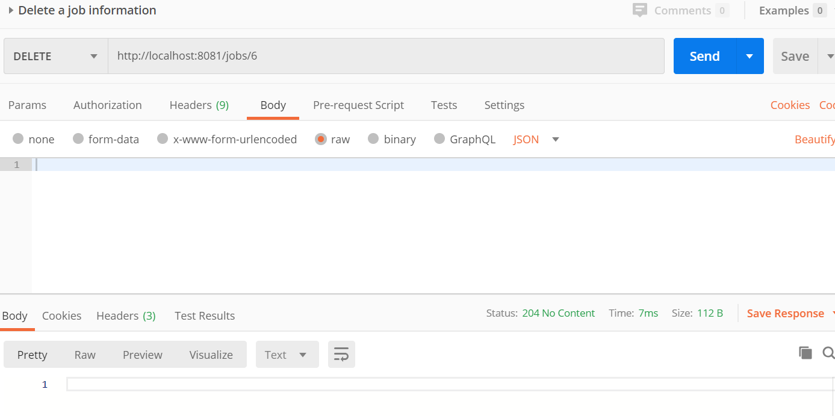

## 2.2 Category

### GET http://localhost:8081/cats

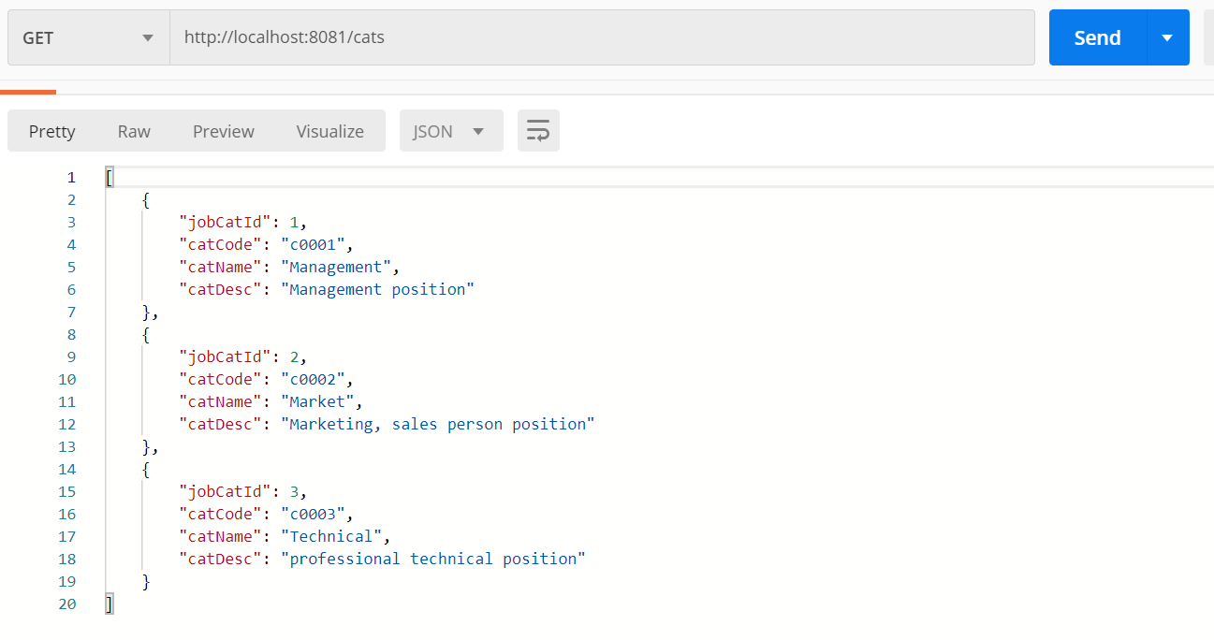

### GET <http://localhost:8081/cats/1> which is existing

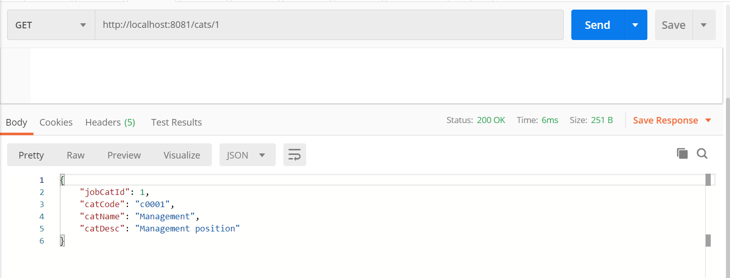

### GET <http://localhost:8081/cats/1> which is NOT existing

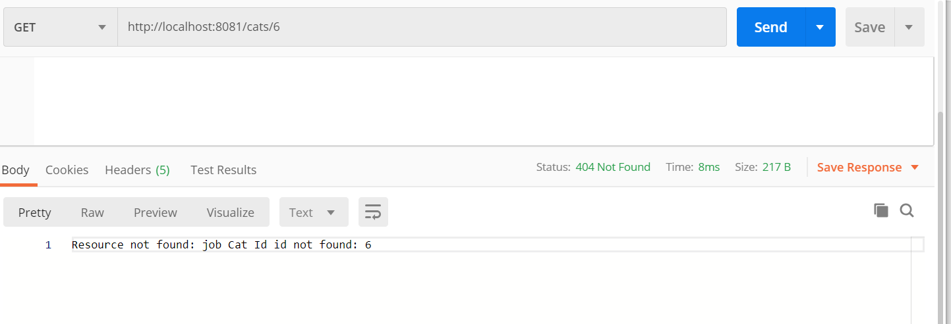

### POST <http://localhost:8081/cats>

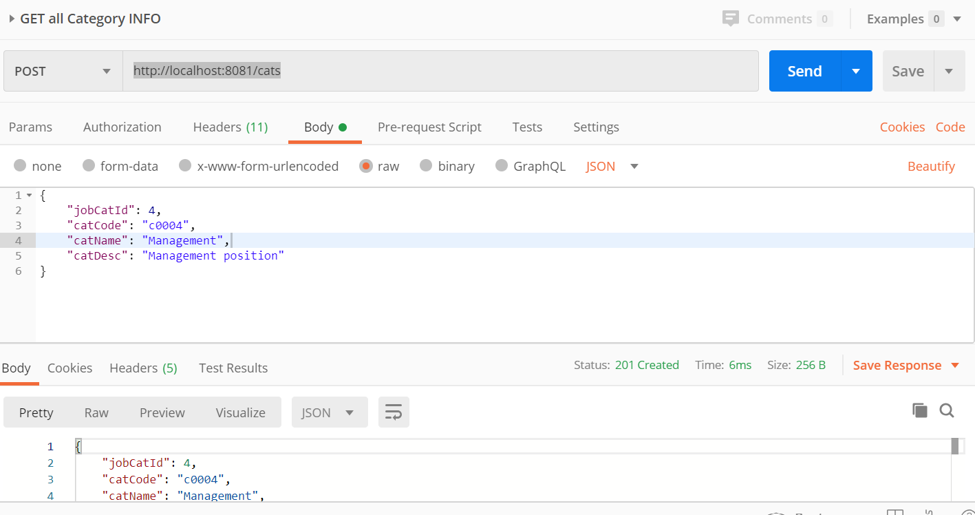

### PUT <http://localhost:8081/cats/4>

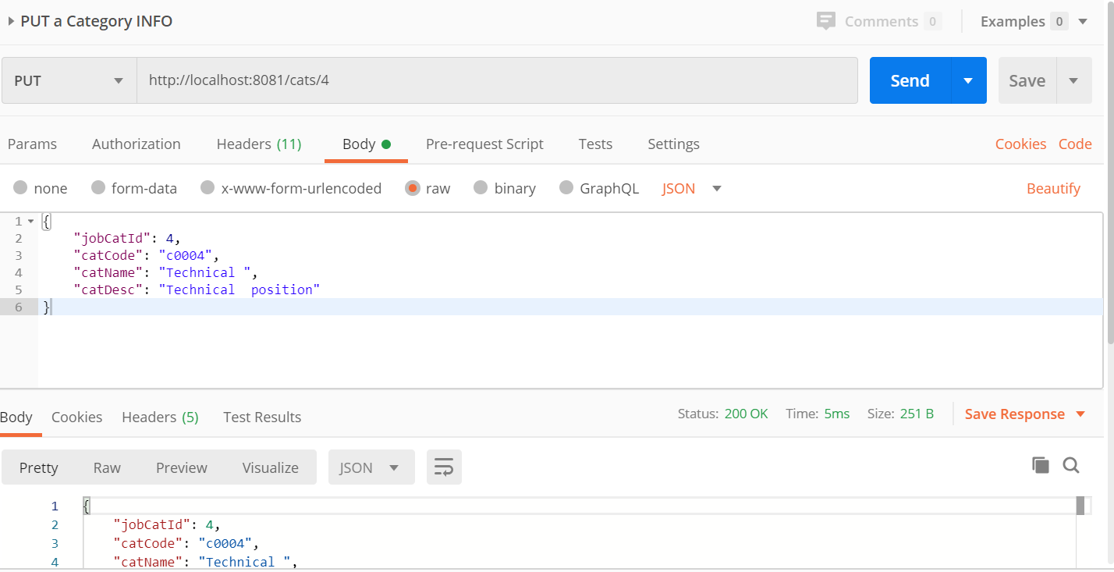

### DELETE http://localhost:8081/cats/4

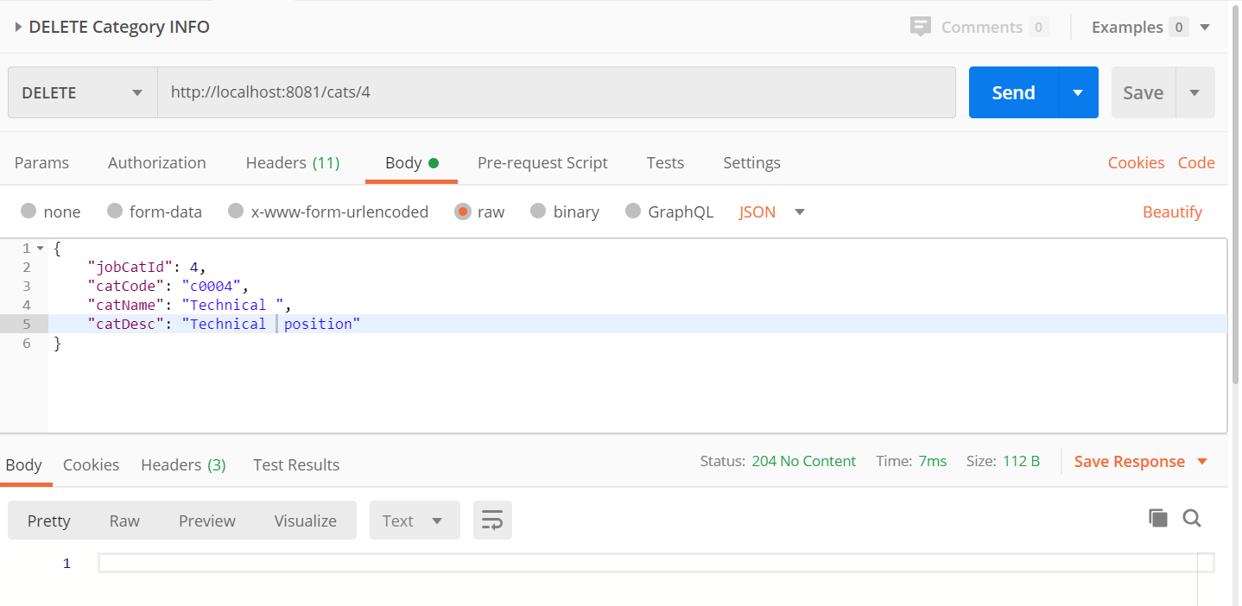

## ORGNIZATION

### GET <http://localhost:8081/orgs>

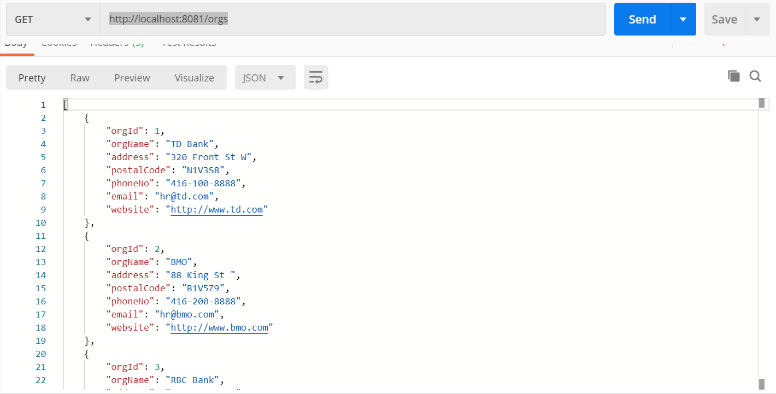

### GET http://localhost:8081/orgs/1

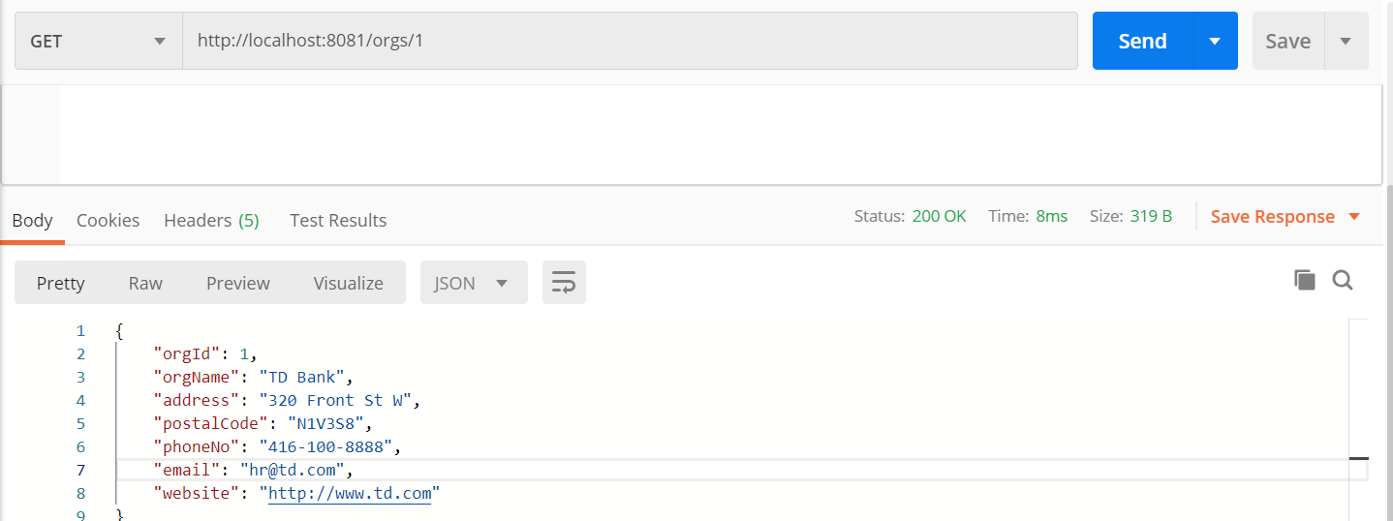

### POST http://localhost:8081/orgs

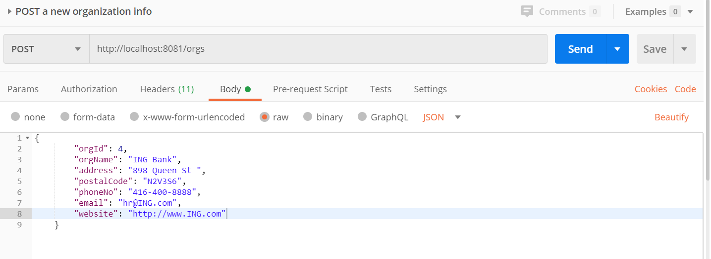

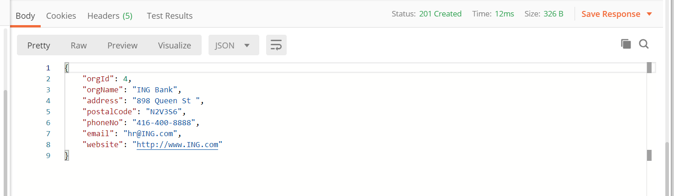

### PUT http://localhost:8081/orgs/4

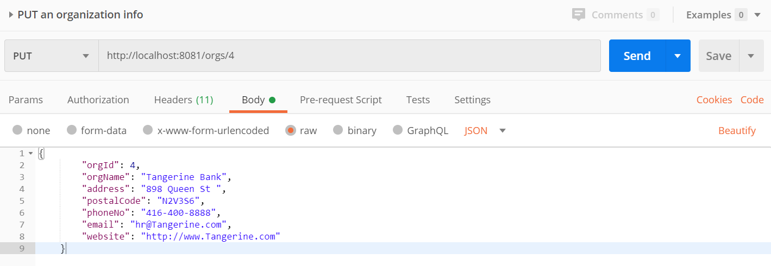

### DELETE http://localhost:8081/orgs/4

