Jessica Lipka  
Nov 19th 2018  
IT FDN 100 B  
Assignment05

# To Do List

## Introduction:

I will be demonstrating how to use different data types, lists, and dictionaries.

### Text file:

First step is to create a text file titled “todo” with ‘clean house’ and ‘pay bills’ in it. Using the read function I will get the data from the text file and display it through PyCharm. (figure1)  
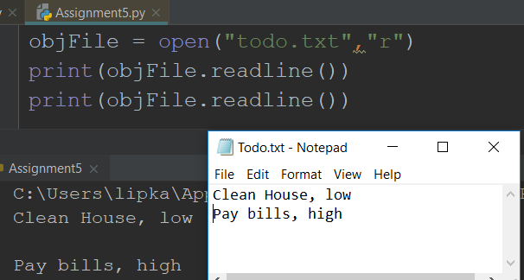  
***(figure1 the read function and the input displayed in PyCharm)***

### Building a dictionary list:

This is the list the that the program will refer back to. (figure2)

dicRow0 = {"Task": "Clean house", "Priority":"low"}  
dicRow1 = {"Task": "Pay bills", "Priority":"high"}  
lstTable = [dicRow0,dicRow1]  
print(lstTable

***(figure2 building a dictionary list)***

### Display:

Next, I create a menu with a series of options a user can choose from to complete specific tasks. (figure3)

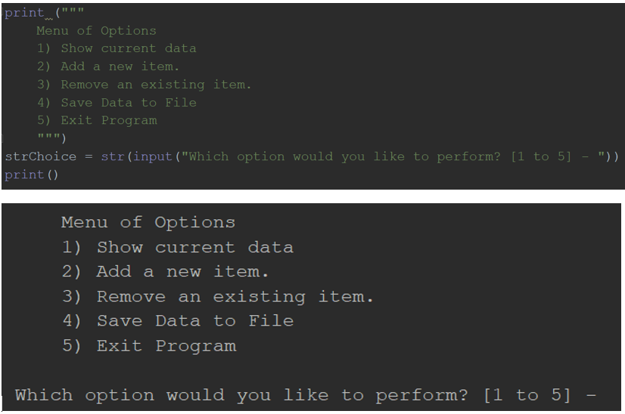

***(figure3 user options)***

### Option 1: Show current data

Shows the current list of todo items. Using the for loop I’m able to display the items in the todo list. (figure4)

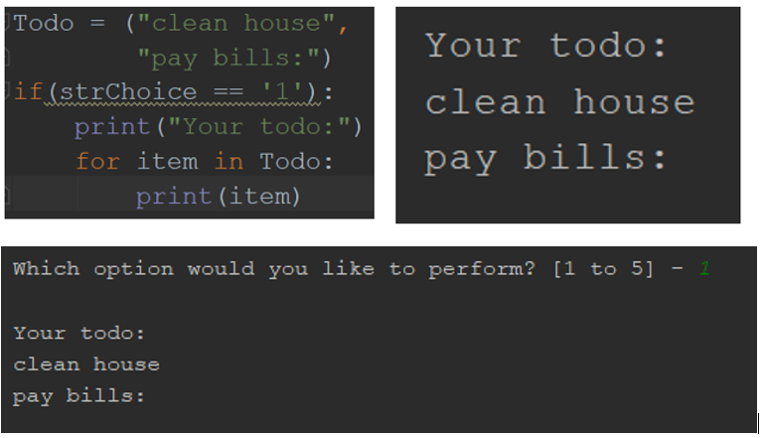  
***(figure 4 using a for loop)***

### Option 2: Add a new item

Using the append function the user is able to enter new tasks to their to do list. (figure 5)

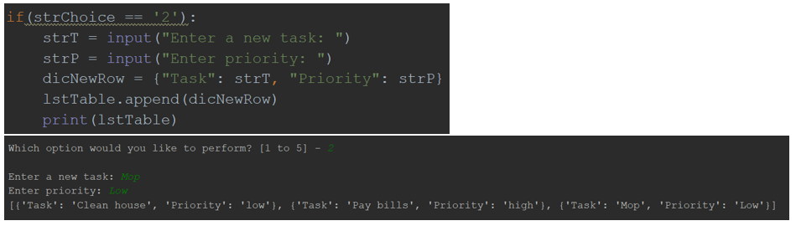  
***(figure5 the append function)***

### Option 3: Remove an item

Using the remove function I allow users to remove items from the todo list. This is where I got stuck. I could not figure out how to properly run the if/elif statement. So the code never runs past the first if statement. (figure6)  
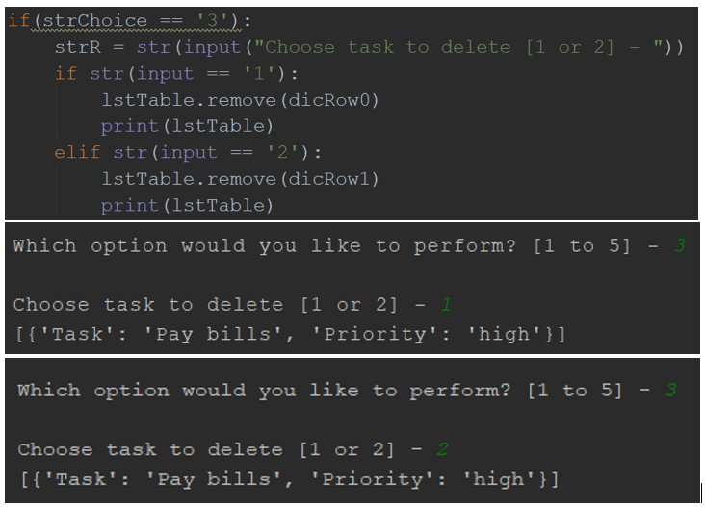  
***(figure6 using the remove function with an if/elif statement)***

### Option 4: Save data to a file

Using the write function, the program saves my initial dictionary list to the text file (figure7)

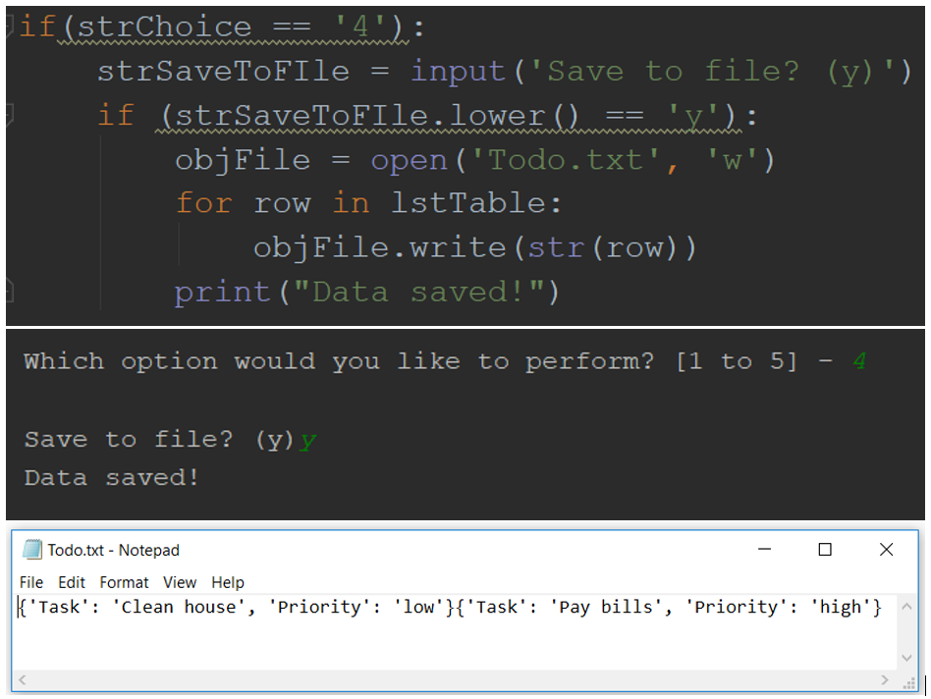  
***(figure7 writing data to a file and saving)***

### Option 5: Exit program

Finally, a simple prompt to exit the program (figure8)

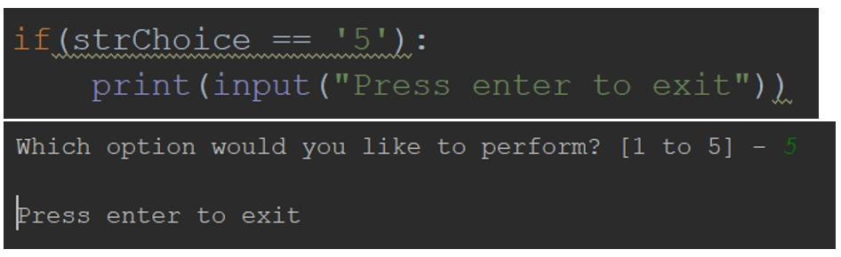  
***(figure8 exiting program)***

### Summary:

This program showed a number of different functions of Python, i.e., the if/elif statement, data structures, lists and dictionaries and how they can all be used in conjunction with each other.