Jessica Lipka  
December 10, 2018  
Assignment 7  
IT FDN 100B

Pickling and Exceptions

# Introduction

I will demonstrate pickling and exception handling. To demonstrate pickling I used cars as the general theme.

## Step 1

. First I have to import the pickle module. *(figure1)*

# Create a simple example of how you would use Python Pickling.  
import pickle

## ***(Demonstrating importing pickle module)***

## Step 2

I create a list to pickle. *(figure2)*

# lists to pickle  
type = ["sedan"**,** "suv"**,** "truck"]  
brand = ["bmw"**,** "honda"**,** "toyota"]  
color = ["red"**,** "blue"**,** "green"]

***(Demonstrating creating a list to pickle)***

## Step 3

Then I must create a new file to write the data in to. I can only use pickle in a binary file so I use the “wb” (write binary) mode. *(figure 3)*

# open new file to store the data  
f = open("cars.dat"**,**"wb")

## ***(Demonstrating creating a file in binary)***

## Step 4

Then I pickle and add the data to the file and close the file. *(figure 4)*

# pickle the data  
pickle.dump(type**,**f)  
pickle.dump(brand**,**f)  
pickle.dump(color**,**f)  
f.close()

***(Demonstrating pickling and storing data)***

## Step 5

To verify the data has been written to the file I unpickle. I open the file with “rb” (read binary.) *(figure 5)*

# unpickle  
f = open("cars.dat"**,**"rb")  
type = pickle.load(f)  
brand = pickle.load(f)  
color = pickle.load(f)

***(Demonstrating unpickling)***

## Step 6

I print to see that my data was saved. *(figure 6)*

# print list  
print(type)  
print(brand)  
print(color)  
f.close()

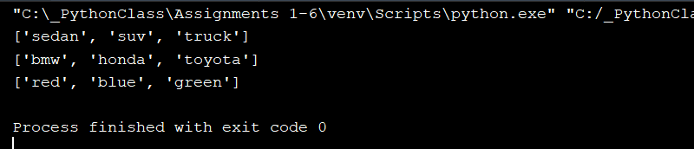***(Printing data from binary file)***

# Exception Handling

Using try statements and an except clause.

## Example 1

I created a try except block to catch any exceptions raised. Since I entered a number, no exception was raised. *(figure7)*

# Create a simple example of how you would use Python Exception Handling.   
try:  
 number = float(input("Enter a number: "))  
except:  
 print("Something went wrong")

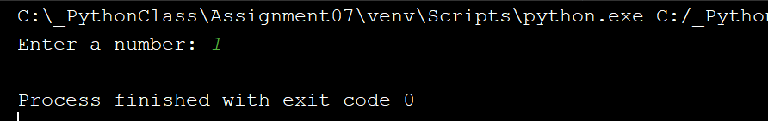  
***(Demonstrating no exception)***

## Example 2

This time I entered a letter instead of a number an exception was raised and caught by the try/except block. *(figure 8)*

try:  
 number = float(input("Enter a number: "))  
except:  
 print("Something went wrong")

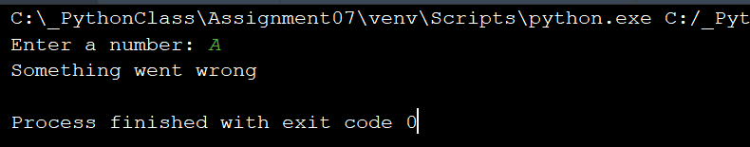  
***(Demonstrating an exception)***

### Summary

Pickling is an easy way to create a list of data to store for later use. Exception handling is great for using with your code to catch errors.