QUEENSLAND UNIVERSITY OF TECHNOLOGY



Advanced Topics in Artificial Intelligence

Siamese Network

IFN 680: Assignment 2

Student Name:

Jianwei Tang – N10057862

Yongrui Pan – N10296255

# Project overview

This project is an implementation of a deep neural network classifier to predict whether two images belong to the same class.

## Dataset

The dataset in this project is a built-in dataset in keras.datasets.fashion_mnist.load_data, it is called Fashion-MNIST. The dataset contains images labelled with classes including ["top", "trouser", "pullover", "coat", "sandal", "ankle boot", "dress", "sneaker", "bag", "shirt"]. They are all small (28x28) grayscale images.

## Siamese network architecture

A Siamese network consists of two identical subnetworks that share the same weights followed by a distance calculation layer. The graph below shows the structure.

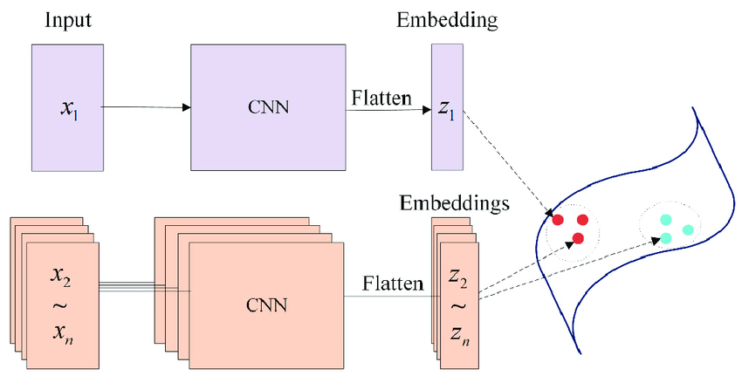

## Implementation environment

This project is using python version 3.7 with keras library. keras is the core part in this project. It involves construction of the network and the classifier. NumPy and Matplotlib.pyplot are also used and they are for datasets slicing and figure plotting respectively.

Details are shown below.

1. **from** __future__ **import** absolute_import, division, print_function, unicode_literals
3. **import** random
4. #rom keras.layers import Input, Conv2D, Lambda, merge, Dense, Flatten,MaxPooling2D,GlobalAveragePooling2D,Activation
5. **import** tensorflow as tf
6. **from** tensorflow **import** keras
7. **from** keras.layers **import** Input, Flatten, Dense, Dropout, Lambda, MaxPooling2D
8. **from** keras.models **import** Model
9. **from** keras.optimizers **import** RMSprop
10. **from** keras **import** backend as K
11. **from** keras.layers.convolutional **import** Conv2D
12. **from** keras.layers **import** LeakyReLU
13. **from** keras.regularizers **import** l2
14. **from** keras.models **import** Model, Sequential
16. **from** tensorflow.keras **import** regularizers
18. **import** numpy as np
19. **import** matplotlib.pyplot as plt

## project objectives

Evaluate the generalization capability of your network by

1. testing it with pairs from the set of images with labels ["top", "trouser", "pullover", "coat", "sandal", "ankle boot"]
2. testing it with pairs from the set of images with labels ["top", "trouser", "pullover", "coat", "sandal", "ankle boot"] union ["dress", "sneaker", "bag", "shirt"]
3. testing it with pairsfrom the set of images with labels in ["dress", "sneaker", "bag", "shirt"]

# coding explanations

## data loading and observation

Firstly, we load the data and have a glimpse on it.

1. (x_train, y_train), (x_test, y_test) = keras.datasets.fashion_mnist.load_data()
3. **print**('train_images : ', x_train.shape, x_train.dtype)
4. **print**('train_labels : ', y_train.shape, y_train.dtype)
5. **print**('test_images : ', x_test.shape, x_test.dtype)
6. **print**('test_labels : ', y_test.shape, y_test.dtype)

train_images : (60000, 28, 28) uint8

train_labels : (60000,) uint8

test_images : (10000, 28, 28) uint8

test_labels : (10000,) uint8

It shows there are 60000 images of training images and 10000 images of test images.

Let us have a look at the first training image.

1. plt.figure()
2. plt.imshow(x_train[0, :])
3. plt.colorbar()
4. plt.grid(False)
5. plt.show()

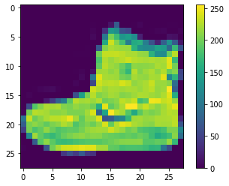

## Data normalization

We normalize the data between 0–1 by dividing train data and test data with 255, then we can take a pixel with value “1” for black color and a pixel with value “0” for white color.

1. x_train = x_train.astype('float32')
2. x_test = x_test.astype('float32')
3. x_train = x_train / 255.0
4. x_test = x_test / 255.0

## data slicing

We slice the data according their label for later usage.

1. # split labels ["top", "trouser", "pullover", "coat", "sandal", "ankle boot"] to train set
2. digit_indices = [np.where(y_train == i)[0] **for** i **in** {0,1,2,4,5,9}]
3. digit_indices = np.array(digit_indices)
5. # length of each column
6. n = min([len(digit_indices[d]) **for** d **in** range(6)])
8. # Keep 80% of the images with labels ["top", "trouser", "pullover", "coat", "sandal", "ankleboot"] for training (and 20% for testing)
9. train_set_shape = n * 0.8
10. test_set_shape = n * 0.2
11. y_train_new = digit_indices[:, :int(train_set_shape)]
12. y_test_new = digit_indices[:, int(train_set_shape):]
14. # Keep 100% of the images with labels in ["dress", "sneaker", "bag", "shirt"] for testing
15. digit_indices_t = [np.where(y_train == i)[0] **for** i **in** {3,6,7,8}]
16. y_test_new_2 = np.array(digit_indices_t)
18. **print**(y_train_new.shape)
19. **print**(y_test_new.shape)
20. **print**(y_test_new_2.shape)

(6, 4800)

(6, 1200)

(4, 6000)

## Create pairs

In order to build a classifier which can identify whether two images belong to a same class, we need to create pairs of images throughout the datasets.

The method we doing it is: 1) For every image belongs to each given class, we pick the image next to it and form a pair. For example, in the class of “top”, the first image and the second image will form a pair, and the second image will form a pair with the third image… Those pairs will be positive pairs. 2) Meanwhile, we pick an image belongs to another class and form a pair. For example, the first image in the class of “top” will form a pair with the first image in the class of “pullover”. Those pairs will be negative pairs. 3) We assign labels to each combination of positive pair and negative pair as [1,0].

1. **def** create_pairs(x, digit_indices):
2. '''''Positive and negative pair creation.
3. Alternates between positive and negative pairs.
4. '''
5. pairs = []
6. labels = []
8. class_num = digit_indices.shape[0]
9. **for** d **in** range(class_num):
10. **for** i **in** range(int(digit_indices.shape[1])-1):
11. z1, z2 = digit_indices[d][i], digit_indices[d][i + 1]
12. pairs += [[x[z1], x[z2]]]
13. inc = random.randrange(1, class_num)
14. dn = (d + inc) % class_num
15. z1, z2 = digit_indices[d][i], digit_indices[dn][i]
16. pairs += [[x[z1], x[z2]]]
17. labels += [1, 0]
18. **return** np.array(pairs), np.array(labels)
19. # two image
20. tr_pairs, tr_y = create_pairs(x_train, y_train_new)
21. tr_pairs = tr_pairs.reshape(tr_pairs.shape[0], 2, 28, 28, 1)
22. **print**(tr_pairs.shape)
24. te_pairs_1, te_y_1 = create_pairs(x_train, y_test_new)
25. te_pairs_1 = te_pairs_1.reshape(te_pairs_1.shape[0], 2, 28, 28, 1)
26. **print**(te_pairs_1.shape)
28. te_pairs_2, te_y_2 = create_pairs(x_train, y_test_new_2)
29. te_pairs_2 = te_pairs_2.reshape(te_pairs_2.shape[0], 2, 28, 28, 1)
30. **print**(te_pairs_2.shape)

(57588, 2, 28, 28, 1)

(14388, 2, 28, 28, 1)

(47992, 2, 28, 28, 1)

## Base network creation

For the base network, we get the insight from the structure below.

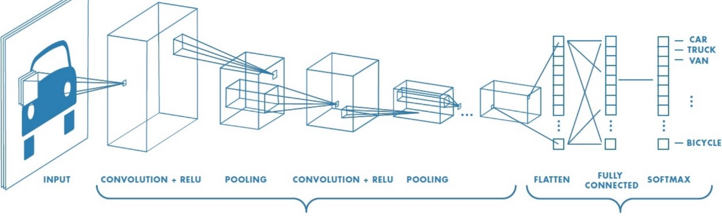

At first, we have a convolution+relu layer with a larger size filter 7*7 and followed by a maxpooling layer which reduce parameters to reduce computation and overfitting. Then, there is another convolution+relu layer with a smaller size filter 3*3. Then the flatten layer flatten the multi-dimensions to one dimension for the followed fully connect layer. Also, in several layers, regularizers are utilized for reducing overfitting.

1. **def** create_base_network(input_shape):
2. '''''Base network to be shared (eq. to feature extraction).
3. '''
4. input = Input(shape=input_shape)
5. **print**(input)
6. x = Conv2D(32, (7, 7), activation='relu', input_shape=input_shape, kernel_regularizer=regularizers.l2(0.01),
7. bias_regularizer=regularizers.l1(0.01))(input)
8. x = MaxPooling2D()(x)
9. x = Conv2D(64, (3 ,3),activation='relu', kernel_regularizer=regularizers.l2(0.01),
10. bias_regularizer=regularizers.l1(0.01))(x)
12. x = Flatten()(x)
13. x = Dense(128, activation='relu', kernel_regularizer=regularizers.l2(0.01),
14. bias_regularizer=regularizers.l1(0.01))(x)
16. **return** Model(input, x)
18. input_shape = (28,28,1)
20. base_network = create_base_network(input_shape)
22. input_a = Input(shape=input_shape)
23. input_b = Input(shape=input_shape)
25. # because we re-use the same instance `base_network`,
26. # the weights of the network
27. # will be shared across the two branches
28. processed_a = base_network(input_a)
29. processed_b = base_network(input_b)
30. **print**(base_network.summary())

## loss layer

A loss layer is needed in the siamese network.

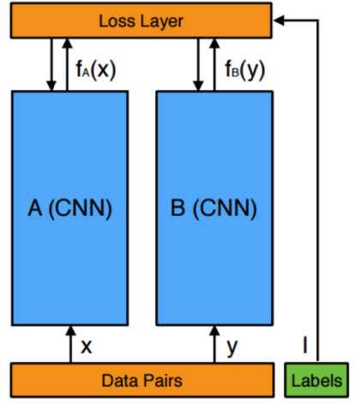

1. # add a lambda layer
2. distance = Lambda(euclidean_distance,
3. output_shape=eucl_dist_output_shape)([processed_a, processed_b])
5. model = Model([input_a, input_b], distance)

## model training

Now we have completed the Siamese network structure. Model can be trained with the training dataset.

1. # train
2. rms = RMSprop()
3. model.compile(loss=contrastive_loss, optimizer=rms, metrics=[accuracy])
4. history = model.fit([tr_pairs[:, 0], tr_pairs[:, 1]], tr_y,
5. batch_size=128,
6. epochs=epochs,
7. validation_data=([te_pairs_1[:, 0], te_pairs_1[:, 1]], te_y_1))

## making prediction

The model is able to make predictions since now. It takes test data as input. The accuracy can be evaluated based its prediction.

1. y_pred = model.predict([tr_pairs[:, 0], tr_pairs[:, 1]])
2. tr_acc = compute_accuracy(tr_y, y_pred)
3. y_pred = model.predict([te_pairs_1[:, 0], te_pairs_1[:, 1]])
4. te_acc = compute_accuracy(te_y_1, y_pred)

# model evaluation

objective 1: testing it with pairs from the set of images with labels ["top", "trouser", "pullover", "coat", "sandal", "ankle boot"]

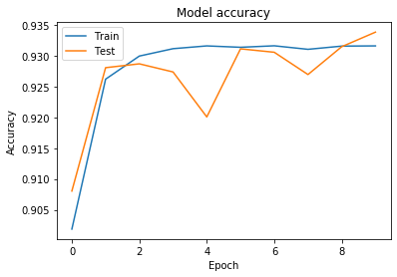 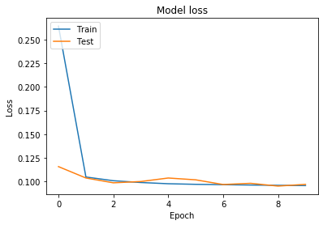

* Accuracy on training set: 93.66%

* Accuracy on test set: 93.38%

objective 2: testing it with pairs from the set of images with labels ["top", "trouser", "pullover", "coat", "sandal", "ankle boot"] union ["dress", "sneaker", "bag", "shirt"]

* Accuracy on training set: 93.36%

* Accuracy on test set: 83.94%

objective 3: testing it with pairsfrom the set of images with labels in ["dress", "sneaker", "bag", "shirt"]

* Accuracy on training set: 93.30%

* Accuracy on test set: 74.85%