Quick start

Labeler UI Walkthrough - part 1

Labeler UI Walkthrough - part 2

Labeling Nodes/Multiplexers - Common

Labeling Nodes

Labeling Multiplexers

# Labeler Guide

**Labeler** is an interactive Python application that communicates with the motes and peripheral boards through a wired USB interface. The application configures barcode based identifiers on both the Bacon (mote) and the Toast (multiplexer) boards, sets various parameters, tests the sensors, and can also reprogram the motes.

**The Bacon** mote has two external Micro USB connectors. The connector on the left (as seen from the component side) is used to program the Bacon, the other, located approximately at the center of the board, is used to connect external sensors and multiplexers (Toast and MiniToast).

**The Toast** board is used to connect 8 external analog sensors to a Bacon. Several Toast boards can be connected in series. It connects to the Bacon through its USB A type connector (the big one). The Micro USB can be used to daisy-chain additional Toast boards to a single Bacon. The board uses a 12 bit ADC, with a range of 4096. The reference voltage is 2.5V, and the supply voltage sent to the analog sensors is 3.3V, regulated.

**The MiniToast** has one external analog sensor, and two built-in sensors, one monitoring the battery voltage, the other a high-precision temperature sensor (US Sensor PS103J2). Its two internal sensors have been potted with epoxy, with its Micro USB cable, that plugs in into a Bacon. The MiniToast can thus be safely buried underground, or immersed in water. The additional analog sensor must be soldered to the three pins at the end of the board. Afterwards it must be covered with a silicone rubber paint or other insulating material (we recommend using PlastiDip).

## Quick start

### I. Connecting the devices

The application requires that:

1. the USB based programmer module be connected to the laptop
2. a Bacon mote be connected to the USB [see note A]
3. optionally, you can connect a single Toast/MiniToast board to the Bacon

First, connect the USB board. The device should normally automatically install itself. If not, locate the FTDI driver installer in the main directory of our software stack and install the driver manually.

Once successful, the Menu buttons at the top of the Labeler application become active, other­wise they stay in DISABLED mode. There is also a short status message displayed at the bottom left of the window. The drop-down menu item at the top of the screen should display the name of the serial port assigned to the USB device. In case there are several ones displayed, and connection still fails, select one that works.

Next, plug in a Bacon mote into the USB. The rest of the Menu buttons should become active as well. Now you can perform different tasks, like uploading a unique ID code into the device, upload different programs into the mote, or configure and test various sensors.

### II. Programming

The Bacon can have one of three functionalities:

1. ***Leaf node***, used as the basic data collection device
2. ***Router***, bridging gaps between distant sites and link deployments on different channels
3. ***Base Station***, connected to a Gateway through a USB, collecting the data and status information, using wireless communication

It is enough to have a single Bacon connected, no Toast board is needed to perform this step. By pressing the appropriate button, the corresponding binary image is uploaded into the mote. Reprogramming the motes does not affect the barcodes, or any data or log information stored on the devices.

### III. Barcoding a Bacon

Once a Bacon node is plugged in into the USB board, press the Connect button at the upper left hand corner. After a short wait period, the button should turn green, indicating a successful connection. The current barcode is then automatically loaded and displayed on the upper left panel on the screen, just below the Connect button. If there is no existing barcode set, the panel displays “Not available“. In this case you need to enter a barcode, either manually or by using a barcode reader. The barcodes are 8 bytes, represented by a 16 character hexadecimal number. The first two characters must be 04 for a Bacon. The rest of the code must be a unique hexadecimal sequential number. Once the barcode is in the Entry field, press the Save button, just below the barcode. For a list of the different device codes see the Appendix.

### IV. Barcoding a Toast

The Toast must be connected to a Bacon board. In order to connect a Toast, you need to use a short USB cable from the USB board to the Bacon, as the USB is too wide, and blocks the sensor connector if a Bacon is connected directly.

[A] The programming port on the Bacon is the Micro USB on the left side of the Bacon, as seen from the component side. For the programming to be successful, the mote should be connected either directly, or with a 5-wire micro USB extension cable. Such cables are typically labelled RR-MCB-EXT-72G5, or RR-MCB-EXT-12G5. For the rest of the communication and testing functions, any standard extension cable with a male and female Micro USB connector will work.

[B]

# Labeler UI Walkthrough - part 1

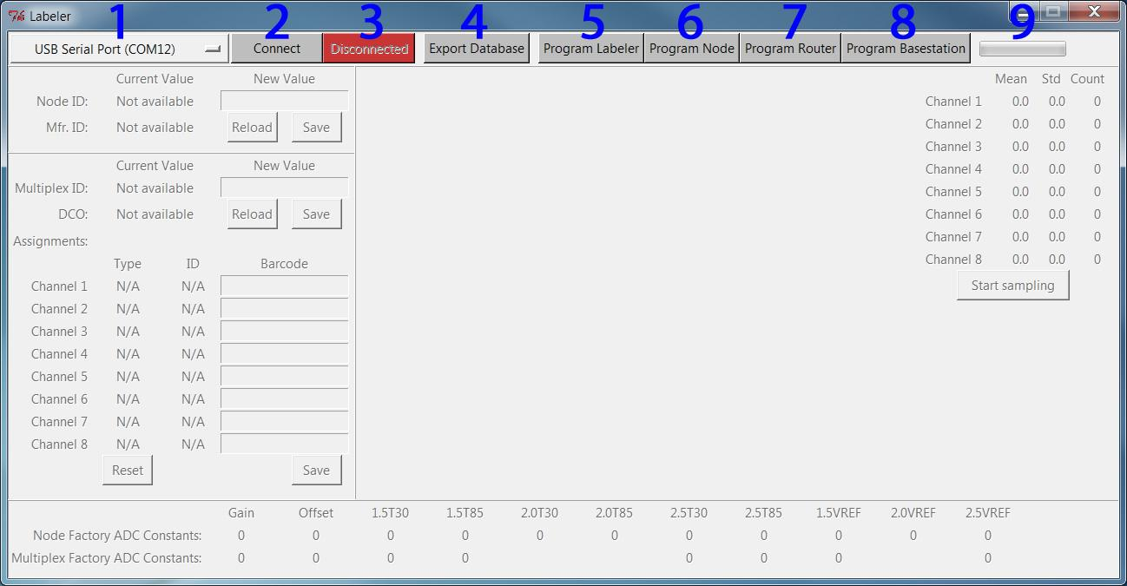

1. Com port selector   
   - If the computer has multiple com ports installed they will show up here.
2. Connect button
3. Disconnect Button  
   - When labeling Nodes and Multiplexers the application must be connected to the Labeler. When programming Nodes the application must be disconnected first.
4. Export Database  
   - Dump database to CSV text files.
5. Program Labeler
6. Program Node
7. Program Router
8. Program Basestation  
   - Install new program on the Nodes. Labeler is used for labeling new Nodes and Multiplexer boards. Node is for sensing in the field. Router is for bridging the connection between the Nodes and the Basestation. Basestation is for connecting to a computer where data will be collected.
9. Progress bar  
   - Shows the progress of the programming operation.

# Labeler UI Walkthrough - part 2

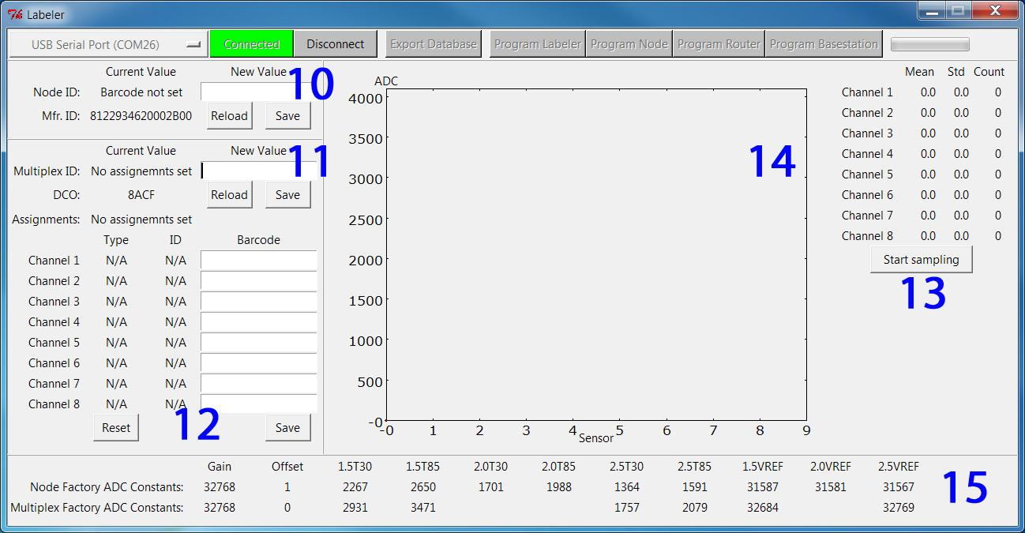

1. Node window
2. Multiplexer window  
   - Shows current ID stored on Node/Multiplexer (if any). New ID can be entered into text field and saved to the Node/Multiplexer with the Save button or by hitting the Enter key. The Reload button can be used if an error occurred during reading/writing to the Node/Multiplexer.
3. Sensor assignments  
   - Shows currently assigned sensors on the Multiplexer board. All 8 channels can be changed simultaneously. Barcodes are 6 digits hexadecimal values, with the first 2 digits being the type and the last 4 being the ID. To remove a sensor assignment input use the value 0 (zero) as barcode. The Reset button will remove all sensor assignments and clear the Multiplexer ID.
4. Start/Stop sampling
5. Graph/Statistics  
   - Sample channels with sensors assigned, calculate simple statistics, and shows data points visually. Useful for testing.
6. Factory ADC constants  
   - For future use.

# Labeling Nodes/Multiplexers - Common

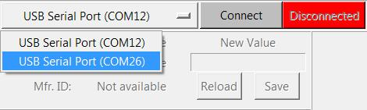

1. Start Labeler application.   
   - Linux/Windows with mouse: double click the Labeler.py icon.  
   - Linux command line: ./Labeler.py  
   - Windows command line: Labeler.py  
   Note: the application’s directory can be moved to any Linux/Windows machine with Python 2.7.x installed (<http://www.python.org/>)
2. Click on the ‘Com port selector’ and note the available port numbers (this list might be empty).
3. Insert the Programming Board into any USB port. (Driver installation might be necessary).
4. Click on the ‘Com port selector’ again and select the newly discovered com port.
5. Attach a Node to the Programming Board (use the edge connector) and press the ‘Program Labeler’ button.
6. If the ‘Mfr. ID’ value has changed to a 16 digit hexadecimal number you are ready to proceed otherwise reprogram the Node and/or restart the application.

# Labeling Nodes

1. Attach a new barcode label to Node.
2. Make sure the ‘Disconnected’ button is red.
3. Connect Node to Programming Board and press the ‘Program Labeler’ button.
4. Once the Node window lights up, make sure the cursor is blinking in the ‘New Value’ field.
5. Scan barcode label or input barcode value manually. (If manual input or scan not being saved, hit the ‘Enter’ key or press the ‘Save’ button.)
6. Remove Node and repeat with new one.

# Labeling Multiplexers

1. Attach new barcode label to Multiplexer board.
2. Attach sensors to Multiplexer board.
3. Attach new barcode labels to sensors.
4. Connect Multiplexer board to Node programmed with the Labeler application as described in the Common step above. (Use the middle connector.)
5. If the ‘Disconnected’ button is red, press the ‘Connect’ button.  
   If the ‘Connected’ button is green, press the ‘Reload’ button in the Multiplexer window.
6. Once the Multiplexer window lights up, make sure the cursor is blinking in the ‘New Value’ field.
7. Scan barcode label or input barcode value manually. (If manual input or scan not being saved, hit the ‘Enter’ key or press the ‘Save’ button.)
8. For each attached sensor move cursor to the corresponding channel and input barcode. Once all barcodes have been entered press the ‘Save’ button.  
   Note: sensor assignments can be undone by assigning the value 0 (zero) to the channel. Use the ‘Reset’ button for a complete restart.
9. Use the ‘Start Sampling’ button to test the sensors attached. Only channels with sensors assigned should be sampled.
10. Remove Multiplexer board and repeat with new one.