1. Obtain a dataset and frame the predictive problem

This project uses the Kaggle telecom churn dataset (abhinav89/telecom-customer), downloaded locally and analysed as a supervised machine learning problem. After loading the CSV and standardising column names, the working dataset contained 100,000 observations and 100 raw variables. The task is binary classification: predict whether a customer will churn (churn = 1) or remain (churn = 0). The objective is not causal explanation, but risk ranking so that a telecom firm can prioritise retention actions.

The target is operational: a positive prediction identifies a customer who may merit intervention. Because campaign size may vary, the model must return probabilities as well as labels. Threshold choice is therefore a business decision rather than a fixed modelling assumption. False negatives are costly because missed churners represent lost retention opportunities; false positives are also costly because outreach consumes budget and may contact customers who were unlikely to leave. Interpretability matters for governance and business communication, but this is primarily a prioritisation problem, so predictive quality is the main objective. Latency is minor because batch scoring is sufficient.

PR-AUC (Average Precision) was chosen as the primary metric, with ROC-AUC and F1 as secondary metrics. PR-AUC is appropriate because the task is identifying churners efficiently. However, the dataset is almost balanced: the observed test-set prevalence is 49.56%. ROC-AUC is therefore informative and worth reporting because it is less sensitive to prevalence than precision-based metrics. A key limitation follows: absolute PR-AUC and precision are likely to look better here than in production environments where churn prevalence is lower.

The agent tooling plan was explicit. I delegated repository scaffolding, notebook structuring, sklearn pipeline implementation, model-comparison code, hyperparameter-search setup, artifact-saving logic, and tracking-file maintenance to the agent. I also used the agent to draft EDA plotting code and the Section 6 artifact-driven reporting logic. I manually verified correct target handling, split discipline, leakage prevention, metric definitions, threshold consistency, and whether notebook outputs matched saved artifacts. I tested execution directly and corrected agent mistakes where the generated solution failed or weakened methodology.

2. Explore the data to gain insights

The first EDA result was that the target is almost perfectly balanced: the mean churn rate is 0.49562, or 49.56% [Figure-1]. This is useful because the dataset is not dominated by one class, but it also means the evaluation setting is more favourable than many real churn applications. A balanced sample supports clean model comparison, yet it likely overstates production precision if deployed to a lower-prevalence population.
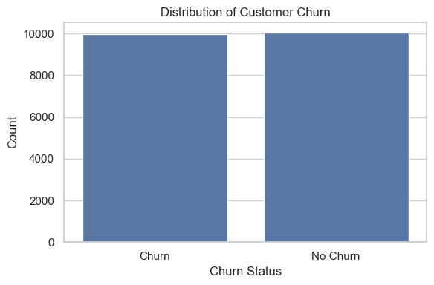
Figure-1

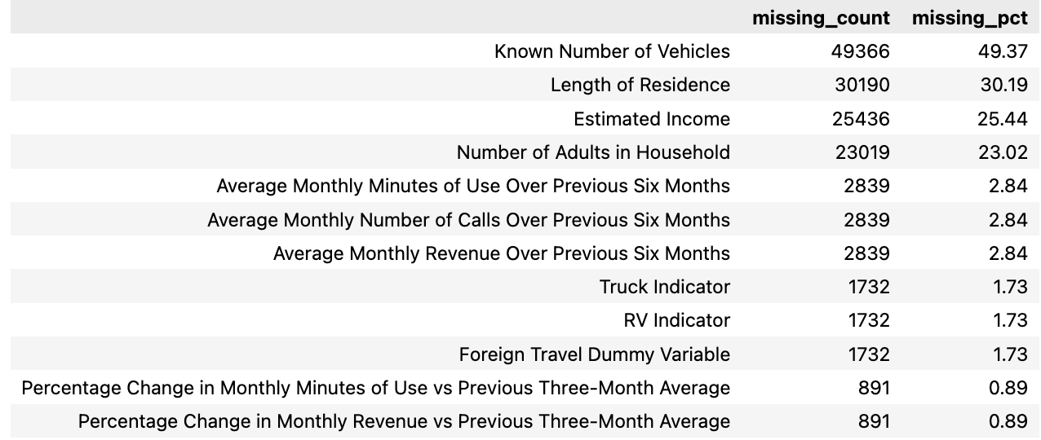
Missingness is substantial and structured. The most incomplete variables were numbcars (49.37%), dwllsize (38.31%), hhstatin (37.92%), ownrent (33.71%), dwlltype (31.91%), lor (30.19%), income (25.44%), adults (23.02%), and infobase (22.08%) [Figure-2]. Most are household or demographic descriptors rather than direct telecom behaviour variables. That
Figure-2
suggests usage, billing, tenure, and service-friction features are likely to be more reliable than static profile fields. It also creates a modelling risk: aggressive imputation of high-missing demographic fields may introduce noise.
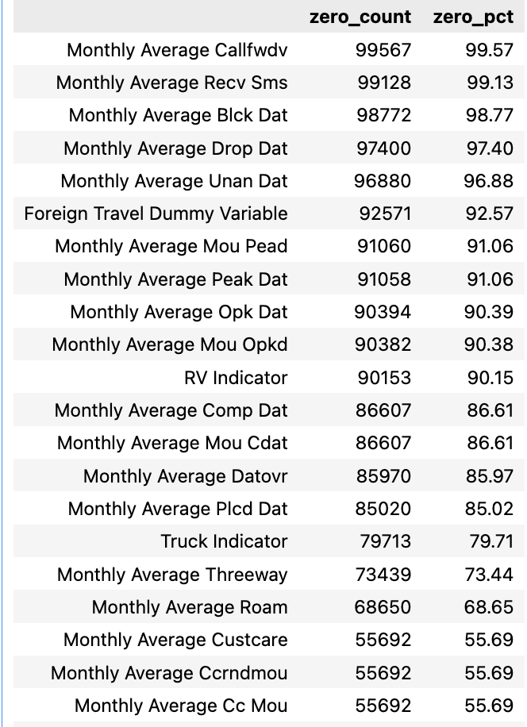
Zero inflation is another defining feature of the dataset. Several numeric variables are zero in more than 90% of rows, such as Mean number of call forwarding calls (99.57%) and Mean number of received SMS messages (99.13%) (Shown in Figure-3). In telecom data, these zeros often mean genuine non-usage, not missingness. Therefore, zero-heavy variables should not be dropped automatically; they may encode inactivity or non-adoption. I also checked churn rates for zero versus non-zero groups in the most inflated variables to assess whether “any usage” might be predictive.
Figure-3

A leakage audit excluded the target and Customer_ID, scanned remaining column names for target-like or post-outcome proxies, and found no suspicious predictors beyond churn itself, with no remaining single feature showing implausibly strong standalone predictive power.
EDA was kept selective rather than exhaustive. I focused on a limited set of usage, revenue, tenure, and service-quality variables and examined their relationship with churn through targeted numeric and categorical views. The box plots (Figure 4-7) suggest that non-churn customers generally have slightly higher usage, recurring charge, and tenure, but the substantial overlap between groups indicates that no single variable is strongly discriminative, reinforcing the need for multivariate modelling.

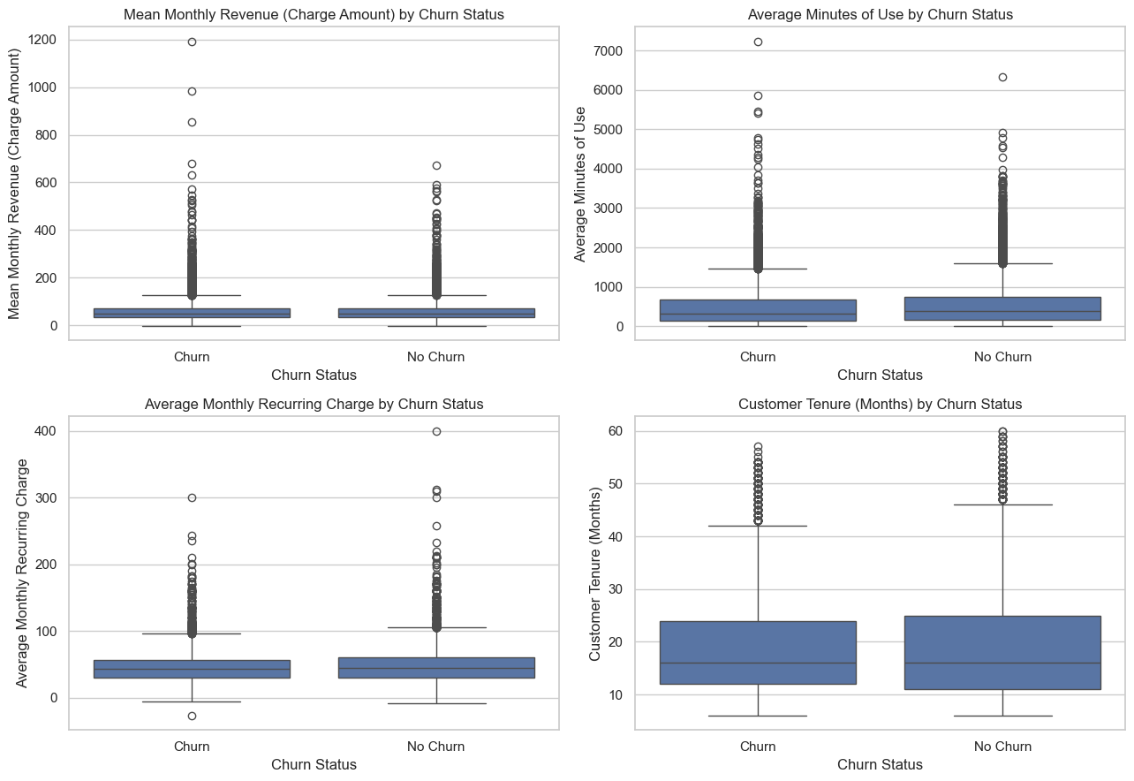
Figure-4 to 7
The correlation heatmap (Figure-8) was used mainly as a redundancy check rather than a causal tool. It showed clusters of telecom usage and billing variables moving together, consistent with multicollinearity among related consumption features, which supports the later choice of tree-based models that are less sensitive to correlated predictors.
Figure-8
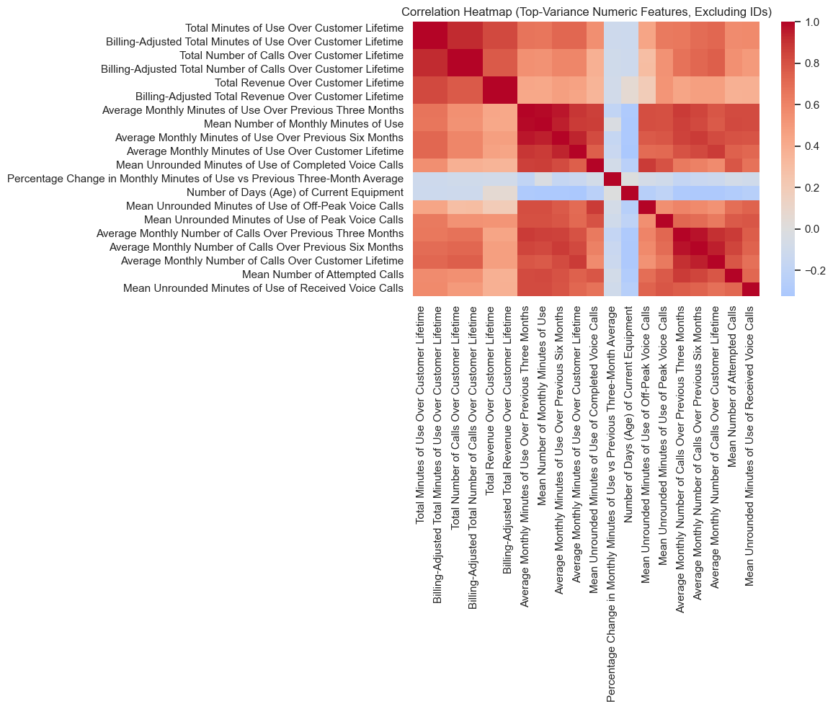

I validated the agent-suggested EDA outputs manually. Raw-coded feature names were initially used in chart titles and axes; these were replaced with business-readable labels. A weaker categorical plot (hnd_webcap) was removed because it did not add enough insight.

3. Prepare the data

Preparation was designed around leakage prevention. The target churn was explicitly coerced to binary 0/1 and removed from the feature matrix. Customer_ID was dropped because it is an identifier. The data was split into training and test sets using a stratified 80/20 split with random_state=42, producing 80,000 training rows and 20,000 test rows. The positive-class rate remained effectively unchanged across train and test, confirming that stratification preserved class balance.

A small set of high-missing, lower-priority household/profile variables was dropped during preparation: numbcars, dwllsize, hhstatin, ownrent, dwlltype, and infobase. This was a parsimonious simplification, not a claim that these fields are universally useless. They were heavily incomplete, relatively indirect for churn, and likely to contribute imputation noise in a baseline pipeline. Feature engineering was limited to interpretable row-wise transformations, including usage ratios, tenure-normalised measures, trend features, and missingness flags. Because these were deterministic row-level calculations, they were safe before the split. Both decision was later checked through controlled ablation tests in Section 4.
Preprocessing was implemented using a sklearn Pipeline plus ColumnTransformer. Numeric features were median-imputed, with missing indicators added, then scaled. Categorical object features were imputed to Unknown and one-hot encoded. Binary numeric features were treated in a separate categorical branch and imputed using the most frequent observed value before one-hot encoding. This prevented binary flags from being treated incorrectly as continuous numeric quantities.
I critically reviewed the agent-suggested preparation steps. The most important correction was that the agent initially used notebook-local lambda transformers in preprocessing, causing a PicklingError when the fitted pipeline was saved. I detected this during execution and replaced that design with sklearn-native preprocessing branches. Additional validation checks confirmed that no churn-like predictors remained, no duplicate rows existed in X_train, and the schema and split configuration were saved as reproducibility artifacts.

4. Explore different models and shortlist the best ones

Model comparison was performed on the training set only. The candidate set included a naive baseline (DummyClassifier(strategy='most_frequent')), Logistic Regression, Random Forest, HistGradientBoosting, and an additional XGBoost. Each model was wrapped in the same preprocessing pipeline from Section 3 so that every estimator received the same leakage-safe inputs.
Evaluation used 5-fold StratifiedKFold cross-validation with random_state=42. PR-AUC was the primary ranking metric, with ROC-AUC and F1 as secondary checks. This ensured that model selection was based on controlled experiments rather than generic beliefs about which algorithm should perform best.
The model comparison results (Table-1) showed a clear ordering. XGBoost performed best with mean PR-AUC 0.6788, followed closely by HistGradientBoosting at 0.6747. Random Forest achieved 0.6528, Logistic Regression 0.6163, and the Dummy baseline 0.4956. ROC-AUC and F1 followed the same broad ranking. These results indicate that boosting-based tree models captured the strongest signal in the dataset. The standard deviations across folds were small for the top models, suggesting reasonably stable validation performance rather than rankings driven by one unusually favourable fold.
Table 1 (Main model Comparison)
Model | PR-AUC_mean | PR-AUC_std | ROC-AUC_mean | F1_mean | fit_time_mean | score_time_mean
XGBoost | 0.678728 | 0.006068 | 0.693462 | 0.639903 | 2.013284 | 0.099677
HistGradientBoosting | 0.674727 | 0.005189 | 0.689922 | 0.638125 | 3.077636 | 0.219946
RandomForest | 0.652843 | 0.008779 | 0.673536 | 0.622183 | 8.076235 | 0.299524
LogisticRegression_balanced | 0.616291 | 0.003853 | 0.638374 | 0.592995 | 2.458401 | 0.085044
Dummy_MostFrequent | 0.495625 | 0.000000 | 0.500000 | 0.000000 | 0.534180 | 0.083011

I included two controlled feature-set ablation tests (Mentioned in Section-3). First, the variant that dropped the selected high-missing features outperformed the corresponding retained-feature baseline (Table-2). Second, adding the engineered features on top of that simplified baseline produced a further, though modest, PR-AUC improvement (Table-3). Therefore, both the feature-dropping decision and the engineered-feature decision were validated experimentally rather than justified only by intuition.

Table-2
Variant | Model_Used | PR-AUC_mean | PR-AUC_std | ROC-AUC_mean | F1_mean
Drop_Selected_HighMissing_NoEngineering | XGBoost | 0.679320 | 0.007777 | 0.693592 | 0.640389
Keep_HighMissing_NoEngineering | XGBoost | 0.678496 | 0.007634 | 0.693180 | 0.640920

Test | Best variant | Model used | PR-AUC_mean | PR-AUC_std | ROC-AUC_mean | F1_mean
High-missing feature drop | Drop_Selected_HighMissing_NoEngineering | XGBoost | 0.679320 | 0.007777 | 0.693592 | 0.640389
Engineered feature value-add | Drop_Selected_HighMissing_WithEngineering | XGBoost | 0.678786 | 0.006068 | 0.693462 | 0.639903
Table-3
The agent suggested Histogram-based-Gradient-Boosting and Random Forest; I included XGBoost and compared the models’ performance. These suggestions were verified experimentally under the same preprocessing, folds, and metrics. The shortlist was justified by evidence rather than preference.

5. Fine-tune and evaluate

Fine-tuning focused on the top-2 performing models (XGBoost and HistGBoost) in Section 4. For both models, tuning was performed using RandomizedSearchCV on the training set, with 3-fold stratified CV and Average Precision as the scoring metric XGBoost model remained the final selected model; the cross-validated PR-AUC was 0.6797. The selected hyperparameters were n_estimators=800, learning_rate=0.05, max_depth=5, min_child_weight=5, subsample=1.0, colsample_bytree=1.0, gamma=0.3, reg_alpha=0.5, and reg_lambda=10.0.
Threshold trade-offs were analysed using only out-of-fold training probabilities. Figure-10 shows precision, recall, and F1 plots across thresholds; a neutral threshold of 0.50 was chosen as it could be adjusted based on the firm’s campaign cost, capacity, and tolerance for false positives versus false negatives. And all final test metrics use that threshold. The plot was therefore diagnostic rather than a justification for changing the operating cut-off.
Figure-9
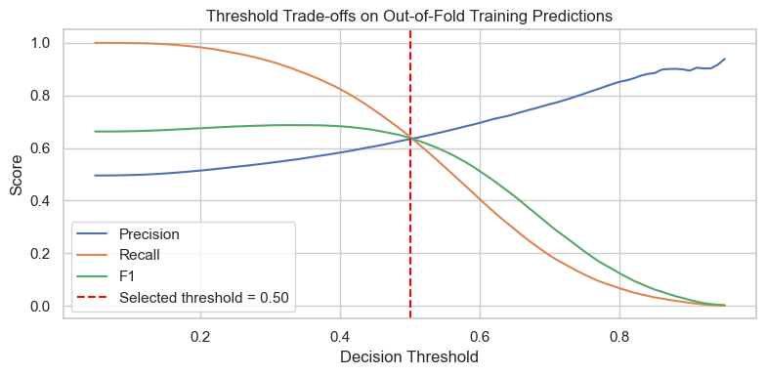

Final evaluation was performed on the test set. Test PR-AUC was 0.6870, ROC-AUC was 0.6986, precision was 0.6374, recall was 0.6497, and F1 was 0.6435. These are moderate but useful results. The model outperforms the baseline and weaker benchmark models, but it should not be described as highly discriminative.
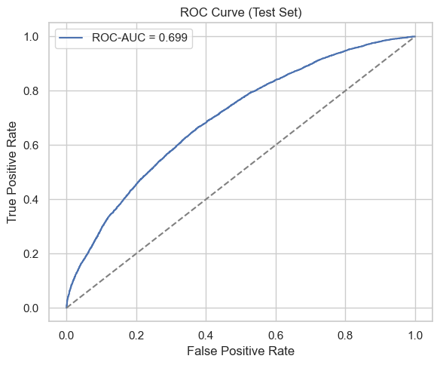
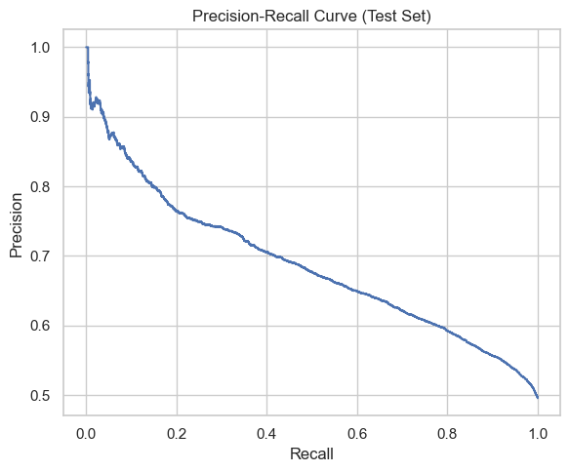
Figure-11
Figure-10

The confusion matrix clarifies the trade-off. Figure-12 shows that, out of 20,000 test observations, there were 6,440 true positives, 3,663 false positives, 3,472 false negatives, and 6,425 true negatives. Many flagged customers would therefore be false alarms. Calibration was reviewed using a calibration curve; probabilities were adequate for ranking but should not be treated as fully calibrated business probabilities without further calibration.
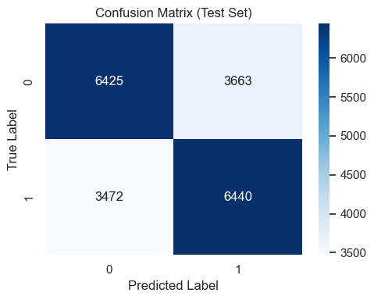
Figure 12

A clear agent mistake was identified and corrected here. The original preprocessing design used lambda-based transformers, which caused a PicklingError when the tuned pipeline was saved. I detected this when using joblib.dump failed, then replaced the design with sklearn-native preprocessing branches. This mattered because a model that cannot be serialized is not reproducible or deployable.

6. Present the final solution

The final selected model is XGBoost because it achieved the strongest cross-validated PR-AUC and remained the best tuned candidate. On the held-out test set, it achieved PR-AUC 0.6870 and ROC-AUC 0.6986, with precision 0.6374, recall 0.6497, and F1 0.6435 at a threshold of 0.50. In business terms, this is a useful prioritisation model rather than a high-certainty classifier.
A simple operational illustration makes the trade-off concrete. If 10,000 customers were scored, using the observed test prevalence as a rough proxy, the model would flag about 5,052 as likely churners. Roughly 3,220 would be true churners captured, while about 1,832 would be false positives. This may be viable if interventions are moderate-cost, but expensive if outreach is costly or capacity-limited.
The main limitations are external validity, calibration, and concept drift. The sample is more balanced than many real churn settings, so production precision may be lower. The Kaggle data may not represent a firm’s actual customer mix or current market conditions. Telecom churn patterns can change over time, so the model requires monitoring and periodic retraining. A realistic deployment plan includes scheduled scoring, drift checks, calibration review, and retraining on a monthly or quarterly cadence depending on behavioural volatility.

Next steps are to set the threshold using explicit business cost trade-offs, improve calibration, extend feature engineering, and enrich the dataset with additional business context such as complaints, campaign history, plan changes, or service-quality indicators.
What the model is for / not for:
Predicting and ranking customers by churn risk to support prioritised retention targeting in batch campaigns. It is not for causal inference or fully automated decision-making without business review.
Data provenance and constraints:
The model was trained on a Kaggle telecom churn dataset. It is appropriate for reproducible coursework, but it should not be treated as a direct substitute for production data. The data shows balanced churn, which is unlikely in reality.
Evaluation summary and caveats:
The model outperforms baselines and provides an operationally useful signal, but overall performance remains moderate. Any deployment should pair the model with business-led threshold setting, calibration review, and ongoing monitoring for drift and changing prevalence.

