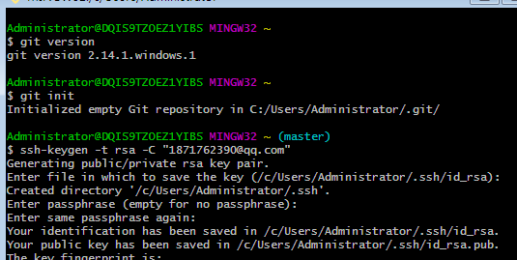

SHA256:+YZUK7vXx6Y5gnJHiW605y42R0vRuz0Hdn5nZc3DOh4 1871762390@qq.com