Develop a food delivery application using Microservices architecture and Spring Cloud

Qingxuan Li

1. **Project structure.**

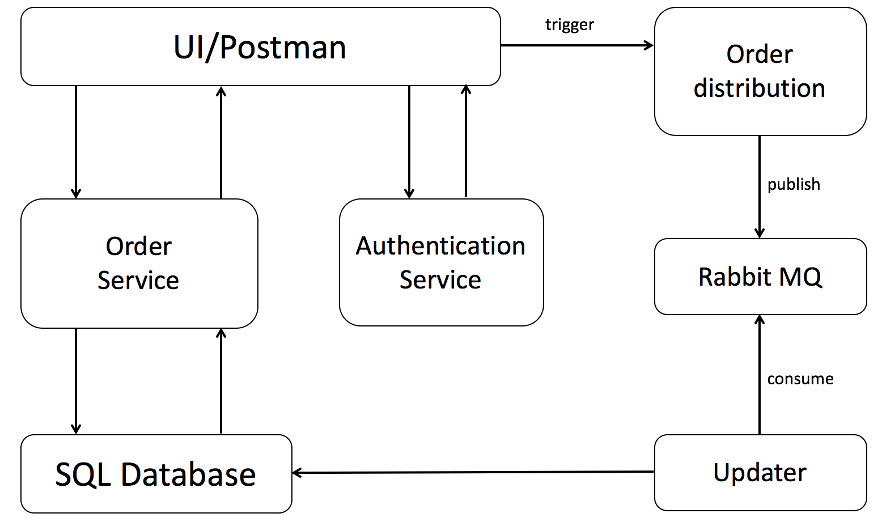

1. **Use h2 SQL database with three tables:**
2. Restaurant info and menu
3. User info
4. Order info
5. **Payment error is handled under both order service and authentication service.**
6. If order is not qualified, return error.
7. If payment is not valid, return error.
8. **Test cases:**
9. Test for order service.
   1. No such restaurant exists.
   2. Order without food.
   3. Valid order with food.
10. Test for order authentication.
    1. Invalid card information.
    2. Payment declined from bank.
    3. Authentication successful.