服务器的方方面面 - Websocket

一、维基定义

websocket是html5开始提供的一种浏览器与服务器间进行全双工通讯的网络技术。

演示：http://www.websocket.org/echo.html

二、简化

Websocket是一个协议。服务器提供了有众多的服务（比如web, ftp, ssh, smtp等），每个服务有自己的端口和通讯协议。

三、Websocket原理

http协议 -> 长短连接 -> websocket协议

1. http协议

request_line\r\n

headers(1,n)\r\n

\r\n

request_body

> telnet localhost 80

1、simple

GET / HTTP/1.1

HOST: 192.168.1.1

2、Content-Length

GET /test.php HTTP/1.1

HOST: 192.168.1.1

Content-Length: 10

chat=hello

3、Transfer-Encoding: chunked

GET /test.php HTTP/1.1

HOST: 192.168.1.1

Transfer-Encoding: chunked

a

chat=hello

3

x=y

0

1. 改进http

* 不会断开连接，即保持长连接

* 只发送一次请求头

* 服务器向相关客户端推送响应内容（跟业务相关）

1. websocket协议

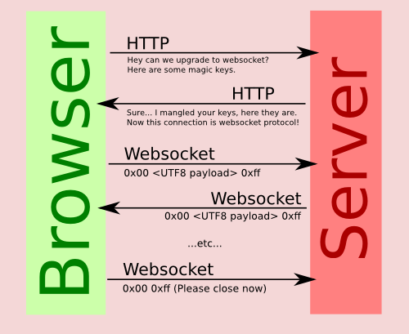

handshake + frame

客户端发起握手 -> 服务器响应握手

客户端发请求内容 -> 服务器处理响应请求

客户端发请求内容 -> 服务器处理响应请求

GET /?encoding=text HTTP/1.1

Host: echo.websocket.org

Sec-WebSocket-Version: 13

Sec-WebSocket-Key: 1xTNVL4QSMCgGbzZjWdXUw==

Upgrade: websocket

HTTP/1.1 101 Web Socket Protocol Handshake

Upgrade: WebSocket

Connection: Upgrade

Sec-WebSocket-Accept: w60L3GAaAnJKHMm8Uc+JqjuYYGc=

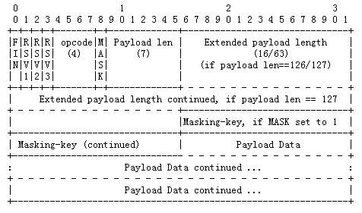

实现(php版)

**/* handshake */**

$accept_key = $headers['Sec-Websocket-Key'] . '258EAFA5-E914-47DA-95CA-C5AB0DC85B11';

$accept_key = sha1($accept_key, true);

$accept_key = base64_encode($accept_key);

header("Status: 101 Switching Protocols");

header("Upgrade: WebSocket");

header("Sec-WebSocket-Accept: $accept_key");

header("Expires: Thu, 01 Jan 1970 00:00:01 GMT");

header("Cache-Control: no-cache, no-store, must-revalidate");

**/* unmask frame */**

function unmask($payload) {

$length = ord($payload[1]) & 127;

if($length == 126) {

$masks = substr($payload, 4, 4);

$data = substr($payload, 8);

} elseif($length == 127) {

$masks = substr($payload, 10, 4);

$data = substr($payload, 14);

} else {

$masks = substr($payload, 2, 4);

$data = substr($payload, 6);

}

$text = '';

for ($i = 0; $i < strlen($data); ++$i) {

$text .= $data[$i] ^ $masks[$i%4];

}

return $text;

}

**/* response encode text */**

function encode($text)

{

// 0x1 text frame (FIN + opcode)

$b1 = 0x80 | (0x1 & 0x0f);

$length = strlen($text);

if($length <= 125) {

$header = pack('CC', $b1, $length);

} elseif($length > 125 && $length < 65536) {

$header = pack('CCS', $b1, 126, $length);

} elseif($length >= 65536) {

$header = pack('CCN', $b1, 127, $length);

}

return $header . $text;

}

4、js api

