Aditya Pandit

[Email address]

Abstract

[Draw your reader in with an engaging abstract. It is typically a short summary of the document.   
When you’re ready to add your content, just click here and start typing.]

TTL Privacy Application

[Document subtitle]

**ABSTRACT**

Communication is the basic need of today’s world. With the evolution of internet, the end to end point communication using various electronic means is no longer safe, the hackers are always in search of a weak point in the system to make use of it. Eavesdropping and man in the middle attack is quite common nowadays to prevent it we came with the idea of TTL (Time to Live).

The basic idea of **Time to Live Privacy Application (TTL)** is to develop a secret means of communication between its users to maintain integrity and confidentiality of the message. TTL is one of its kind of messenger that overcomes the problem of safe communication by using a unique algorithm of time to live for the messages.

**INTRODUCTION**

TTL gives its users an alternate means of communication or transfer of information between its users. With the help of TTL a secret portal on the server will be created by the users for the other users in whose name will be a combination of alphabets and numerals that will be shared by the creator to only the people with whom he wants to communicate.

The list of all the available portals will be displayed on the page and user can see all the portals will be there but the user will be able to access only them which he is granted access for. Its integrity is maintained, and each user will get a limited number of chances to access the portal as it is having a count how many times it can be accessed which is decided by the creator and the time to live after which the portal will be destroyed. With the help of number of counts of users who can access the portal that to for a specified period the integrity and confidentiality can be maintained.

IT overcomes the problem of hacking or man in the middle attack as it uses a unique combination of portal name and password without which one cannot access the message. So, this way only the user who is authorised to access the message can read the message.

**Project Timeline and Role Designations**

We divided the project basically into 6 phases they are-

* **Phase 1:** Studying the feasibility and past development in this field to be Completed in 15 days.
* **Phase 2:** Select the user and selecting the target audience, features and studying conventional sources of communication. Taking the best out of them to be completed in 25 days.
* **Phase 3:** Designing the framework and functionality of the project to be Completed in 35 days from the start.
* **Phase 4:** Start working on the designing and coding of the project to be completed in 60 days from the start.
* **Phase 5:** Design and evaluation of test cases with a handful of users(students) to study the shortcomings and pitfalls for the project to be completed in 75 days from the start.
* **Phase 6: F**inal evaluation and presentation of the project with proper documentation and step by step evaluation to be presented in 90 days from the start.
* **Frontend (UI Design)**: Satyajit Deshmukh

Designing HTML page for TTL Privacy Application using Handlebar, jQuery and Mustache.js

* **CSS, Bootstrap, HTML** – Adtiya Aditya
* **Backend Authentication/ Database Calls**: Aditya Pandey

Minimal frontend authentication, backend Authentication, server calls using ajax and express.js framework for the backend

* **Overall Work Flow/ Conceptual Design:** Aditya Aditya/ Satyajit Deshmukh.
* **Documentation and Presentations:** Aditya Aditya

**Related Work and Background**

We basically made use of the previous research in the field of HCI and Security and came up with a few research papers that are related to our idea. The research papers that helped us in the improvising the idea of TTL are-

* Humans in the loop: human-computer interaction and security.

This research paper gave us an idea how security is lagging in the field of HCI and what improvements can be made.

* Secure Snaps: A New Forward Secrecy Cryptosystem for Self-Destructing Messages in Mobile Services.

This was one of the nearest idea to our project and described how the snapchat was having a lot of security flaws in it and how the concept of time to live for a message came into existence and it’s uses.

* HCI and security systems.

This research paper deals how humans are the weakest link in any system considering the security aspect of the system and how can we improve in that.

* Human-Computer Interaction and Visualization

This research paper gave us an idea how good visualization can help us to improve on flaws and build a transparent system to overcome the flaws.

**Proposed System**

We designed a basic system outline first with the basic functionality of the system and improvised on it over the stages to help us combat the challenges and finally came up with the following system described in the Activity Flow Diagram below.

-----------IMAGE

* As we can see in the activity flow diagram above diagram the user gets to the portal and on the welcome page he has two choices either to create a new user or login in his account.
* The user can navigate to the register page and register himself as the new user and can come back to the login page to login to the website.
* As the user login he gets to the Dashboard page where he basically has three choices Access Portal, create a Portal, Show Your Portal Information.
* With Access portal he can see the list of available portals and can access the secret message that was for him by providing the proper credentials before the time to expire of the portal and exhausting the number of accesses that the creator of the portal has permitted.
* Create a portal option leads us to the portal creation page where the user can create the portal defining the time to live for the portal and limiting the number of users that can access the message by defining it here. It is basically the defining phase for the portal where the message will be posted and leads to the success page and ultimately is navigated to the dashboard.
* Show your portal information option gives us the details of the portals created by the user on hovering over the option. The information consists of the time remaining for the portal to expire and number of accesses left for it and who all have accessed the portal.
* The last is the logout option which will direct the user back to the navigation page.

**Methodology and Approach**

This involves the step by step tour of the application and where each page lead us to and what we can do at each step is involved in this phase.

**The Welcome Page**

The welcome page or navigate to TTL page is the first page we encounter on logging in to the application from where user has basically two choices to navigate to –

* Create User -To create new user.
* Login it is basically for the existing user to login- The user must provide his username and password to login the portal which will be verified with the database with which he registered on the time of registration as a user before providing him the access to the Dashboard page.

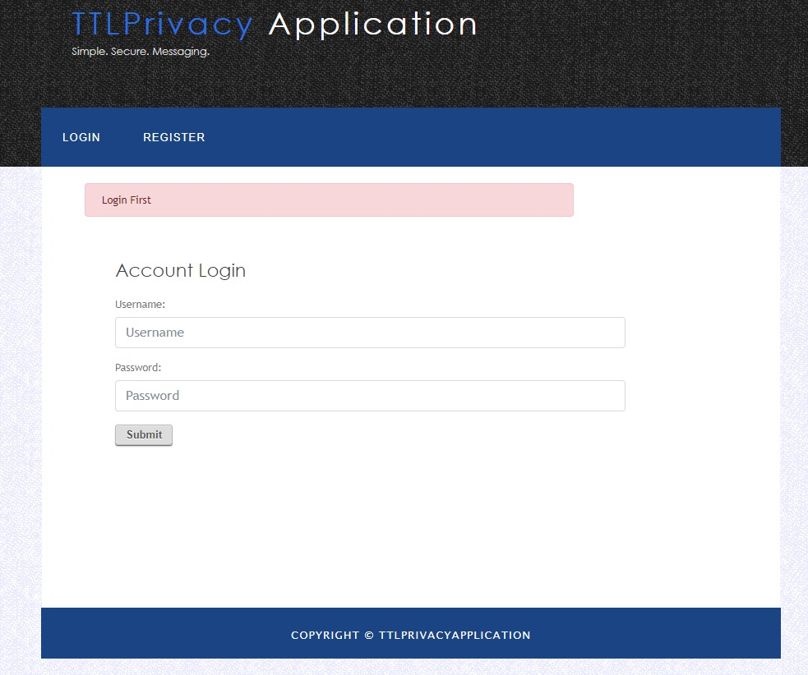

**Create User Page**

In this page the user can register himself as a new user. For the new user to create his account the user has to provide his Name, Username, password and confirm password. On this page there is a server side as well as front end verification taking place for a valid email and password, in case the user enters a wrong field the user has to enter all the details again in order to register himself again. On clicking the submit detail the new user will be registered, and we can check for it’s details in the database and the user is directed to the main dashboard page again from where he can login as an existing user.

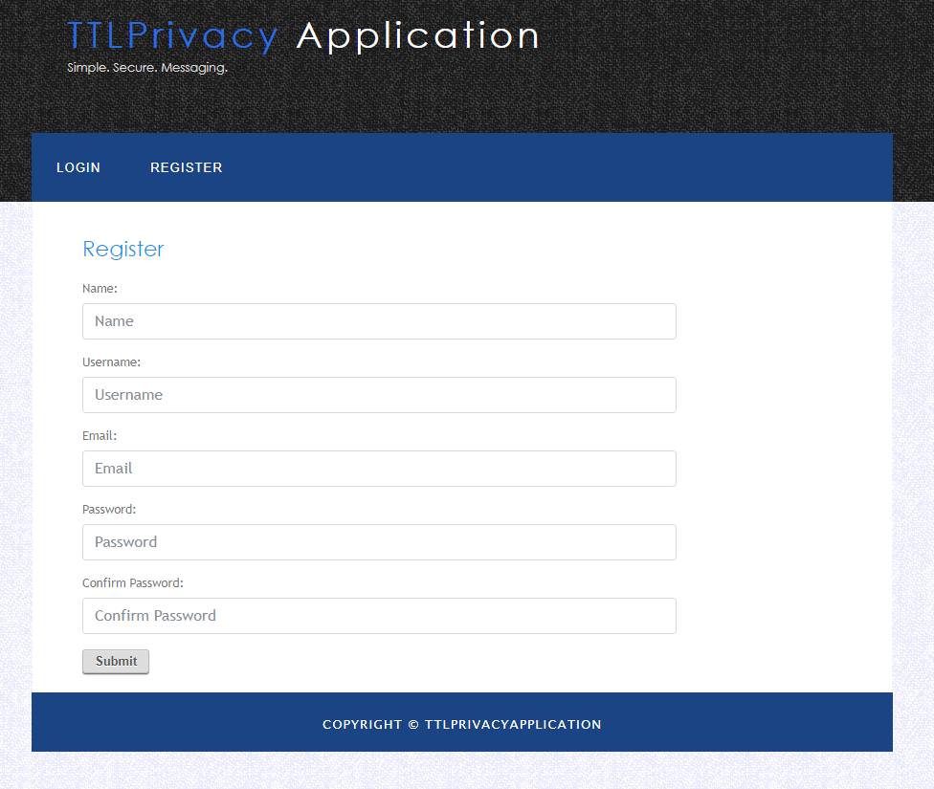

**Dashboard Page**

The Dashboard page he is welcomed with ‘Welcome to the Dashboard page’ that is the main page from where the user can decide what he has to do. As soon as the user gets to this page he has following options available with him-

* Create a New Portal- To create a new portal.
* Show All Available Portals- To get the list of all available portals.
* Show Your Portal Information- To get the information about the portals user created.
* Logout- This button is used to logout of the application for the user and directs him to the welcome page.

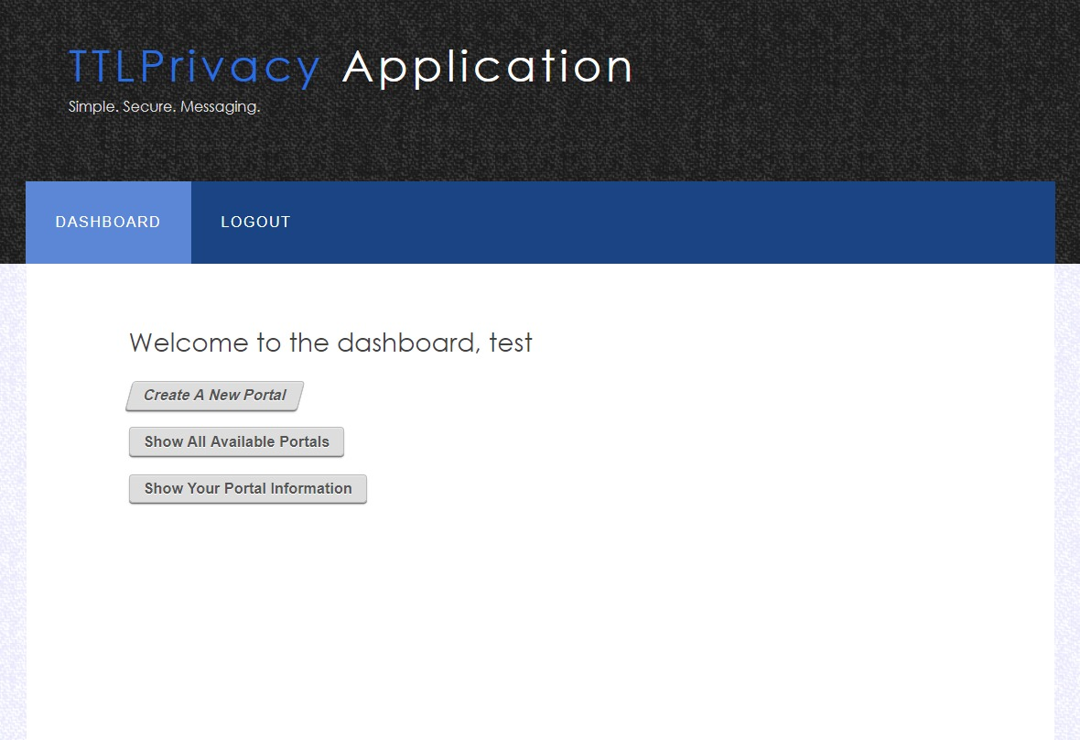

**Create a New Portal**

This is the page where user can create a new portal. The user must provide the following information to create the portal-

* Portal name- This is the field where the user has to give a name to the portal which will be used to access it, which a combination of characters and the user can enter any name of his choice that can be a combination of alphabets, integers or any special character so the user has n choices to name the portal. The poral name is case sensitive.
* Portal Password- In this field the user has to set the password which will be used to access the portal by the users and read the message. The password is case sensitive it is 8-16 characters long and may consists of upper case, lower case, integers or special characters.
* Confirm Password- In this field the user has to again enter the password which he set in the Portal Password field. The value for both the fields must match for the successful creation of the portal.
* Expire Time (Time to Live) -In this field the user must enter the time for which the user wants to create the portal. The user must provide number of hours, minutes and seconds in this field. The portal will live for the specified period in this field. So, the user must enter the time it taking in consideration all the aspects because as soon as the time is over the portal will be destroyed.
* Message for the User- In this field the user enters the secret message which he wishes to transfer securely to the rightful people. In this field right now only, text can be entered which can be secret message like credit card details, password or bank details which are highly sensitive but in future we will try to improvise it to transfer media even.
* Portal User Count- In this field the user enters the number of people he wants to access the portal. There is nom limit to the number of users which the creator can enter but that will be the maximum number of users who can access the information. So, the user must enter it taking in consideration all the aspects because as soon as the visit reaches this number the portal will be destroyed.
* Submit – As soon as the user hits the submit button the portal will be created with following details for the particular period of time in case all the verifications are satisfied by the user and he will be directed to the dashboard again. In case user fails to satisfy any one all details will be gone, and the user has to enter all the details again to create the portal. 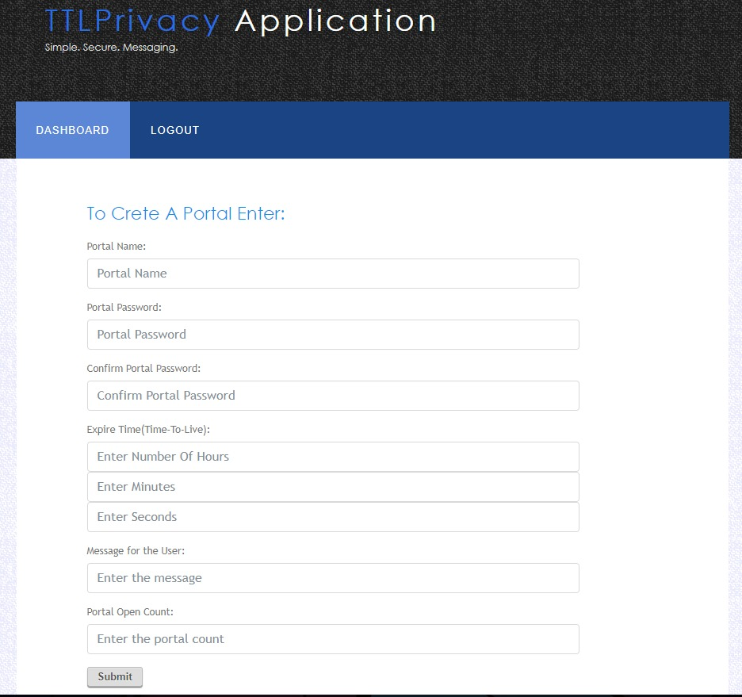
* **Show All Available Portals**

This link leads the user to the List of Portals page where the user can see all the alive portals available created on the application at that point of time. The user can choose from the list of portals which he has to access and click on that and a new window will open that will ask him for the authentication details to access the portal. The details the user must enter to access are-

* Portal Name- The user needs to enter the portal name set by the creator of the portal at the time of creation of the portal. The portal name is case sensitive and is verified on the server side to grant the user access to the portal.
* Password- The user is prompted to enter the password set by the creator of the portal which will also be validated on the server side.
* Confirm Password- the user is again asked to enter the password for double verification which will also be validated on the server side.
* Show me Button- This is the submit button and will show the message if all the above details are validated from server side upon submission of the above details right by the user.
* Refresh Button- The user can refresh the list of all available portals with this button.

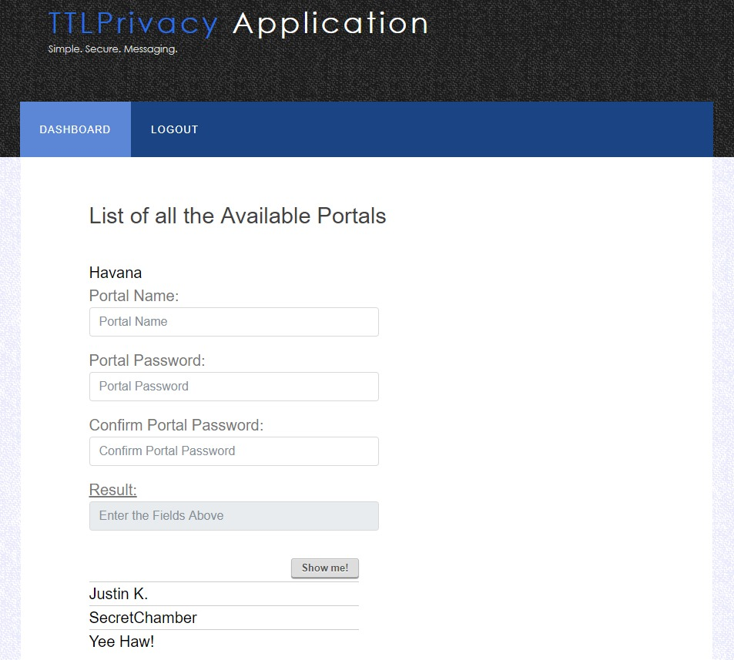

Upon successful validation of all the fields the Result will be displayed which will come out in the form of a Pop- Out Message with the secret message for the user and will also display the following details-

* Portal Created by- This field will contain the name of the creator of the portal that is the username of the creator.
* Portal Name- This field will display the name of the portal as designated by the creator.
* Message- This field will display the secret message for the user sent by the creator of the portal at the time of creation of portal.
* The Portal Will Expire in – This field will display the running time left for the portal to expire.
* Cross button – This will lead the user back to the Show All Available Portals page and will decrease the value of visits by one.

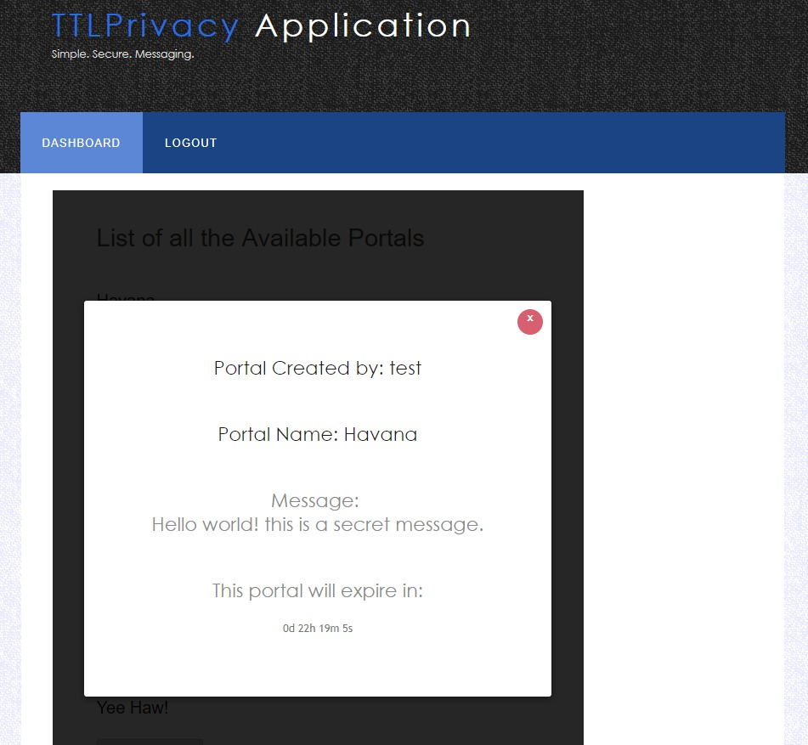

**Show Your Portal Information**

As Soon as we click this link the page will display the information about the portals created by the user and the name of the button will change to hide information which will contain the following information-

* Portal Name- The name of the portal created by the user.
* Portal Access Count Left- This field contains the number of counts left to access the portal at that particular point of time, it is a dynamic value continuously changing as soon as someone accesses the portal.
* Life- This field displays the time left for the portal to die that is the time tat is left after which the portal will vanish, , it is a dynamic value continuously changing with the passage of time.
* Visited List- This field will contain the list of all the users that had visited the portals created by the user and will also contain the following information-
* Username- this specifies the name of the user who have accessed the portal.
* Email- This field will specify the email of the user who have accessed the portal.
* Number of times visited- This field will show the number of counts the particular user has accessed the portal.

**The Different Phases in Development**

* **Phase 1:** Studying the feasibility and past development in this field.
* **Phase 2:** Select the user and selecting the target audience, features and studying. Taking the best out of conventional Sources.
* **Phase 3:** Designing the framework and functionality of the project.
* **Phase 4:** Start working on the designing and start coding of the project.
* **Phase 5:** Design and evaluation of test cases with handful of users and collect their responses.
* **Phase 6:** Final evaluation and presentation of the project.

**Experimental and Evaluation Plan**

* We used the Natural Settings involving users approach to evaluate the project.
* In this we choose 17 users who created different portals and tried to access the messages and creation of portal.
* Some users tried to access the portals they don’t have access rights and will tried to distort the messages.
* User Survey link to study the response towards TTL- <https://docs.google.com/forms/d/1tKx48Qep8Z4T2GwBirNYS_UY6CdKo-cteXek_DpTSRk/edit?ts=5a1cf1df>.

**The Questions in Google survey were**-

* Email – The Email of the user.
* First Name and Last Name.
* Have you ever used any application like this?
* You need to transfer your bank account details to your family or friends what you will use? (select all which apply).
* Rate User interface.
* Rate Functionalities of the product.
* Report number of bugs or problems faced.
* What do you think of our product? And, does our product solve your problem?
* How likely are you to tell your friends and family about our product?
* Any important feature we should add besides already added features?

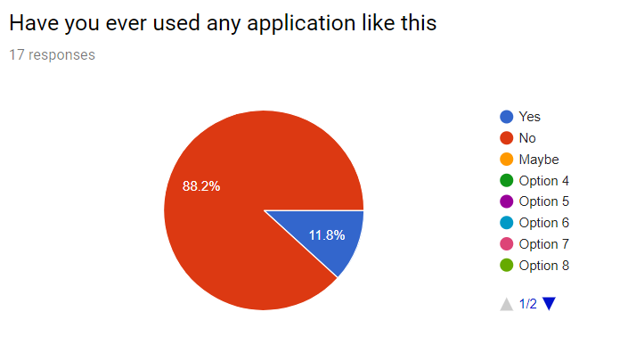

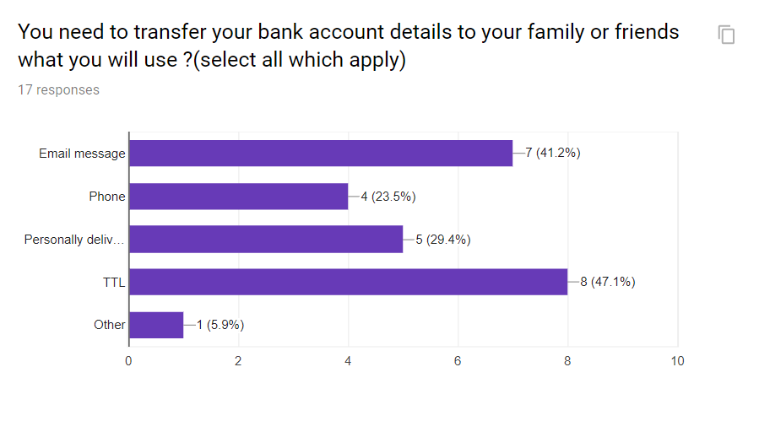

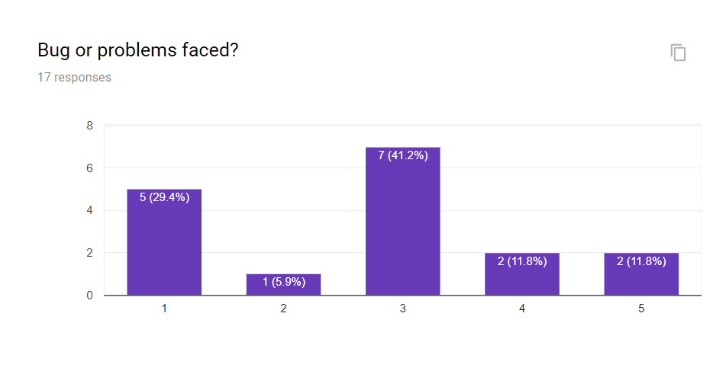

**Discussion and Future Work**

* There is a wide scope for this application in near future with the increase in number of Cyber-attacks to securely transfer the confidential and sensitive information.
* In future we can add functionality to transfer images and multimedia and files. As of now we are only transferring the text data but there is a scope to add functionality to transfer the multimedia files.
* In the current scenario it is a desktop application but in near future we can get it for mobile devices such as smartphones and tablets. As now a days mobile devices are the need of hour so we will be trying to develop it as a smart phone application across various platforms such as IOS, Android and Windows.