Sasha Boulgakov

Annie Chin

Kevin Lo

Running our program for N=1, 10, 20, we got the following results for

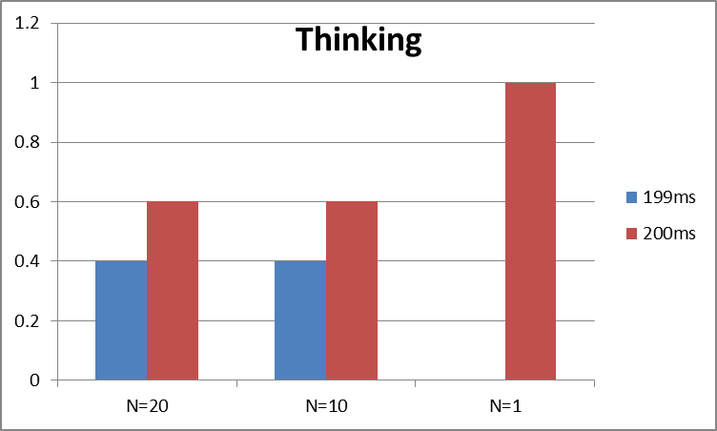

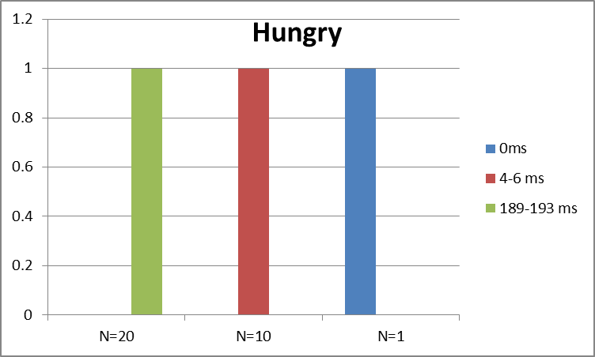

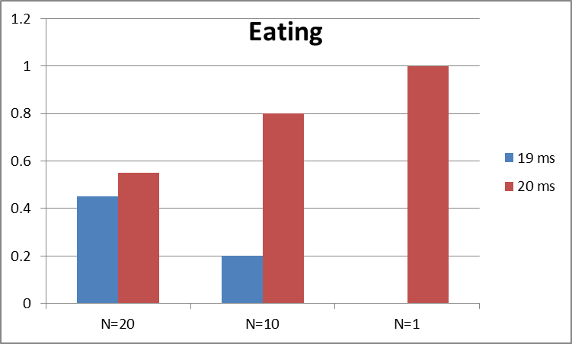

The stats for N=1, 10, 20 are printed below. Note that for all three cases, the thinking time and eating time distributions are the same; this is something that doesn't change with the value of N. Hungry times, however, are very dependent on the number of clients, since the waiting time increases if there is a high demand for a single token.

--- Stats for N=1 clients ---

Client 0's avg thinking time: 200 ms

Client 0's avg hungry time: 0 ms

Client 0's avg eating time: 19 ms

--- Stats for N=10 clients ---

Client 0's avg thinking time: 199 ms

Client 0's avg hungry time: 4 ms

Client 0's avg eating time: 20 ms

Client 1's avg thinking time: 199 ms

Client 1's avg hungry time: 5 ms

Client 1's avg eating time: 19 ms

Client 2's avg thinking time: 199 ms

Client 2's avg hungry time: 6 ms

Client 2's avg eating time: 19 ms

Client 3's avg thinking time: 199 ms

Client 3's avg hungry time: 5 ms

Client 3's avg eating time: 20 ms

Client 4's avg thinking time: 200 ms

Client 4's avg hungry3 time: 5 ms

Client 4's avg eating time: 20 ms

Client 5's avg thinking time: 200 ms

Client 5's avg hungry time: 4 ms

Client 5's avg eating time: 20 ms

Client 6's avg thinking time: 200 ms

Client 6's avg hungry time: 6 ms

Client 6's avg eating time: 19 ms

Client 7's avg thinking time: 199 ms

Client 7's avg hungry time: 6 ms

Client 7's avg eating time: 20 ms

Client 8's avg thinking time: 199 ms

Client 8's avg hungry time: 7 ms

Client 8's avg eating time: 20 ms

Client 9's avg thinking time: 200 ms

Client 9's avg hungry time: 4 ms

Client 9's avg eating time: 19 ms

--- Stats for N=20 clients ---

Client 0's avg thinking time: 199 ms

Client 0's avg hungry time: 188 ms

Client 0's avg eating time: 19 ms

Client 1's avg thinking time: 200 ms

Client 1's avg hungry time: 189 ms

Client 1's avg eating time: 19 ms

Client 2's avg thinking time: 200 ms

Client 2's avg hungry time: 188 ms

Client 2's avg eating time: 20 ms

Client 3's avg thinking time: 199 ms

Client 3's avg hungry time: 189 ms

Client 3's avg eating time: 19 ms

Client 4's avg thinking time: 199 ms

Client 4's avg hungry time: 188 ms

Client 4's avg eating time: 19 ms

Client 5's avg thinking time: 199 ms

Client 5's avg hungry time: 188 ms

Client 5's avg eating time: 20 ms

Client 6's avg thinking time: 199 ms

Client 6's avg hungry time: 188 ms

Client 6's avg eating time: 20 ms

Client 7's avg thinking time: 200 ms

Client 7's avg hungry time: 189 ms

Client 7's avg eating time: 19 ms

Client 8's avg thinking time: 200 ms

Client 8's avg hungry time: 190 ms

Client 8's avg eating time: 19 ms

Client 9's avg thinking time: 200 ms

Client 9's avg hungry time: 189 ms

Client 9's avg eating time: 19 ms

Client 10's avg thinking time: 199 ms

Client 10's avg hungry time: 190 ms

Client 10's avg eating time: 19 ms

Client 11's avg thinking time: 199 ms

Client 11's avg hungry time: 190 ms

Client 11's avg eating time: 20 ms

Client 12's avg thinking time: 199 ms

Client 12's avg hungry time: 191 ms

Client 12's avg eating time: 19 ms

Client 13's avg thinking time: 198 ms

Client 13's avg hungry time: 191 ms

Client 13's avg eating time: 19 ms

Client 14's avg thinking time: 200 ms

Client 14's avg hungry time: 190 ms

Client 14's avg eating time: 20 ms

Client 15's avg thinking time: 199 ms

Client 15's avg hungry time: 192 ms

Client 15's avg eating time: 20 ms

Client 16's avg thinking time: 200 ms

Client 16's avg hungry time: 191 ms

Client 16's avg eating time: 20 ms

Client 17's avg thinking time: 200 ms

Client 17's avg hungry time: 190 ms

Client 17's avg eating time: 19 ms

Client 18's avg thinking time: 199 ms

Client 18's avg hungry time: 191 ms

Client 18's avg eating time: 20 ms

Client 19's avg thinking time: 199 ms

Client 19's avg hungry time: 192 ms

Client 19's avg eating time: 19 ms