* High strategic flexibility (SF > 6.25) with high technological turbulence (TT > 3) [20 samples] (19 samples as HIGH)

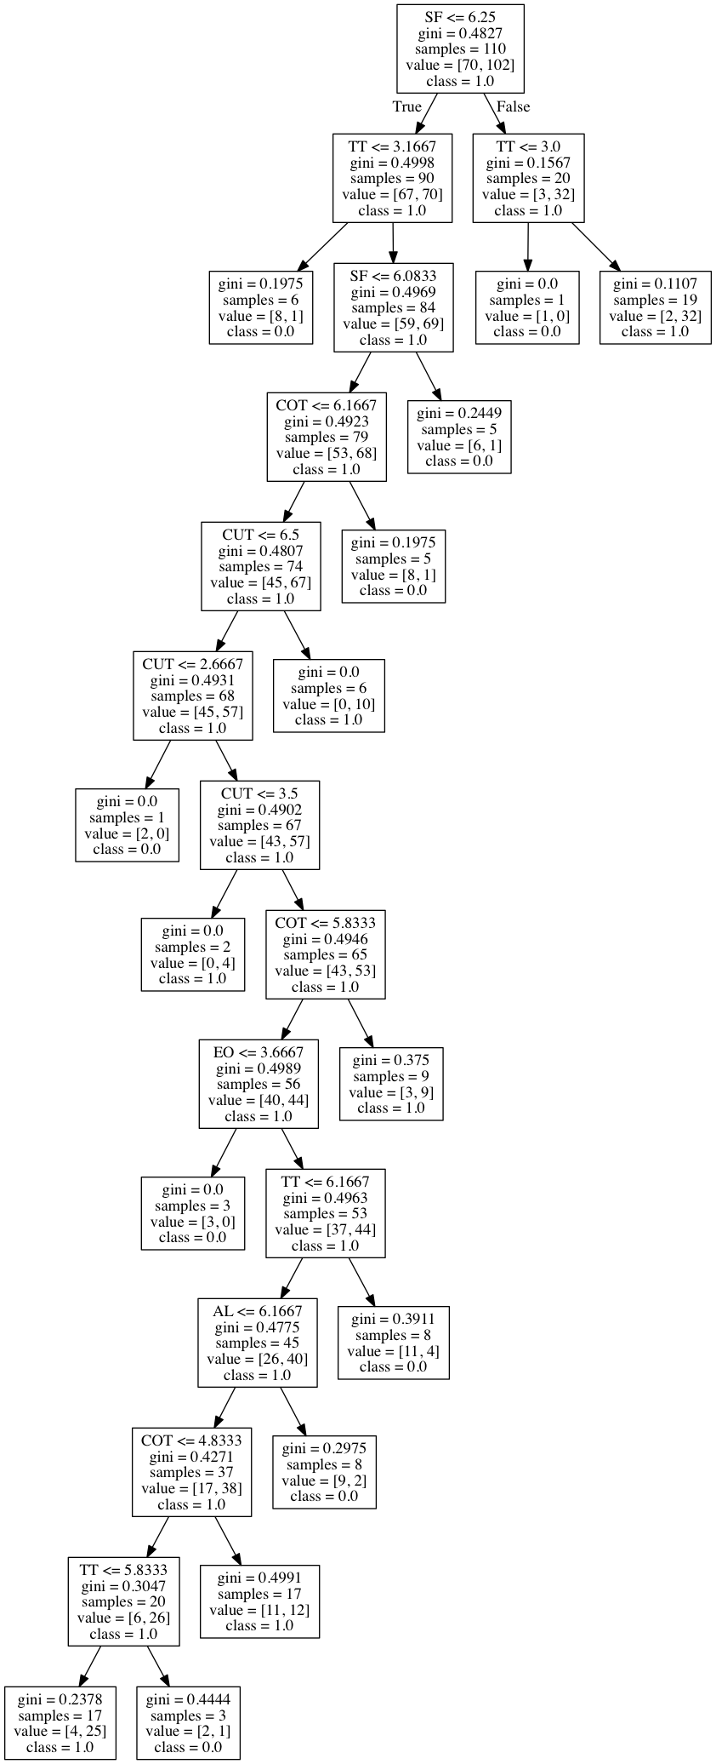

* Highly entrepreneurial organization [EO > 5.3] with high competitor turbulence (COT > 3.1) and high customer turbulence (CUT > 5.1)  
  (these conditions classify 6 samples as HIGH and 21 as LOW and only work if AD < 6.8, otherwise 17 samples are HIGH)
* [or] Lower entrepreneurial orientation (EO < 4.7) negatively influences organizational growth (the var we predict) unless the alignment is high (AL > 5.8)

(These conditions only work if AD < 6.8, CUT > 3.1, and in this case AL doesn’t affect result If EO is < 4.7)

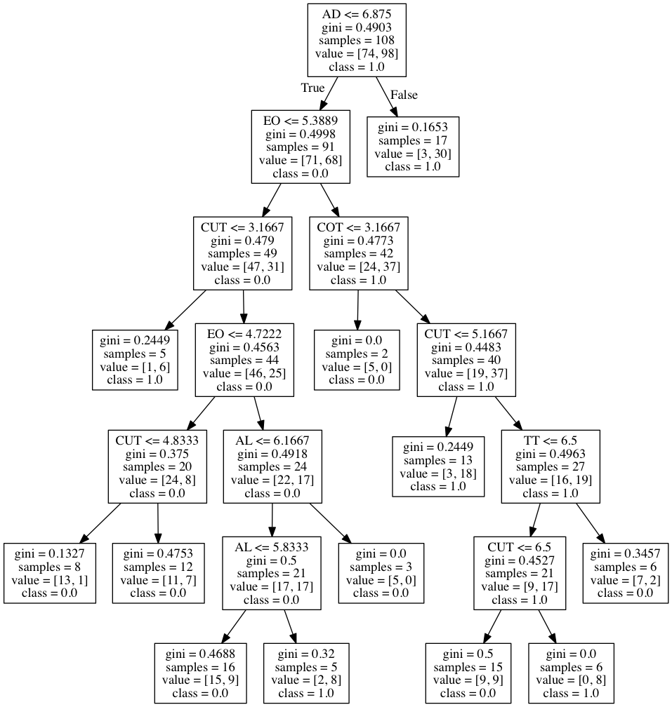

* High customer turbulence (CUT > 5.8) and high technological turbulence (14 samples classified as HIGH)
* [or] High customer turbulence (CUT > 5.8) and high alignment (AL > 4.8) (21 as high, 2 as LOW)
* [or] High adaptability (AD > 4.3) and high strategic flexibility (SF > 4.9) unless competitor turbulence is too high (COT > 3.6) (1 as unknown, 18 as HIGH, 21 as LOW)

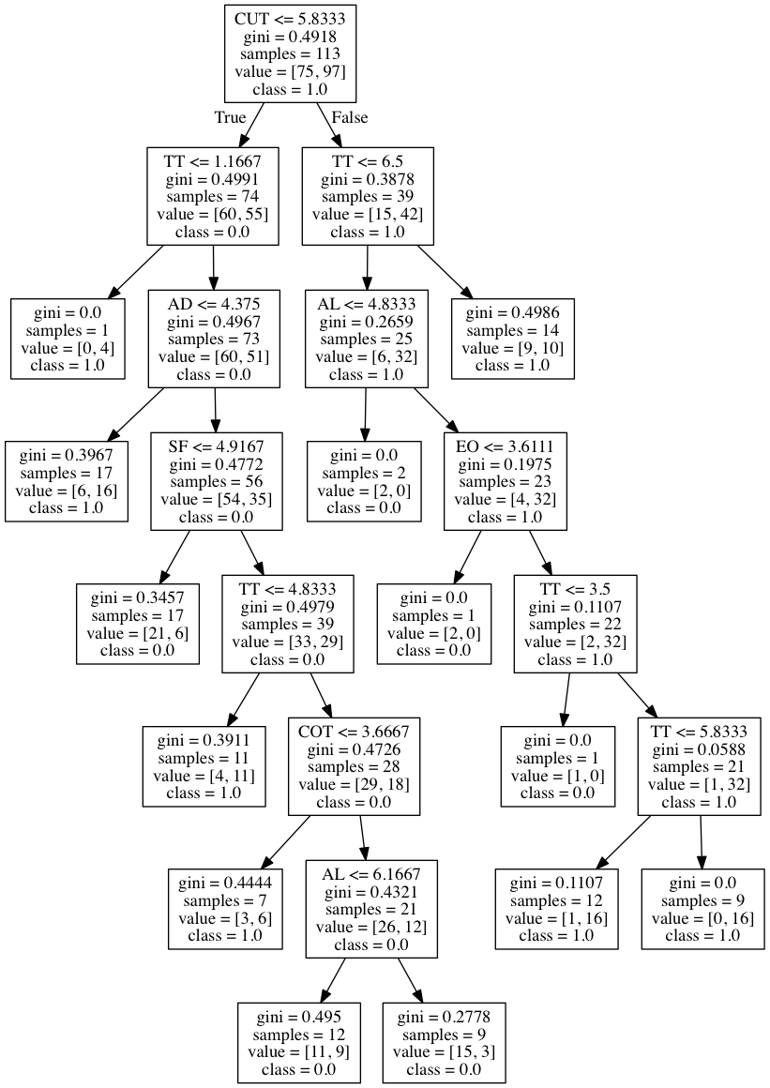

* High customer turbulence (CUT > 5.8) and very high alignment (AL > 6.8)
* High customer turbulence (CUT > 3.1) and lower adaptability (<= 6.8) with lower strategic flexibility (SF <= 4.9) negatively influences organizational growth (the var we predict)
* High customer turbulence (CUT > 3.1) and lower adaptability (<= 6.8) with higher strategic flexibility (SF > 4.9) positively influences organizational growth (the var we predict) unless the technological turbulence (TT) is too high (> 4)

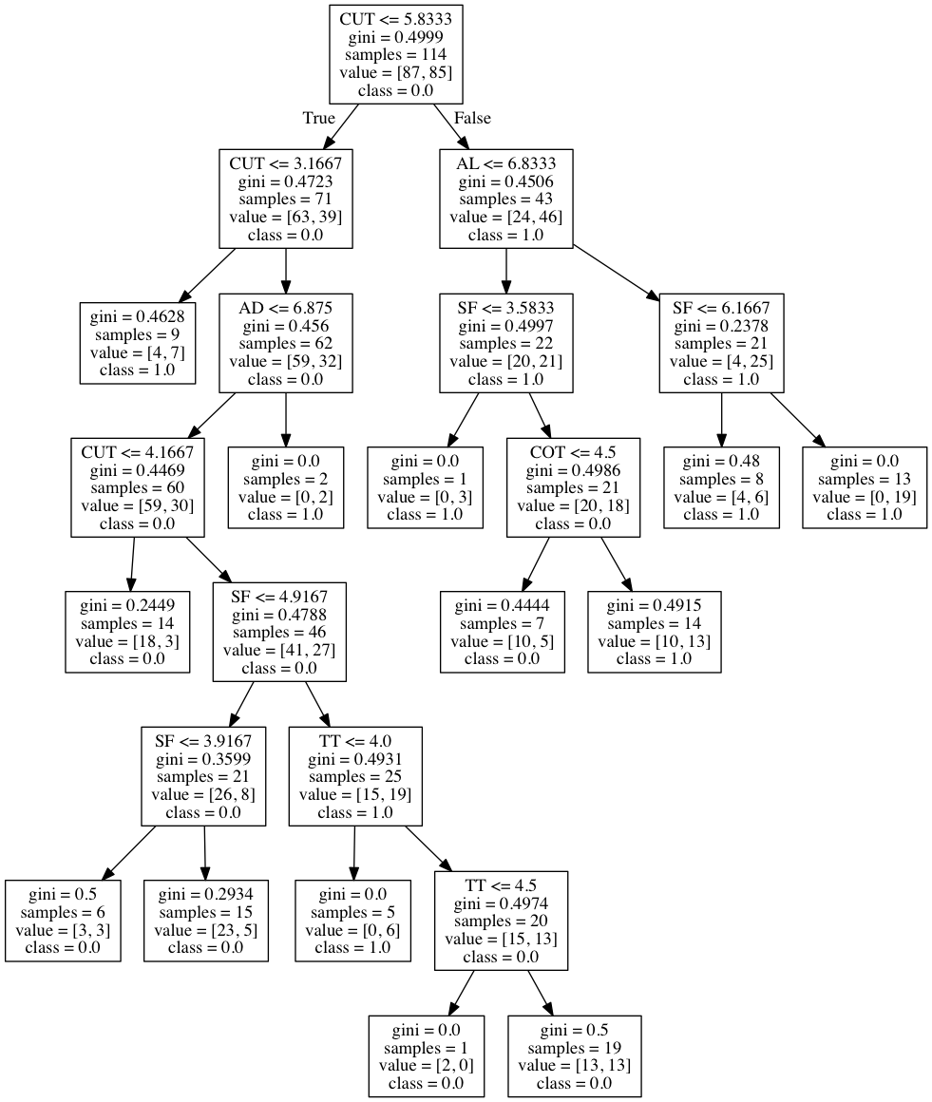

* Organizations that are not very entrepreneurial (EO <= 5.5) while competitor turbulence is high (COT > 5.1) are not likely to exhibit high growth (the var we predict)
  + The growth is likely with competitor turbulence being lower (COT <=5.1)
  + 