Grit and Self-control Measures IRB

Below are four statements, each followed by two questions. The questions concern how often and how deeply/strongly you experience what is described in the statement. Please answer both questions after each statement by circling numbers from 1 to 7.

**1. I experience inspiration.**

1a. How often 1 2 3 4 5 6 7

does this happen? never very often

1b. How deeply or 1 2 3 4 5 6 7

strongly (in general)? not at all very deeply

or strongly

**2. Something I encounter or experience inspires me.**

2a. How often 1 2 3 4 5 6 7

does this happen? never very often

2b. How deeply or 1 2 3 4 5 6 7

strongly (in general)? not at all very deeply

or strongly

**3. I am inspired to do something.**

3a. How often 1 2 3 4 5 6 7

does this happen? never very often

3b. How deeply or 1 2 3 4 5 6 7

strongly (in general)? not at all very deeply

or strongly

**4. I feel inspired.**

4a. How often 1 2 3 4 5 6 7

does this happen? never very often

4b. How deeply or 1 2 3 4 5 6 7

strongly (in general)? not at all very deeply

or strongly

Key for the Inspiration Scale:

Inspiration frequency subscale: sum of items 1a, 2a, 3a, 4a

Inspiration intensity subscale: sum of items 1b, 2b, 3b, 4b

Overall scale: sum of items 1a, 1b, 2a, 2b, 3a, 3b, 4a, 4b

Reference:

Thrash, T. M., & Elliot, A. J. (2003). Inspiration as a psychological construct. *Journal of Personality and Social Psychology, 84*, 871-889.

**Creative Activities Questionnaire (CAQ)***Instructions: Place a check mark beside the areas in which you feel you have more talent, ability, or training than the average person.( check all that apply):*

____ Visual arts (painting, sculpture)

____ Music

____ Dance

____ Individual sports (tennis golf)

____ Team sports

____ Architectural design

____ Entrepreneurial ventures

____ Creative writing

____ Humor

____ Inventions

____ Scientific inquiry

____ Theater and film

____ Culinary arts

1. *Place a check mark beside the sentences that apply to you*. *Next to sentences with an asterisk (*), write the number of times this sentences applies to you.*
   1. **Visual Arts**

__ 0. I have no training or recognized talent in this area.

__ 1. I have taken lessons in this area.

__ 2. People have commented on my talent in this area.

__ 3. I have won a prize or prizes at a juried art show.

__ 4. I have had a showing of my work in a gallery.

__ 5. I have sold a piece of my work.

__ 6. My work has been critiqued in local publications.

*__ 7. My work has been critiqued in national publications.

* 1. **Music Performance**

__ 0. I have no training or recognized talent in this area.

__ 1. I play one or more musical instruments proficiently.

__2. I have played with an organized musical group.

__ 3. I have played with a professional orchestra or band.

__ 4. My performance has been recorded.

__ 5. Recordings of my performance have been sold publicly.

__ 6. My musical talent has been critiqued in a local publication.

*__7. My performance has been critiqued in a national publication.

1. **Music Composition**

__ 0. I have never composed a piece of music.

__1. I contributed to the composition of an original work.

__ 2. I have composed one original piece of music.

__3. I have composed multiple original works.

__ 4. My composition has been recorded.

__ 5. Recordings of my composition have been sold publicly.

__6. My compositions have been critiqued in a local publication.

*__7. My compositions have been critiqued in a national publication.

* 1. **Dance**

**__** 0**.** I have no training or recognized talent in this area.

__ 1. I have danced to (or choreographed) an original dance number.

__ 2. My dancing or choreography has been performed publicly.

__ 3. I have danced with (or choreographed for) a recognized dance company.

__ 4. I have danced (or choreographed dance) professionally.

__5. My dance (or choreography) has won an award or awards.

__ 6. My dance (or choreography) abilities have been critiqued in a local publication.

*__ 7. My choreography has been critiqued by a national publication.

* 1. **Architectural Design**

__ 0. I do not have training or recognized talent in this area.

__ 1. I have designed an original structure.

__ 2. A structure designed by me has been constructed.

__ 3. I have sold an original architectural design.

__ 4. A structure that I have designed and sold has been built professionally.

__ 5. My architectural design has won an award or awards.

__ 6. My architectural design has been recognized in a local publication.

*__ 7.My architectural design has been recognized in a national publication.

* 1. **Creative Writing**

__ 0. I do not have training or recognized talent in this area.

__ 1. I have written an original short work (poem or short story).

__ 2. My work has won an award or prize.

__ 3. I have written an original long work (epic, novel, or play).

__ 4. I have sold my work to a publisher.

__ 5. My work has been printed and sold publicly.

__ 6. My work has been reviewed in local publications.

*__7. My work has been reviewed in national publications.

* 1. **Humor**

__ 0. I do not have recognized talent in this area.

__ 1. People have often commented on my original sense of humor.

__ 2. I have created jokes that are now regularly repeated by others.

__ 3. I have written jokes for other people.

__ 4. I have written a joke or cartoon that has been published.

__ 5. I have worked as a professional comedian.

__ 6. I have worked as a professional comedy writer.

__ 7. My humor has been recognized in a national publication.

* 1. **Inventions**

__ 0. I do not have recognized talent in this area.

__ 1. I regularly find novel uses for household objects.

__ 2. I have sketched out an invention and worked on its design flaws.

__ 3. I have created original software for a computer.

__ 4. I have built a prototype of one of my designed inventions.

__ 5. I have sold one of my inventions to people I know.

*__6. I have received a patent for one of my inventions.

*__7. I have sold one of my inventions to a manufacturing firm.

* 1. **Scientific Discovery**

__ 0. I do not have training or recognized ability in this field.

__ 1. I often think about ways that scientific problems could be solved.

__ 2. I have won a prize at a science fair or other local competitions.

__ 3. I have received a scholarship based on my work in science or medicine.

__ 4. I have been author or coauthor of a study published in a scientific journal.

__ 5. My work has been cited by other scientists in national publications.

*__ 6. I have won a national prize in the field of science or medicine.

*__ 7. I have received a grant to pursue my work in science or medicine.

* 1. **Theater and Film**

__ 0. I do not have training or recognized ability in this field.

__ 1. I have performed in theater or film.

__ 2. My acting abilities have been recognized in a local publication.

__ 3. I have been paid to act in theater or film.

__ 4. I have won an award or prize for acting in theater or film.

__ 5. I have directed or produced a theater or film production.

__ 6. I have been paid to direct a theater or film production.

*__7. My theatrical work has been recognized in a national publication.

* 1. **Culinary Arts**

__ 0. I do not have training or experience in this field.

__ 1. I often experiment with recipes.

__ 2. My recipes have been published in a local cookbook.

__ 3. My recipes have been used in restaurants or other public venues.

__ 4. My recipes have won a prize or reward.

__ 6. I have received a degree in culinary arts.

__ 5. I have been asked to prepare food for celebrities or dignitaries.

*__7. My recipes have been published nationally.

1. *Place a check mark beside sentences that apply to you*.

___ One of the first things people mention about me when introducing me to others is my

creative ability in the above areas.

___ People regularly comment on my “artistic” temperament.

___ People regularly accuse me of being an “absent-minded professor” type.

**Raven’s Matrices**

**These problems will get more and more challenging as you go along. There are 12 total, and you will have 15 minutes to complete (a little over one minute per problem.)  
  
In every problem you use the same method of working. You look along each row and decide what the missing figure might be like. You look down each column and decide again. Then look for the answer that is right in both ways, among the eight choices available. Please try to concentrate and solve the problem to the best of your ability.  
  
Try each problem in order and do your best to find the correct piece before going on to the next problem. If you get stuck, move on, and come back to the problem later.**

1

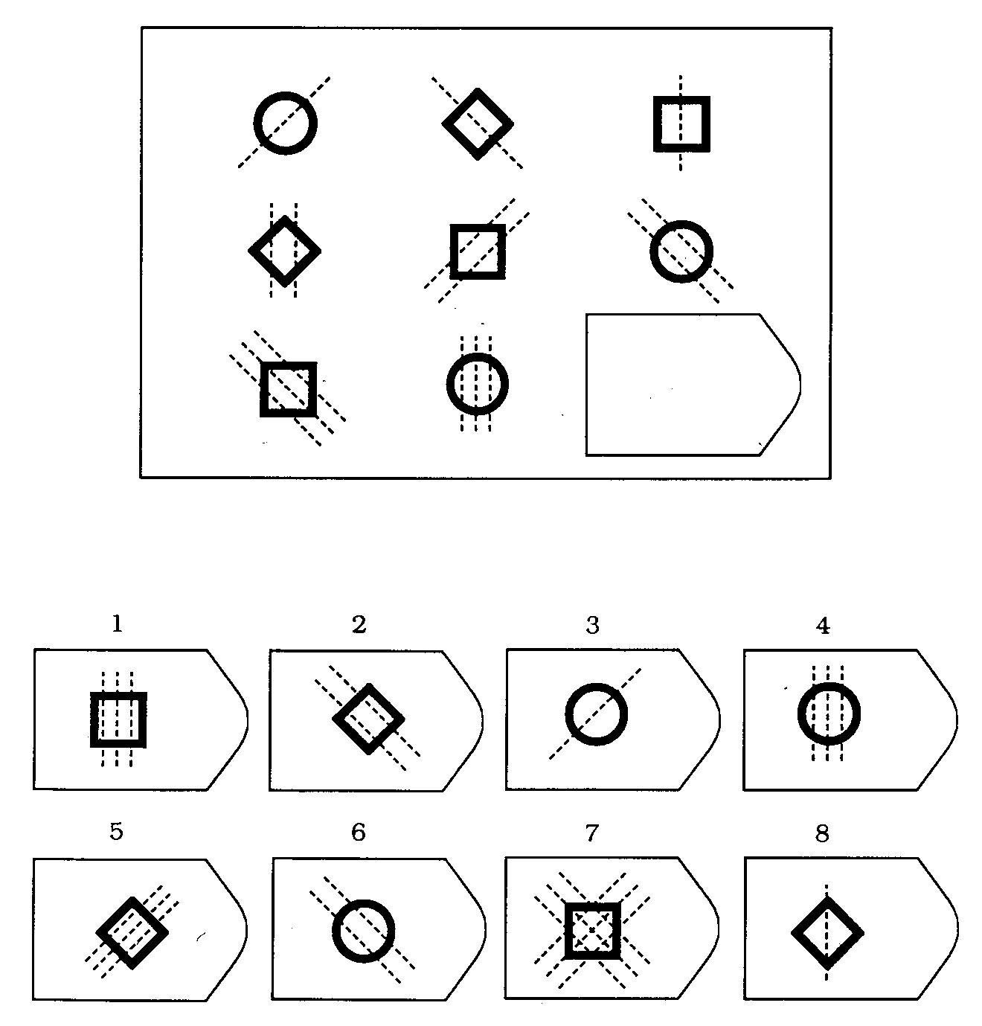

2

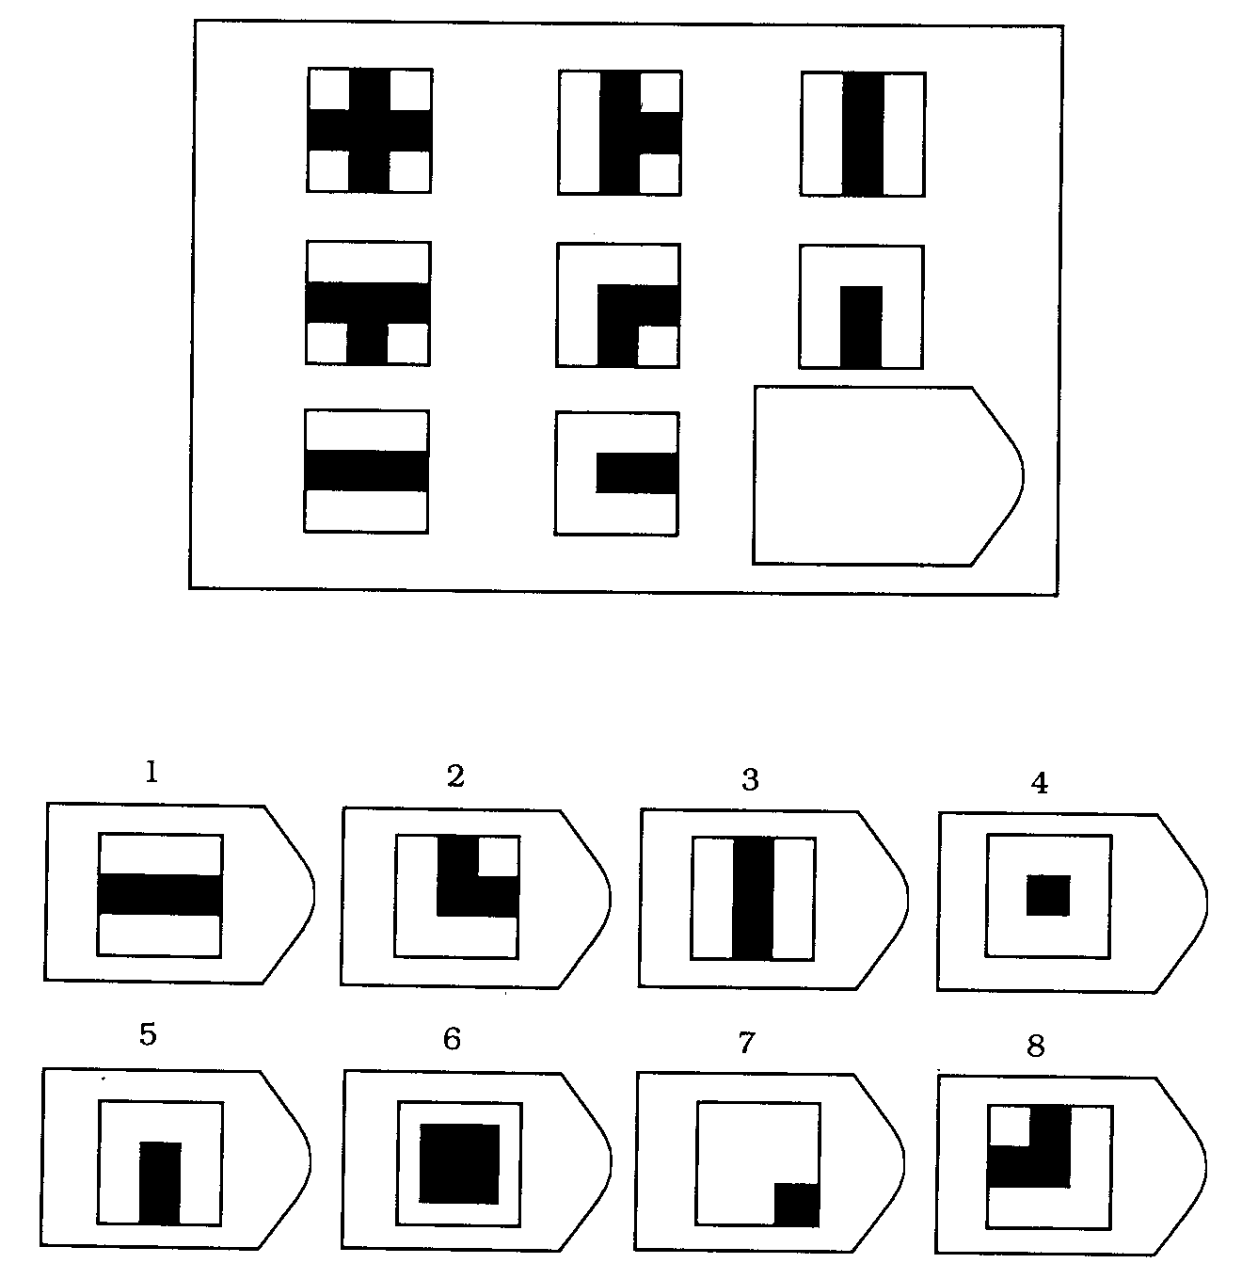

3

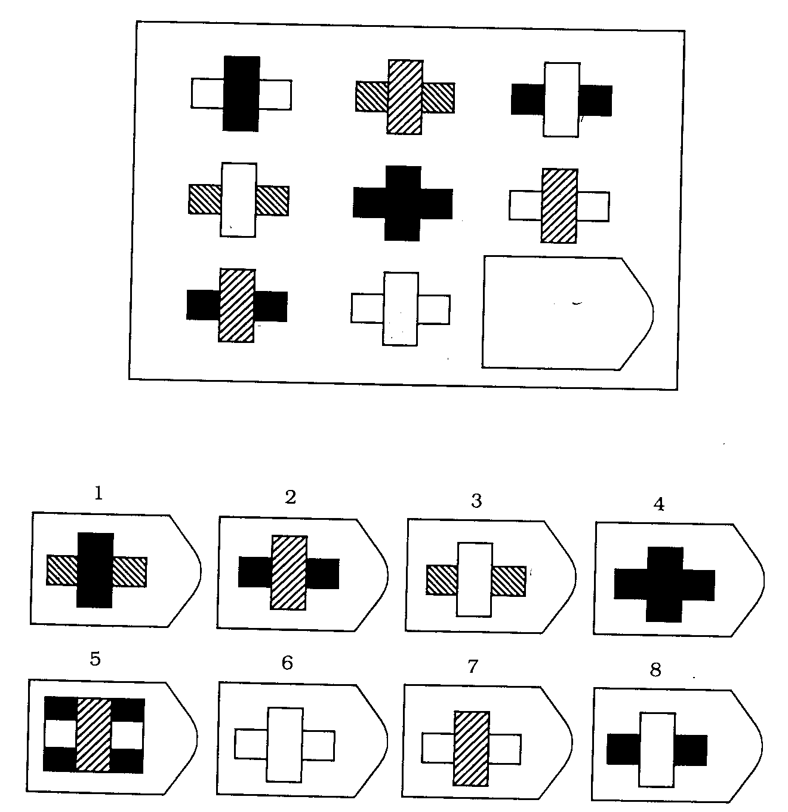

4

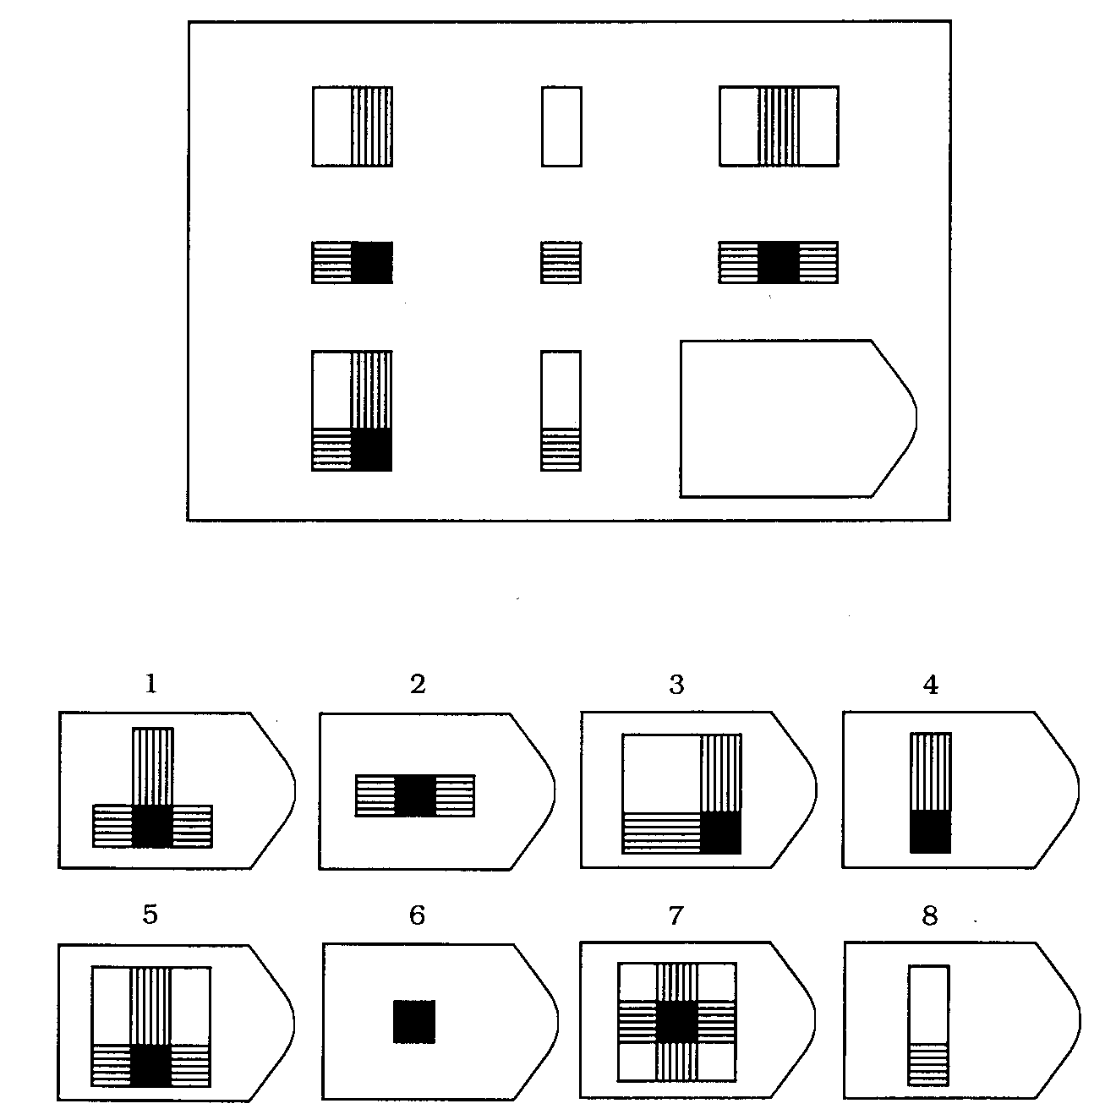

5

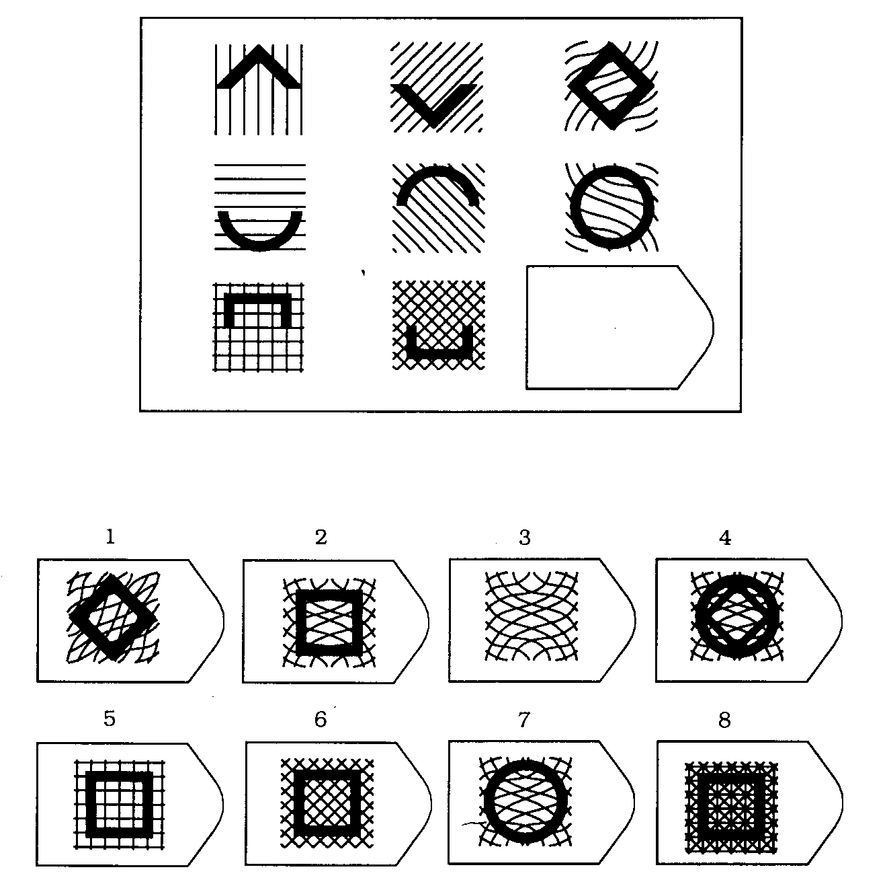

6

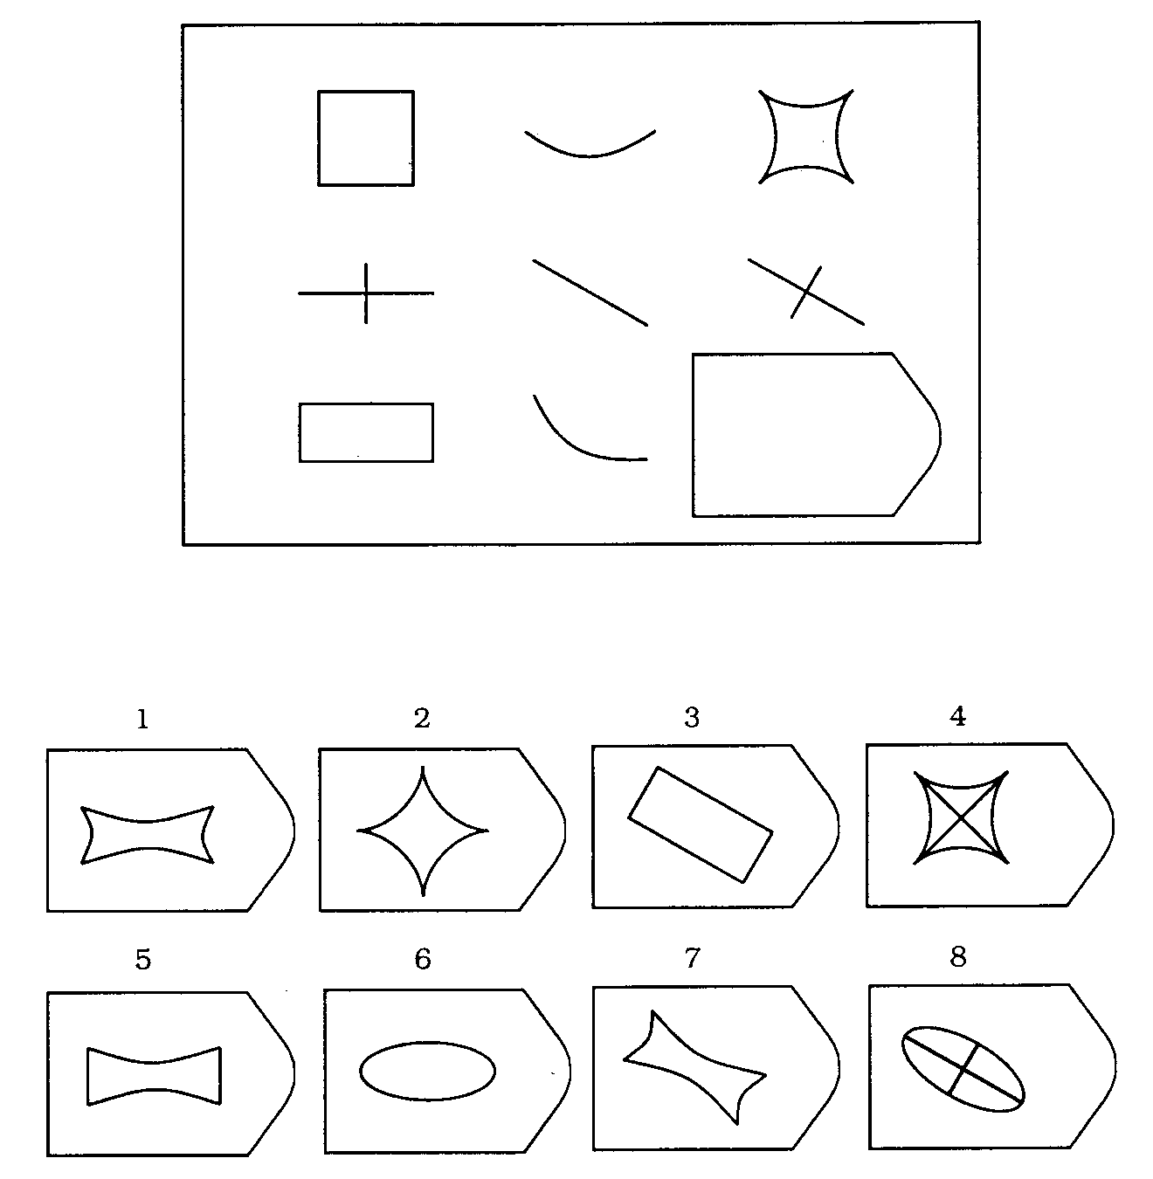

7

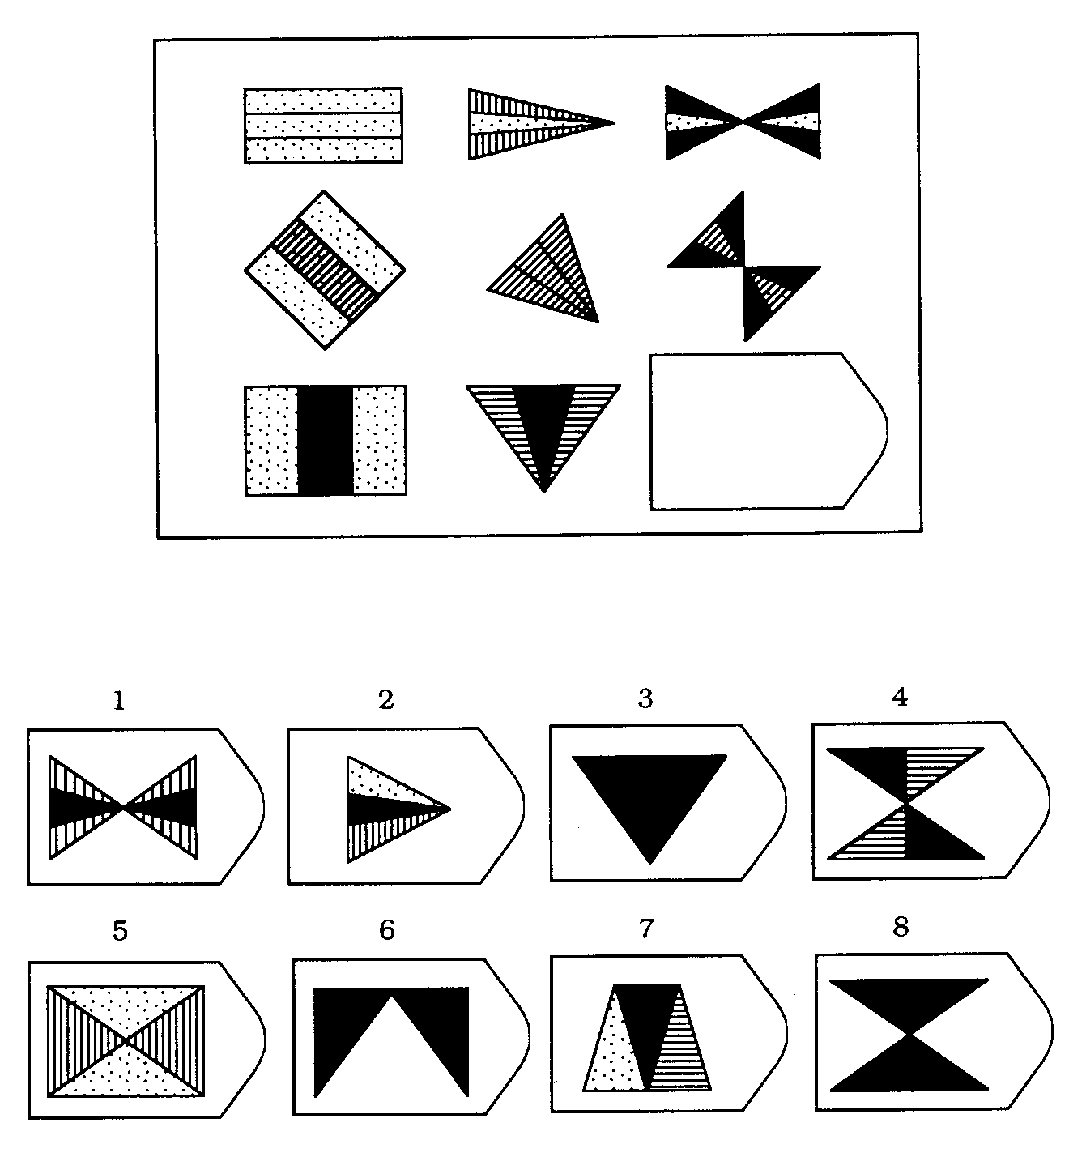

8

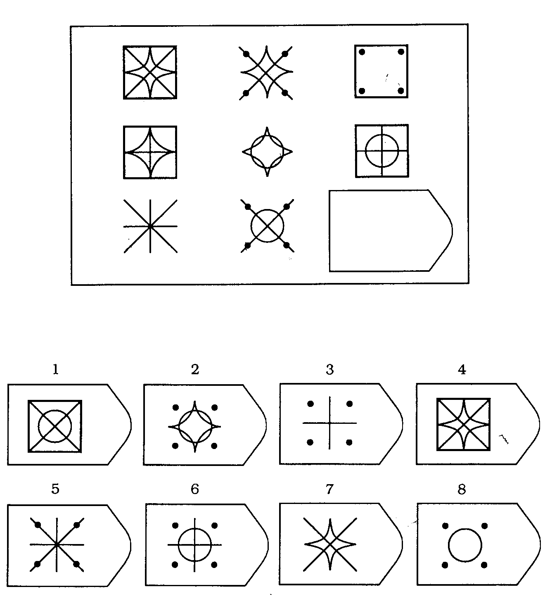

9

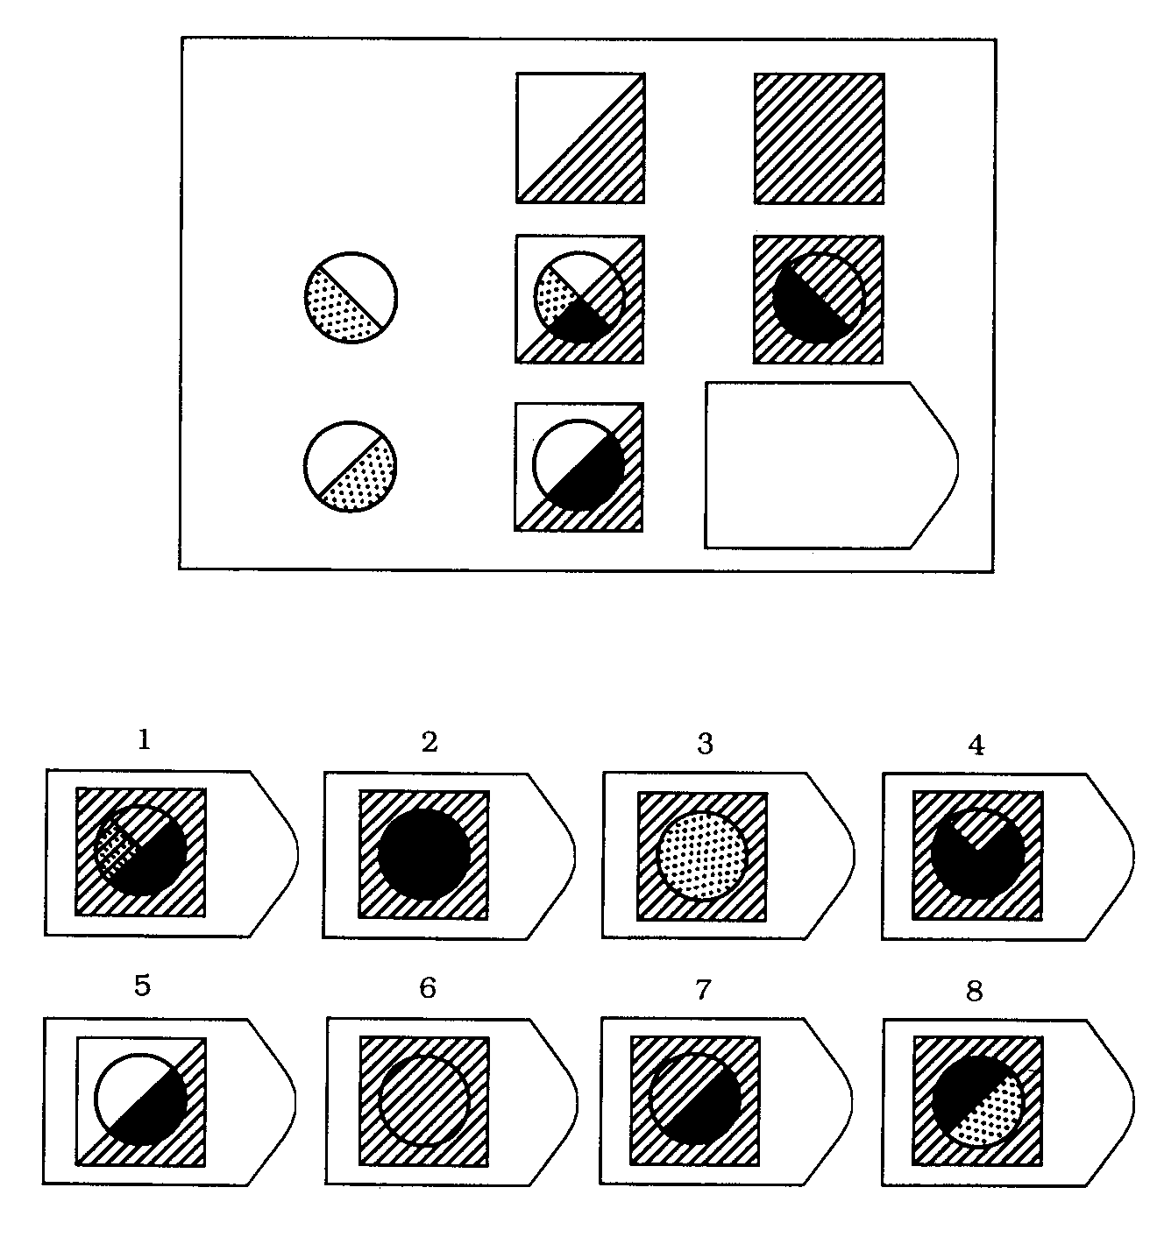

10

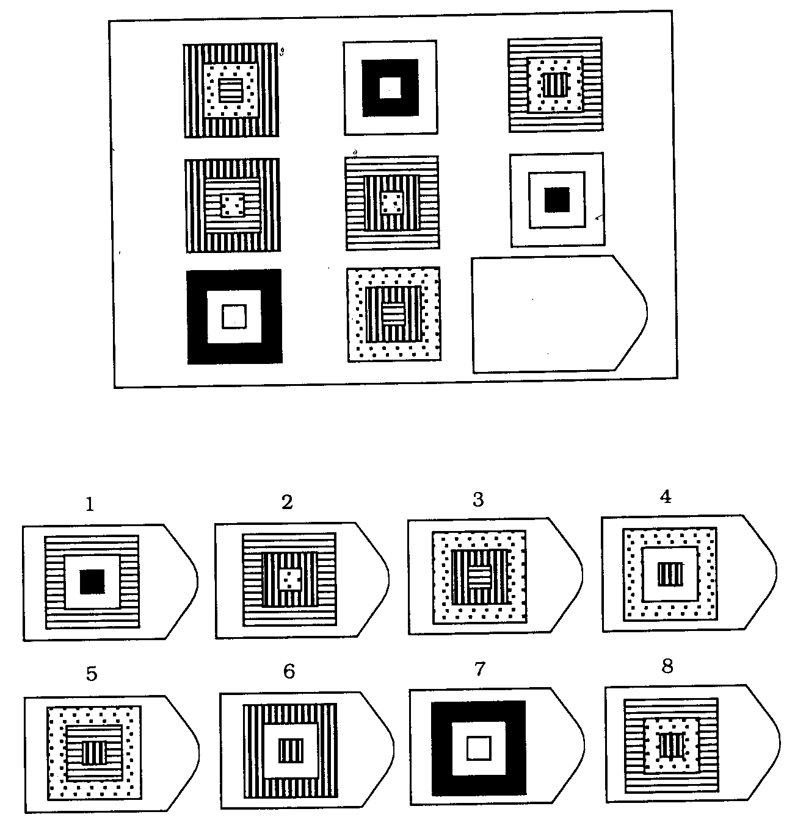

11

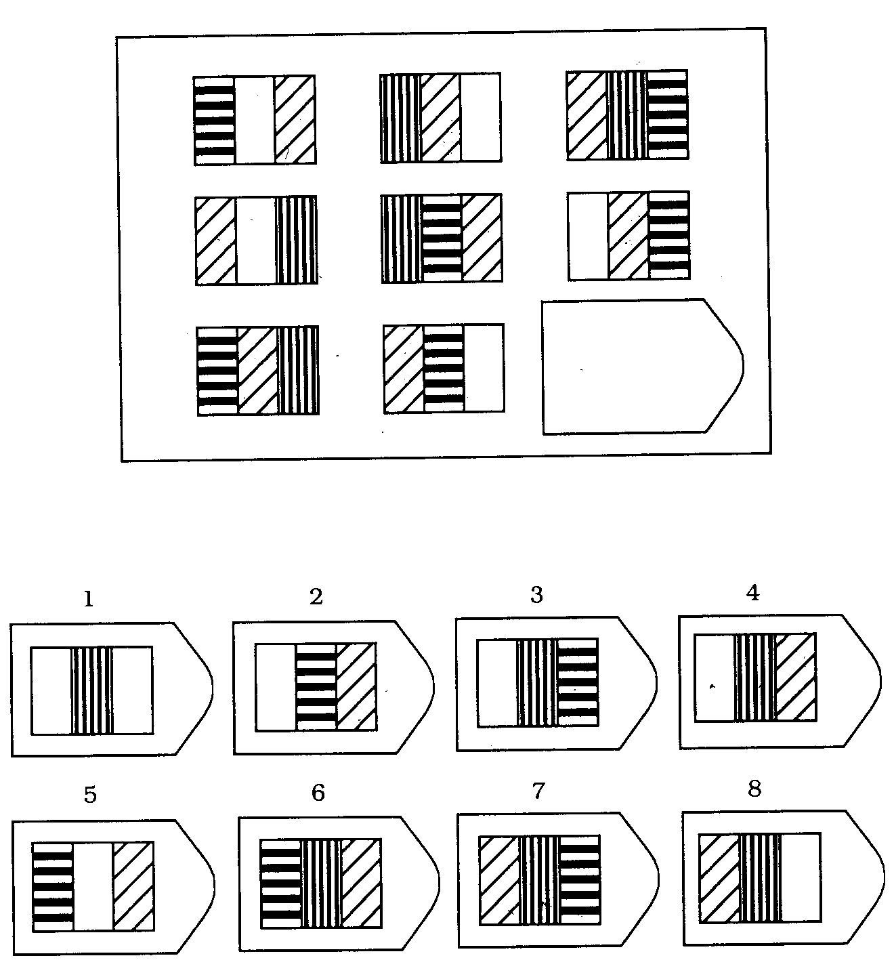

12

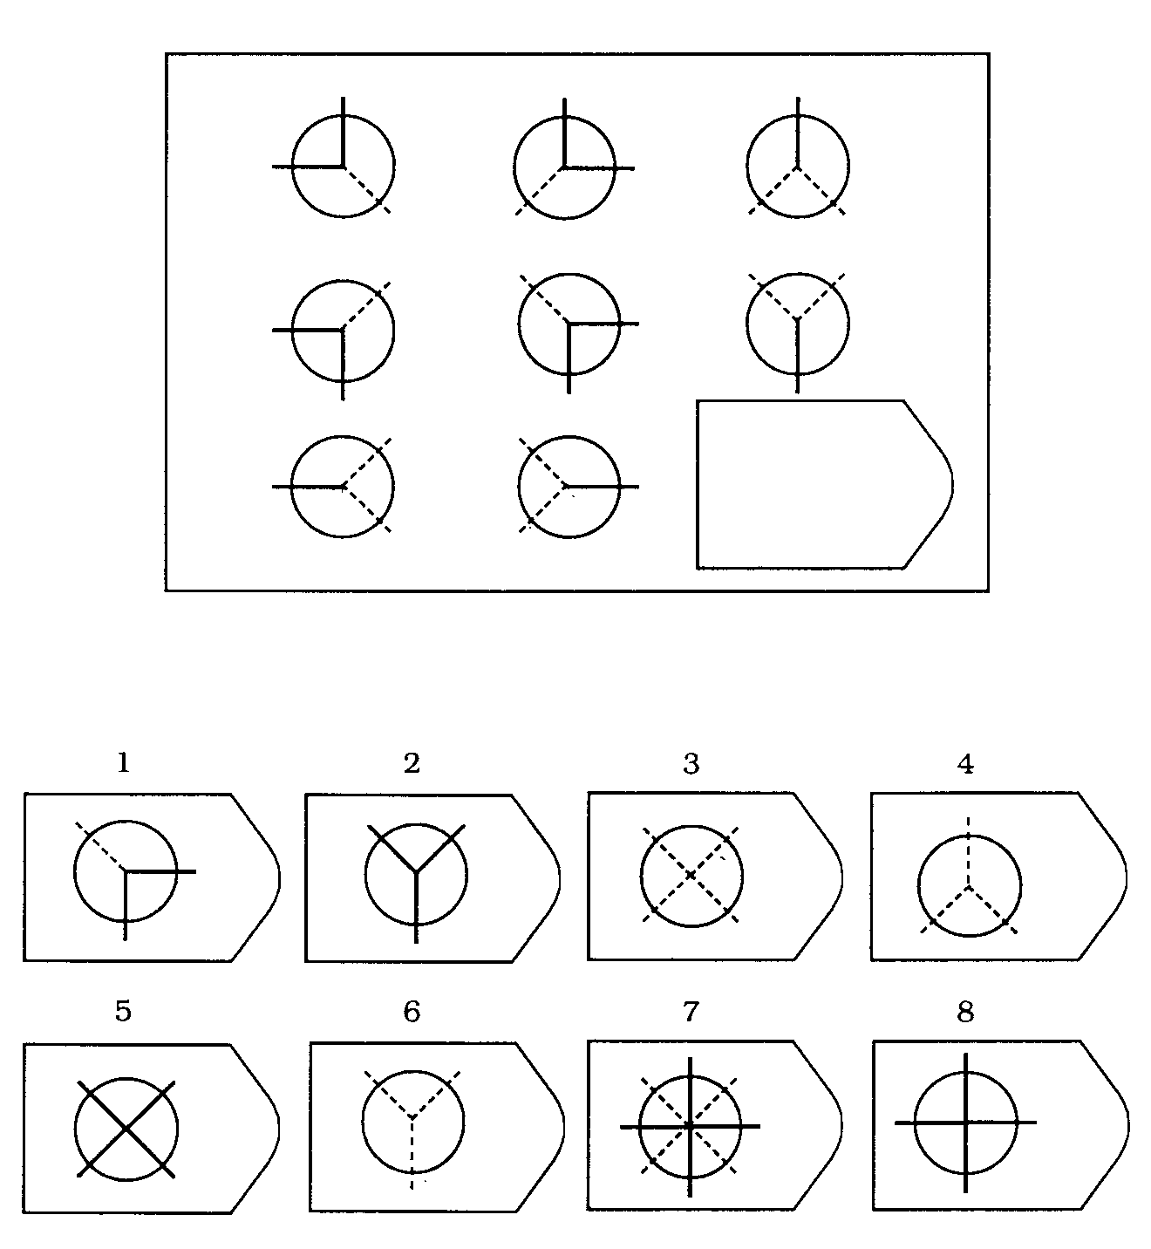

**Short Scale of Creative Self**

Maciej Karwowski (2011)

Below you will find several sentences used by people to describe themselves. Please decide to what extent each of these statements describes you. There are no good or wrong answers.

**(1) I think I am a creative person**

Definitely not – somewhat not – neither yes or no – somewhat yes – definitely yes

**(2) My creativity is important for who I am**

Definitely not – somewhat not – neither yes or no – somewhat yes – definitely yes

**(3) I know I can efficiently solve even complicated problems;**

Definitely not – somewhat not – neither yes or no – somewhat yes – definitely yes

**(4) I trust my creative abilities;**

Definitely not – somewhat not – neither yes or no – somewhat yes – definitely yes

**(5) My imagination and ingenuity distinguishes me from my friends;**

Definitely not – somewhat not – neither yes or no – somewhat yes – definitely yes

**(6) Many times I have proved that I can cope with difficult situations;**

Definitely not – somewhat not – neither yes or no – somewhat yes – definitely yes

**(7) Being a creative person is important to me**

Definitely not – somewhat not – neither yes or no – somewhat yes – definitely yes

**(8) I am sure I can deal with problems requiring creative thinking;**

Definitely not – somewhat not – neither yes or no – somewhat yes – definitely yes

**(9) I am good at proposing original solutions to problems.**

Definitely not – somewhat not – neither yes or no – somewhat yes – definitely yes

**(10) Creativity is an important part of myself**

Definitely not – somewhat not – neither yes or no – somewhat yes – definitely yes

**(11) Ingenuity is a characteristic that is important to me**

Definitely not – somewhat not – neither yes or no – somewhat yes – definitely yes