Digital Twins vs. GPT Personas: Can AI Chatbots Correct False Polarization
in Environmental Marketing Attitudes?
Pilot Study — March 2026

Methods

Participants
N = 400 U.S. adults were recruited via Prolific. Three participants who identified as Republican were excluded, leaving a final analytic sample of 397 Democrats (Control: n = 131, GPT Persona: n = 134, Digital Twin: n = 135). The experiment was pre-registered (https://aspredicted.org/ys35n8.pdf).

Design
Participants were randomly assigned to one of three between-subjects conditions: (1) a control condition in which they chatted with a bot about cats and dogs for 10 minutes; (2) a GPT persona condition in which they chatted with an off-the-shelf ChatGPT bot prompted to represent an average Republican; or (3) a digital twin condition in which they chatted with a bot built from extensive real survey data representing a specific Republican respondent drawn at random from the Twin-2K-500 dataset (N = 540 Republicans).

Procedure
Participants first indicated their political identification. They then completed a 10-minute chatbot interaction with their assigned bot. Following the interaction, they completed the primary outcome measures.

Measures
GREEN scale accuracy. Participants completed the 6-item GREEN scale (e.g., “It is important to me that the products I use do not harm the environment”; “I consider the potential environmental impact of my actions when making many of my decisions”) as they believed the average Republican would respond (1 = Disagree strongly, 5 = Agree strongly; α = .87). The ground truth Republican mean (M = 3.18) was derived from the Twin-2K-500 dataset. The primary accuracy DV was the absolute deviation of participants’ mean estimate from the ground truth; signed error (estimate − ground truth) was examined as a secondary measure of directional bias.
Ad persuasiveness. Participants rated how persuasive they believed the average Republican would find a target advertisement on a 5-point scale (1 = Not at all persuasive, 5 = Extremely persuasive). The ad read: “More and more Americans are choosing eco-friendly products — not because they’re perfect, but because small everyday choices add up. Join your neighbors in making a difference for your community and your kids.” Ground truth Republican ratings will be collected in a follow-up post-test.

Results

GREEN Estimation Accuracy
Democrats systematically underestimated Republicans’ environmental attitudes across all conditions (all signed errors < 0, all ps < .001), consistent with false polarization. A one-way ANOVA on absolute error revealed a significant effect of condition, F(2, 394) = 12.27, p < .001, η² = .058. Both chatbot conditions produced significantly more accurate estimates than the control condition (Control M = 1.08, SD = 0.61; GPT Persona M = 0.75, SD = 0.53: t = 4.54, p < .001, d = 0.58; Digital Twin M = 0.85, SD = 0.53: t = 3.39, p < .001, d = 0.43). The two chatbot conditions did not differ significantly from each other (t = −1.28, p = .202, d = −0.16). See Figures 1 and 2.
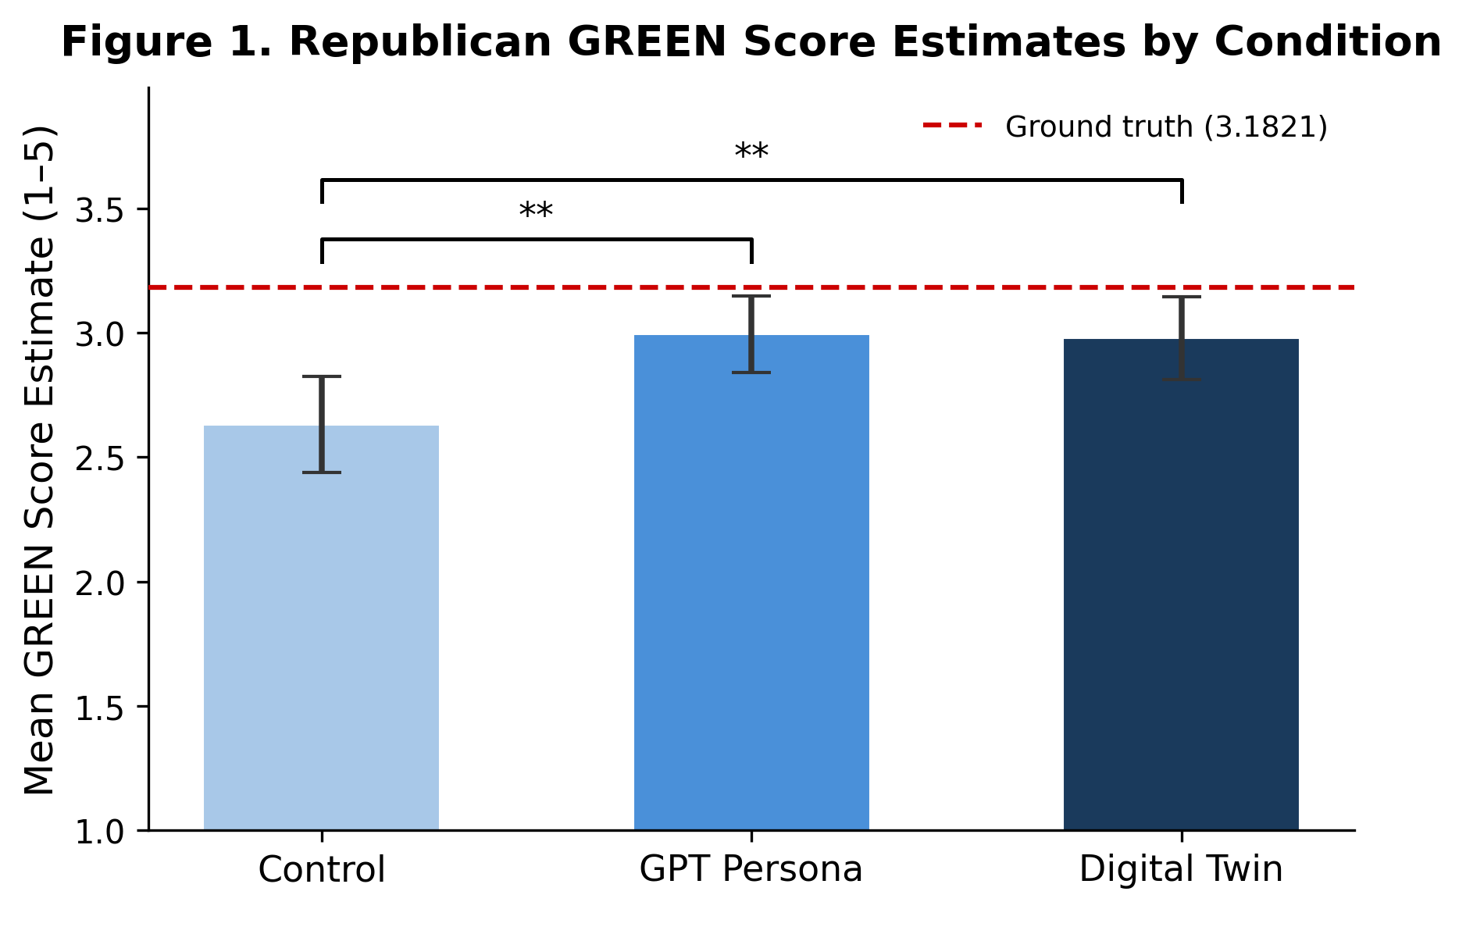
Figure 1. Mean Republican GREEN score estimates by condition. Error bars = 95% CI. Dashed red line = ground truth Republican mean (3.18). ** p < .01.
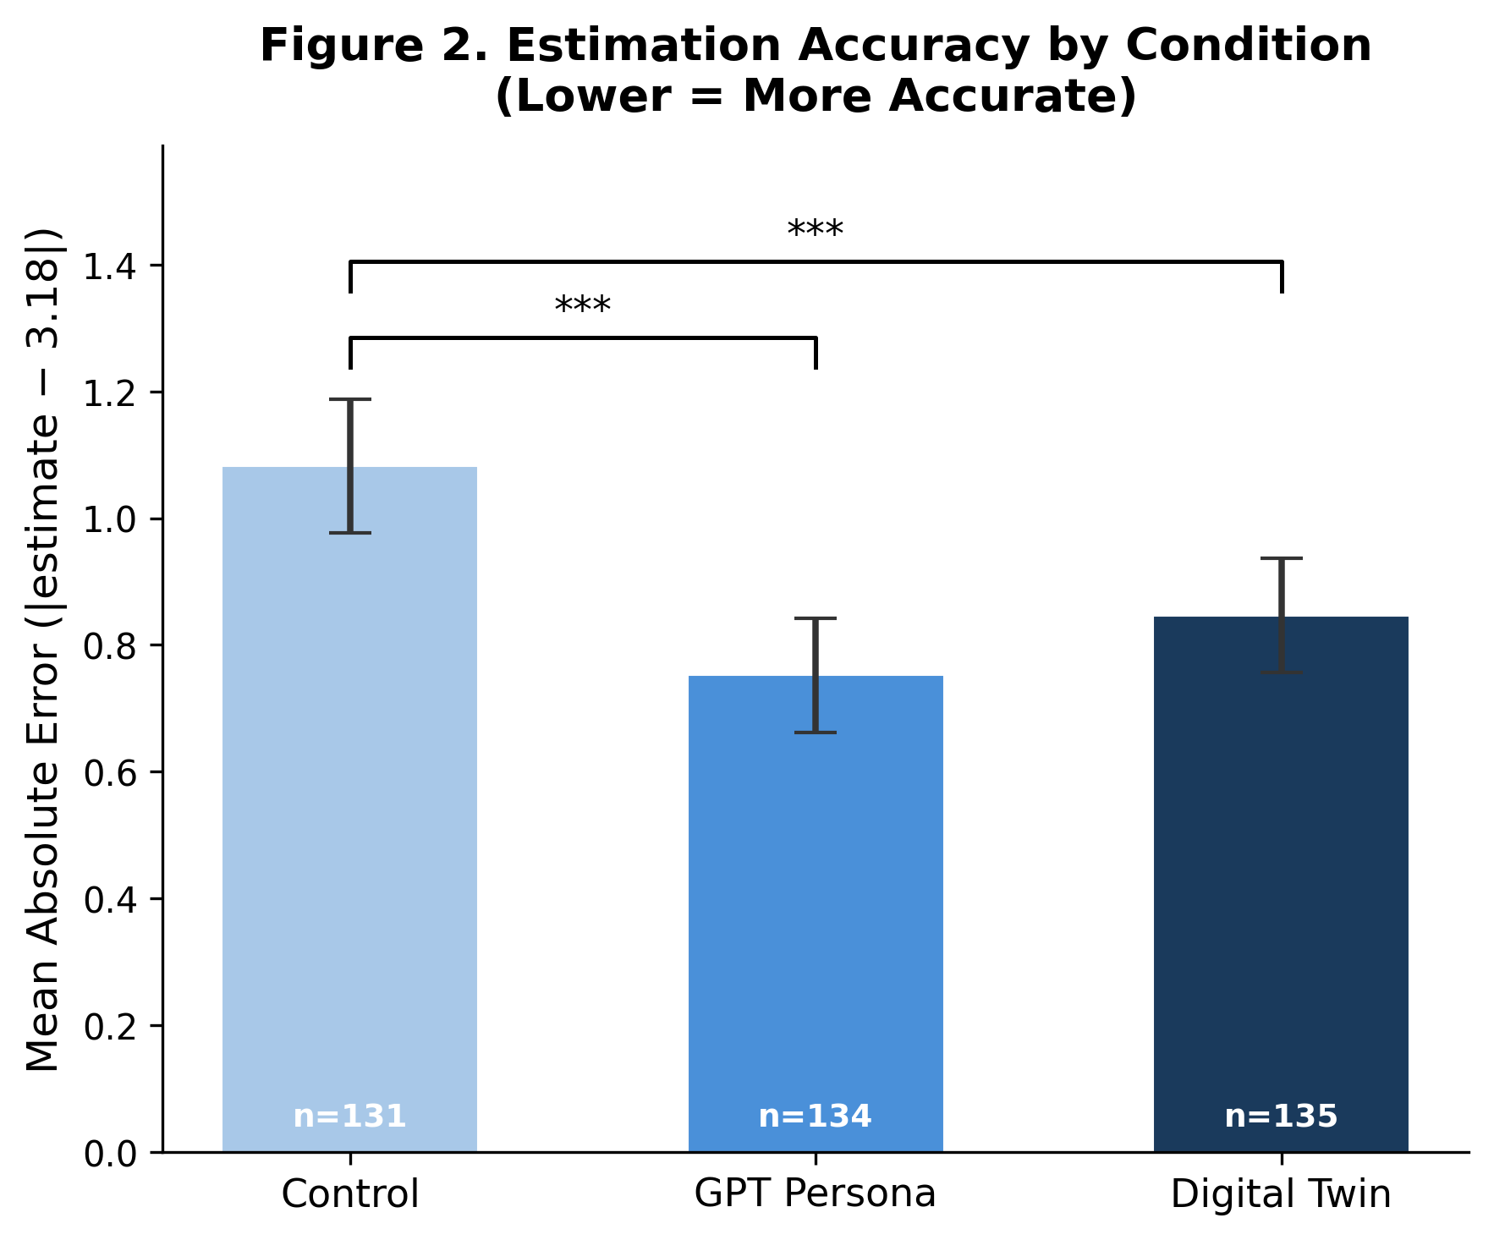
Figure 2. Mean absolute estimation error by condition (lower = more accurate). Error bars = 95% CI. *** p < .001.

Ad Persuasiveness
Participants in all conditions predicted that Republicans would find the target eco-friendly ad relatively unpersuasive (all Ms < 3 on a 1–5 scale). A one-way ANOVA revealed a significant effect of condition, F(2, 393) = 3.47, p = .032, η² = .017. The digital twin condition predicted significantly higher Republican ad persuasiveness than control (Control M = 2.42, SD = 1.12; Digital Twin M = 2.76, SD = 1.12: t = −2.50, p = .013, d = 0.31). The GPT persona condition did not differ significantly from control after Bonferroni correction (t = −1.80, p = .073, d = 0.23). See Figure 3.
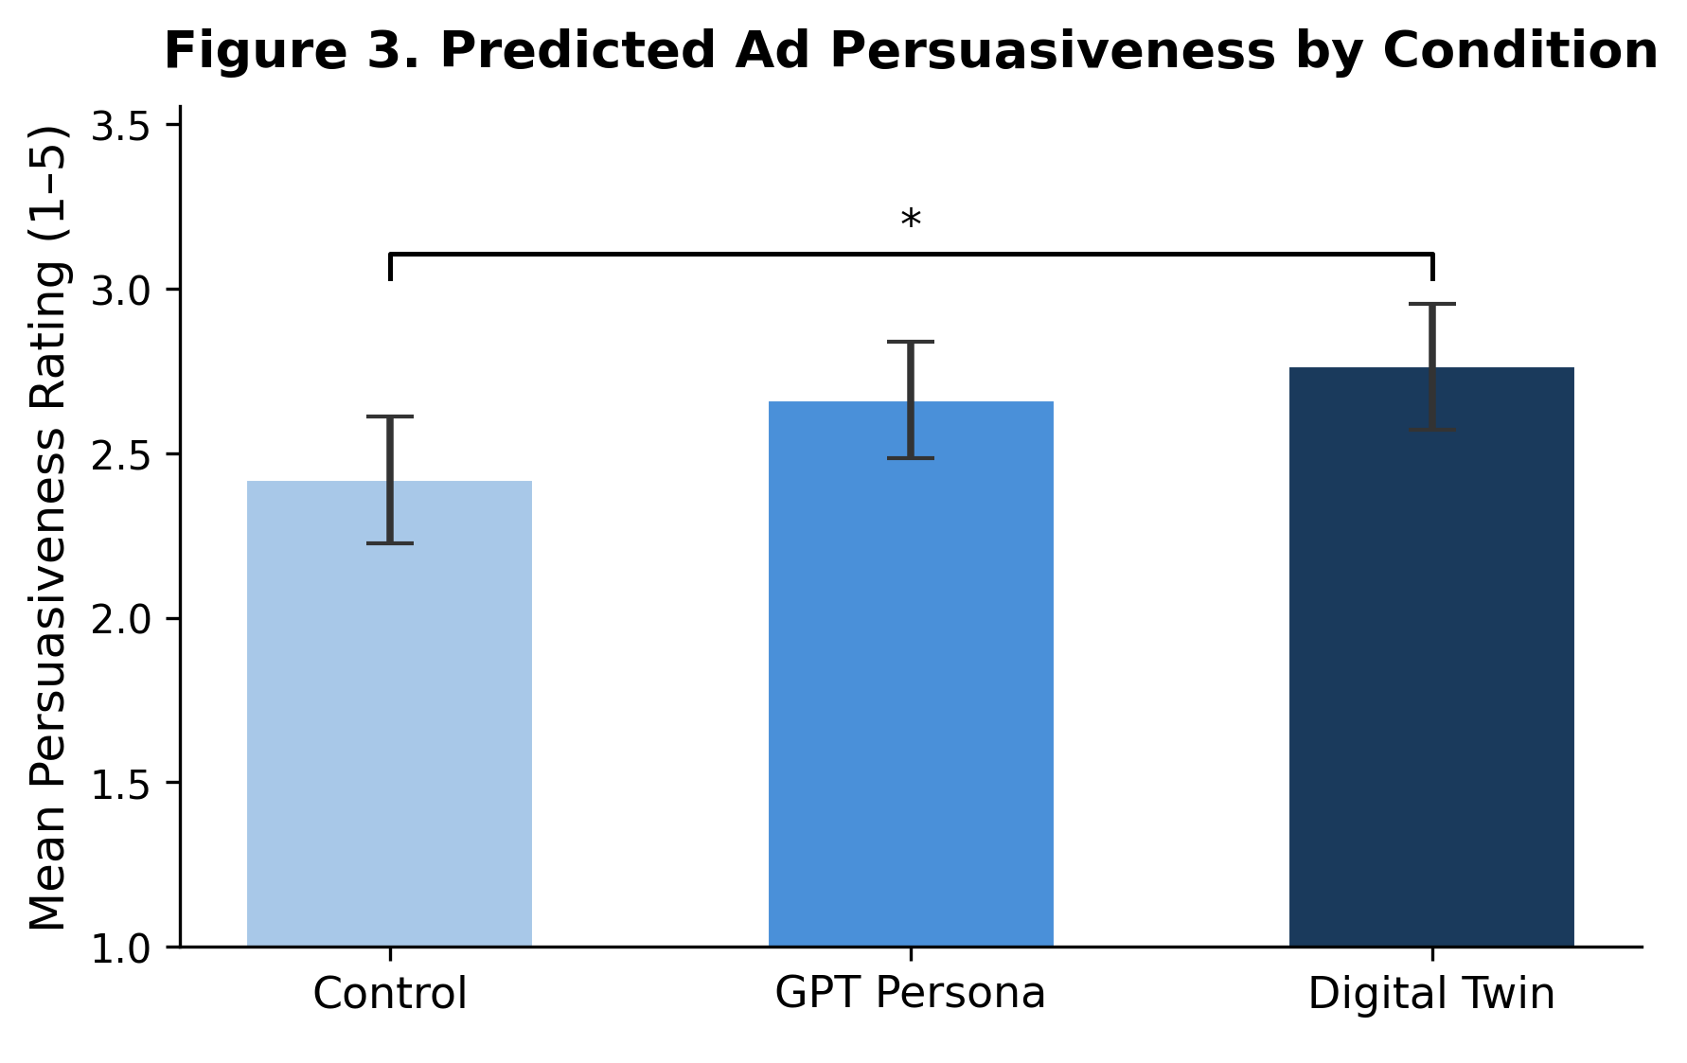
Figure 3. Mean predicted ad persuasiveness by condition. Error bars = 95% CI. * p < .05 (Bonferroni corrected).

