Lab 1 – From CTI to SOC Investigation and MITRE ATT&CK Mapping
AI-Enhanced Cybersecurity · Individual submission
Submitted by: Liran Vainshtein
Date: October 25, 2026

1. Selected CTI report
Field | Details
Title | Impersonating IT support: how threat actors turn a remote session into enterprise-wide access
Publisher | Microsoft Threat Intelligence (Microsoft Security Blog)
Authors listed | Microsoft Security Research, with Sagar Patil, Arlette Umuhire Sangwa, Jesse Birch and Ravikant Tiwari
Published | September 2, 2026
URL | https://www.microsoft.com/en-us/security/blog/2026/09/02/impersonating-it-support-threat-actors-turn-remote-session-into-enterprise-wide-access/

The report was chosen because it describes a full multi-stage intrusion with concrete process, file, registry and network behaviors, labels what was observed versus assessed, and lists hunting guidance and ATT&CK techniques.

2. Attack summary
Microsoft Threat Intelligence describes a human-operated intrusion in which an external operator, working from a separate Microsoft Teams tenant, impersonates IT or helpdesk staff by chat or call and persuades a user to approve a remote-control request or share a Quick Assist code. The affected environment is an enterprise with external Teams collaboration enabled, Windows endpoints and a domain-joined Active Directory estate. After the session is established, PowerShell downloads an MSI from attacker-controlled cloud storage and installs it silently. The package stages a script-based loader and an encrypted JavaScript implant that runs through a Node.js runtime under LocalAppData, with persistence under an "EdgeUpdate" name. The implant polls its command-and-control (C2) server over HTTPS, performs host reconnaissance and screen capture, enumerates Active Directory, runs operator-supplied DLLs with rundll32, and uses WinRM to reach dozens of domain-joined systems, including domain controllers and certificate authorities. The objective is to expand one foothold into enterprise-wide, credential-backed access. Microsoft assesses the activity as consistent with pre-exfiltration, extortion or ransomware preparation, but does not report that these outcomes were confirmed.

3. Attack flow
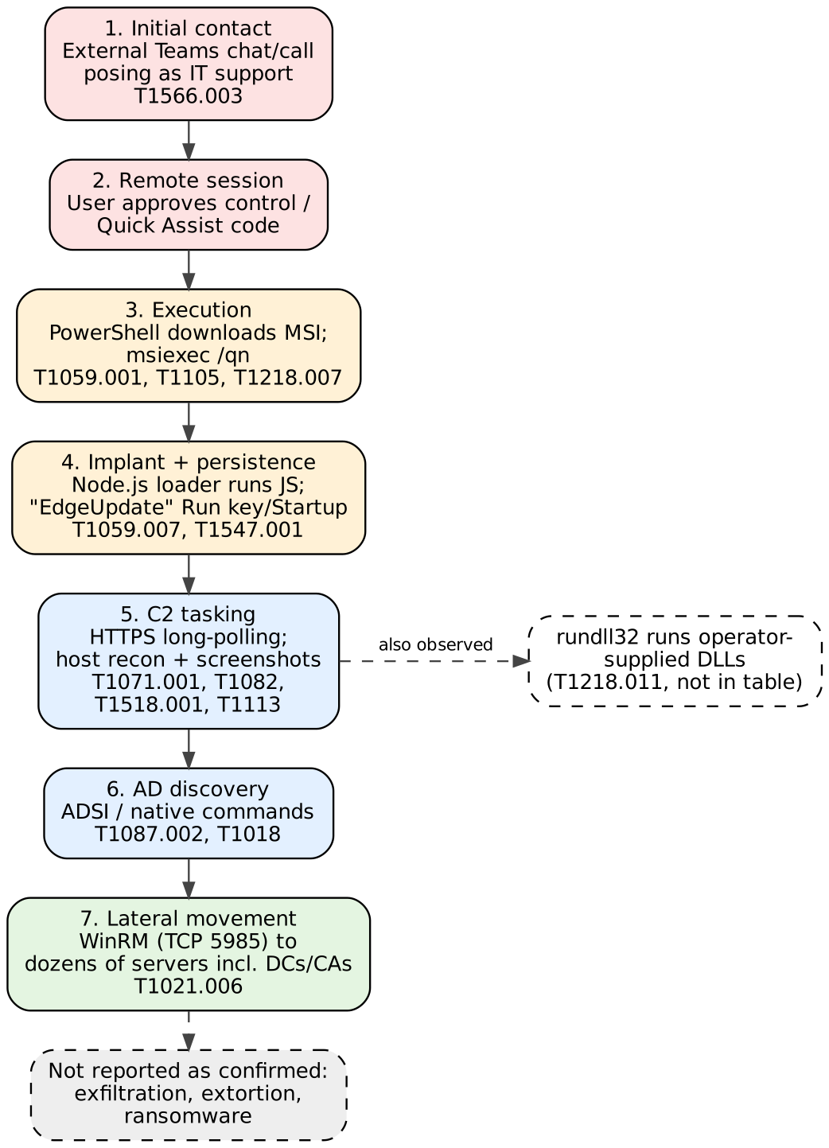
Figure 1. Attack sequence as described in the report. Box colors group the phases: initial access, execution/persistence, discovery/C2, lateral movement. Dashed boxes are outside the confirmed sequence.

Observed facts versus interpretation
Reported as observed | Reported as assessed / possible (not treated as fact)
External Teams contact posing as IT; user guided to approve a control prompt or Quick Assist.  PowerShell downloads an MSI; silent install with msiexec /qn.  Node.js runs the loader; "EdgeUpdate" persistence in an HKCU Run value or Startup shortcut.  HTTPS long-polling C2; recon commands; repeated screen capture to a temp file.  ADSI/native-command AD discovery; rundll32 runs DLLs; WinRM (TCP 5985) to dozens of systems. | Vishing may be layered on so instructions never appear in chat logs ("sometimes").  Signed Node.js runtime "can evade" controls focused on unsigned executables.  AV and display-adapter queries are "characteristic" of sandbox checks.  WinRM from a non-admin context "strongly suggests" credential-backed lateral movement.  Overall activity is "consistent with" extortion/ransomware precursors; no theft or ransomware is reported.

4. ATT&CK mapping table
Observed behavior | ATT&CK tactic | Technique / ID | Evidence and mapping rationale | SOC telemetry / investigation
1. External operator contacts users on Teams posing as IT/helpdesk; user approves remote control or Quick Assist | Initial Access | Phishing: Spearphishing via Service  T1566.003 | Report: operator in a separate tenant contacts users over Teams chat/call with update-themed lures and guides them to approve a control prompt. Teams is a service channel (not email), so the sub-technique fits. Quick Assist is treated as part of this delivery step, not mapped separately. | CloudAppEvents (external ChatCreated), MessageEvents, CallActivityEvents.  Check: unfamiliar external tenant, IT-themed wording, first-time contact.
2. PowerShell downloads an MSI from cloud storage and installs it silently with msiexec /qn | Execution; Command and Control; Defense Evasion | PowerShell  T1059.001  Ingress Tool Transfer  T1105  Msiexec  T1218.007 | Report: PowerShell fetches the MSI from actor-controlled cloud storage and installs it with the /qn switch; MSI uses update-themed names. PowerShell is explicit (sub-technique justified); the download is tool transfer; msiexec is the signed binary used to run the package (also listed by the report). | DeviceProcessEvents (powershell -> msiexec, command line), DeviceFileEvents (.msi in user-writable path), DeviceNetworkEvents (blob storage).  Check: parent process and who was logged on.
3. Node.js (incl. renamed copies) runs a JS loader from LocalAppData; "EdgeUpdate" persistence via HKCU Run value or Startup shortcut | Execution; Persistence | JavaScript  T1059.007  Registry Run Keys / Startup Folder  T1547.001  (+ Masquerading T1036, no sub-technique) | Report: Node.js executes the loader (script via stdin or temp file); persistence is an "EdgeUpdate" Run value or Startup-folder shortcut. T1547.001 covers both Run keys and the Startup folder. The name imitates a browser updater (T1036, listed by the report); no masquerading sub-technique is claimed. | DeviceProcessEvents (node.exe from AppData\Local, wscript.exe parent), registry events for HKCU Run (e.g., Sysmon Event 13), Startup-folder file creation.  Check: unsigned/odd parent chain.
4. Implant polls C2 over HTTPS; recon commands run (AV products, adapters, disk, locale); repeated desktop screenshots saved as Base64 temp files | Command and Control; Discovery; Collection | Web Protocols  T1071.001  System Information Discovery  T1082  Security Software Discovery  T1518.001  Screen Capture  T1113 | Report: randomized HTTPS long-polling; short-lived cmd.exe/PowerShell queries for AV, display adapters, disks, locale; desktop captured, resized, Base64-encoded and written to a temp file. Disk/locale -> T1082; AV query -> T1518.001 (see Section 6); screenshots -> T1113. | DeviceNetworkEvents (periodic HTTPS to rare domain), DeviceProcessEvents (hidden PowerShell/cmd child of node.exe), file events (temp Base64 files).
5. Domain account and server discovery using native commands and ADSI; servers probed for admin reachability | Discovery | Account Discovery: Domain Account  T1087.002  Remote System Discovery  T1018 | Report: commands enumerate specific domain accounts; an ADSI sweep lists Windows Server computer objects, resolves addresses and tests reachability. Accounts -> T1087.002; servers/hosts -> T1018. | Defender alerts for suspicious LDAP/AD enumeration; domain controller LDAP logs; process events for ADSI/CIM from PowerShell.
6. WinRM connections (TCP 5985) from the compromised host to dozens of domain-joined systems, incl. domain controllers and CAs | Lateral Movement | Remote Services: Windows Remote Management  T1021.006 | Report: operator tasking opens WinRM sessions to many servers; WinRM from a non-admin context "strongly suggests" credential-backed movement (assessment). How credentials were obtained is not stated, so no Credential Access technique is mapped. | DeviceNetworkEvents (outbound 5985 from a workstation), DeviceProcessEvents (PowerShell with wsman), authentication events on targets (network logons).

Also observed but not mapped in the table: the operator runs supplied DLLs through rundll32.exe (corresponds to System Binary Proxy Execution: Rundll32, T1218.011, listed by the report). Technique IDs and names follow attack.mitre.org and the report's own technique list; the mapping rationale in each row is based on the behaviors the report describes.

5. SOC investigation notes
Telemetry names follow the Microsoft Defender XDR advanced-hunting tables referenced in the report; equivalent sources (Windows Security 4688/4624, Sysmon, PowerShell logging, proxy/DNS) can be substituted in other environments. An ATT&CK mapping describes behavior; it does not by itself prove malicious intent.

Behavior 1 – Teams impersonation (T1566.003)
Telemetry: CloudAppEvents (external chat creation), MessageEvents, CallActivityEvents, MessageUrlInfo.
Tier 1 triage: Flag a chat or call from an external tenant that claims to be IT or helpdesk, uses update/verification wording, and reaches users who normally do not receive external support contacts. Confirm with the user whether they approved a remote-control request.
Tier 2 investigation: Correlate the Teams thread with Quick Assist or remote-support launches on the user's device in the following minutes; check the external tenant across other users; contain the host and review what ran afterwards. Because vishing may leave nothing in chat, interview the user.
Why this alone is not proof: Legitimate vendors and partners also contact users externally, and IT teams do use remote help tools.

Behavior 2 – PowerShell download and silent MSI install (T1059.001, T1105, T1218.007)
Telemetry: DeviceProcessEvents (powershell.exe and msiexec.exe command lines and parent), DeviceFileEvents (MSI written to a user-writable path), DeviceNetworkEvents (download from cloud blob storage).
Tier 1 triage: Alert on PowerShell that writes an .msi to a user profile folder and then runs msiexec with /qn, especially shortly after a remote-support session started. Note the user, host and download domain.
Tier 2 investigation: Pull the full command line and parent chain, hash the MSI, check the storage subdomain against indicators and other hosts, list files and registry values the installer created, and determine whether the host already has a loader or implant running.
Why this alone is not proof: msiexec /qn is a normal software-deployment pattern; context (parent, source, timing) is what makes it suspicious.

Behavior 3 – Node.js loader and "EdgeUpdate" persistence (T1059.007, T1547.001)
Telemetry: DeviceProcessEvents (node.exe or renamed copies under AppData\Local launched via wscript/cmd/PowerShell), registry telemetry for HKCU Run values, file creation in the Startup folder.
Tier 1 triage: Alert on a Node.js runtime executing from AppData\Local on a user who is not a developer, or on a new "EdgeUpdate"-named autorun that does not point to the real browser updater.
Tier 2 investigation: Inspect the autorun target and its arguments, recover the loader and encrypted payload (odd extensions such as .tmp/.dat), hunt for the same runtime path and persistence name on other hosts, and review outbound network connections from the Node.js process.
Why this alone is not proof: Developers legitimately run Node.js and updaters use autoruns; the unusual location, naming and parent chain are the signal.

Behavior 6 – WinRM lateral movement (T1021.006)
Telemetry: DeviceNetworkEvents (outbound TCP 5985/wsman from endpoints), DeviceProcessEvents (PowerShell remoting commands), authentication events on target servers.
Tier 1 triage: Alert when a workstation, not a management host, opens WinRM connections to many servers, particularly domain controllers or certificate authorities.
Tier 2 investigation: Identify which account was used and where it originated, list all targets reached, check for follow-on actions on those servers (new services, rundll32 DLL runs, credential access), and rotate credentials that were reachable from the first host.
Why this alone is not proof: Administrators use WinRM routinely; fan-out to many servers from a non-admin endpoint is the anomaly.

6. Uncertain mapping, alternative interpretation and resolving evidence
Mapping in question: Antivirus and display-adapter queries during early tasking (T1518.001 versus T1497.001).
Current mapping: The report observes short-lived cmd.exe/PowerShell processes querying installed antivirus products, display adapter names, disks and locale. The table maps the AV query to Security Software Discovery (T1518.001) and the rest to System Information Discovery (T1082), because the commands themselves are observed.
Alternative interpretation: The report assesses the adapter and AV queries as characteristic of sandbox or defense-evasion checks, which would map to Virtualization/Sandbox Evasion: System Checks (T1497.001). The same data could simply be an operator inventorying the host before choosing next steps. The report does not show the implant changing behavior based on the results, so the evasion interpretation stays an assessment.
Evidence needed: (a) Implant or loader code showing a conditional branch (exit, sleep or different payload) based on VM or sandbox strings such as virtual adapter names; (b) tasking logs showing whether the operator continued normally on both virtual and physical hosts; (c) whether the same queries appear in analysis-environment detonations; (d) the results returned to C2. Evidence of (a) would justify adding T1497.001; evidence that the results only fed an inventory would leave the mapping as T1518.001/T1082.

7. Self-review
This lab was submitted individually and no other group or reviewer was available for discussion, so the review step was done as a structured self-review of the uncertain mapping from Section 6 and of the other sub-technique choices.
Review criteria: For each mapping I checked (1) whether a specific passage of the report shows the behavior, (2) whether the technique description matches that behavior rather than only the name, and (3) whether a sub-technique was chosen only because the report states it explicitly.
Uncertain mapping re-examined: The AV and display-adapter queries are directly observed commands, which supports T1518.001 and T1082. Nothing in the report shows the implant or operator changing behavior based on the results, which is what T1497.001 would require. Result: the mapping stays T1518.001 + T1082, and T1497.001 is kept only as a conditional alternative pending the evidence listed in Section 6.
Other mappings challenged: Row 1 could also be read as User Execution (T1204) because the user approved a prompt. I did not map it, since the user approved a remote session and the later execution was driven by the operator through that session, not by the user opening a file. Row 2 relies on PowerShell being named in the report (T1059.001), and row 3 does not add a masquerading sub-technique because the report does not justify one.
Outcome: No change to the table after the review. The review did add the explicit conditions under which T1497.001 would be added, and the reasoning for not mapping T1204.

8. References
Microsoft Threat Intelligence. "Impersonating IT support: how threat actors turn a remote session into enterprise-wide access." Microsoft Security Blog, September 2, 2026. https://www.microsoft.com/en-us/security/blog/2026/09/02/impersonating-it-support-threat-actors-turn-remote-session-into-enterprise-wide-access/
MITRE ATT&CK Enterprise matrix. https://attack.mitre.org/
MITRE ATT&CK, CTI mapping training. https://attack.mitre.org/resources/learn-more-about-attack/training/cti/

