**Driving School**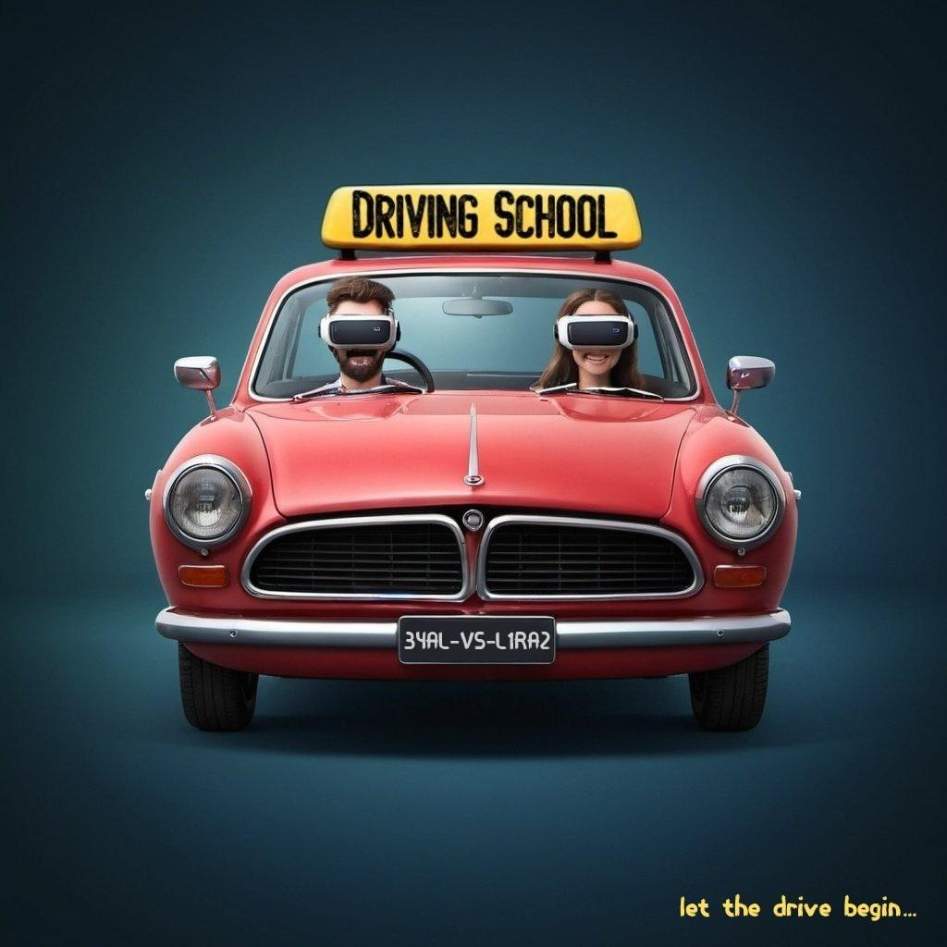

Unity Seminar - Project Proposal

Members: Eyal Politansky, Liraz Inbar

# Introduction

Our project is a virtual reality driving school simulation game. The game will simulate driving a car and incorporate real-world driving elements - roads, lanes, traffic signs, pedestrians, other vehicles, etc. The project aims to teach people learning to drive and help them prepare for driving lessons and practical tests - without leaving the house!

## Purpose Of The Project

Today, driving lessons are not accessible to all young people who want to get a license, both from the economic point of view and the psychological point of view - they do not prepare driving students for extreme situations that they may find themselves in in the future.

Our application is designed to simulate driving while defining the driving conditions in advance (lighting, weather, various distractions), in addition to practicing the theory content (such as signs and markings identification), and a driving instructor who can give comments. The VR game will give a real driving experience and allow tracking and measuring the player's responses, including where he looks and when.

The application provides an immediate response from anywhere and wherever the student wishes. It has added value to educational content - such as traffic rules, traffic signs identification (theory), vehicle operation, etc.

By harnessing the capabilities of VR technology and the Unity game engine, we deliver a compelling and educational driving simulation experience that prepares users for real-world driving scenarios while providing an engaging gameplay experience.

## Target Audience

Our target audience is people who want to learn to drive to obtain a license, students of driving refresher and preventive driving courses, and people who want to gain confidence on the road or for fun.

## Market Analysis

There are some driving games on the market today. Still, our game has 4 main key differences:

1. Teacher - In our game, a digital instructor sits next to you during all the lessons and improves the feeling you are in a real driving lesson.

2. Feedback And Scoring - At the end of every lesson the player is given feedback on how his driving was in the lesson. He gets a score on every fault or good action he did with explanations that he can learn from and improve his driving for the next lessons.

3. Editor - The teacher can create the roads and the route the student will drive in, and thus can focus on specific driving difficulties the student encounters and wants to practice.

4. VR Experience - Our VR game gives a real driving experience by tracking and measuring the driving actions of the player in a precise way - moving the wheel, gearbox, winkers, and looking at the mirror with the VR simulates the real moves and actions of the driver as in a real car.

# Game Interface

## The Game Users

There are two player types in the game - student and teacher.

### Student

The main player. The student drives the car during the lesson and follows the instructions from the teacher. The student needs to follow both the instructions on where to drive along with obeying traffic rules. At the end of the lesson, the student will get a score for his driving performance.

### Teacher

The teacher will build and shape the environment and route of the lesson for the student. In the Editor tool, the teacher can create an environment from scratch in which and student will drive (roads, junctions, signs, etc). The teacher decides on the difficulty of the route and can change the environment based on what he wants the student will practice and focus on.

## Screens Structure

1. Main Menu
   1. Start Lesson
      1. Select an Environment
         1. Lesson Play
         2. Summary of points
   2. Editor
      1. Environments Creation And Edit
         1. Create New Environment
         2. Edit an Existing Environment
   3. Exit

## Screens Overview

### Main Menu

The game's first screen will be the main menu. In it, the player can choose to start a lesson or to enter the editor.

### Start Lesson

1. Select an environment

In this screen, the player chooses an environment to play in from various options. The differences between each environment are the driving elements and conditions. Therefore the difficulty of the driving lesson, and the subjects the lesson will be focused on, will be determined.

When the player hovers over each environment, bullets of the conditions will be visible.

For example, if an environment is more urbanic and has many signs, the lesson will focus on sign rules and how to respond to each sign. If there is a lot of rain the lesson's difficulty will be increased.

1. Lesson Play

After choosing the environment, The player will start to play the driving lesson.

The user controls his progress on the route using the controls of the VR kit.

When the lesson ends, the player can play again in the same environment or return to the main menu.

### Editor

Existing Environments

In this screen, the player will see all the existing environments by name. The player can create a new environment by pressing the + button or editing an existing environment by pressing one of the existing environments (see sketch below).

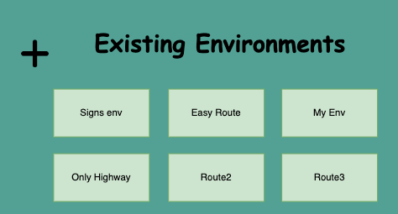

Environment Editor

The environment editor can open and present in two different ways:

1. Create a New Environment:

The player will see a fresh new environment with basic roads and signs. He can add and change the environment as he pleases, as described in the “In-Game Editor” section (see sketch below).

When the player is finished, he can save the environment and give it a name, or cancel and go back to the editor menu.

1. Edit an Existing Environment:

If the player chooses an existing environment, he will see the current roads, signs, and the external factors assigned to it. He then can change the environment as he pleases.

When the player is finished, he can save the environment, or cancel all changes and go back to the editor menu.

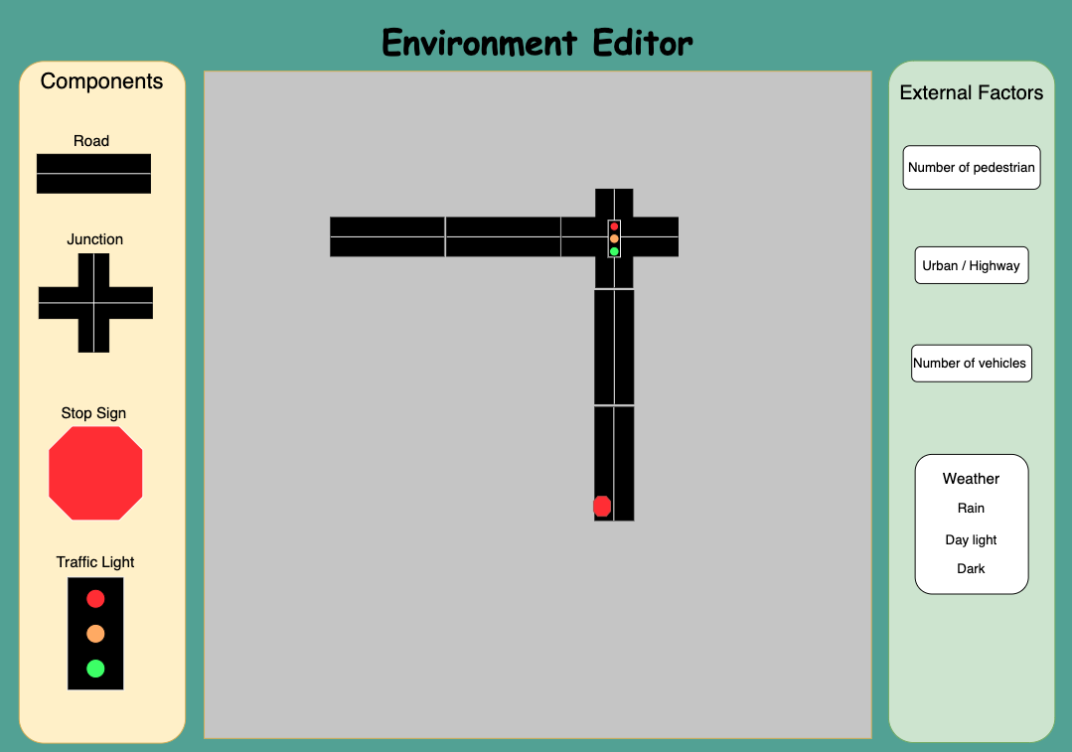

## Lesson Gameplay

The student player will put on the VR headset, and will be inside the car and drive from a driver's point of view (as in the picture below) on a route predetermined and will control navigation using the controls.

Next to the student player is an NPC which represents the teacher. The player will get the driving instructions from the teacher by voice and visual commands. For example - the teacher will say "Turn right in the next junction", and a right arrow will appear in front of the player.

The player will control the car directly with wheel, gas and brake pedals, winkers and gearbox (Drive, Reverse, Park). The game will track the looks direction of the player and check if he looks in the mirrors.

Outside the car will be traffic signs, roads with lane markings, crosswalks, sidewalks for pedestrians, and parking lots.

The digital teacher will give a score to the driver regarding his driving performance. The score consists of various parameters: Moving the car according to the instructions of the teacher, following the traffic rules such as not crossing a red light, stopping at a stop sign, giving [preemption](https://pubmed.ncbi.nlm.nih.gov/15216591/) to cars and pedestrians, driving speed according to signs, etc.

The score will be presented to the player at the end of the lesson, as well as the points for each action included in the final score. The score will be saved for later inspection.

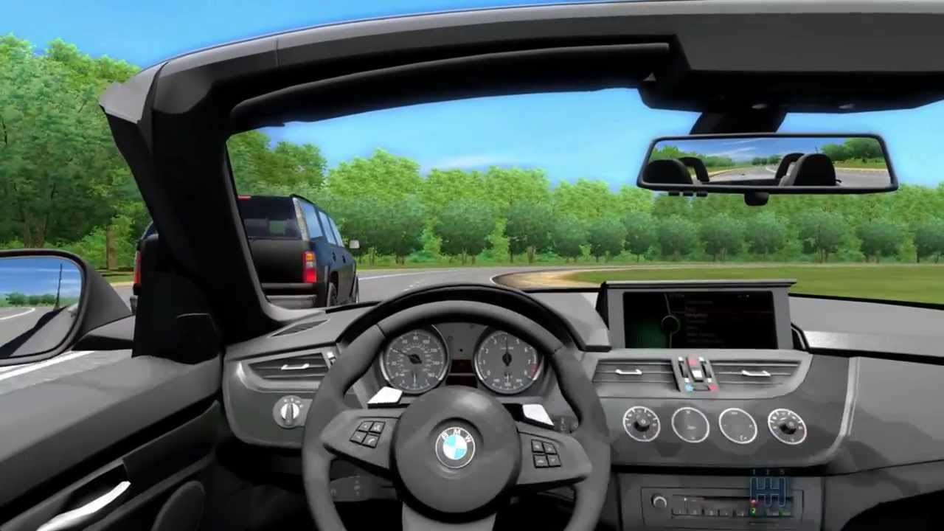

## In-Game Editor

The in-game editor environment creation is composed of two main components - environment construction and external factors.

Environment Construction

The user will be able to construct a route from existing components - road segments, intersections, signs, etc. The construction will be done through a user interface, and the data generated from it will be loaded into the driving route in the game.

The player can connect roads, assign between them junctions and traffic lights, put road signs he wishes to see during the drive, etc.

These components are built-in, and could not be changed.

The route would consist of existing components that the user will connect like a puzzle. For example, sections of intersections, and road segments with signs - such as stop signs, traffic lights, speed limit signs...

External Factors

The player can choose to add external factors to the environment, and thus

change the dynamic of the lesson when playing in this environment.

Among others, the external factors control will be the number of pedestrian crossings, urban or highway driving, number of vehicles, weather conditions, and driving in the dark/light.

All the available factors will be visible on the screen, and they can be changed by

slides, toggles, etc.

## Technologies Used

In developing our virtual reality driving school simulation game, we leverage cutting-edge technologies to provide an immersive and educational experience. Two key technologies at the core of our game are Virtual Reality (VR) and the Unity game engine.

### Virtual Reality (VR)

VR technology plays a pivotal role in creating an immersive driving experience for our users. By donning a VR headset, players are transported into a realistic driving environment where they can interact with the virtual world as if they were behind the wheel of a real car. VR enables players to experience the nuances of driving, such as operating the steering wheel, gearbox, and observing their surroundings through virtual mirrors. This technology not only enhances the realism of the game but also facilitates an effective learning environment by simulating real-world driving scenarios.

### Unity Game Engine

Our game is built using the Unity game engine, a powerful and versatile platform for game development. Unity provides a robust set of tools and features that enable us to create stunning visuals, realistic physics, and seamless gameplay experiences. With Unity, we can develop cross-platform applications, ensuring that our game is accessible to a wide audience across various devices. Additionally, Unity's intuitive interface and extensive asset store allow for efficient development and customization, empowering us to bring our vision to life effectively.