# TITLE

Performance [/evaluation] of a multi-model ensemble for the simulation of temperature variability [and trends] over Ontario, Canada

# ABSTRACT

[200-300 words, write this part after you finish everything else]

# KEY WORDS

Regional climate model, NA-CORDEX, multi-model ensemble, temperature variability, Ontario,

# 1. Introduction

[Paragraph 1: why did we carry out this study: why climate modeling (temperature) is important].

[Paragraph 2: what has been done in the past: brief introduction to GCM, RCM, and NA-CORDEX].

[Paragraph 3: what needs to be done: validation and evaluation of NA-CORDEX models for climate modeling in Ontario + development of a reliable multi-model ensemble for Ontario].

[Paragraph 4: Therefore, the objective of this study is to … what did we do in this study… how could this be useful for adapting to climate change in Ontario].

# 2. Methodology

## 2.1. Study Area and Data Collection

[Briefly introduce Ontario geography and climate]

[Introduce sources of observation data – 12 stations and data from Environment Canada, CRU data…]

--------------------------------------------------------

Place Figure 1 here? [map of Ontario?]

--------------------------------------------------------

--------------------------------------------------------

Place Table 1 here [list of the 12 stations]

--------------------------------------------------------

## 2.2. Multi-model Ensemble

[Introduce NA-CORDEX simulations, selection of GCM-RCM combinations, and the ensemble method]

--------------------------------------------------------

Place Table 2 here [list of the simulations <GCM, RCM, resolution, RCP scenario…etc>]

--------------------------------------------------------

## 2.3. Evaluation of simulation Performance

[Describe the quantitative criteria used to validate the model performance. Use equations and cite your sources]

# 3. Results and Discussion

## 3.1. Validation of model performance with observation data at selected stations

--------------------------------------------------------

Figure 2: Long-term (30-year?) monthly mean at 12 stations [see example near the end]

--------------------------------------------------------

--------------------------------------------------------

Figure 3: Taylor diagrams for 12 station (first quartile only?) [see example near the end]

--------------------------------------------------------

--------------------------------------------------------

Table 3: R2 or monthly bias [or other criteria] [see example near the end]

--------------------------------------------------------

## 3.2. Validation of model performance with observationally-based gridded data sets

--------------------------------------------------------

Figure 4: Absolute error of the long-term (30-year?) annual mean temperature over the whole domain [3 sub-figures: Tmean, Tmax, and Tmin]

--------------------------------------------------------

--------------------------------------------------------

Figure 5 (or a table, or several figures): other criteria: correlation coefficient, R2, RMSE, RRSE, etc.

--------------------------------------------------------

--------------------------------------------------------

Figure 6: design a figure to show models with the highest accuracy [refer to <http://onlinelibrary.wiley.com/doi/10.1002/rra.3136/epdf>]

--------------------------------------------------------

## 3.3. Analysis of temperature variability over Ontario, Canada

--------------------------------------------------------

Figure 7: Long-term monthly mean over the domain [see example near the end]

--------------------------------------------------------

--------------------------------------------------------

Figure 8: average monthly temperature variation over the domain

--------------------------------------------------------

--------------------------------------------------------

Other figures/tables to present temperature variability: Min Temperature of Coldest Period, Max Temperature of Warmest Period, Temperature Seasonality, etc.

--------------------------------------------------------

# 4. Conclusions

[Paragraph 1: summarize what we did in this study]

[Paragraph 2: summarize the major findings of this study]

[Paragraph 3: limitations of study and recommendations for future research]

# Acknowledgements

This research was supported by the Natural Science and Engineering Research Council of Canada.

# List of Figures

Figure 1.

Figure 2.

…

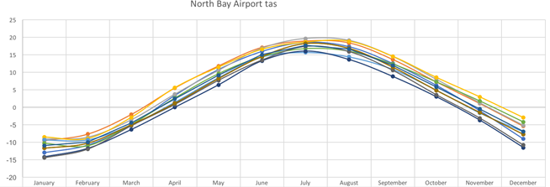



… [12 figures, Tmean only]

**Figure 2. Long-term (30-year?) monthly mean at 12 stations**

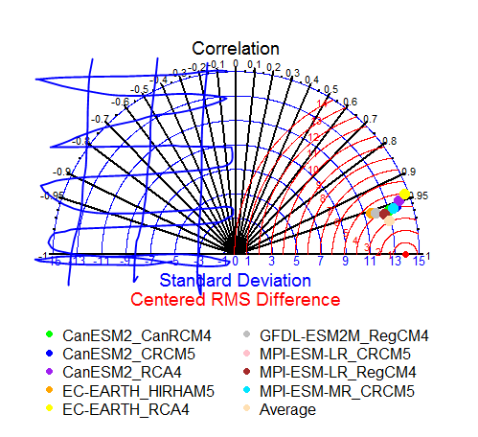

….[12 figures, first quartile only]

**Figure 3. Taylor diagrams for 12 station (first quartile only?)**

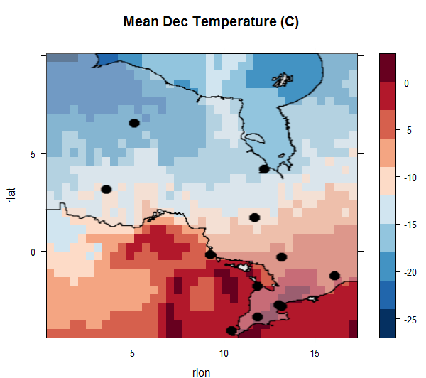

…[12 figures, annual Tmean from Jan to Dec]

**Figure 7. Long-term monthly mean temperature over the domain**

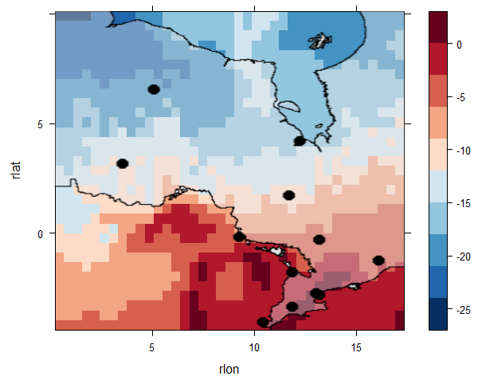

[12 figures, from Jan to Dec, variation = Tmax – Tmin]

**Figure 8. average monthly temperature variation over the domain**

# List of Tables

Table 1.

Table 2. …

**Table 3: R2 or monthly bias [or other criteria]**

|  |  |  |  |  |
| --- | --- | --- | --- | --- |
| **Simulations** | January | February | … | … |
| CanESM2_CanRCM4 |  |  |  |  |
| … |  |  |  |  |
| … |  |  |  |  |
| … |  |  |  |  |
| … |  |  |  |  |
| … |  |  |  |  |
|  |  |  |  |  |

# References:

[use Endnote or Google Scholar]