MINI PROJECT: SMART FOOD WASTE PREDICTION
AND REDISTRIBUTION ANALYTICS
NAME: LIRESH NV
ROLL NO: 241501100
DEPT: AIML
YEAR: 3RD
SEM: 5TH

AIM:
To analyze food inventory and sales data using Python, identify food surplus and waste patterns, estimate potential surplus, and present actionable insights through Power BI and Tableau dashboards.

OBJECTIVES:
- Load a food inventory and sales dataset and check data quality.
- Clean missing values, duplicates and inconsistent records.
- Calculate surplus quantity, quantity wasted and waste rate.
- Compare waste by food category and weekday/weekend patterns.
- Identify potential surplus items for timely, safety-checked redistribution.
- Export the cleaned dataset for Power BI and Tableau dashboards.

DATASET DESCRIPTION:
Dataset Name: Smart Food Waste Sample Dataset (synthetic illustrative data created for this project).
Coverage: 30 days (1–30 January 2026), 8 food items and 240 daily item records.
Note: All records and results in this document are generated sample data for demonstrating the workflow; they are not actual records from a restaurant, supermarket or donation organization.
Attribute | Description
Date | Date of daily inventory and sales record
Food Item / Category | Food product and category
Quantity Prepared | Units prepared or stocked
Quantity Sold | Units sold during the day
Surplus Quantity | Prepared quantity minus quantity sold
Quantity Donated | Illustrative quantity recorded as donated
Quantity Wasted | Surplus remaining after recorded donation
Shelf Life (Days) | Illustrative shelf-life field; does not establish food safety
Day Type | Weekday or weekend
Waste Rate (%) | Wasted quantity divided by prepared quantity × 100

TOOLS USED:
- Python libraries: Pandas, NumPy, Matplotlib (Google Colab or Jupyter Notebook).
- Business intelligence: Power BI and Tableau.

PYTHON IMPLEMENTATION — CODE:
The next page contains the reproducible data preparation and analysis code used to generate the sample output.

PYTHON IMPLEMENTATION
import pandas as pd
import matplotlib.pyplot as plt

# Load the sample CSV generated for this project
data = pd.read_csv("Smart_Food_Waste_Sample_Data.csv")

# Clean and validate
data["Date"] = pd.to_datetime(data["Date"], errors="coerce")
data = data.drop_duplicates()
data = data.dropna(subset=["Date", "Food Item", "Quantity Prepared",
"Quantity Sold", "Quantity Wasted"])
numeric = ["Quantity Prepared", "Quantity Sold", "Surplus Quantity",
"Quantity Donated", "Quantity Wasted"]
for col in numeric:
data[col] = pd.to_numeric(data[col], errors="coerce")
data = data.dropna(subset=numeric)
data = data[(data["Quantity Prepared"] >= 0) &
(data["Quantity Sold"] >= 0) &
(data["Quantity Wasted"] >= 0)]

# Feature engineering
data["Waste Rate (%)"] = (
data["Quantity Wasted"] / data["Quantity Prepared"].replace(0, pd.NA) * 100
).fillna(0).round(2)
data["Month"] = data["Date"].dt.month_name()
data["Day Type"] = data["Date"].dt.dayofweek.map(
lambda d: "Weekend" if d >= 5 else "Weekday"
)

# Key performance indicators
prepared = data["Quantity Prepared"].sum()
sold = data["Quantity Sold"].sum()
surplus = data["Surplus Quantity"].sum()
donated = data["Quantity Donated"].sum()
wasted = data["Quantity Wasted"].sum()
print("Total prepared:", prepared)
print("Total sold:", sold)
print("Total surplus:", surplus)
print("Total donated:", donated)
print("Total wasted:", wasted)
print("Waste rate (%):", round(wasted / prepared * 100, 2))

# Category analysis and charts
category_waste = data.groupby("Category")["Quantity Wasted"].sum()
category_waste.sort_values().plot(kind="bar", title="Food Waste by Category")
plt.ylabel("Quantity wasted (units)")
plt.tight_layout()
plt.show()

data["Date"] = data["Date"].dt.strftime("%Y-%m-%d")
data.to_csv("Cleaned_Smart_Food_Waste.csv", index=False)
data.to_excel("Cleaned_Smart_Food_Waste.xlsx", index=False)
Implementation note: Run the code in the same folder as Smart_Food_Waste_Sample_Data.csv. The CSV is supplied alongside this report.

ANALYSIS LOGIC
Metric | Formula / Interpretation
Surplus Quantity | Quantity Prepared − Quantity Sold
Waste Rate (%) | Quantity Wasted ÷ Quantity Prepared × 100
Donation Share (%) | Quantity Donated ÷ Surplus Quantity × 100
Category Waste | Sum of Quantity Wasted grouped by food category
Daily Trend | Sum of Quantity Wasted grouped by date

Important: The sample dataset is designed to demonstrate analysis. For real deployment, donation eligibility must also consider temperature control, packaging, allergen information, expiry/use-by rules and local food-safety requirements. Analytics alone cannot certify food as safe.

PYTHON OUTPUT
The following results were calculated from the synthetic 30-day sample dataset supplied with this report.
Measure | Sample Result
Records analyzed | 240 daily item records
Distinct food items | 8
Coverage | 1–30 January 2026
Total quantity prepared | 9,902 units
Total quantity sold | 7,570 units
Total recorded surplus | 2,332 units
Total recorded donations | 630 units
Total recorded waste | 1,702 units
Waste rate | 17.19% of prepared quantity
Donation share of surplus | 27.02%

1. Food Waste by Category
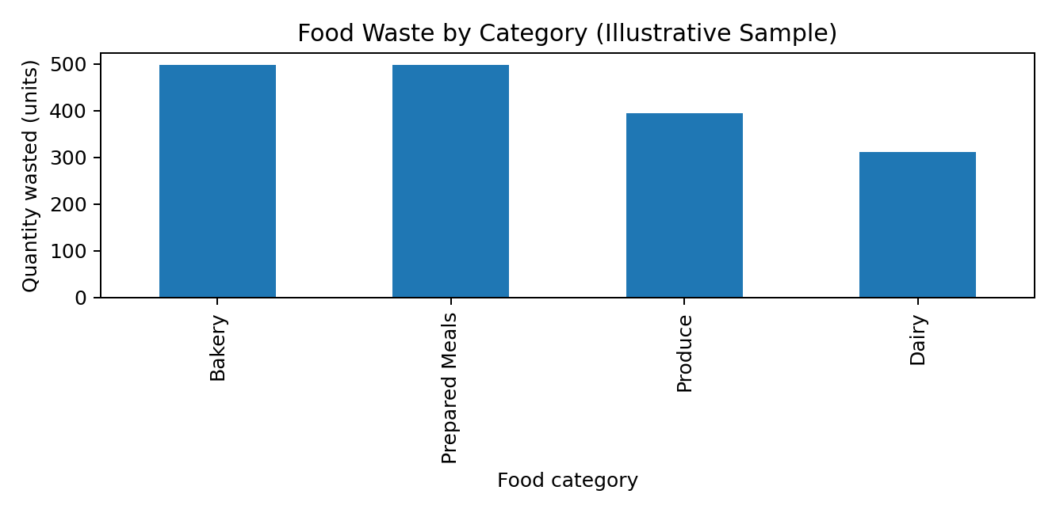
Observation: Bakery has the highest recorded waste in this illustrative dataset (498 units). This category should be reviewed first for demand forecasting, batch sizing and safe redistribution opportunities.

2. Daily Waste Trend
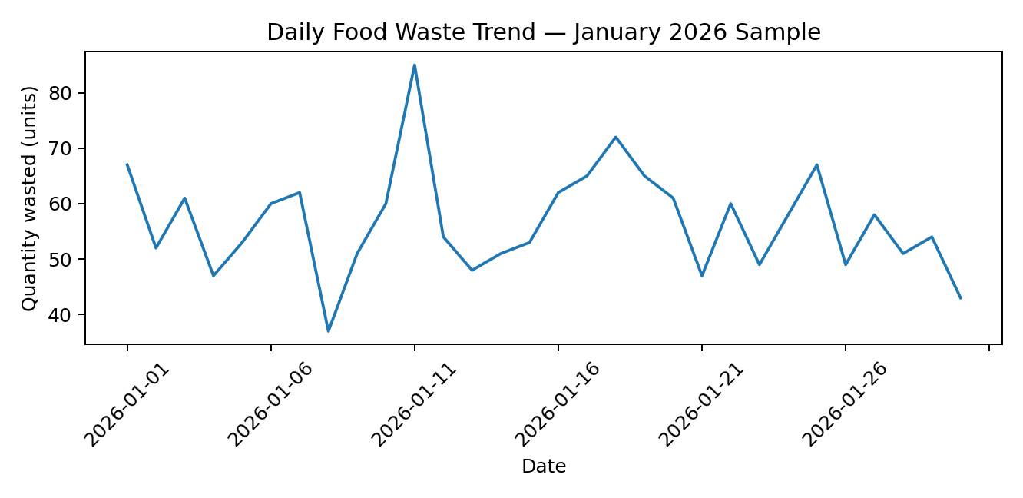
Observation: Daily waste fluctuates with the generated sample demand and production values. A real business should compare trends with events, promotions, weather, stock availability and actual sales before changing production.

3. Food Flow Summary
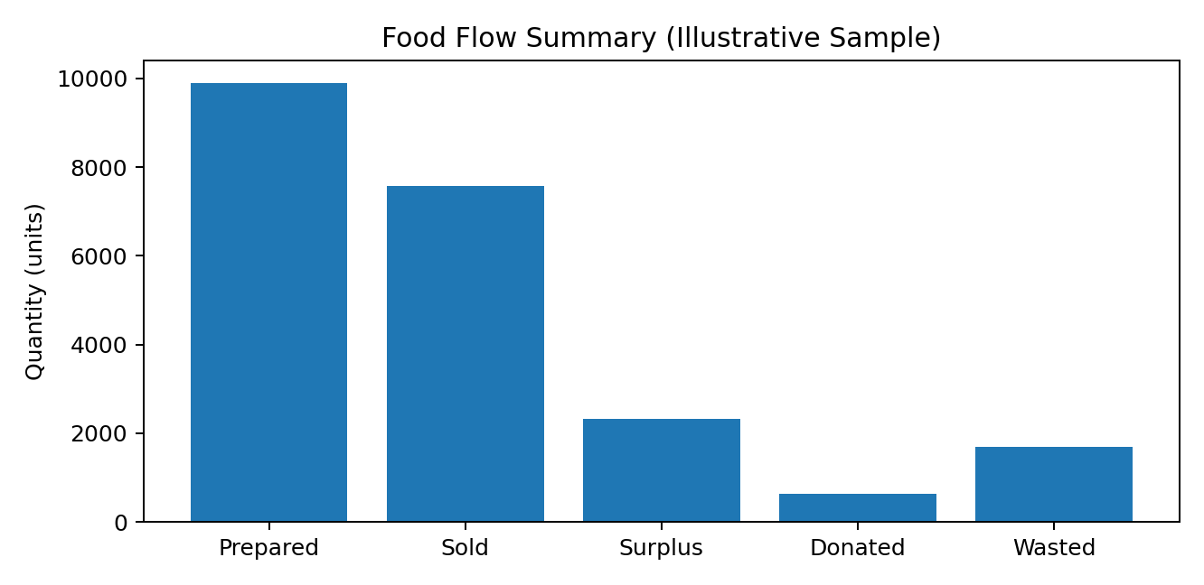
Observation: The food-flow chart compares prepared, sold, surplus, donated and wasted quantities. These measures should be monitored together: reducing overproduction can prevent surplus, while safe redistribution may divert eligible surplus from waste.

CATEGORY-LEVEL SUMMARY
Category | Prepared | Sold | Donated | Wasted
Bakery | 2128 | 1442 | 188 | 498
Prepared Meals | 2719 | 2034 | 187 | 498
Produce | 2939 | 2398 | 147 | 394
Dairy | 2116 | 1696 | 108 | 312

KEY INTERPRETATIONS
- Waste hotspots: Prioritize categories with higher recorded waste, then inspect item-level and day-level causes.
- Production planning: Compare past sales with production to reduce avoidable over-preparation.
- Redistribution: Flag surplus early enough for review by an authorized food-safety or donation coordinator.
- Measurement: Track waste rate over time, not only total waste, so that changing production volumes do not distort comparisons.
The figures above are calculated from generated sample data and must not be presented as verified outcomes from a real organization.

POWER BI OUTPUT — PROPOSED DASHBOARD
Dashboard name: Smart Food Waste Monitoring Dashboard
Visual / KPI | Purpose
KPI cards: Prepared, Sold, Surplus, Donated, Wasted | Show the overall food flow at a glance
Waste rate (%) | Track waste relative to quantity prepared
Waste by category bar chart | Identify categories with the largest recorded waste
Daily waste trend line | Spot unusually high-waste dates
Weekday vs weekend comparison | Compare typical waste levels across day types
Food item detail table | Inspect prepared, sold, surplus, donated and wasted quantities
Filters: date, category, food item | Allow focused investigation

Suggested Power BI measures
Total Prepared = SUM(FoodWaste[Quantity Prepared])
Total Sold = SUM(FoodWaste[Quantity Sold])
Total Waste = SUM(FoodWaste[Quantity Wasted])
Waste Rate % = DIVIDE([Total Waste], [Total Prepared], 0)
Total Surplus = SUM(FoodWaste[Surplus Quantity])
Total Donated = SUM(FoodWaste[Quantity Donated])
These measures are illustrative formulas. Field names should match the imported dataset exactly.

TABLEAU OUTPUT — PROPOSED DASHBOARD
Dashboard name: Food Waste and Redistribution Overview
- Category waste comparison with interactive filters.
- Daily waste trend and date-level drill-down.
- Food flow comparison for prepared, sold, surplus, donated and wasted quantities.
- Day-type comparison and item-level detail table.
Power BI and Tableau dashboards are specified as implementation designs in this report. No screenshots are represented as completed software outputs; create the dashboards by importing the supplied CSV or Excel file.

RESULT
The sample food-waste dataset containing 240 records was generated, cleaned and analyzed. Across the illustrative period, 9,902 units were prepared and 7,570 units were sold. The dataset records 2,332 surplus units, 630 donated units and 1,702 wasted units, giving a waste rate of 17.19% of prepared quantity. Bakery recorded the highest category-level waste in this sample.

CONCLUSION
- Python provides a repeatable workflow for cleaning food inventory and sales data.
- Waste rates and category-level comparisons help identify where further investigation may be valuable.
- Historical sales and production data can support demand planning and reduce avoidable surplus.
- Power BI and Tableau can communicate waste trends and operational KPIs through interactive dashboards.
- Redistribution must be limited to food that passes appropriate safety, handling and eligibility checks.

LIMITATIONS AND FUTURE ENHANCEMENTS
- The dataset is synthetic and illustrative; findings cannot be generalized to real businesses.
- Future work can use real timestamped inventory and sales data and evaluate a forecasting model on held-out dates.
- A future version could add donation partner capacity, pickup time windows, food-safety checks and location-based matching.

APPENDIX: DATA FILE
Companion file: Smart_Food_Waste_Sample_Data.csv. It contains the 240 generated daily item records used to calculate the report's results. The Python code exports cleaned CSV and Excel versions when executed.
Project prepared for academic demonstration. Sample values are disclosed explicitly and should be replaced with validated real data for a live deployment.

