Impact of Social Media Marketing on Consumer Purchase Behavior in
E-Commerce Platforms

Objective: how social media marketing campaigns (ads, influencer promotions, user reviews, and product posts) influence consumer purchasing decisions on platforms like Amazon, Flipkart, and Meesho.

Introduction
In recent years, the exponential rise of social media platforms has revolutionized the landscape of marketing, especially for e-commerce businesses. With billions of users actively engaging on platforms such as Instagram, YouTube, Facebook, WhatsApp, and Twitter (now X), social media has become integral to consumers' digital lives and, consequently, their shopping behaviors. The fusion of visual content, instant sharing, peer interactions, and targeted advertisements allows brands unprecedented access to their audiences—shaping perceptions, influencing decisions, and fostering brand loyalty in ways that traditional marketing mediums cannot match.
India’s e-commerce sector, driven by giants like Amazon, Flipkart, and emerging platforms like Meesho, has benefited immensely from this shift. As the country embraces digital payment systems, affordable smartphones, and increased internet penetration, the line between social engagement and shopping is rapidly blurring. Social media marketing, encompassing influencer endorsements, paid ads, user-generated reviews, and interactive product posts, has become a cornerstone for reaching new customers and sustaining engagement. Companies now invest significant resources in crafting campaigns that not only capture attention but also create trusting relationships with potential buyers.
The influence of social media on consumer behavior is multifaceted. Advertisements tailored to a user’s interest, recommendations from online personalities (influencers), and authentic user reviews offer persuasive power in the decision journey—often tipping the balance in favor of a purchase. Younger demographics, in particular, are more susceptible to social media cues, but the influence extends across all age groups due to the omnipresence of digital platforms. Despite the obvious impact, it remains crucial for marketers and businesses to understand which platforms, strategies, and content types most effectively convert engagement into purchase action.
This project report aims to examine how social media marketing campaigns affect consumer purchase behavior within leading e-commerce platforms. Using survey data and Power BI visualizations, the analysis focuses on four primary components: ads, influencer promotions, user reviews, and product posts. The objective is to uncover actionable insights regarding which marketing tactics and channels are most influential—thereby enabling businesses to refine their approaches for better customer acquisition and retention. The study also considers demographic factors such as age and gender, offering a holistic view of the digital marketplace in today’s social era.

Methodology
To investigate the impact of social media marketing on consumer purchase behavior in e-commerce platforms, a systematic and structured approach was employed. The methodology encompassed survey design, data collection, analytical processing, and visualization using robust business intelligence tools. Each stage was carefully planned to ensure the reliability, validity, and relevance of findings.
1. Research Design
The study adopted a quantitative, descriptive research design to capture the measurable influence of social media activities on consumer decisions. The focus was on major e-commerce platforms—Amazon, Flipkart, and Meesho—where social media content, including ads, influencer promotions, and user reviews, plays a pivotal role in marketing. The project aimed to answer how frequently and in what ways social media interventions can affect purchase decisions across demographic variables.
2. Data Collection
- Survey Development: A structured survey was created to gather consumer data. The survey included both closed-ended and scaled questions addressing key factors such as frequency of ad exposure, interaction with influencer videos, reliance on user reviews, preferred social media platforms, and demographic information (age, gender).
- Sample Selection: The target sample consisted of active e-commerce users in India, ranging from below 18 to above 45 years old. Efforts were made to achieve diversity in gender and platform preferences. Sampling was random but focused on individuals who engaged with social media for shopping and information.
- Data Acquisition: Respondents accessed the survey via digital links distributed on social media groups, forums, and messaging services. Participation was voluntary and responses were anonymized to promote honest feedback.
3. Data Processing and Analysis
- Data Cleaning: Survey responses were checked for completeness, consistency, and accuracy. Invalid, duplicate, or incomplete records were excluded from the final analysis.
- Variable Categorization:
Data fields included:
  - Type and frequency of product ads seen (Tech, Apparel, Health, etc.)
  - Platforms used most often (Instagram, YouTube, WhatsApp, Facebook, X/Twitter, Pinterest)
  - Social media influence level (moderately, slightly, very strongly)
  - Influencer category (Tech, Food, Health, Fashion, Niche)
  - Purchase actions and ROI indicators
  - Demographics (age groups, gender)
- Analytical Tools: Power BI was utilized to visualize data distributions, trends, and relationships. The software enabled the creation of pie charts, bar graphs, stacked visuals, and tree diagrams to enhance interpretation and communication of results.
4. Data Visualization
- Power BI Visualization: Graphics were designed to illustrate:
  - Demographic breakdowns by platform and age
  - Frequency and ROI of product ads by company and category
  - Impact of influencer videos on purchase probabilities
  - Cross-platform social media usage and its effect on buying behavior
- Figure Reference System: Each visualization was referenced in the results and discussion sections, with clear figure captions and interpretation.
5. Ethical Considerations
Participants were informed about the purpose of the study and their right to confidentiality. No personally identifiable information was collected, and all data was analyzed at an aggregate level to ensure privacy.
6. Limitations
The methodology was subject to limitations such as sample size, potential response bias, and restricted geographic focus. These were acknowledged to guide future research improvements.

Result
The analysis of survey data through Power BI visualizations yielded several insightful findings on the impact of social media marketing on consumer purchase behavior in e-commerce platforms. Results are organized around the major themes: platform usage, ad frequency and ROI, influencer impact, demographic trends, and user reviews/suggestions.
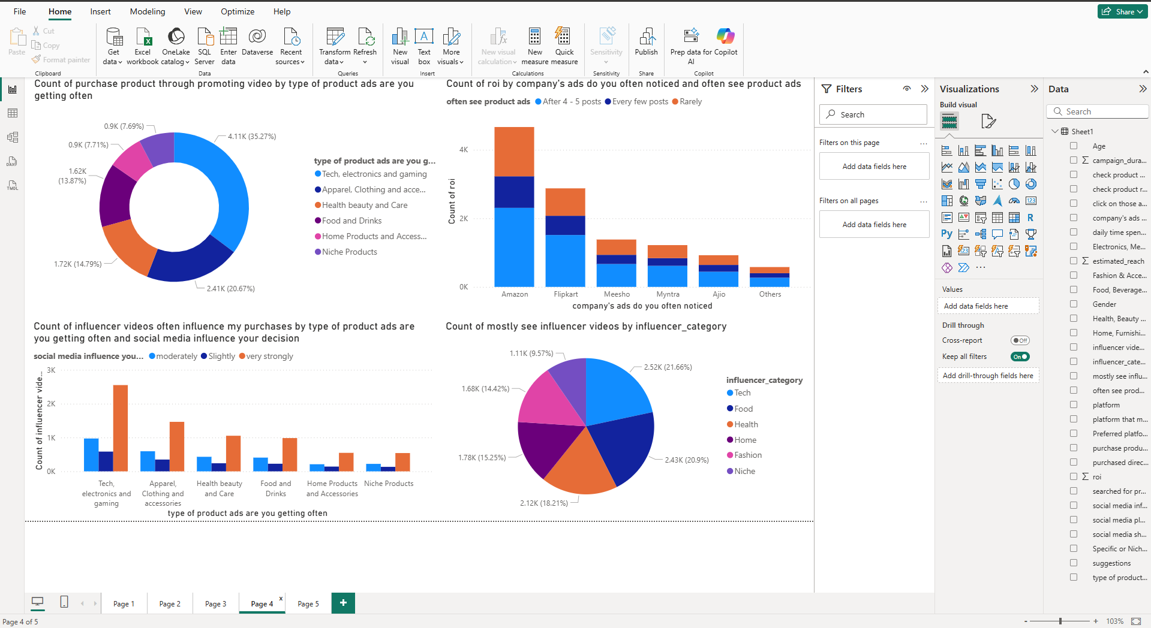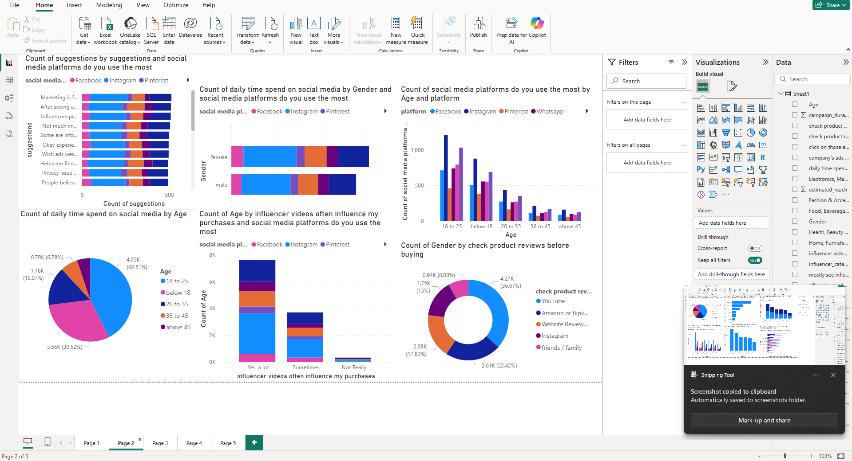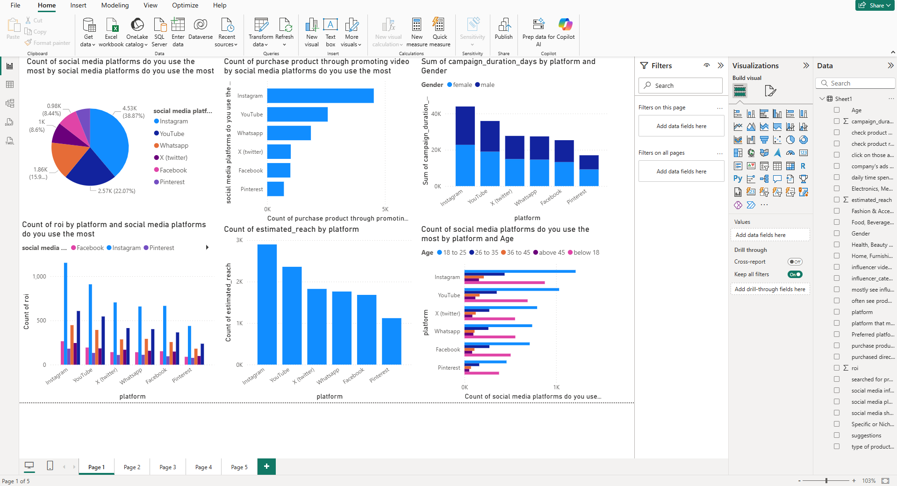
1. Social Media Platform Usage
- The pie chart indicates Instagram dominates as the most frequently used social media platform for shopping and engagement (nearly 39%), followed by YouTube (22%) and WhatsApp (16%).
- Facebook, Pinterest, and Twitter (X) have moderate user engagement compared to the leading platforms.
- Bar graphs show Instagram and YouTube are preferred across all age groups, with the 18–25 age segment particularly active.
2. Impact of Product Ads
- Product ads are most frequently viewed for categories like Tech, Electronics, Apparel, and Health & Beauty.
- Amazon and Flipkart are top-performing platforms in terms of ad frequency and resulting ROI, with Amazon’s ads reaching the greatest number of respondents and yielding high returns.
- Respondents reported seeing product ads most often after viewing four to five posts, suggesting targeted ad frequency is a key factor in driving purchases.
3. Influencer Marketing and Purchase Decisions
- Influencer videos have a significant effect on consumer choices, most notably within tech, apparel, health, and food product categories.
- Younger consumers (primarily aged 18–25) report more frequent purchases under the influence of social media personalities.
- The data indicates that “very strongly influenced” respondents are more likely to buy promoted products after seeing influencer endorsements.
4. ROI by Platform and Campaign Length
- Instagram, YouTube, and Facebook led in ROI and the sum of campaign duration days.
- Both male and female respondents showed high engagement and ROI across these platforms, with slight variations depending on category and age group.
5. Demographic and Social Media Influence Trends
- Social media influence on purchasing is highest among the 18–25 and below 18 age groups, dropping significantly among older demographics.
- Both moderate and strong influence levels are present, but those reporting “very strong” influence form the largest segment among active buyers.
6. Role of User Reviews and Suggestions
- Survey results highlight the importance of product reviews from friends, family, and social platforms such as YouTube and Instagram.
- Suggestions and recommendations through social media networks build trust and influence purchase decisions.
7. Summary Table of Key Insights from Visualizations
Theme | Key Finding
Platform Usage | Instagram & YouTube are dominant for shopping engagement
Ad Frequency/ROI | Amazon & Flipkart lead in ad reach and ROI
Influencer Impact | Young buyers most influenced; tech/fashion/health categories respond strongest
Demographics/Influence | Very strong social media influence in 18–25 segment
Reviews/Suggestions | User reviews and peer suggestions drive trust and intent

Visual Reference:
- Pie charts and bar graphs included in the Appendix further illustrate these relationships, with captions and analysis for each.

Discussion
The findings of this study highlight the dominant role that social media marketing plays in shaping consumer purchase behavior on e-commerce platforms. The results align with and expand upon existing literature, which consistently underscores the growing power of digital platforms in influencing buyer choices. Several critical implications emerge from the data that warrant careful analysis.
1. Social Media as a Primary Marketing Channel
Most notably, Instagram and YouTube’s dominance—shown both in frequency of use and ROI for e-commerce ads—confirms that these platforms are no longer just social spaces but have transformed into vibrant marketplaces. The interactive and visual nature of Instagram, as well as the immersive, demonstration-driven marketing on YouTube, make them ideal for brands seeking to build awareness and drive immediate conversions. Marketers should continue investing in these channels, focusing on content that engages visually and emotionally.
2. Influencer Impact and Consumer Psychology
The results strongly reinforce the notion that influencer-based promotions have an outsized effect on young consumers (especially 18–25 years old). This is possibly because influencers build trust and rapport over time, narrowing the psychological distance between consumers and products. The ability of influencers to “humanize” brands, provide authentic reviews, and demonstrate product use in real-life contexts appears to help overcome consumer hesitation and skepticism. This aligns with the AIDA (Attention-Interest-Desire-Action) model, where influencers move audiences from awareness to action with persuasive storytelling.
3. Ad Frequency, Platform Differences, and ROI
Amazon and Flipkart’s high ROI and ad reach reflect their massive user bases and sophisticated advertising algorithms. The data suggests a “sweet spot” in ad frequency, as most respondents notice product ads after viewing four to five posts—indicating that over-exposure can lead to banner blindness, while strategic targeting maximizes impact. Personalization based on user interest and recent activity leads to more meaningful engagement and higher conversion rates.
4. Demographic Sensitivities
The research illustrates significant demographic trends. Younger consumers are more impressionable to social media cues and influencer marketing, possibly due to higher time spent on digital platforms and social sharing behaviors. Conversely, older segments show more moderate influence, suggesting that a one-size-fits-all approach is less effective. E-commerce firms must thus segment audiences and customize campaigns for maximum effectiveness.
5. User Reviews and Peer Influence
An interesting insight is the continuing relevance of peer reviews and recommendations—even in an era saturated with influencer and corporate messaging. Respondents placed significant trust in product reviews by friends, family, and relatable users, indicating that authenticity and community sentiment remain central to online purchase decisions. Platforms that encourage honest user feedback and social sharing can strengthen consumer confidence.
6. Integrated Marketing Strategies
The findings advocate for integrated marketing approaches: combining paid ads, influencer partnerships, and authentic user content can create a synergistic effect on consumer intent. Campaigns should be data-driven but retain a human touch, blending emotion with information.
7. Practical and Strategic Implications
For marketers and e-commerce platforms, the implications are clear:
- Focus on high-engagement platforms (especially Instagram/YouTube).
- Target campaigns based on demographic insights.
- Invest in influencer and micro-influencer relationships.
- Foster trustworthy user review systems.
- Use analytics to fine-tune ad exposure and frequency.
Limitations and Future Research
While this analysis provides valuable insights, limitations exist. The data may be influenced by sample size, possible self-reporting bias, and concentration on Indian urban/semi-urban users. Future research could expand on these findings through qualitative interviews, larger sample pools, or comparative studies across different regions and cultures.

