

KOCCA - Kinect & Optitrack Calibration & Capture Application

User Manual

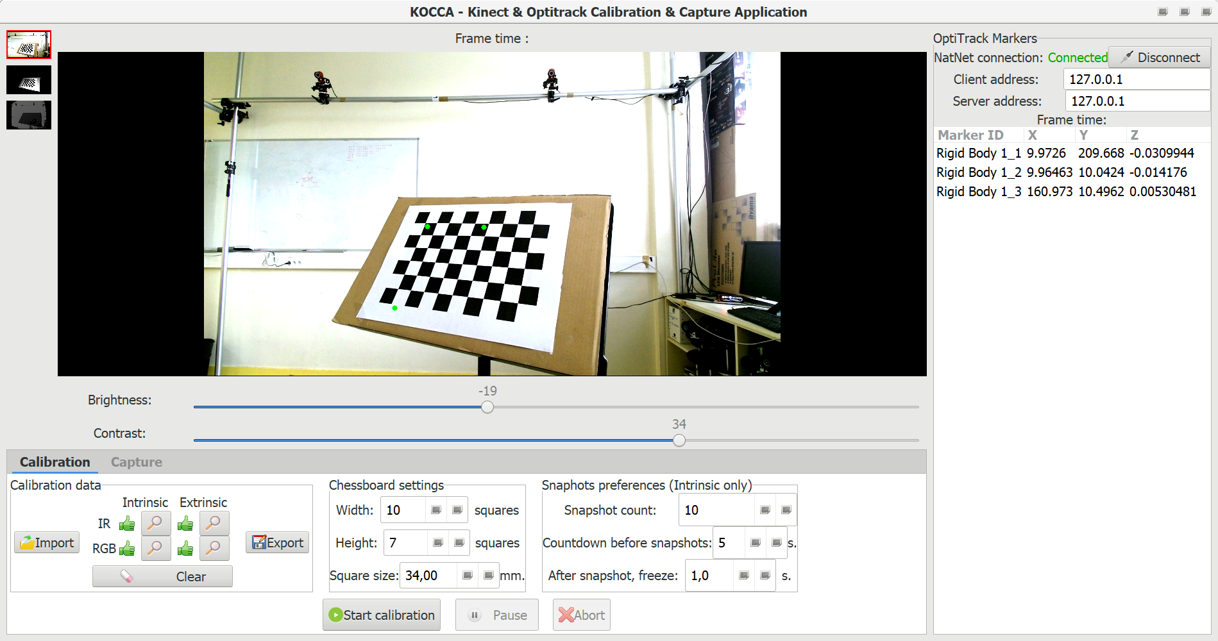

Index
1 General purpose 3
2 Main features 3
3 Prerequisites 4
3.1 Hardware 4
3.2 Software 4
4 Set-up 5
5 Chessboard calibration target 6
6 User Interface 7
6.1 Overview 7
6.2 NatNet Connection panel 8
6.3 Calibration tab 8
6.4 Capture / Playback tab 9
7 Step-by-step calibration 10
7.1 Calibrate your Optitrack system 10
7.2 Set Motive as a NatNet server 10
7.3 Connect KOCCA to Motive 10
7.4 Adjust brightness and contrast settings 10
7.5 Configure KOCCA calibration settings 11
7.6 Kinect Intrinsic calibration 12
7.7 Kinect Extrinsic calibration 13
7.8 Set ground plane in Motive 13
7.9 Saving / loading calibration file 14
7.10 Kinect Calibration File (.kcf) format description 14
8 Capture 15
9 Manipulating captured data 16
9.1 Exporting a captured sequence from KOCCA 16
9.2 Opening / reading a sequence file into KOCCA 16
9.3 KOCCA Sequence Archive (.ksa) format description 16
9.4 CSV markers data file format 17
9.5 KOCCA temp folders and recovery 17
10 Appendix : Printable chessboard target model 18

General purpose
KOCCA's ultimate purpose is to simultaneously acquire data from both an Optitrack system and a Microsoft Kinect V2, in order to be able to project the Optitrack makers coordinates to Kinect images.
Calculating such a projection requires to know some characteristics of the Kinect, aswell as it's physical position towards the Optitrack system.
The action of measuring these informations is called « calibration » and another major purpose of KOCCA is to help you achieving it.
All of these features are accessible through a (hopefully) comprehensive user interface.

Main features
KOCCA allows to :
- Perform intrinsic calibration of the two cameras (color and infrared) of one Kinect V2 device.
- Perform extrinc calibration of these two cameras relatively to an Optitrack system's 3D-space.
- Save / load cameras calibration data.
- Connect to an Optitrack system through network and stream it's 3D markers data.
- Get 3 streams from a Kinect : color, infrared and depth.
- Monitor all these data streams in realtime.
- Project 3D Optitrack markers on 2D Kinect images, according to calibration data.
- Record all of these streams data into a sequence and save it as a sequence file.
- Re-open a sequence file and play it back.

Prerequisites

Hardware
- An Optitrack Motion Capture system.
- A Microsoft Kinect V2 device.
- At least one computer with :
- x86 architecture processor
- USB 3 (recommended to save one dedicated USB3 controller only for the Kinect)
- SSD drive (not mandatory, but highly recommended)
- A chessboard calibration target (see 5)

Software
- Microsoft Windows 10 operating system, with additional components :
- Microsoft Kinect SDK v2
https://www.microsoft.com/en-us/download/details.aspx?id=44561
- Microsoft Visual C++ 2015 redistributable
https://www.microsoft.com/fr-fr/download/details.aspx?id=48145
- Microsoft Visual C++ 2013 redistributable
https://www.microsoft.com/fr-fr/download/details.aspx?id=40784
- Microsoft Visual C++ 2010 redistributable
https://www.microsoft.com/fr-fr/download/details.aspx?id=5555
- Optitrack Motive

Set-up
Below is a schematic representation of the full set-up, hardware and software :
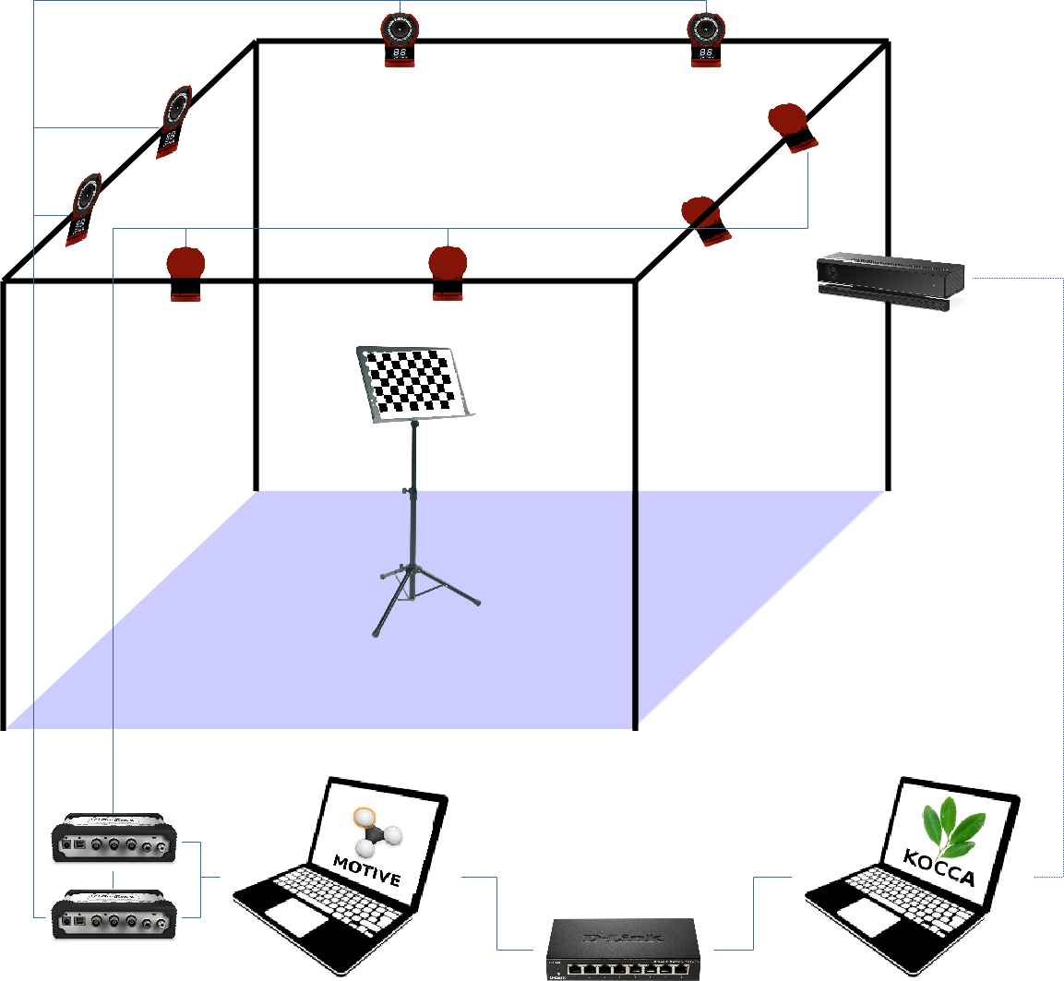
- Kinect V2 Sensor, plugged to the computer running KOCCA (5)
1
2
3
4
5
7
6
Could also run on the same single computer
- Optitrack cameras, plugged to Optitrack hubs (3)
- Optitrack hubs, plugged to a computer running Optitrack Motive (4)
- Computer running Optitrack Motive
- Computer running KOCCA
- If Motive and KOCCA run on different computers, they must be connected through network
OR : Motive and KOCCA can also run on the same single computer and communicate through a local connection
- Chessboard calibration target (see 5).

Chessboard calibration target
With the OpenCV library (that KOCCA uses), in order to perform camera calibration, you can use a a printed chessboard-pattern target like this one :
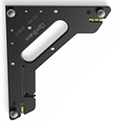
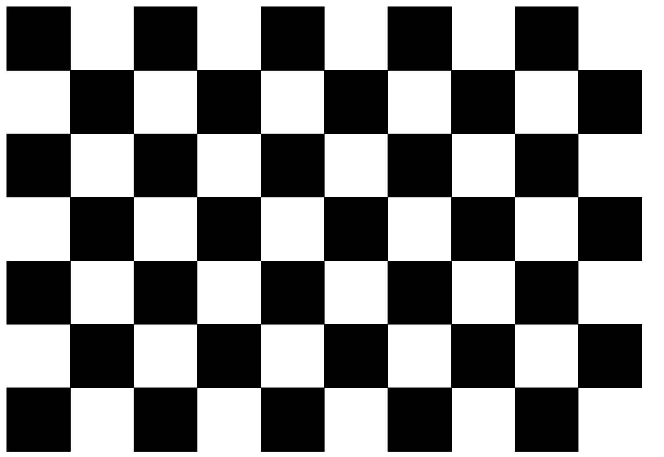
With Optitrack, you would use a specially designed triangle square (with three markers) at the end of calibration, in order to define the ground plane as well as origin of coordinates axis (X,Y, & Z).
With KOCCA, we merged these two accessories into one : a printed chessboard with three markers sticked on it. The position of the markers is designed so :
- markers on the chessboard keep the same distance and position between each other as those on the original square triangle.
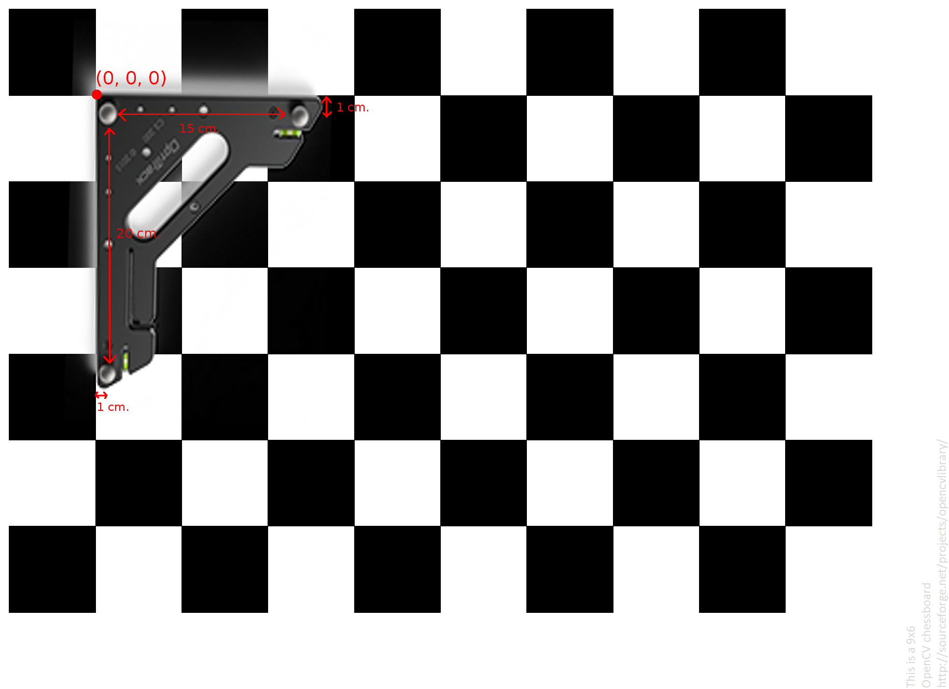
- corner of the « simulated » triangle square (wich Optitrack uses as it's 0,0,0 origin) coincide with the lower-right corner of the top-left square in the the chessboard (wich OpenCV uses as it's 0,0,0 origin).
Note that, according to OpenCV requirements :
- The size of squares in the chessboard doesn't matter, as long as they are squares, all of the same size, and you know that size (bigger squares help for more precise calibration, though).
- The number of rows and columns in the chessboard doesn't matter as long as one is odd and the other is even.
You will find in appendix 10 a target model. You can print it in A3 format, attach it on a plane and rigid support, then finally stick three markers on the dedicated spots.

User Interface

Overview
Below is a screenshot of the UI's main window :
- Monitor : displays the currently selected Kinect stream. Optitrack markers are also shown as green dots if the application is connected to a NatNet server (i.e. Optitrack Motive) and if the kinect is fully calibrated (intrinsic and extrinsic). Hovering a marker displays it's name. Click one marker or serveral holding 'Ctrl' key to select them. Selected markers show as red dots on the monitor and the corresponding lines in the Optitrack markers list (3) are highlighted.
4
3
5
6
2
1
- Stream monitoring selectors : click one of the three thumbnails (image, infrared or depth) to display the corresponding stream in the monitor (1).
- Optitrack markers list : shows the list of Optitrack markers with their 3D position. Click one line of the list, or several holding 'Ctrl' or 'Shift' key to select them. Selected markers lines are highlighted and the corresponding markers show as red dots on the monitor (1).
- NatNet connection panel : allows to set the connection setting and connect to / disconnect from a NatNet server (i.e. Optitrack Motive). For more details see chapter 6.2.
- Brightness / Contrast adjustments : allows to adjust brightness and contrast for color image and infrared streams (not for depth as it would make no sense). This is especially usefull during calibration process, in order to optimise the detection of the chessboard.
- Calibration / Capture tabs : allows to switch between calibration or capture/playback modes. For more details see chapters 6.3 and 6.4.

NatNet Connection panel
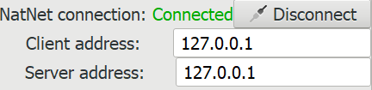
- Client address entry : enter the IP of your client machine that runs KOCCA. If you run KOCCA and Motive on the same computer, this address should be 127.0.0.1
3
2
1
4
- Server address entry : enter the IP address of the NatNet server to connect to. If you run KOCCA and Motive on the same computer, this address should be 127.0.0.1
- Connect / Disconnect button : when the client and server addresses are set correctly, click this button to initiate connection to NatNet server. When KOCCA is already connected, click this button to disconnect.
- Connection status indicator : writes « Connected » (in green) or « Diconnected » (in red) to indicate wheter KOCCA is connected to the NatNet server or not.

Calibration tab
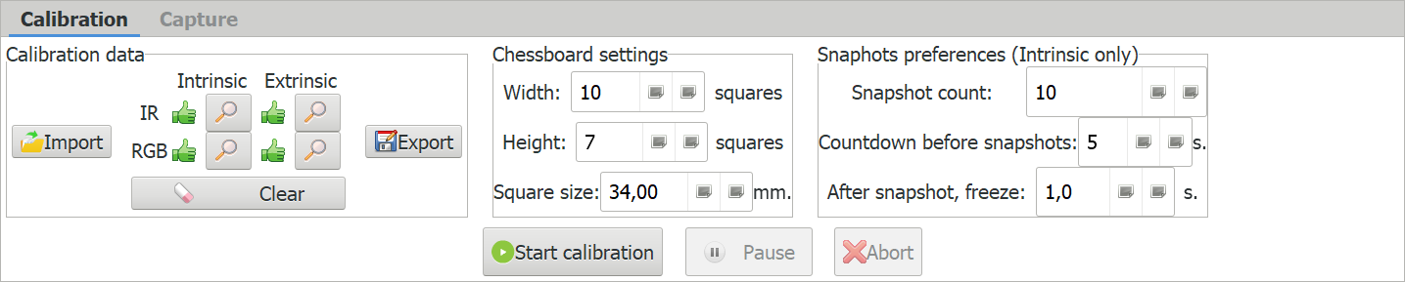
- Import calibration button : allows to load calibration data from a .kcf file.
1
2
3
4
5
12
13
14
6
7
8
9
10
11
- Export calibration button : allows to export current calibration data into a new .kcf file.
- Clear calibration button : allows to clear some or all of the current calibration data.
- Calibration error indicators : visually indicates with a icon, for each calibration type of each camera, if the calibration error is important or not.
- Show calibration details buttons : allows to show the full calibration data for each calibration type of each camera.
- Chessboard width setting : indicate here the number of columns in your chessboard target.
- Chessboard height setting : indicate here the number of rows in your chessboard target.
- Chessboard square size setting : indicate here the size (in millimeters) of each square in the chessboard target you use.
- Snapshot count setting : choose the number of snaphots to take for intrinsic calibrations.
- Countown duration setting : choose the duration of countdown beetween each snapshot during intrinsic calibrations.
- Freeze duration setting : choose the duration of freeze when the snapshot has been taken.
- Start calibration button : click to start any calibration operation.
- Pause calibration button : click this button to temporarily suspend ongoing calibration.
- Abort calibration button : click this button to stop ongoing calibration.

Capture / Playback tab
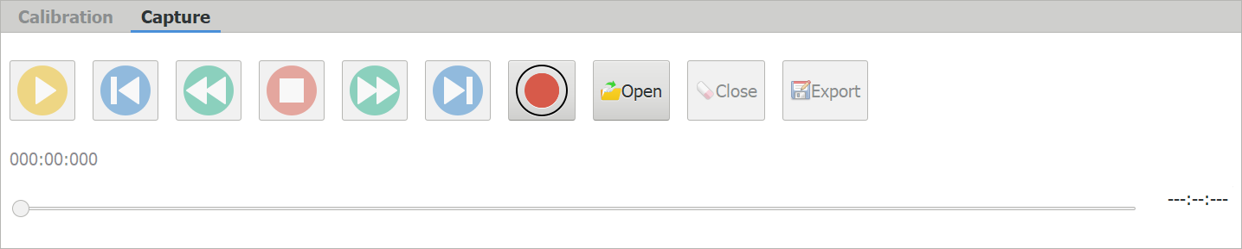
- Record button : when KOCCA is in monitoring mode, click this button to start recording a new sequence.
10
11
12
13
1
2
3
4
6
5
7
8
9
- Open sequence button : click this button to open a KOCCA Sequence Archive file (.ksa) from your filesystem and load it into KOCCA's playback mode.
- Close sequence button : click to unload current sequence and go back to monitoring mode.
- Export sequence button : click to save the currently loaded sequence as a new KOCCA Sequence Archive file (.ksa).
- Playhead : in playback mode, playhead visually indicates where you are in the sequence. You can drag it forward or backward to move within the sequence.
- Playhead time indicator : in playback mode, shows precisely the playhead time within the sequence.
- Sequence duration : in playback mode, shows the total duration of the current sequence.
- Play button : in playback mode, start playing the sequence from the playhead position.
- Go back to begining button : in playback mode, moves the playhead back to the begining of the sequence.
- Go to previous frame button : in playback mode, moves the playhead to the latest event (color image frame, infrared frame, depth frame or Optitrack markers frame) that is before the current playhead position.
- Stop button : in playback mode, stops the plahead at it's current position. In recording mode, stops the current recording and load the newly recorded sequence in playback mode.
- Go to next frame button : in playback mode, moves the playhead to the first event (color image frame, infrared frame, depth frame or Optitrack markers frame) that is after the current playhead position.
- Go to end button : in playback mode, moves the playhead to the end of the sequence.

Step-by-step calibration
Below is a step-by-step guide on how to achieve full connectivity and calibration of the set-up.

Calibrate your Optitrack system
Motive must be started, the Optitrack system must be calibrated as usual, with the wand.
However, you can skip the « Set ground plane » step for now, as we will later (7.8) set a « fake » ground plane with our custom-made hybrid calibration target (see chapter 5).

Set Motive as a NatNet server
To be able to stream makers data from Motive into KOCCA, Motive must be configured as a NatNet server, wich is not activated by default.
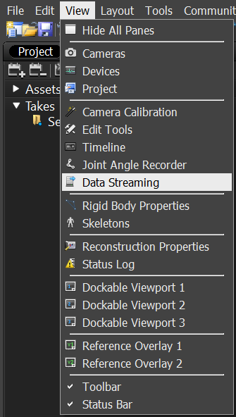
In Motive, from any layout, show the « Data Streaming » panel from the main menu > View > Data Streaming :
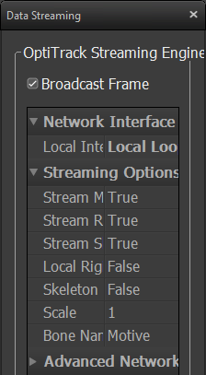
This will show the « Data Streaming » panel. Make shure « Broadcast Frame » is checked :

Connect KOCCA to Motive
Start KOCCA and set the appropriate values for « Server address » and « Client address » fields. Then click the « Connect » button. The status label should turn green and indicate « Connected ». One connected, if you have identified markers tracked in Motive, the markers names should appear with their coordinates in the markers list on the right of KOCCA's user interface (as shown in 6.1).

Adjust brightness and contrast settings
Before starting any calibration, it is recommended to adjust brightness and contrast for the cameras you wish to calibrate. Put the chessboard calibration target in sight of the cameras and adjust brightness and contrast in order to view the chessboard as clearly as possible.

Configure KOCCA calibration settings
Set the right values in the « Chessboard setting » panel, accordingly to the chessboard calibration target you use.
Adjust the « Snapshot preferences » as you prefer.
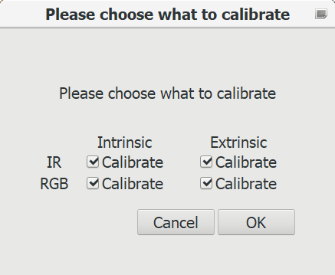
Then, click the « Start calibration » button. A dialog will appear, asking you which calibration you wish to perform for which camera :
Check the boxes for the cameras and calibration types you want to perform, then click « OK ».
Note that :
- You can overwrite a calibration for which you already have calibration data loaded.
- Both Extrinsic calibration (IR and RGB) must be performed together, or not at all. You can't have one without the other.
- You can't perform extrinsic calibration of a camera without having it's intrinsic calibration data first. That means you MUST either have intrinsic calibration already loaded OR perform it right before performing the extrinsic calibration.

Kinect Intrinsic calibration
If you checked at least one intrinsic calibration in the dialog at 7.5, then after clicking OK, intrinsic calibration will start.
A countdown will let you some time to put the chessboard calibration target in sight of the camera before taking a snapshot :
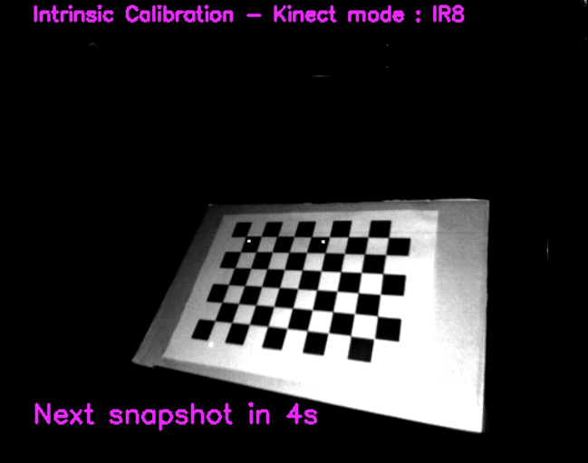
When the countdown is over, KOCCA will attempt to take a snapshot. When the chessboard is properly detected, a colored figure will be drawn on it, and the display will momentarily freeze to let you see the snapshot and to remind you the number of this snapshot.
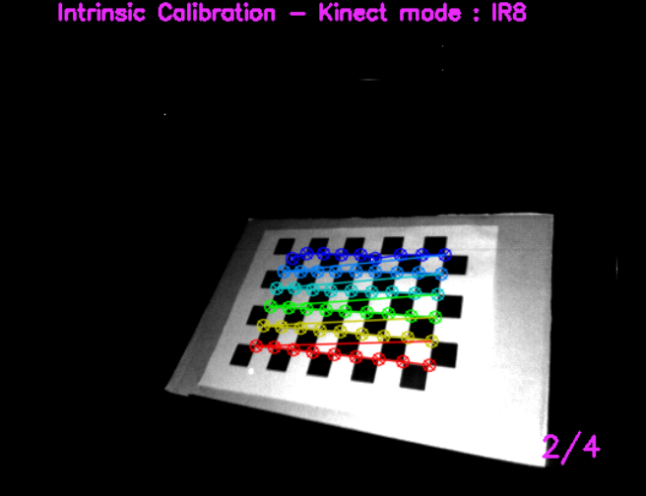
Repeat this operation as many times as configured in the « Snaphots count » setting (see 6.3).
If you chose to perform intrinsic calibration for both kinect cameras, KOCCA will start with infrared, then move to color image.
When all desired intrinsic calibrations are done, KOCCA will move to extrinsic calibration if you chose to perform it too.

Kinect Extrinsic calibration
Extrinsic calibration must be performed on both cameras (infrared and color image) in a row.
It is very important to ensure that the chessboard calibration target absolutely doesn't move a bit during this operation and the next one (Set ground plane in Motive, see 7.8). A popup dialog will appear to remind you this, before extrinsic calibration is performed :
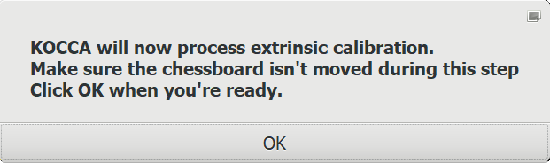
It is recommended to use a stand to put the chessboard calibration target still and in sight of both kinect cameras AND with it's markers properly detected in Optitrack.
When you're ready, click the « OK » button of the dialog above.
KOCCA will instantly (no countdown, no freeze) take two snapshots in a row (one for infrared camera and one for color image camera).
When this two snapshots are taken with the chessboard properly detected, KOCCA will display another popup dialog informing you the calibration process is finished :
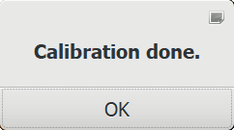
At this point, you must STILL NOT MOVE the chessboard calibration target until the next step (Set ground plane in Motive) is completed.

Set ground plane in Motive
In Motive, go to the « Calibration layout » screen, and show the « Ground Plane » tab :Be sure to put « 0 » as a value in the « Vertical Offset » entry, then click the « Set Ground Plane » button.
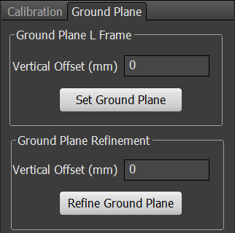
At this point, calibration is complete. You should now see the projected markers drawn as green dots on the monitor :
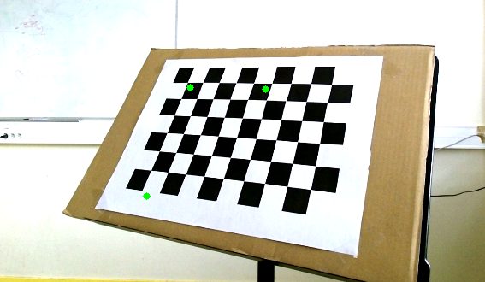
You can now move the chessboard calibration target out of the set-up.

Saving / loading calibration file
Once your setup is fully calibrated, you can save the Kinect calibration data as a .kcf file : in KOCCA's « Calibration » tab, click the « Export » button, pick a location on your filesystem, and name the file with a .kcf extension.
Note that :
- this will save the kinect calibration data but not the Optitrack system calibration. If you wish to save it too, you will have to do it from Motive.
- if you wish to re-use the calibration data later, you must be sure the Kinect device has absolutely not been moved at all since the calibration was performed, or extrinsic calibration will not be usable anymore.
- intrinsic calibration, however, is not likely to change as long as you use the same Kinect device.
- if your Kinect device has been moved since the calibration file was saved, you can still use it's intrinsic calibration data and a previous Motive Calibration file : you'll only have to re-do extrinsic calibration and set ground plane in Motive (7.7 and 7.8 steps).
- when you export a sequence as a KOCCA Sequence Archive (.ksa), the exported archive will automatically include a version of the Kinect Calibration File (.kcf) containing the calibration data used for the sequence capture.

Kinect Calibration File (.kcf) format description
Kinect calibration files are text files (with a « .kcf » extension) containing intrinsic and/or extrinsic calibration data structured in XML. You can open them with any text editor of your choice to see what's inside.
XML tag names and attributes should be self-explanatory if you are familiar with the concepts of camera calibration. If you are not, then you probably shouldn't / don't need to edit these file.

Capture
When your set-up is fully calibrated, KOCCA is connected to Motive's NatNet server, you can now start to capture some data !
Go to the « Capture » tab, and click the « Record » button.
During recording, the monitor will display a « REC [ ] » indicator (with a blinking red dot) on the top-left corner, and the elapsed recording time on the top-right corner :
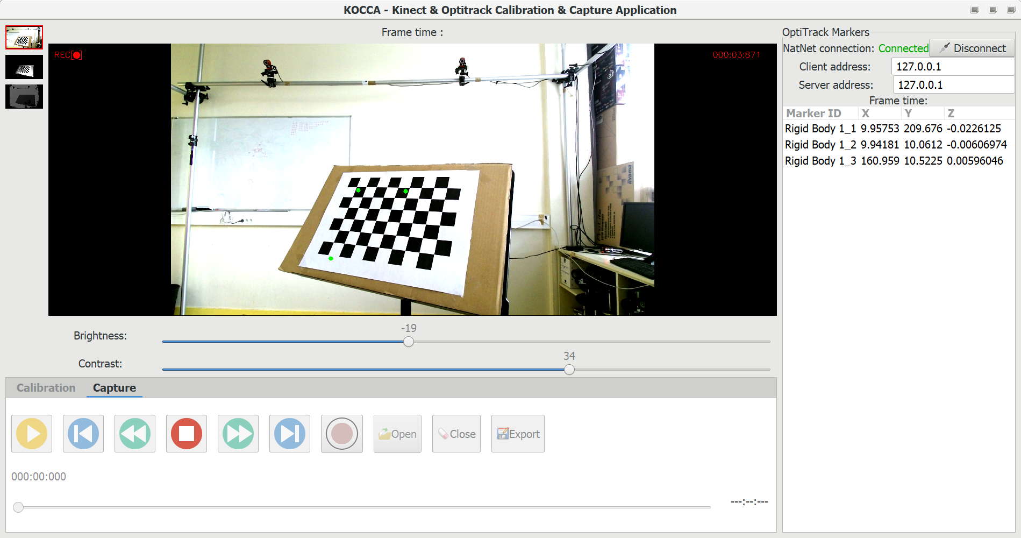
When you are done, click the « Stop » button. Recording will stop, and after a few seconds of reindexing, KOCCA will open the newly recorded sequence in playback mode.
Important : at this point, your new sequence is not saved yet. If you want to keep it, don't forget to export it before closing the sequence, opening an new one or quitting KOCCA !

Manipulating captured data

Exporting a captured sequence from KOCCA
Once you have finished capturing a sequence, from playback mode, click the « Export » button to save it on the filesystem.
Choose the folder you want to save it to, and give it a name with a .ksa extension.

Opening / reading a sequence file into KOCCA
When in monitoring mode, click the « Open » button from the « Capture » tab to open a .ksa file from your filesystem.
The archive will be unzipped in KOCCA's temp folder (see 9.5).
A popup will show the progress during unarchiving :
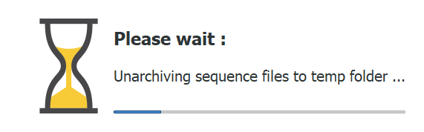
Then, after unarchiving, the content is indexed :
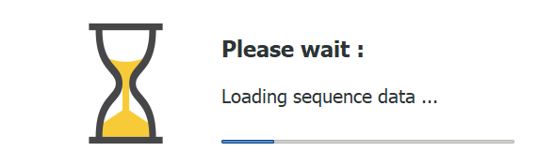
Note : for better performance it is recommended to use a fast drive (preferably SSD) at least for KOCCA's temp folder.
Once the archive content is unzipped and index, KOCCA will open the sequence in playback mode.

KOCCA Sequence Archive (.ksa) format description
KOCCA sequence archive files are essentially ZIP-encoded archives that can contain the following elements :
- a .kcf file named « kinect_calibration_parameters.kcf » containing the calibration data used for the sequence capture (see 7.10).
- a .csv file named « markersData.csv » containing all the Optitrack markers names and coordinates (see 9.4).
- Three folders named « image », « infrared » and « depth » each containing images files for the corresponding streams.
Each Kinect frame aquired during sequence's recording is stored in a separate image file, whose name is the time the frame was received (relative to the begining of recording) plus a « .png » or « .jpeg » extension.

CSV markers data file format
The captured Optitrack markers data is stored in a Comma-Separated Values (CSV) file.
All the values, even numeric ones, are text-encoded, which makes the file a lot bigger but also a lot more readable for humans, compared to a binary file.
The first line of this file contains each marker name as a separate value.
Then each following line contains an Optitrack data frame, stored as follwing :
- First value : the frame time
- Second value : X position for the first marker
- Third value : Y position for the first marker
- Fourth value : Z position for the first marker
- Fifth value : X position for the second marker
- Sixth value : Y position for the second marker
- and so on ...
So, each line starting from the second one should have a number of value equals to 1 + (3 * (number of values in the first line)).

KOCCA temp folders and recovery
Kocca comes with a « temp » folder that contains unarchived content of sequences the application is currently working on :
- sequences that are being recorded or that have just been recorded
- sequences that have been opened from a .ksa archive file
For each sequence (recorded or unarchived) a separate temp sub-folder is created with a unique name. This allows several instances of KOCCA to simultaneously work on different sequences without interferring each other.
These per-sequence temp sub-folder should be automatically deleted when the user closes the sequences or exist KOCCA.
That means the « temp » folder should be empty when KOCCA is not started or when it hasn't started working on sequences yet. If it is not empty, that could mean the data could remain from a sequence not closed properly (i.e. application crash).
At startup, KOCCA will check it's temp folder for sequence data. If some is found, KOCCA will offer you to recover it :
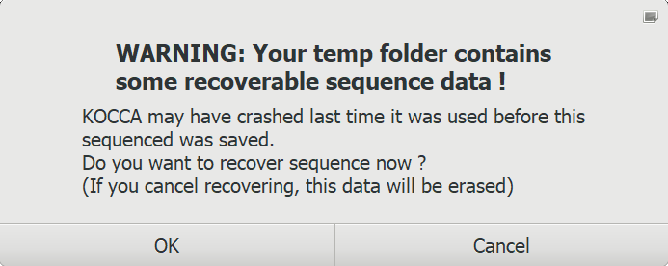
If you accept, the sequence will be loaded in playback mode.
If you decline, the remaining temp data will be cleared and it won't be recoverable anymore.

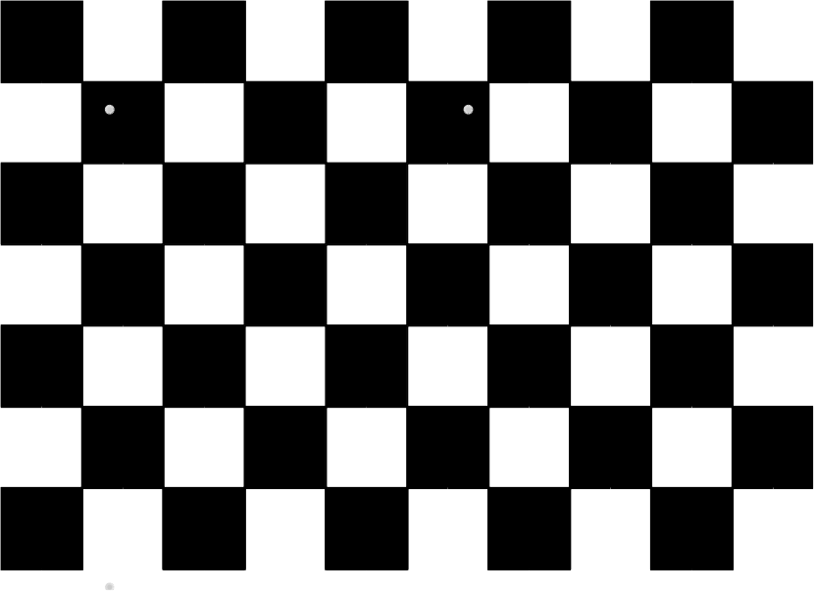
Appendix : Printable chessboard target model

