MCU pin configuration:

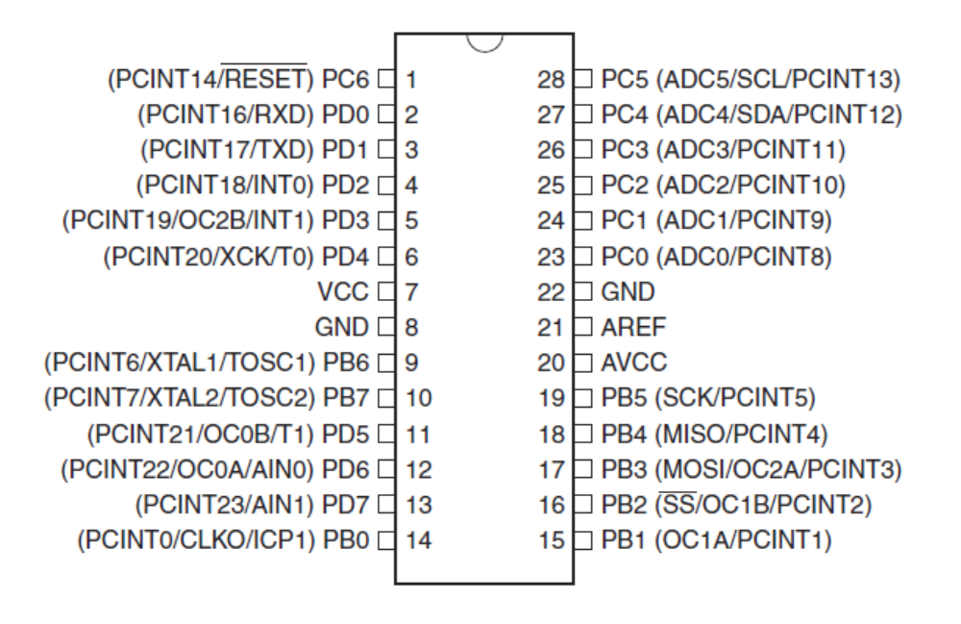

#include <avr/io.h>
#include <util/delay.h>
#include <avr/interrupt.h>

int main(void)
{
}

Configure output pins:
DDRD=(1<<0)|(1<<1)|(1<<PD2);

Loading X to PORT D:
PORTD=X;

Reading PIND to X:
X=PIND;

Delay using util/delay.h:
_delay_ms(200);

simple delay

#include <avr/io.h>
#include <util/delay.h>

int main(void)
{
DDRC|=(1<<PC4|1<<PC5);//D0 & D1 are outputs

while(1)
{
PORTC^=(1<<PC4|1<<PC5); // blink
_delay_ms(500);
}

}

Timers:
Target Timer Count = (1 / Target Frequency) / (1 / Timer Clock Frequency) - 1
= (1 / 20) / (PRESCALE / 1000000) - 1
= .05 / 0.000001 - 1
= 50000 - 1
= 49999

Timer0 is a 8 bit, while Timer1 is a 16 bit one.

#include <avr/io.h>

int main (void)
{
DDRB |= (1 << PB2); // Set LED as output

TCCR1B |= (1 << CS11); // Set up timer prescale

for (;;)
{
// Check timer value in if statement, true when count matches 1/3 of a second
if (TCNT1 >= 57600)
{
PORTB ^= (1 << PB2); // Toggle the LED

TCNT1 = 0; // Reset timer value
}
}
}

CTC mode:

#include <avr/io.h>

int main (void)
{
DDRB |= (1 << PB2); // Set LED as output

TCCR1B |= (1 << WGM12); // Configure timer 1 for CTC mode
OCR1A = 15624; // Set CTC compare value to 1Hz at 1MHz AVR clock, with a prescaler of 64

TCCR1B |= ((1 << CS10) | (1 << CS11)); // Start timer at Fcpu/64

for (;;)
{
if (TIFR1 & (1 << OCF1A))
{
PORTB ^= (1 << PB2); // Toggle the LED

TIFR1 = (1 << OCF1A); // clear the CTC flag (writing a logic one to the set flag clears it)
}
}
}

CTC Mode using Interrupts
#include <avr/io.h>
#include <avr/interrupt.h>

int main (void)
{
DDRB |= (1 << PB2); // Set LED as output

TCCR1B |= (1 << WGM12); // Configure timer 1 for CTC mode

TIMSK1 |= (1 << OCIE1A); // Enable CTC interrupt

sei(); // Enable global interrupts

OCR1A = 15624; // Set CTC compare value to 1Hz at 1MHz AVR clock, with a prescaler of 64

TCCR1B |= ((1 << CS10) | (1 << CS11)); // Start timer at Fcpu/64

for (;;)
{

}
}

ISR(TIMER1_COMPA_vect)
{
PORTB ^= (1 << PB2); // Toggle the LED
}
The Overflow Event
#include <avr/io.h>
#include <avr/interrupt.h>

int main (void)
{
DDRB |= (1 << PB2); // Set LED as output

TIMSK1 |= (1 << TOIE1); // Enable overflow interrupt
sei(); // Enable global interrupts

TCCR1B |= (1 << CS11); // Start timer at Fcpu/8

for (;;)
{

}
}

ISR(TIMER1_OVF_vect)
{
PORTB ^= (1 << PB2); // Toggle the LED
}

Overflow as CTC
#include <avr/io.h>
#include <avr/interrupt.h>

int main (void)
{
DDRB |= (1 << PB2); // Set LED as output

TIMSK1 |= (1 << TOIE1); // Enable overflow interrupt
sei(); // Enable global interrupts

TCNT1 = 49911; // Preload timer with precalculated value

TCCR1B |= ((1 << CS10) | (1 << CS11)); // Set up timer at Fcpu/64

for (;;)
{

}
}

ISR(TIMER1_OVF_vect)
{
PORTB ^= (1 << PB2); // Toggle the LED
TCNT1 = 49911; // Reload timer with precalculated value
}

send and receive using the usart

#include <avr/io.h>
#include <util/delay.h>

#define BAUD 38400
#define MYUBRR F_CPU/16/BAUD-1

void USART_Init(unsigned int);
void USART_Transmit(unsigned char);
unsigned char USART_Receive( void );

int main( void )
{

int check=80;
DDRC |= (1<<PC4)|(1<<PC5);
USART_Init(MYUBRR);

while(1)
{

check=USART_Receive();
USART_Transmit(check);

if (check==0x36)
PORTC^=(1<<PC5);
else PORTC&=~(1<<PC5);
if (check==0x11)
{
PORTC^=(1<<PC4);
}
else PORTC&=~(1<<PC4);

}
}

void USART_Init(unsigned int ubrr)
{
/*Set baud rate */
UBRR0H = (unsigned char)(ubrr>>8);
UBRR0L = (unsigned char)ubrr;
/*Enable receiver and transmitter */
UCSR0B = (1<<RXEN0)|(1<<TXEN0);
/* Set frame format: 8data, 1stop bit, non parity */
UCSR0C =(3<<UCSZ00);
}

void USART_Transmit(unsigned char data)
{
/* Wait for empty transmit buffer */
while ( !( UCSR0A & (1<<UDRE0)) )
;
/* Put data into buffer, sends the data */
UDR0= data;
}

unsigned char USART_Receive( void )
{
/* Wait for data to be received */
while ( !(UCSR0A & (1<<RXC0)) );

/* Get and return received data from buffer */
return UDR0;
}

send and receive using the usart - interrupt

#include <avr/io.h>
#include <avr/interrupt.h>

#define BAUD 38400
#define MYUBRR F_CPU/16/BAUD-1

void USART_Init(unsigned int);
volatile char ReceivedByte;

int main( void )
{

int check=0x80;
DDRC |= (1<<PC4)|(1<<PC5);
DDRB |= (1<<PB2);
USART_Init(MYUBRR);

while(1)
{

check= ReceivedByte;
if (check==0x36)
PORTC|=(1<<PC5);
else PORTC&=~(1<<PC5);
if (check==0x11)
{
PORTC|=(1<<PC4);
}
else PORTC&=~(1<<PC4);
if (check==0x80)
PORTB|=(1<<PC2);
else PORTB&=~(1<<PC2);
sei();

}
}

ISR(USART_RX_vect)
{
ReceivedByte = UDR0; // Fetch the recieved byte value into the variable "ByteReceived"
UDR0 = ReceivedByte; // Echo back the received byte back to the computer
cli();

}

void USART_Init(unsigned int ubrr)
{
/*Set baud rate */
UBRR0H = (unsigned char)(ubrr>>8);
UBRR0L = (unsigned char)ubrr;
/*Enable receiver and transmitter */
UCSR0B = (1<<RXEN0)|(1<<TXEN0);
/* Set frame format: 8data, 1stop bit, non parity */
UCSR0C =(3<<UCSZ00);

UCSR0B |= (1 << RXCIE0);
sei();
}

