**XPARK**

1. **Overview**

*Non-local drivers, who come to a foreign city, do not know the possible parking spaces, or alternatively the places where it is possible to park at random hours (density, load, adaptation to large vehicles, city regulation). Hence, they will prefer to park the vehicles in public / private parking lots, in order to save time and to reduce the risk of damage to the vehicle from external hazards.  
In some cases, especially in major cities, there are serious parking problems, such as those manifested in such a way that there are no public parking spaces available, and moreover - the situation in the parking lots is the same, to such an extent that at a certain time, the parking lot itself is already full.  
In the given situation, the owners of the vehicles that arrive at the parking lots are disappointed, because when they arrived at the desired parking lot, it was discovered that it was full and there was no room for them. This situation is very familiar in the main cities, and causes frustration and disappointment and especially a waste of time, since the route of those car owners, created according to the final destination - which is the parking lot they aimed to reach, and its base was found to be irrelevant. On top of that - the navigation apps that exist today do not support this information, and for them they only bring the drivers to the destination.*

1. **Goals**

*The main goal will be that the end users of the app will not spend their precious time to look for a parking spot and will not plan their daily activity out of town when they are taking in count a time that will take them to look for a parking spot*

*Our product connects drivers coming to the big city, and local parking lot owners by an innovative and dynamic parking model where you are not looking for parking, parking is looking for you.*

**The Need / Problem**

* 1. ***Segmentation***
* ***Car owners:***
  + ***Daily arrivals****:*
    - *Navigating to a dedicated parking lot is extremely disappointing when you find it full.*
    - *Parking in the parking lot is expensive, and it is difficult for drivers to reduce these expenses on existing platforms.*
    - *Car users want to know where the cheapest parking lots are.*
    - *Car users waste a lot of time and money searching for an available parking lot near their destinations.*
    - *During rush hours the demand for parking spots is high and the supply is relatively low.*
  + ***Occasional arrivals****:*
    - *Car users don’t know where the parking lots are located.*
    - *When you come to the big city for fun or a party, the search for parking is disturbing.*
    - *Occasional drivers lack a platform where they can rate their experience.*

***Needs:***

* *Needs to meet the standard of his company, he should not make any excuses for his hard work, for when he is late to work, and take a full responsibility of his actions.*
* *Needs to find an available parking lot in Tel-Aviv and any city that he doesn’t know.*
* *Needs needs the ability to save a dedicated parking spot at a parking lot nearby his office.*
* *Needs needs the ability to search parking lot depending on rating and price.*

***Frustrations:***

* *Encounters the problem of wasting a lot of time searching for an available parking lot when he arrives to Tel-Aviv.*
* *Wasting time near the automated paying machines that are located in the parking lots, he needs the option to pay upfront his arrival.*
* *Disappointed from the price or the attitude of the parking lot owner.*
* ***Parking lots owners:***
* ***Peripheral:***
* *Parking lot owners don't want to have free parking spots for a long period of time; they want to have a high turnover of vehicles.*
* *Parking lot owners want to attract more customers by displaying their positive reviews.*
* *Discoverability – parking lot owners want their reach to be much higher.*
* ***Not Peripheral:***
* *Parking lot owners want to have a real-time image on what is going on in their parking lot.*
* *Parking lots that are hidden from view due to problematic locations within the city, want the ability to stand out and be accessible by the app for drivers.*
* *Parking lot owners want to have the upper hand on top of his competitors that are in his very nearby location in the city.*

***Needs****:*

* *Needs a platform that will make an easy entrance to new cities.*
* *Needs a platform that will extend his reach in his current parking lots so he can focus on building new ones.*
* *Wants to share his customers' experiences with much more people.*
* *Needs a platform in which he can view the current state of his parking lots at any given time.*

***Frustrations:***

* *Encounters the problem in which smaller parking lot owners enjoy more traffic in their parking lots because of non-availability in the parking lots.*
* *Doesn’t have a way to share with the world the better experiences that customers get at the parking lots.*
* *Trying to expand his reach among the people that are foreign to the city.*
* *Profit maximization*

*The database : 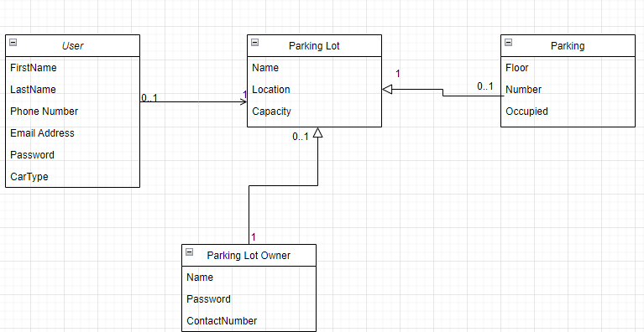*

*UI Specifications:*

*The app wishes to leave a good impression when it comes to its users, to save time, to create a more innovative approach towards achieving the goal of maximizing the availability of parking lots, saving time and effort, create and increase credibility, etc.*

*The graphical components will include a map that the user can navigate through and search for the parking lot that suits him the best.*

*The colors will be purple (rgba(127, 104, 245, 1)), white (rgba(255, 255, 255, 1)), and blue (rgba(55, 123, 255, 1)) because they are user friendly and delivers a calm feeling while navigating through the app.*

*Fonts: Heebo*

