**Lab5 Report**Liron Cohen 207481268  
Yuval Mor 209011543

**Question 1 - SRAM verification**

We filled the missing code in the sram.v module and the sram_tb.v module.

We ran the xrun command the simulation finished successfully:

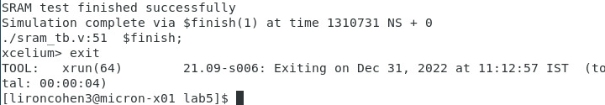

The waveform is:

As we can see for example, on the clock rises, and the integer 1 is written to address 0001 (shows in ) and on the clock rises and the output data that is read from address 0001 is the value 1 (shows in ), so the read after write is working and the simulation succeeded.

**Question 2 - processor implementation (no DMA)**

We filled the missing code in the alu.v module, sp.v module and ctl.v module.

The required files are attached.

**Question 3 - verification #1: example.bin**

We ran the simulation of the provided example.bin and made sure the traces are matched.

**Question 4 - verification #2: add**

We ran the simulation of our add.bin program and made sure it's trace matched the lab 2 cycle trace.

The relevant waveforms:

We can see that in , the value of is the first number (80000007) and it is read into in .

We can also see that in , the value of is the second number (80000001) and it is read into in .

We can see that in , the value of is the result (80000008) and it is written to in .

**Question 5 - verification #3: sqrtq**

We ran the simulation of our sqrtq.bin program and made sure it's trace matched the lab 2 cycle trace.

The relevant waveforms:

We can see that in , the value of is the input to the program () and it is read into in .  
We can see that in , the value of is the result () and it is written to in .

**Question 6 - DMA implementation**

**Question 7 - DMA verification**