{Id | today}

VIA EMAIL TO: {#Deal_Contacts__r.EscrowAgent}{Deal_Contacts__r.Email__c}

{Deal_Contacts__r.Contact_Full_Name__c}

{Deal_Contacts__r.Company_Name__c}

{Deal_Contacts__r.Street__c}

{Deal_Contacts__r.City__c}, {Deal_Contacts__r.State__c} {Deal_Contacts__r.Zip__c}

Tel. No.: {Deal_Contacts__r.Phone__c}

{/Deal_Contacts__r.EscrowAgent}

**Re:** **{Property_Advances__r[0].Property__r.Name}, {Property_Advances__r[0].Property__r.City__c}, {Property_Advances__r[0].Property__r.State__c} {Property_Advances__r[0].Property__r.ZipCode__c}** (“**Property**”); **Lender’s Escrow Instructions**

* **Order No.: {Deal__r.Order_No__c}**
* **Lender: CoreVest American Finance Lender, LLC.** (“**Lender**”)
* **Borrower: {borrowerdetails.name | upperCase}**
* **Seller: {Deal__r.Seller__c}**
* **Sales Price: {Deal__r.Sales_Price__c | formatCurrency}**
* **Loan Amount: {Deal__r.LOC_Commitment__c | formatCurrency} ({Property_Advances__r[0].Property__r.Initial_Disbursement__c | formatCurrency} disbursed at closing).**

Dear {#Deal_Contacts__r.EscrowAgent}{Deal_Contacts__r.Contact_Full_Name__c}{/Deal_Contacts__r.EscrowAgent}:

We are the Lender in connection with the above-referenced transaction, and these escrow instructions (“**Escrow Instructions**”) are submitted to you in regard to such transaction. We expressly make no representations or warranties regarding any factual or legal matter, including, but not limited to, matters relating to state of title, Loan Documents (defined below), the Property or the ownership interests therein. The factual statements made in this letter are based on information supplied to us. Such statements should be independently confirmed by you. We reserve the right to modify or withdraw these Escrow Instructions at any time.

It is presently anticipated that the closing of the above-mentioned transaction will occur on or about ***{Deal__r.CloseDate | addDaysFull:0}*** (“**Closing Date**”), and you should receive all necessary documents on or before that date.

The escrow instructions are as follows:

**A. LENDER’S LOAN SECURED BY THE PROPERTY**

1. Loan Documents. You, as escrow officer or agent for {#Deal_Contacts__r.TitleCompany}{Deal_Contacts__r.Company_Name__c}{/Deal_Contacts__r.TitleCompany}, (“**Title Company**”) shall receive, or have in your possession, on or before the Closing Date, the following duly executed original documents:

a. Security Instrument (Mortgage or Deed of Trust), Security Agreement, Assignment of Rents and Leases, and Fixture Filing executed by {borrowerdetails.name | upperCase}, in the benefit of CoreVest American Finance Lender, LLC. (“**Mortgage**”). We require that a certified copy of the Mortgage be delivered to us.

b. Secured Promissory Note executed by {borrowerdetails.name | upperCase}, in the benefit of CoreVest American Finance Lender, LLC. (“**Note**”).

c. Resolution by Unanimous Consent of Members and Managers executed by {borrowerdetails.name | upperCase}. (“**Borrower Resolution**”).

d. Environmental Indemnity Agreement executed by {borrowerdetails.name | upperCase}. (“**Environmental Indemnity Agreement**”).

e. Guaranty Agreement executed by {#Deal_Contacts__r.Guarantors}{Deal_Contacts__r.Contact_Name__c} {/Deal_Contacts__r.Guarantors}, an individual, (“**Guaranty**”).

f. Loan Agreement executed by {borrowerdetails.name | upperCase}. (“**Loan Agreement**”). {#Property_Record_Type}

g. Architect’s Consent and Agreement executed by {#Deal_Contacts__r.Architect}{Deal_Contacts__r.Company_Name__c**}{**/Deal_Contacts__r.Architect**}**, an individual (**“Architect’s Consent”**).

h. Completion Guaranty executed by{#Deal_Contacts__r.Guarantors}{Deal_Contacts__r.Contact_Name__c}, {/Deal_Contacts__r.Guarantors}, an individual (**“Completion Guaranty”**).

1. Contractor Consent and Agreement executed by the principal, officer or authorized signor for {#Deal_Contacts__r.Contractor}{Deal_Contacts__r.Company_Name__c**}{**/Deal_Contacts__r.Contractor**}**. (**“Contractor Consent”**).

j. Engineer Consent and Agreement executed by the principal, officer or authorized signor for {#Deal_Contacts__r.Engineer}{Deal_Contacts__r.Company_Name__c**}{**/Deal_Contacts__r.Engineer**}**. (**“Engineer Consent”**). {/Property_Record_Type}

The documents above, listed “a” through “f” are herein defined as the “**Loan Documents**”. Immediately after signing, deliver to Lender via overnight Federal Express all of the Loan Documents with the exception of those Loan Documents to be recorded by you. This includes the additional original of any deed. **PLEASE** send the original documents to my attention at our Utah office at: 4 Park Plaza, Suite 900, Irvine, CA 92614. **DO NOT** send documents to our Irvine office.

1. Loan Amount. The loan amount for this transaction (the “**Loan Amount**”) is {Deal__r.LOC_Commitment_In_Words__c} and NO/100 DOLLARS ({Deal__r.LOC_Commitment__c | formatCurrency}). **PLEASE NOTE** that only {Property_Advances__r[0].Property__r.Initial_Disbursement__c | formatCurrency} from the loan will be disbursed at closing. The remaining amount of {Property_Advances__r[0].Property__r.Approved_Renovation_Holdback__c | formatCurrency} will be retained by the lender for future construction project funding.

2. Allocation of Expenses. Title Company has received, or at closing will receive, funds sufficient to pay for all closing costs (which shall include your escrow fee, Lender’s title premium, all recording fees, prepaid interest, and all of Lender’s fees, as shown on the Fee and Prepaid Interest Schedule attached hereto) from an escrow account set up to pay such expenses.

3. Pro Rata Prepaid Interest. Pro rata prepaid interest is no longer collected by CoreVest. Instead, the loan servicer will collect any interest due from the date of closing through the 1st of the ensuing month with the first billing cycle.

**B. CONDITIONS TO CLOSING.** Upon compliance with all of the conditions set forth below, immediately available funds will be, or have previously been, deposited with you representing the Purchase Price (as set forth on the approved settlement statement) to be paid to Seller.

You are instructed to close this transaction in accordance with Article C below only at such time as all of the following conditions are satisfied, or which upon closing can be satisfied:

1. The undersigned has informed you that he has received any outstanding items from Borrower.

2. You are in possession of all the documents described in Section A.1.

3. You have received the Purchase Price.

4. You are prepared to issue to Lender upon closing an ALTA Lender’s Policy of Title Insurance in the amount of {Deal__r.LOC_Commitment_In_Words__c} and NO/100 DOLLARS ({Deal__r.LOC_Commitment__c | formatCurrency}) (the “**Policy**”) insuring Lender’s interest in the Property pursuant to the Deed subject only to the matters set forth in the Commitment. The Policy shall be issued in the form hereto attached.

5. You have verified that all property taxes and any applicable homeowners’ association fees or dues are paid current and if not, any delinquent or due amounts shall be paid from loan proceeds. Any water, garbage and similar city services liens shall also be paid from loan escrow.

6. You have verified that all liens on the Property are paid off and if not, any due amounts shall be paid from the loan proceeds.

7. You have obtained proof of fire and liability insurance for the subject property, with mortgagee/loss payee endorsements in the name of the Lender, indicating an insured amount not less than full replacement cost.

8. A duly authorized signatory of Title Company has executed, a copy of these Escrow Instructions and has delivered to the undersigned a duly executed original.

9. You have spoken to the undersigned and have been advised that items 1 through 8 above have been complied with or will be complied with at closing, and you have been authorized to proceed to close this transaction.

**C. CLOSING PROCEDURES.** At such time as all of the conditions set forth in Article B have been met, and upon verbal direction by the undersigned, you are hereby instructed to close the transaction provided herein by doing the following in the order stated as concurrently as possible:

1. Date all undated documents at our direction.

2. Subject to authorization of the undersigned, disburse the Purchase Price to Seller.

3. Record the Mortgage with the {Property_Advances__r[0].Property__r.County__c} County Clerk’s Office

4. After recording, deliver to the undersigned, all of the original recorded documents described in Section A.1, if those documents were electronically recorded, and the recording information for those documents (Instrument Number or Book and Page Numbers).

5. Disburse all monies owed to Lender as described in Sections A.3 and A.4.

In the event you receive additional or contrary instructions regarding this transaction, you are instructed not to close the transaction until you have been advised by me to comply with these Escrow Instructions. In the event the closing does not occur on the Closing Date, you are instructed to deliver to me all the documents, checks, funds and filings deposited with you on behalf of Lender, unless I have advised you that a subsequent closing date has been agreed upon in which case all references to the “Closing Date” herein, including those references set forth in this paragraph, shall refer to such subsequent closing date.

Thank you for cooperation in this matter. Please acknowledge your acceptance to be bound by these Escrow Instructions by your authorized signature below.

Very truly yours,

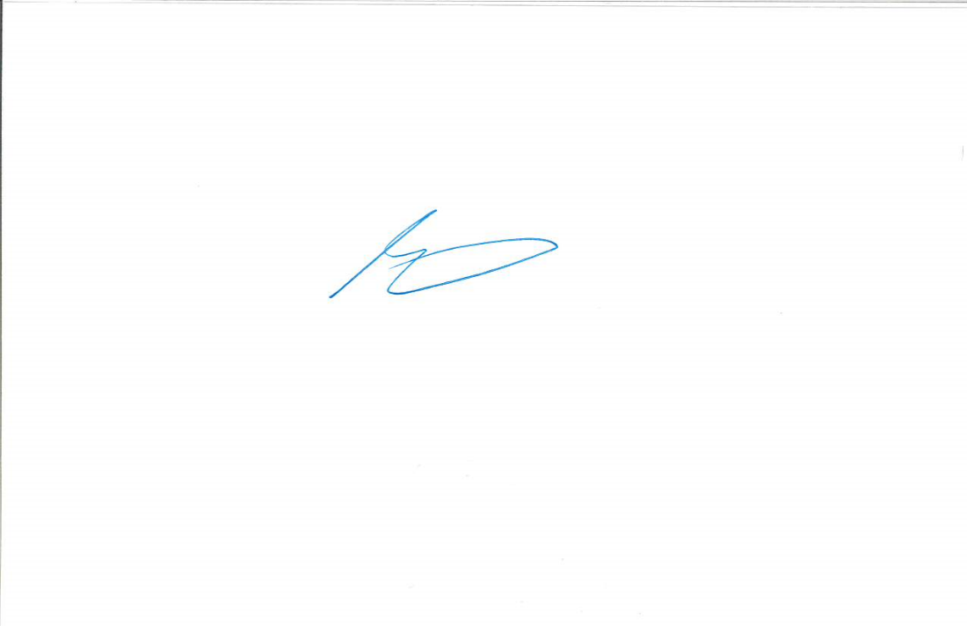

David M. Francis

cc: {Property_Advances__r[0].Property__r.Deal__r.Contact__r.FirstName} {Property_Advances__r[0].Property__r.Deal__r.Contact__r.LastName} (via email)

{Deal__r.Referral_Source__r.Name} (via email)

{Deal__r.Owner.Name} (via email)

{Deal__r.Loan_Processor__r.Name} (via email)

{Deal__r.Underwriter__r.Name} (via email)

Encl: Fee and Prepaid Interest Schedule

Preliminary Title Report

ACCEPTED AND AGREED TO

THIS ____ OF {null | month | upperCase}, {null | year}.

{#Deal_Contacts__r.EscrowAgent}{Deal_Contacts__r.Company_Name__c | upperCase}{/Deal_Contacts__r.EscrowAgent} / {#Deal_Contacts__r.TitleCompany}{Deal_Contacts__r.Company_Name__c | upperCase}{/Deal_Contacts__r.TitleCompany}

By: _______________________________

Name: _____________________________

Its: Authorized Signatory