**Introduction to Bioinformatic – Assignment 3**

By: Liron Naccache, Seggev Haimovich, William Manuel, and Jayden Johnson

[GitHub](https://github.com/lironnaca/Bioinformatics-Project)

**Unsupervised Analysis**

We incorporated 4 different clustering algorithms within this assignment.

Each algorithm was completed 4 times, using the following K’s (number of clusters): 2, 4, 6, 10

1. K-means

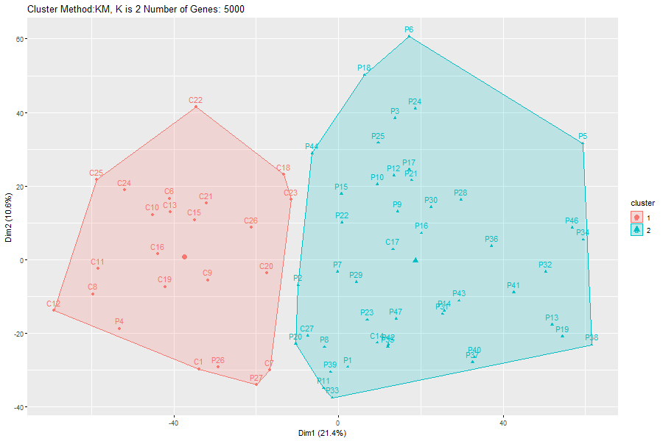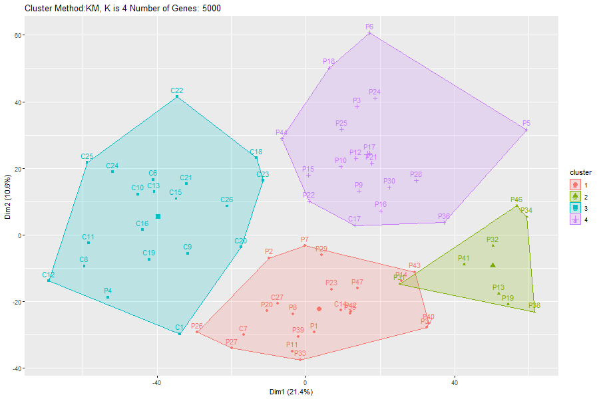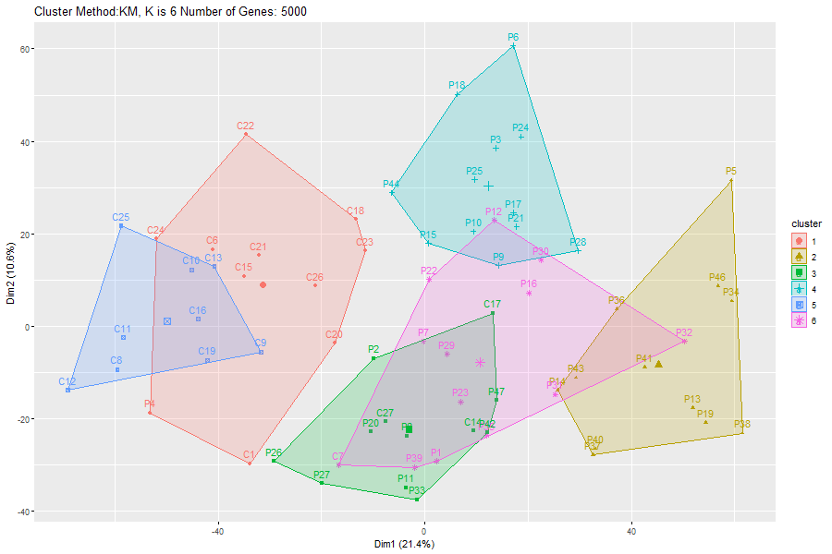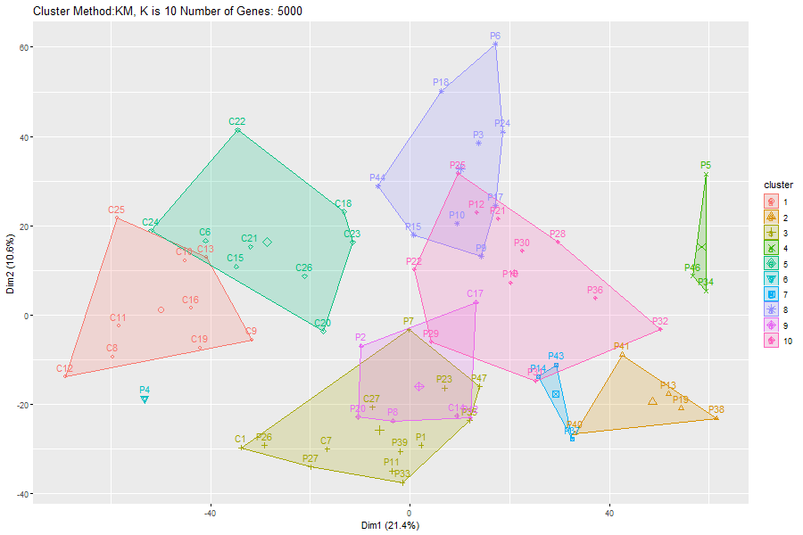

We can see that the bigger the K the more clusters there are.

In the k=2 clustering, we see that the cluster groups are very alike to our patient groups (p: critical, c: non-critical).

In addition, we see that even with 10 clusters, there are still clusters that contain both critical and non-critical patients.

1. Hierarchical clustering (hclust)

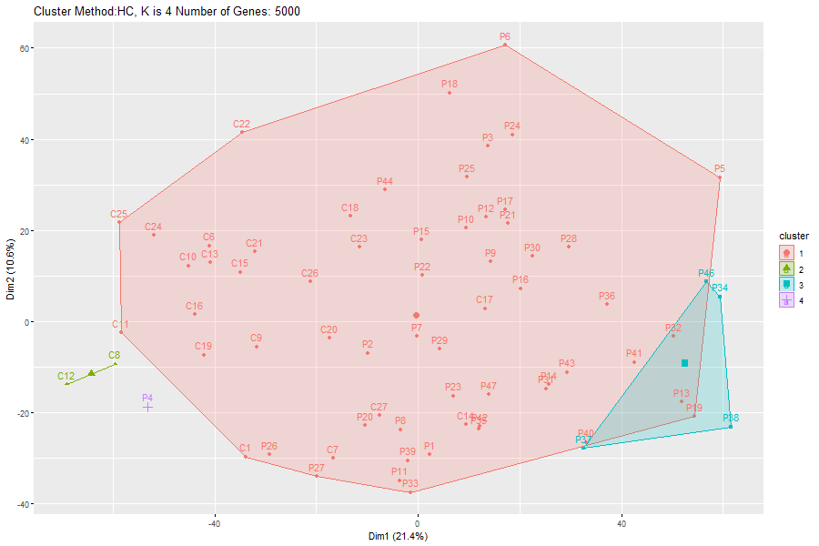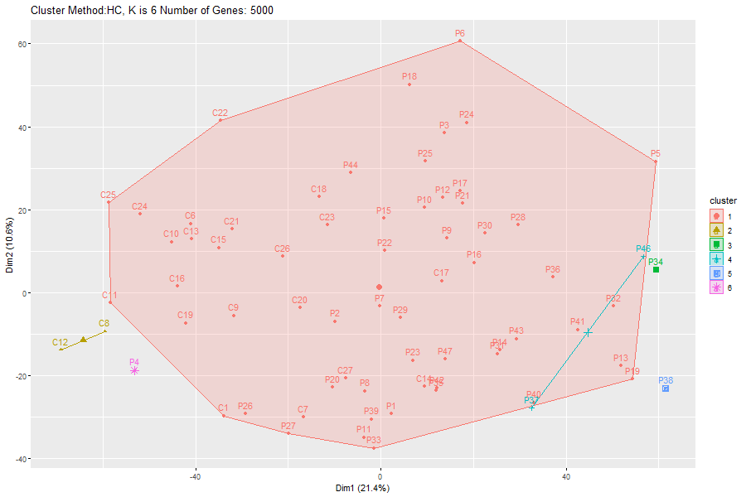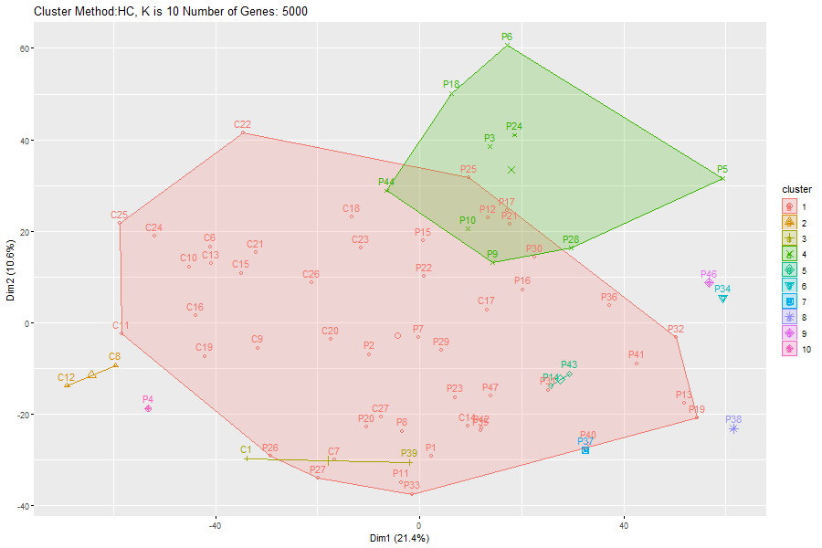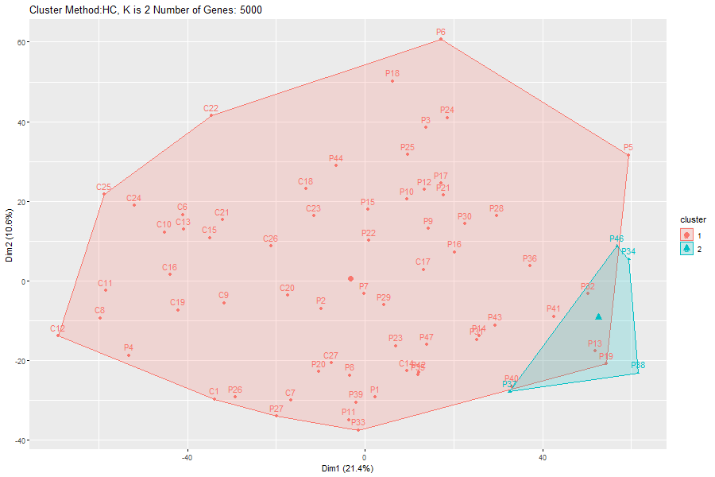

Our findings here signify that the algorithm had no success in separating the real group (critical and non-critical patients), no matter how many clusters we defined. Increasing the number of clusters had very little effect on the outcome.

1. PAM clustering

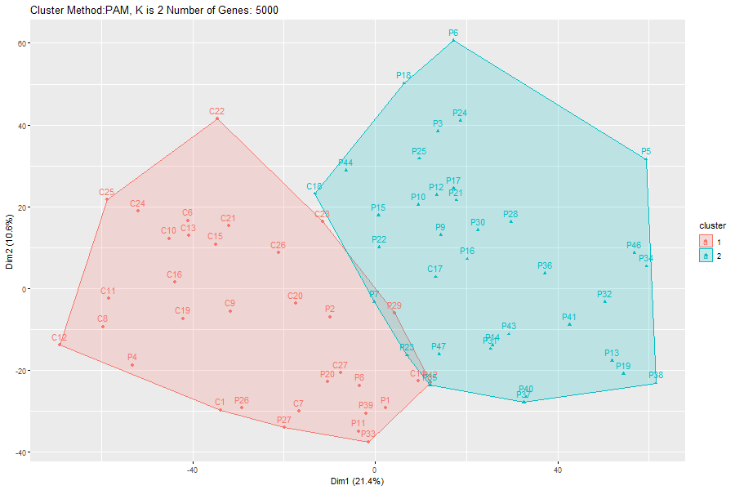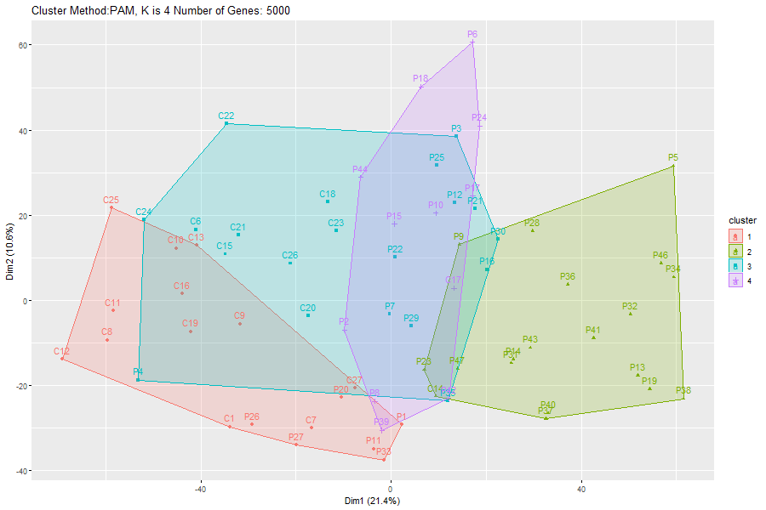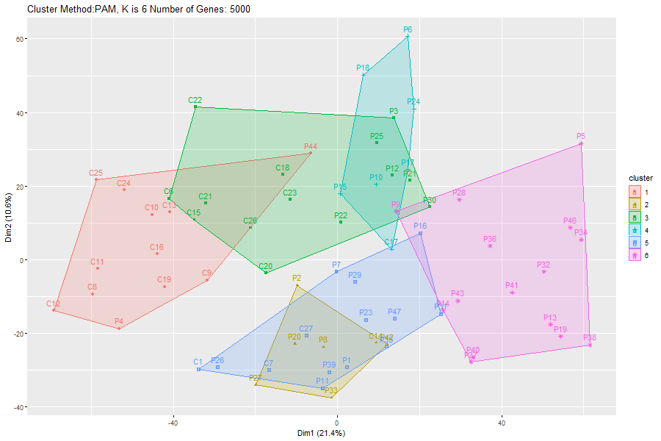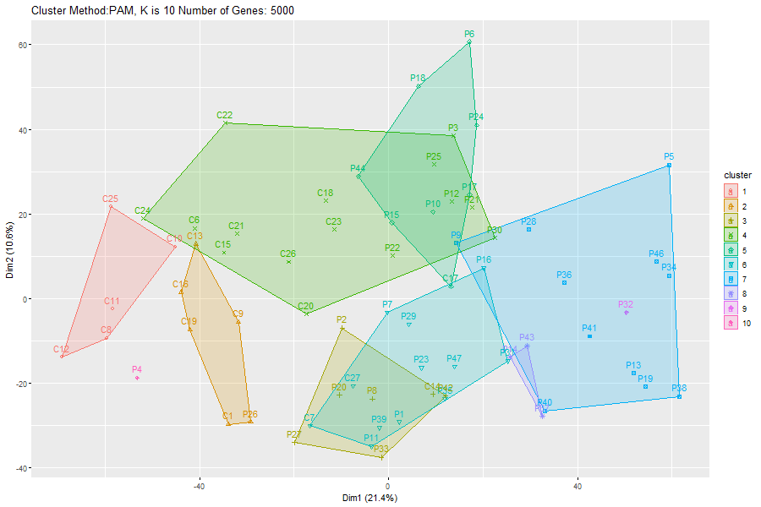

In comparison to the HC clustering, we see that if we increase the number of clusters we give the algorithm, we generate clusters with similar sizes. However, the increase in the K given to the algorithm does not refine the clusters themselves. This is shown due to some clusters containing samples from critical and noncritical patients.

1. **Gaussian Mixture Models**

Overall, when running this modeling algorithm, we witness an improvement in the clusters as we increase the K value resulting in the clusters becoming more refined, which allows our graph to better separate the samples. However, even with k= 10, the graph still contains some degree of error due to some clusters containing noncritical and critical samples.

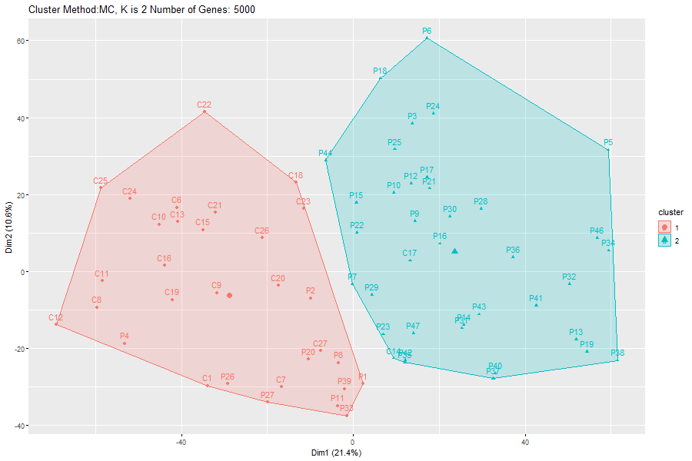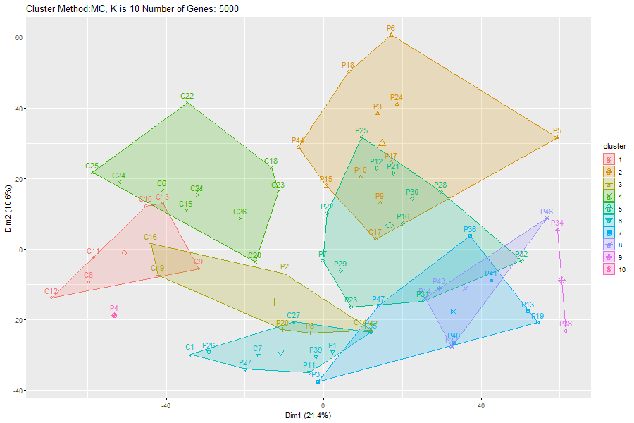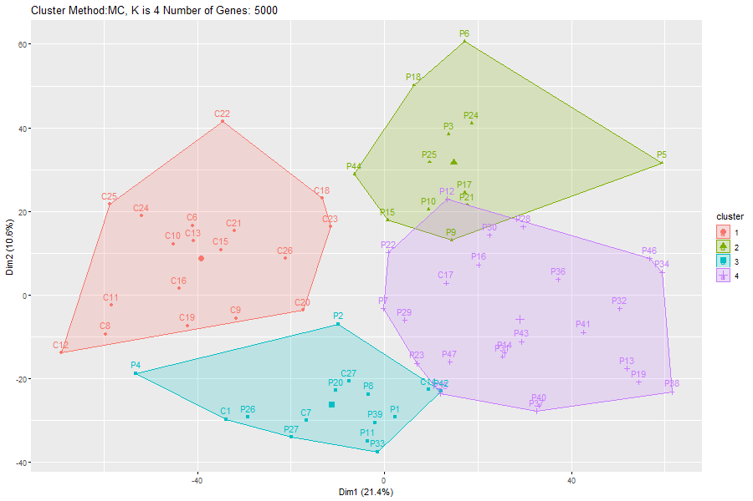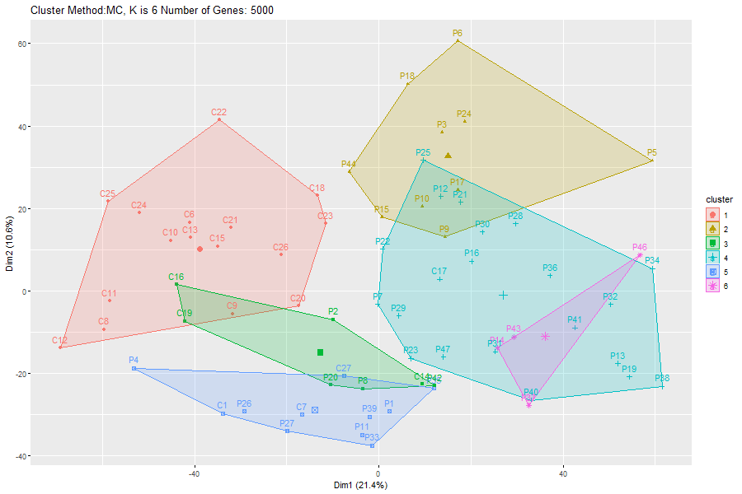

In the next step, we ran each algorithm with a different number of genes, using: 10, 100,1000, and 10000 genes. In all the runs, we gave the algorithm K = 2.

First, we must notice that all the clustering happens in a 2-dimensional plot, meaning that the R function had to run a dimensional reduction algorithm first. That's why when we increased the number of genes, we get different distributions of the points on the grid.

**K-Means:** We can see that as we increase the number of genes, the clusters become wider. Also, the more genes we use, the better the algorithms perform in terms of creating 2 clusters of critical and non-critical samples.

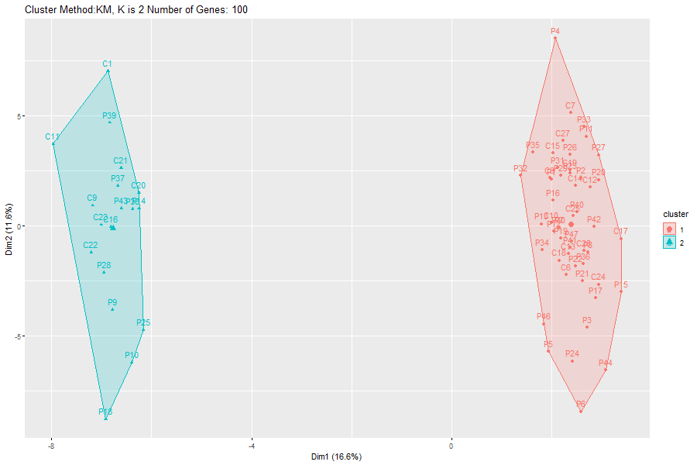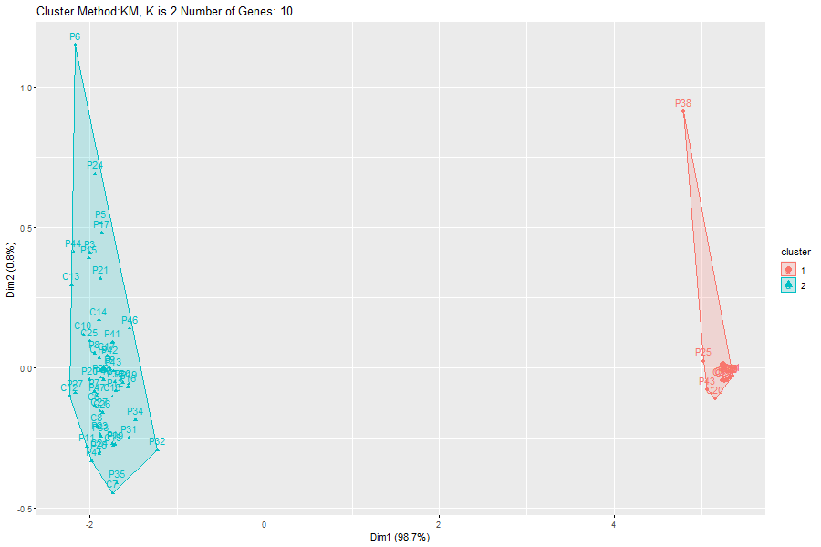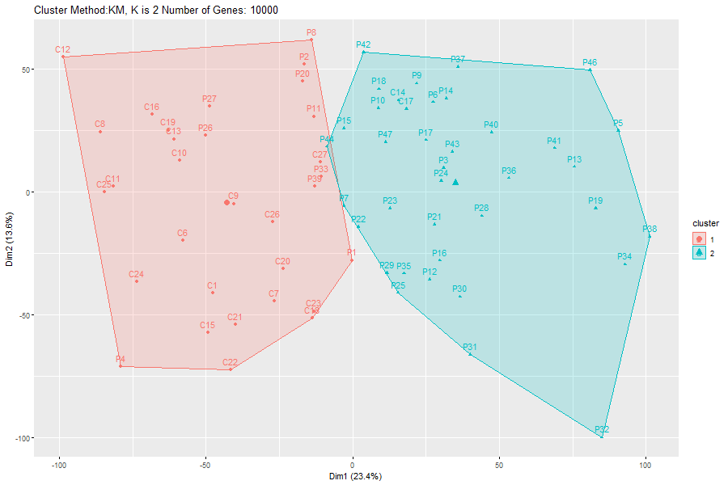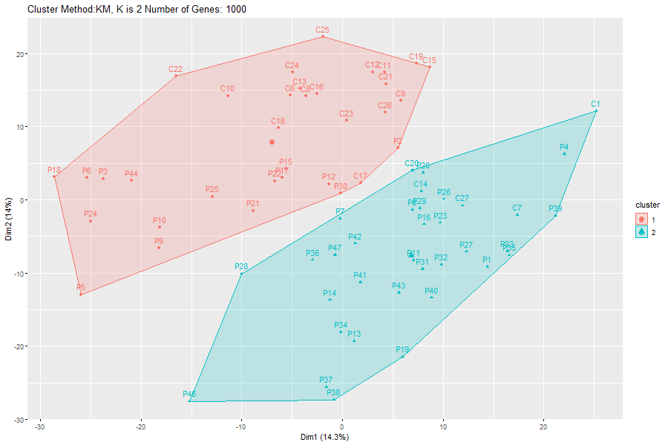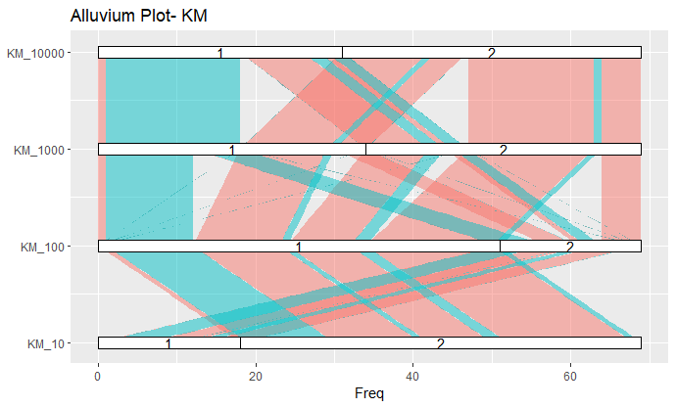

When looking at the alluvial plot, we see that with 10 and 100 genes the two clusters contain approximately the same samples. However, when using more than 100 genes, the clusters are not similar, as samples separate differently between the two clusters.

**HC:**  Here it is demonstrated again that HC does not work well with our data. In contrast to KM, when increasing the number of genes, the algorithm creates one big cluster. It seems like it can't handle many features in our data.

This also stands out when looking at the alluvial plot. One can also notice that clustering with 10 and 100 genes gives the same result.

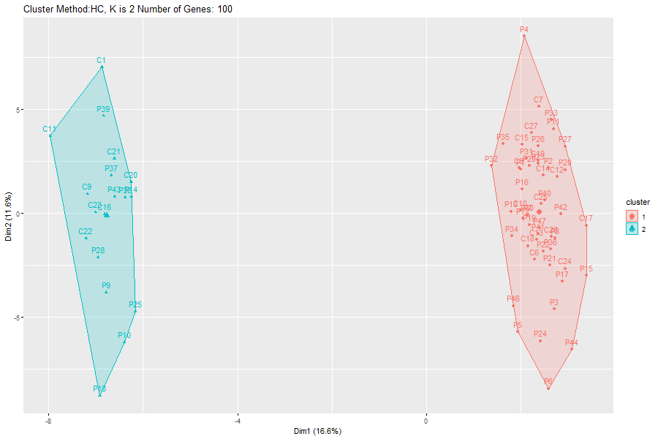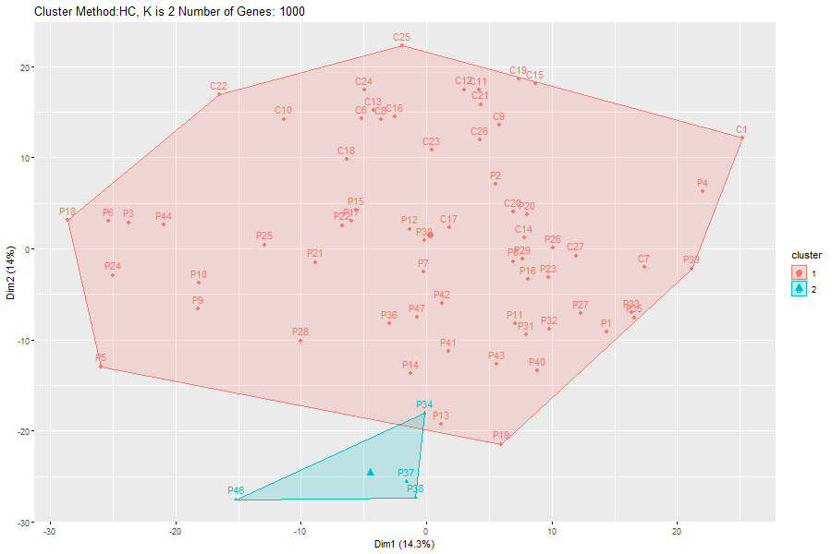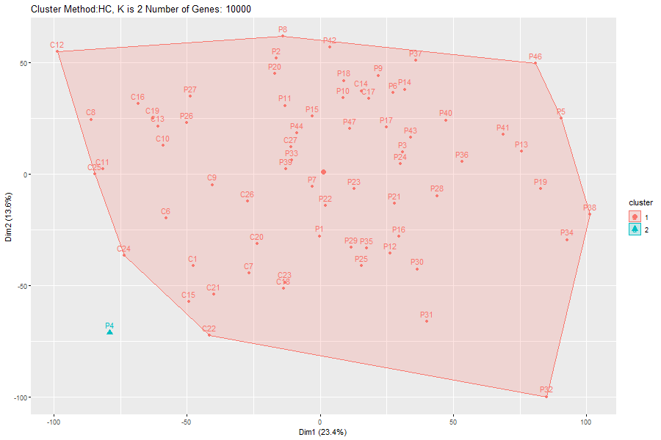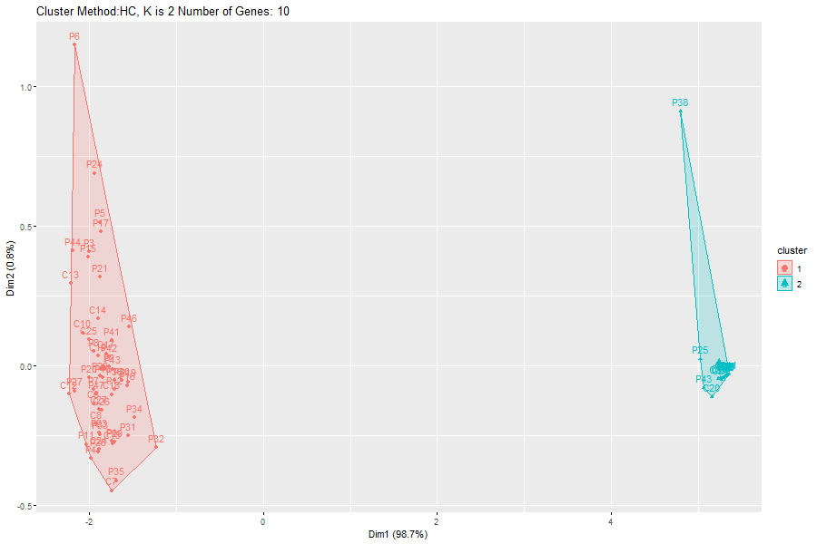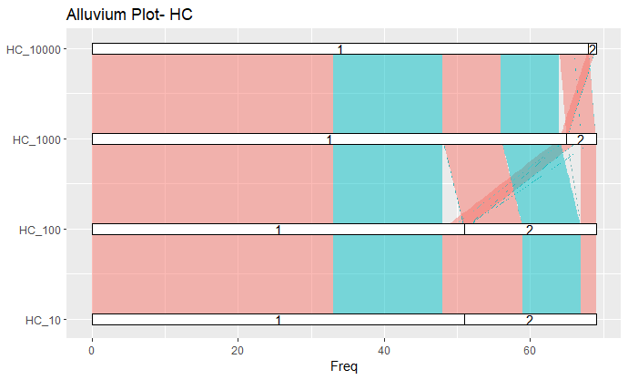

**PAM:**  By looking at the alluvial plot, we see that with 10 and 100 genes we get the same clusters. Also, we notice that for 1000 and 10000 genes, we notice a decrease in the accuracy of the groups do to overlaps between sample groups.

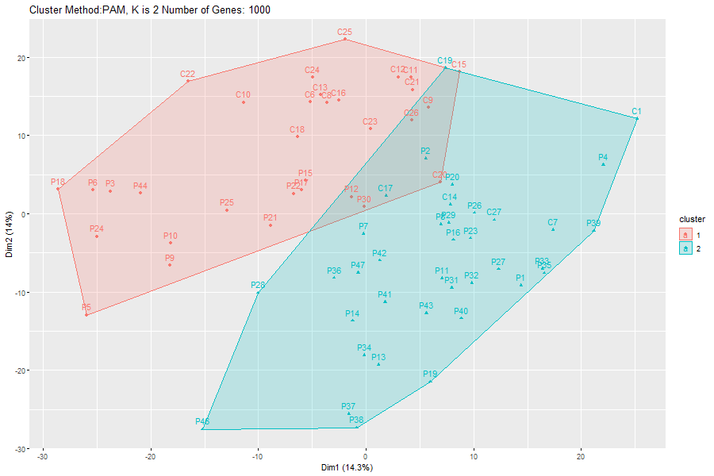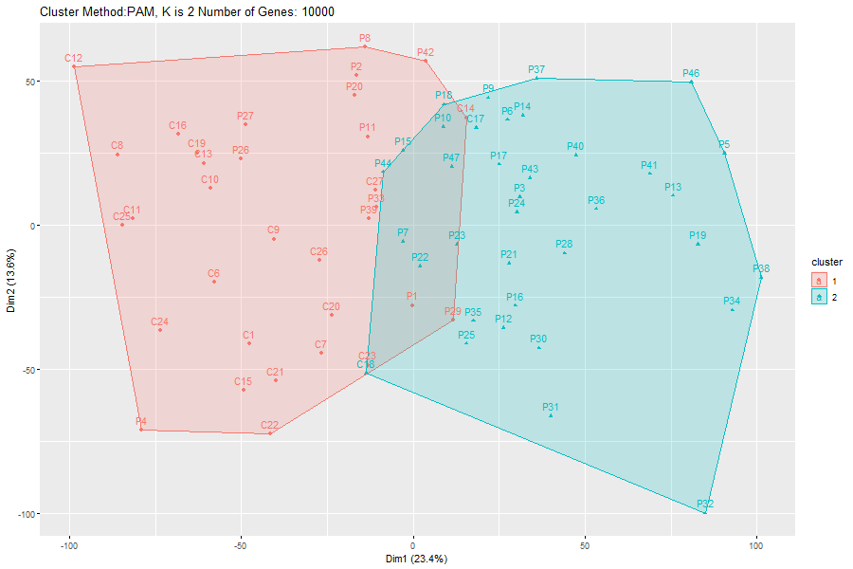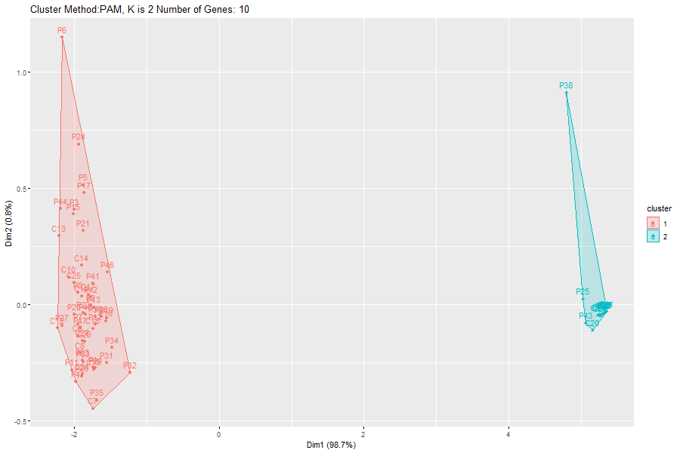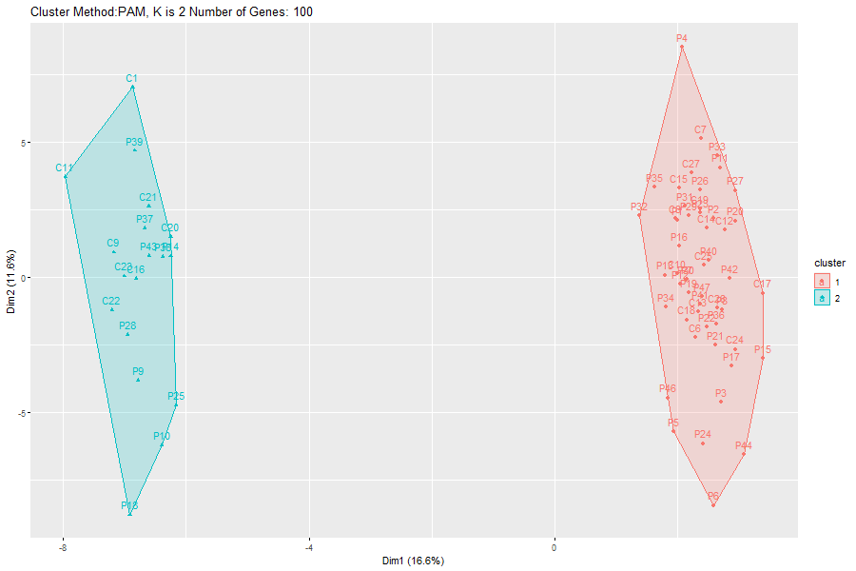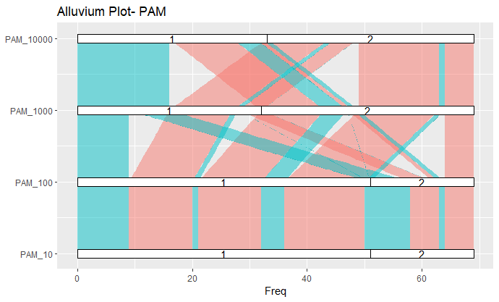

**Gaussian Mixture Models:** By looking at the alluvial plot, we can see that the clusters created using 10 and 100 genes are the same and that the difference between the clusters created using 1000 and 10000 genes is that many samples moved from cluster number 1 to cluster number 2. The algorithm shows that as the number of samples provided increases, the accuracy of the graph improves too.

**Heatmaps and Dendrograms**

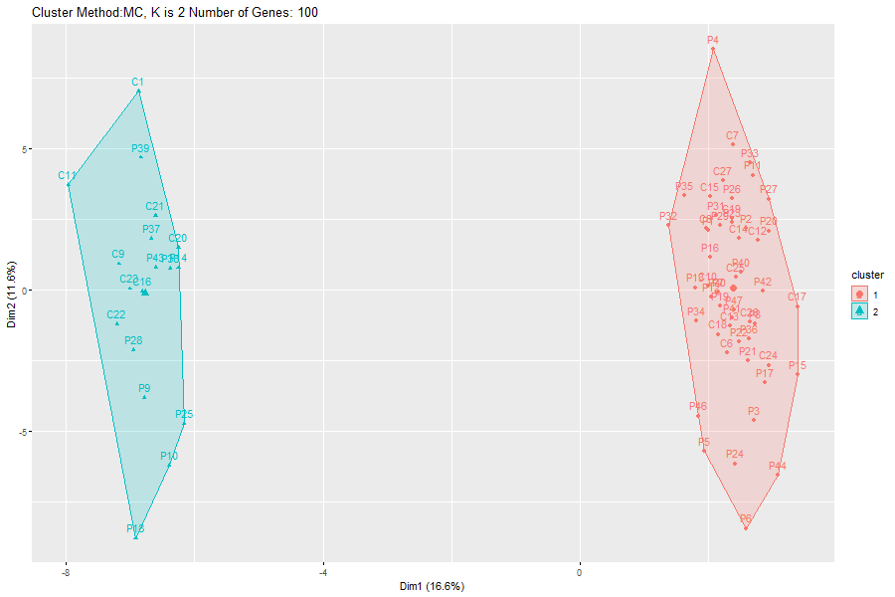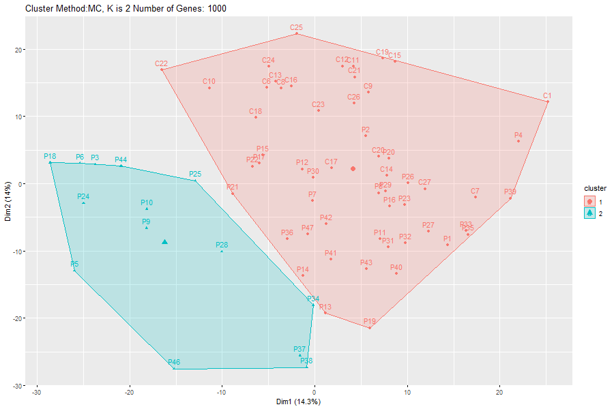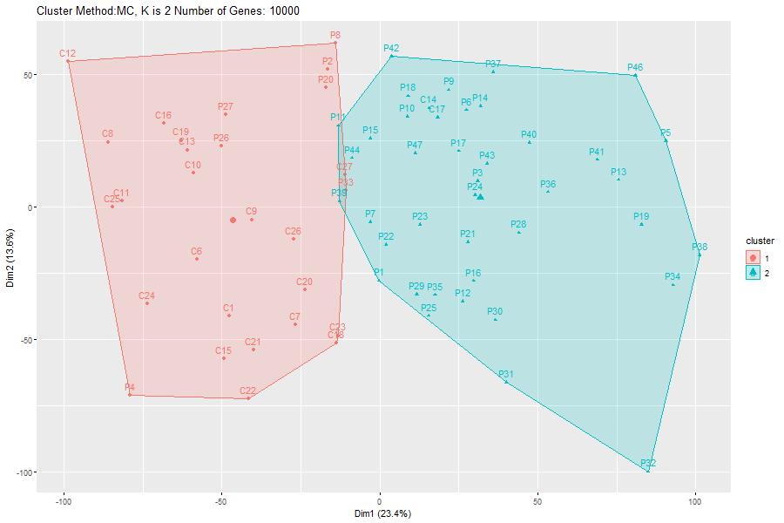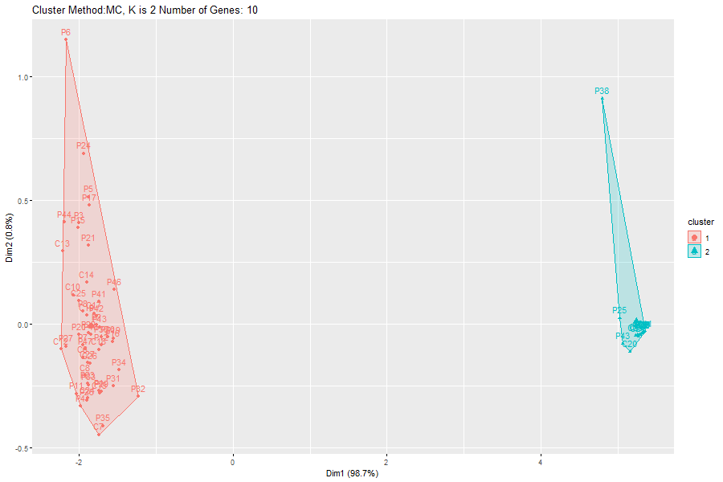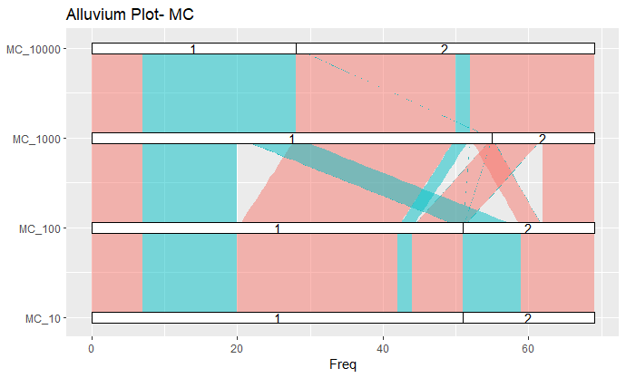

We created a Heatmap using the 5000 most varied genes, we chose k=4.

In the graph, we can see the heatmap of the genes by the samples and for each sample, we can see the cluster it belongs in each algorithm.