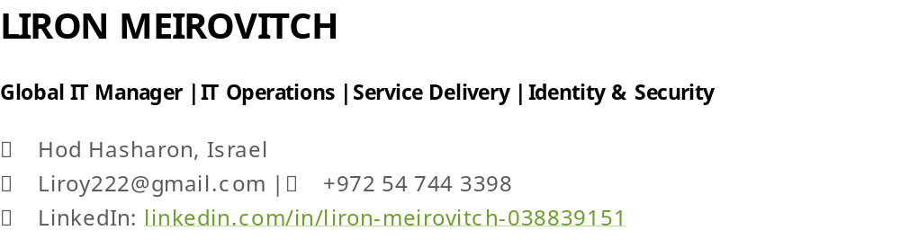
GIT https://liroy222-arch.github.io/liron-meirovitch.github.io/

BACKGROUND  Global IT Manager with 10+ years of experience leading IT operations, Microsoft 365 environments, identity management, security initiatives, and service delivery across international organizations. Proven success supporting global workforces of approximately 300 employees, managing distributed IT teams, and delivering secure, scalable workplace technology services aligned with business objectives. | CORE EXPERTISE  Microsoft 365 • Entra ID • Intune • Exchange Online • Teams • SharePoint • IT Operations • Service Delivery • Identity & Access Management • Security Operations • Compliance • Vendor Management • Incident Management • Automation • Endpoint Management • IT Governance • Business Continuity • Process Improvement • Team Leadership

PROFESSIONAL EXPERIENCE

TOMIA / Flash Networks | IT Manager
2024 – Present
- Lead global IT operations supporting approximately 300 employees across multiple countries, ensuring secure, scalable, and business-aligned technology services.
- Manage a distributed international IT team responsible for workplace technology, governance, and service delivery.
- Own the Microsoft 365 ecosystem, including Entra ID, Intune, Exchange Online, Teams, and SharePoint.
- Automated onboarding and offboarding workflows, improving operational consistency and access governance.
- Partner with executive leadership on compliance, operational improvement, vendor management, and service modernization initiatives.
- Drive major incident response and monitoring modernization efforts supporting global operations.

Cyolo Security | Global IT Manager
2023 – 2024
- Managed global IT services supporting a distributed workforce.
- Administered enterprise identity management, endpoint management, collaboration platforms, and SaaS environments.
- Led initiatives involving SSO, authentication services, identity governance, and security operations.
- Managed software licensing, procurement, vendor relationships, and employee lifecycle processes.
- Improved operational efficiency through automation, process standardization, and service optimization.

Ram Aderet | IT & Information Systems Specialist
2022 – 2023
- Managed infrastructure, networking, telephony, and workplace technology services across multiple business locations.
- Served as a senior escalation point for business-critical incidents and operational issues.
- Coordinated third-party technology vendors and service providers to maintain service quality and business continuity.
- Supported technology modernization initiatives while ensuring stable day-to-day operations.

Verint / Cognyte | IT Tier 2 Engineer
2018 – 2022
- Supported enterprise Microsoft environments including Microsoft 365, Azure AD, Intune, and Citrix technologies.
- Coordinated and mentored 10 IT specialists during a migration affecting 1,000+ users and endpoints.
- Managed onboarding, offboarding, workplace technology services, and asset lifecycle activities in a large enterprise environment.
- Served as a senior escalation resource for complex incidents, technology transformations, and business-critical support requirements.

TECHNICAL SKILLS
Cloud & Infrastructure  - Microsoft 365  - Entra ID  - Intune  - Exchange Online  - Teams  - SharePoint  - Endpoint Management  - SaaS Administration  - Azure Fundamentals  - Process Automation | Operations & Security  - IT Operations  - Service Delivery  - Identity & Access Management  - Security Operations  - Compliance  - Incident Management  - Vendor Management  - IT Governance  - Business Continuity  - Operational Excellence

CERTIFICATIONS & PROFESSIONAL DEVELOPMENT
- Johns Hopkins University – Cybersecurity Certificate
- Microsoft Azure Fundamentals (AZ-900)
- Introduction to Cyber Security Specialization – New York University (NYU)
- AWS Cloud Fundamentals
- Google IT Support Professional Certificate
- ITIL 4 Foundation Preparation
- CCNA Curriculum
- MCSA Curriculum

LANGUAGES
- Hebrew – Native
- English – Fluent

MY GIT PAGE
My Git Page for detailed technology landscape and certificates
https://liroy222-arch.github.io/liron-meirovitch.github.io/

