//week02-1-void-setup-void-draw-fill-textsize-text-key
//鍵盤的操作 與上週的mouse結合
//File-Preference 字型放大
void setup(){
size(500, 500); //視窗大小
}
void draw(){
if(mousePressed) background(#F58A8A);
else background(#D6F074);//tool-color選擇器
fill(0, 0, 255);//藍色的填充色
textSize(80); //字的大小
text("key: "+ key, 200, 300);
}

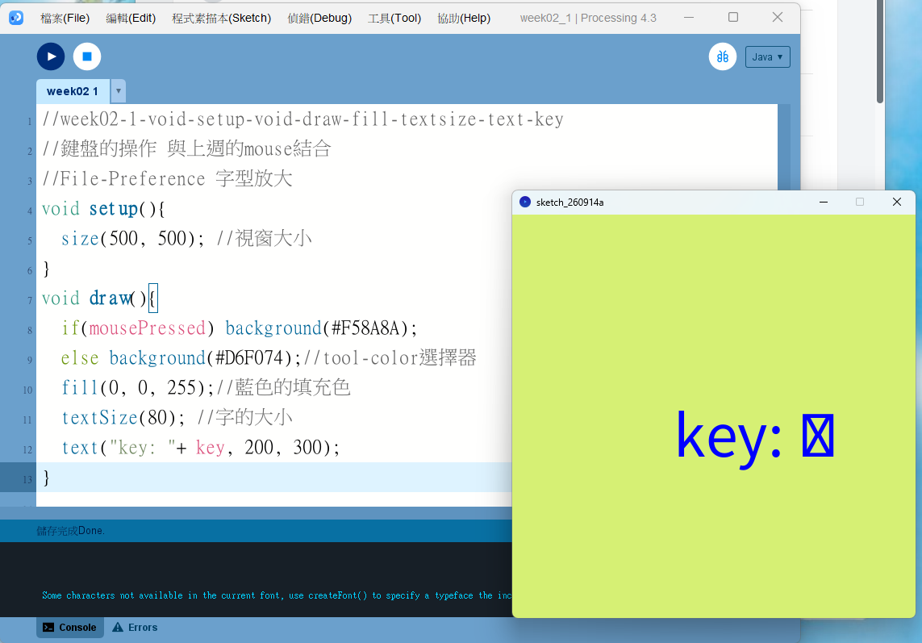

打開桌面資料夾 2024葉正聖老師上課資料
開啟CH341SER.EXE
Install 安裝
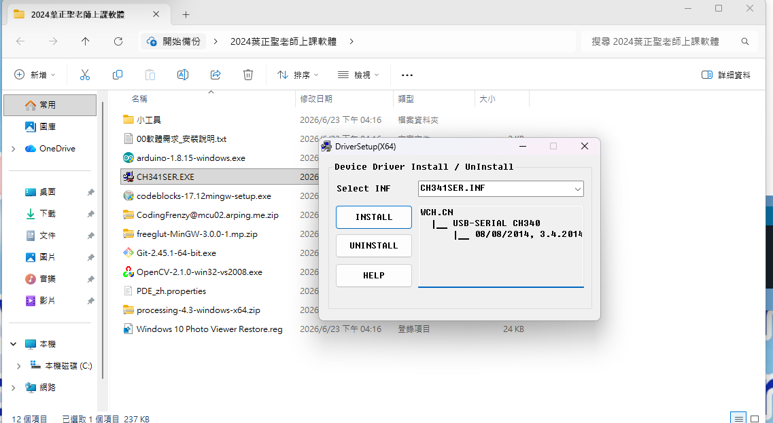
桌面windows右鍵選裝置管理員
選連接埠 看USB-SERIAL CH340(看這裡是COM多少)

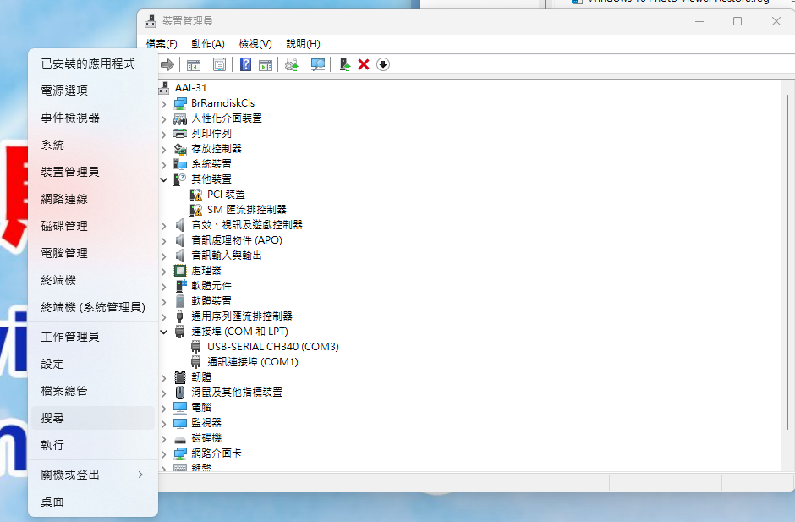
選工具連接埠 選跟剛剛一樣的數字COM
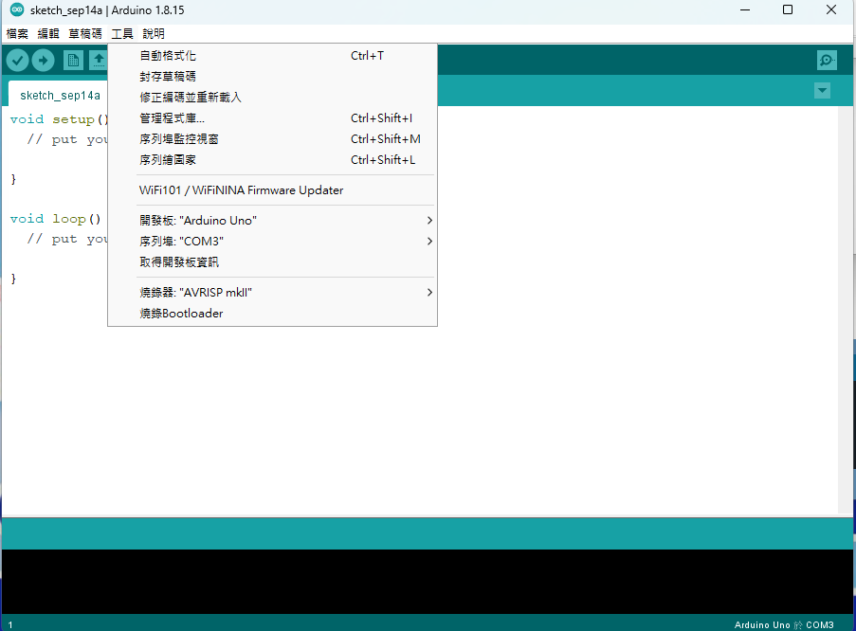

//week02-2-arduino-void-setup-void-loop-digitalwrite
//人生中第一個arduino程式
void setup() {
// put your setup code here, to run once:
pinMode(8, OUTPUT); //第8個腳 要發出buzzer聲音

}
//勾勾(CTRL-R編譯程式)箭頭往右(CTRL-R上傳到電路板)
void loop() {
// put your main code here, to run repeatedly:
digitalWrite(8, HIGH); //發出高電位
delay(1000); //等1秒(1000ms = 1sec 1ms = 0.001sec)
digitalWrite(8, LOW); //發出低電位
delay(1000); //等1秒(1000很慢 10很吵 2有點聲音 1音頻很高)
}
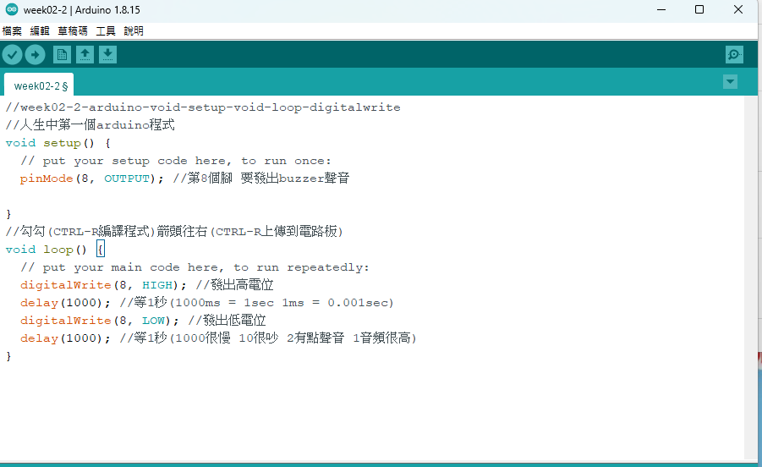

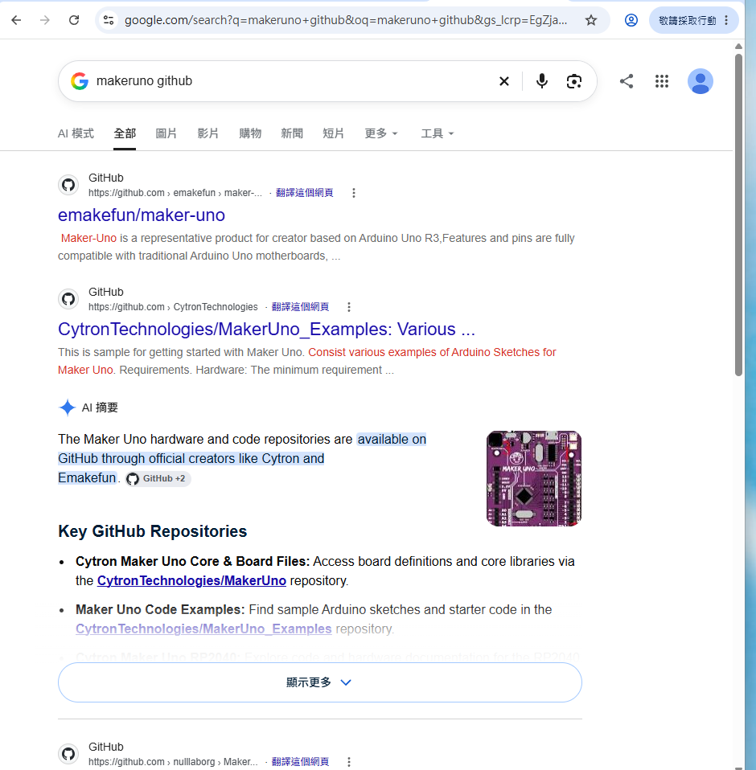

選makeruno defaultsketch
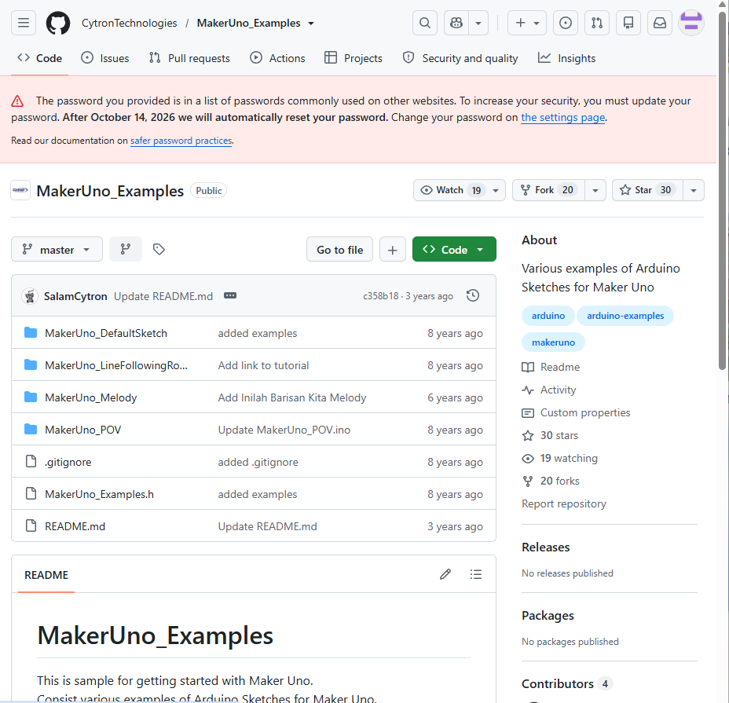

//week02-3-arduino-makeruno-github-dafault-sketch
//google: makeruno github 找到 CytronTechnology 官網的 default sketch
#define NOTE_C5 523
#define NOTE_E5 659
#define NOTE_G5 784

#define BUTTON 2
#define BUZZER 8

int melody[] = {
NOTE_E5, NOTE_E5, 0, NOTE_E5, 0, NOTE_C5, NOTE_E5, 0, NOTE_G5
};

int noteDurations[] = {
10, 10, 10, 10, 10, 10, 10, 10, 10
};

int pin;
int ledArrayHigh;
int ledArrayLow;
boolean mode = false;
boolean buttonPressed = false;

void setup()
{
delay(1000);

pinMode(BUTTON, INPUT_PULLUP);
for (pin = 3; pin < 14; pin++) {
pinMode(pin, OUTPUT);
}

for (int thisNote = 0; thisNote < 9; thisNote++) {
int noteDuration = 1000 / noteDurations[thisNote];
tone(BUZZER, melody[thisNote], noteDuration);
int pauseBetweenNotes = noteDuration * 1.30;
delay(pauseBetweenNotes);
noTone(BUZZER);
}
}

void loop()
{
for (pin = 0; pin < 5; pin++) {
if (digitalRead(BUTTON) == LOW &&
buttonPressed == false) {
buttonPressed = true;
mode = !mode;
pin = 0;
if (mode == false) {
tone(BUZZER, NOTE_C5, 100);
delay(100);
tone(BUZZER, NOTE_G5, 100);
delay(100);
noTone(BUZZER);
}
else if (mode == true) {
tone(BUZZER, NOTE_G5, 100);
delay(100);
tone(BUZZER, NOTE_C5, 100);
delay(100);
noTone(BUZZER);
}
}

if (mode == false) {
ledArrayHigh = 13 - pin;
ledArrayLow = 7 - pin;
}
else if (mode == true) {
ledArrayHigh = 9 + pin;
ledArrayLow = 3 + pin;
}
digitalWrite(ledArrayHigh, HIGH);
digitalWrite(ledArrayLow, HIGH);
delay(100);
digitalWrite(ledArrayHigh, LOW);
digitalWrite(ledArrayLow, LOW);
if (pin == 4) delay(100);
}

if (buttonPressed == true) {
buttonPressed = false;
}
}
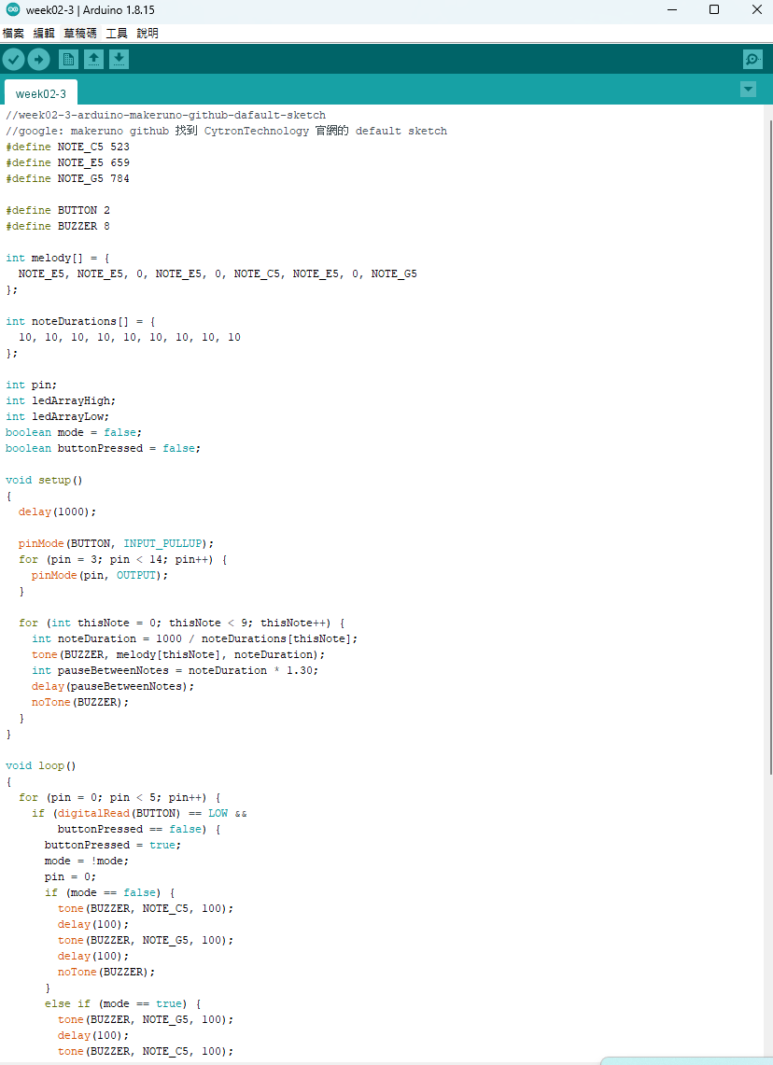
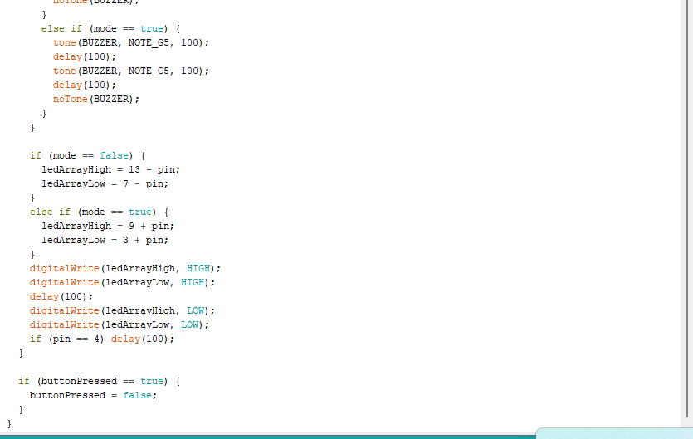

//week02-4-arduino-tone
void setup() {
// put your setup code here, to run once:
pinMode(8, OUTPUT);
//上面setup只做一次
tone(8, 523, 1000); // Do 0.1sec
delay(1000);
tone(8, 587, 1000); // Re 0.1sec
delay(1000);
tone(8, 659, 1000); // Me 0.1sec
delay(1000);
}

void loop() {
// put your main code here, to run repeatedly:
//下面會一直迴圈重複做 不會停
}
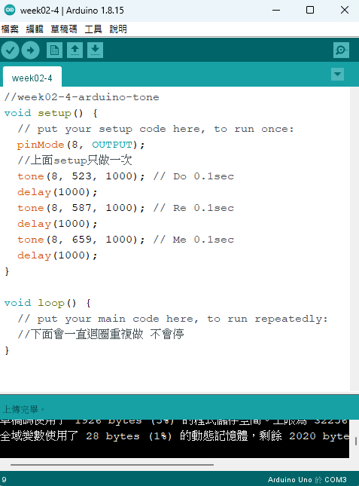

//week02-5-arduino-do-re-me-serial-begin-available-read-if-tone
//把arduino跟processing結合
//在processing按下1 2 3 對應do re mi使用usb serial
//寫完程式 用工具tool-序列埠監控視窗serial monitor 來傳送1 2 3 測試很麻煩
void setup() {
Serial.begin(9600); //usb serial 開始轉動 轉速 9600 bps

}

void loop() {
if (Serial.available()){ // 如果usb serial有收到資料
char c = Serial.read(); //讀近來
if (c=='1') tone(8, 523, 1000); // Do 0.1sec
if (c=='2') tone(8, 587, 1000); // Re 0.1sec
if (c=='3') tone(8, 659, 1000); // Me 0.1sec
}

}
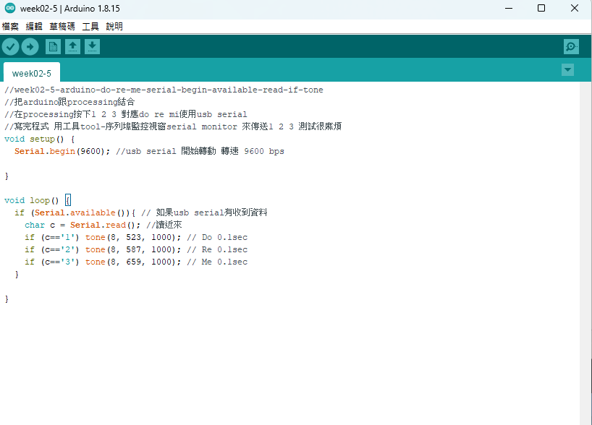

//week02-5-processing-do-re-mi-import-serial-myport--void-keyPressed-write
//把arduino跟processing結合
//在processing按下1 2 3 對應do re mi使用usb serial
import processing.serial.*;
Serial myPort;
void setup(){
myPort = new Serial(this, "COM3", 9600);
}

void draw(){

}
void keyPressed(){
if(key==&apos;1&apos;) myPort.write(&apos;1&apos;);
if(key==&apos;2&apos;) myPort.write(&apos;2&apos;);
if(key==&apos;3&apos;) myPort.write(&apos;3&apos;);
}

