Submission Links

1. GitHub Repository URL:
https://github.com/liryasxx/quinio_markcyrell_labact9
2. Render Deployment URL:
https://quinio-markcyrell-labact9.onrender.com
3. Postman Evidence:
GET https://quinio-markcyrell-labact9.onrender.com/api/items/ Get all items
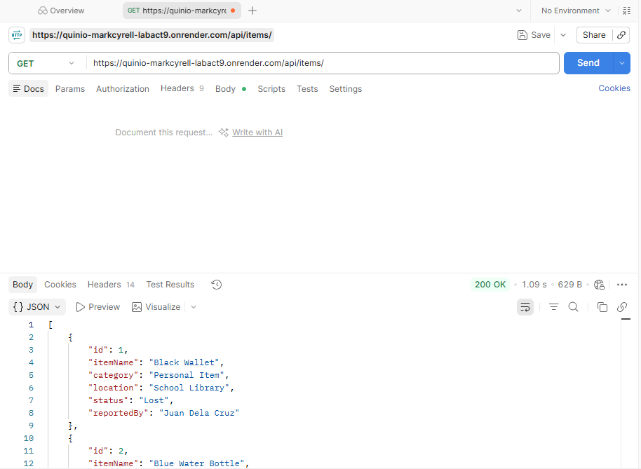
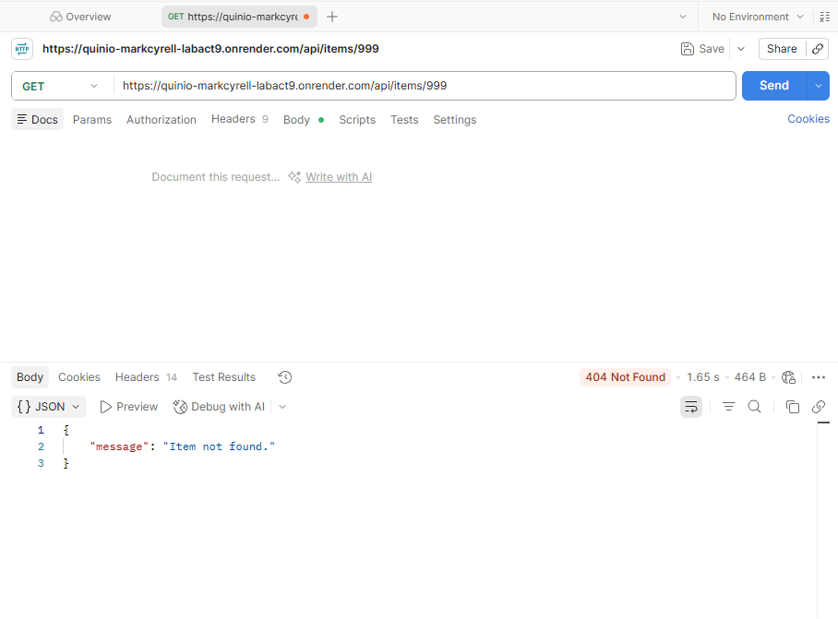
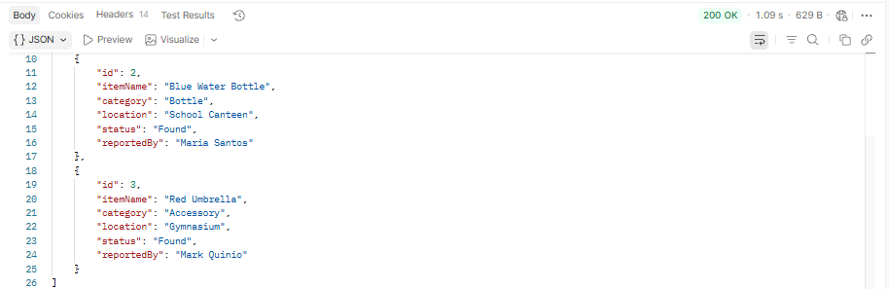

GET https://quinio-markcyrell-labact9.onrender.com/api/items/999 Item not found

GET https://quinio-markcyrell-labact9.onrender.com/api/items/1 Get one item

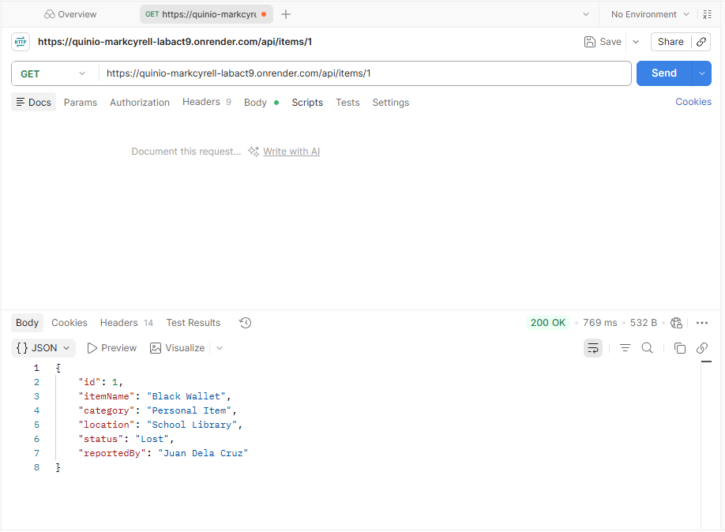

POST https://quinio-markcyrell-labact9.onrender.com/api/items Create item
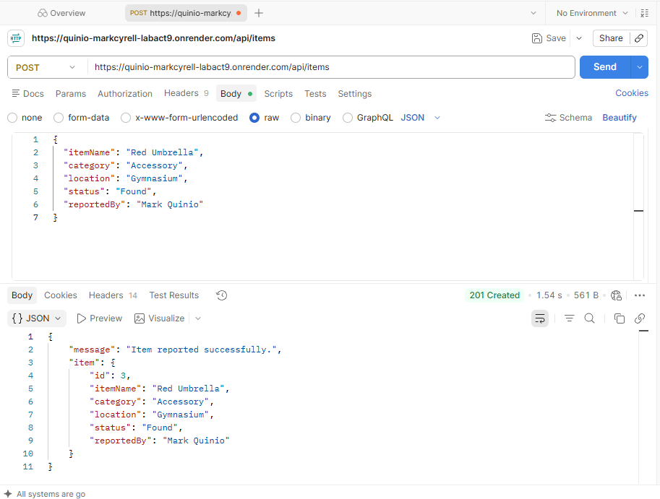

GET https://quinio-markcyrell-labact9.onrender.com/api/items Create item with missing field
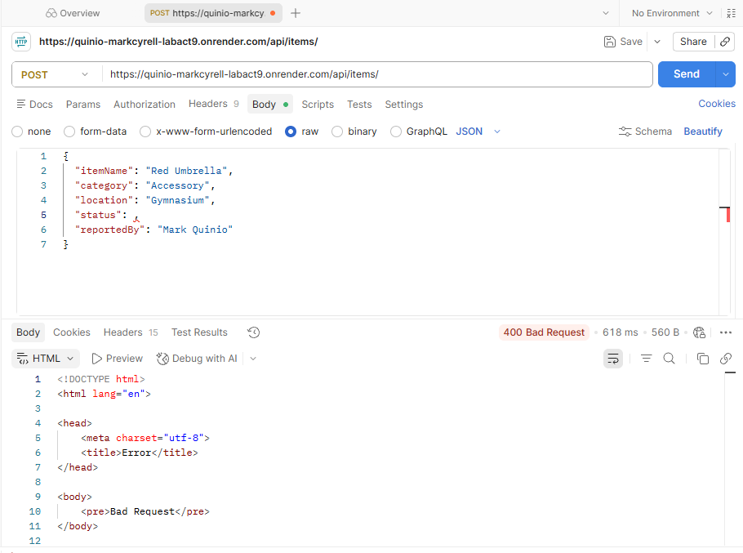

PUT https://quinio-markcyrell-labact9.onrender.com/api/items/1 Update item
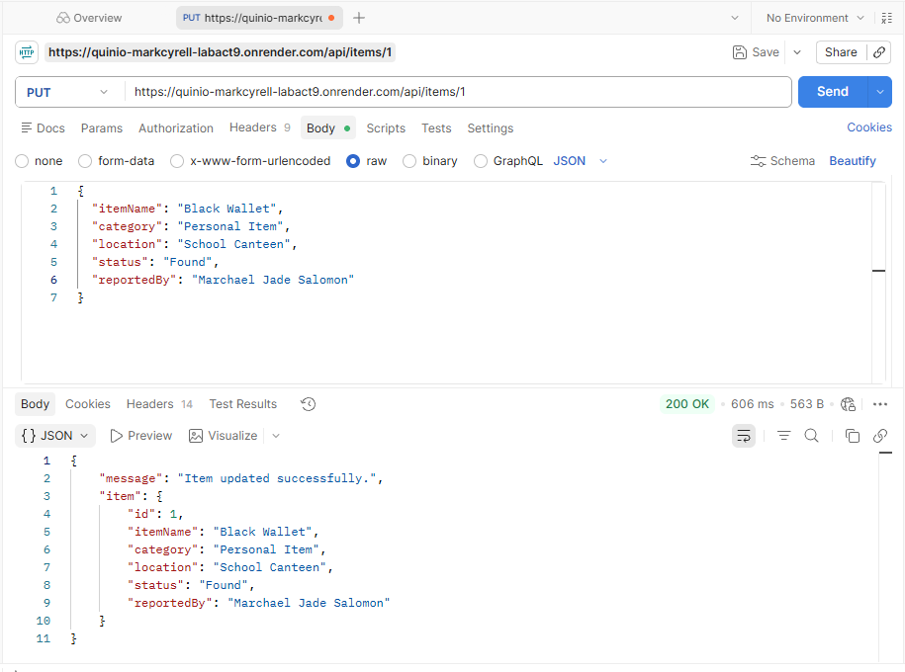

DELETE https://quinio-markcyrell-labact9.onrender.com/api/items/2 Delete item
