Lesser Antilles Trench:

Haiti:

2010 eq, 2018 5.4 M eq. Cretaceous Volcanic Island. Boundary Hispaniola and North-American plate: termination of Lesser Antilles subduction zone. Look at seismicity underneath Haiti (300km depth) to find the remanent slab[1]. According to Calais et al. (1992a), the slab is broken off west of Puerto Rico and is sinking into the mantle under Hispaniola.

* Research main P axis to find what type of deformation dominates.
* West-dipping transitions into south-dipping. Bent subduction zone. But where does south-dipping end? (Symithe, 2015). Look at Wadati-Benioff zone.
* Slow-spreading Atlantic lithosphere. One of the two subduction zones is in lesser Antilles. Look at heterogeneity of the mantle (Bie, 2019).

Greater Antilles Arc

Trans-Haiti project.

Study region proposal Lisanne Blok

The region I have chosen for my independent project is the Caribbean Plate. The region has high seismicity and large earthquakes. In 2010, a M7 earthquake hit Haïti and since then, the interest in this plate and its hazards like tsunamis has increased. The plate seems to be moving eastward (70° bearing), but some other parts of the plate like Hispaniola are moving slower. I would like to find out why that is the case.

Figure 1: Earthquakes on Caribbean plate, plotted with certain depths.

On my plate, I have two large subduction zones. In the west is the central America trench, which seems to be a straight zone. In the east is the Lesser Antilles Trench, which is curved and forms the Great Arc of the Caribbean (GAC) system. There is a transition in the direction of dipping in the subduction zone as well as from subduction to oblique collision in central Hispaniola. The subduction is very slow and not caused by slab pull like in the Pacific, so I want to figure out what the driver is. This could be the westward movement of the Americas. Both subduction zones have formed volcanic ocean arcs with volcanoes which I want to research as well. I also want to research the origin of the volcanoes in figure 2.

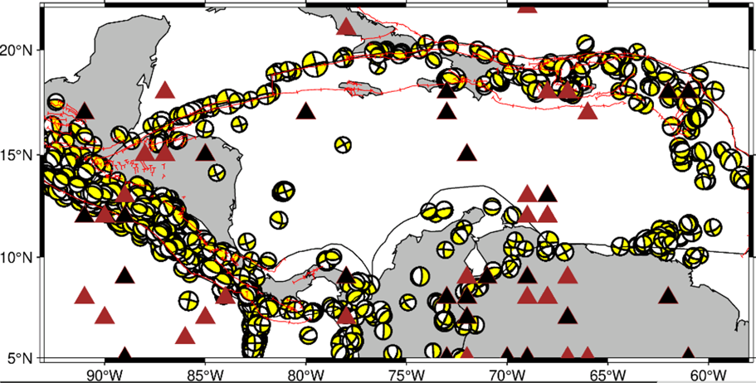The fault zones associated with the oblique collision bound the Cayman trough, an oceanic spreading centre.

Figure 2: volcanoes on Caribbean plate.

Underneath Haiti, there are earthquakes below the Moho according to Harris et al (2016), which I could not find on my map. However, these earthquakes could indicate a remanent slab from an ancient collision with the North American Plate (Calais, 1992). I would like to find out if the slab is torn and whether I could possibly include these deep earthquakes in my analysis as well.

Some earthquakes are not included in the figure and the Harvard catalogue such as a M7.5 and M8.1 in 1943 and 1946 respectively. I will try to include these earthquakes in my analysis as well, because these were significantly large.

The Caribbean plate consists of a Caribbean large igneous province (CLIP), resulting from Cretaceous volcanism of the Galapagos hotspot. The lithosphere is thicker beneath the CLIP, which has an impact on the behaviour of the plate such as the collision with the Bahamas. I am interested in finding out the effect on seismicity this thick plate has.

Size of study area will vary: look at size of system. 100-1000 km

Velocities from strain rates

* Mechanics
* Kostrov

Harvard CMT catalogue. PSmecca format.

Catalogue-completeness: Gutenberg-Richter relationship.

Ductile deformation (not seismically at MOR)

Compare to GPS measurement -> undershooting?

Take right assumptions for earthquake seismogenic depth. Uncertainty.

If kostrov doesn’t work, plate is interesting and can cause hazards!

Earthquakes are result of plate a moving past plate b.

Subduction: cannot calculate velocity as is deforming in the mantle. Can look at orientation of the axis. 660 km (downdip compression) and 410 km (accelerate, downdip extension). Where does slab go, can map style of deformation/state of stress.

Plate system:

* Many earthquakes
* Much deformation, different types
* Himalayan plateau (strike-slip faults and compression)
* Aegean many types of deformation
* Philippine different styles but also subduction
* New Zealand subduction, extension, strike-slip

Split up areas for separate Kostrov summations.

Hand-in on ESESIS in a week: GMT figure on study area.

1. https://pubs.geoscienceworld.org/gsa/geosphere/article/15/6/1738/573848/Is-the-local-seismicity-in-western-Hispaniola