IN511 Programming 2
Class 21

Pseudocode

Pseudocode is the documented outline or draft of a program. It is written as text, not in a programming language, so it cannot be compiled or executed. It does not require strict syntax, but instead serves as a plan of how the program will be constructed and function. The process of writing pseudo code involves:

Step 1: Decomposition

Break down or decompose the problem.

- Summarise the aim of the game in 1-2 sentences.
To build a game called Pacman. In this game, there will be a Pacman running in a maze and eating kibbles, while avoiding be hit by the ghouls. When the Pacman eat all kibbles or the Pacman meet Ghoul, game over.

- Give a full description of the game. Explain how the game works to someone who has never played the game before.
- The game is easy to control. The player will use the arrow key to control the direction to control the Pacman running in the maze, while avoid being hit by ghouls. The user should try their best to eat all kibbles.

What characters are in the game?
1 Pacman, 3 Ghost,
What does each character do?
Pacman: Draw, Move, EatKibble, Die, Hitwall
Ghost: Draw, Move,RandomDirection, HitWall, PacmanDie
Maze: Draw, KibbleToBlank, CountKibble
How do the characters interact?

How do you win the game?
When he Pacman eats all Kibbles, the player will win.

How do you lose the game?
The Pacman is eaten by the Ghosts.
This is the Description section of the Block Comment at the beginning of the Form1.cs file.
- For each character, identify all the actions needed for this character.
Then for each action, list what will happen when the action is carried out.
- What are the extra features or functionalities that are not essential to the basic game?
-Multiple lives, the ghouls follow the Pacman.
-orientation of Pacman/Ghost when moving
-power-ups
-walking from one side of form into other form
- What are the curly issues that will still need to be resolved?
-Not walking into walls- ghost and pacman on move
-EatKibble – replacing kibble with bland, and keeping score

Step 2: Form Design

What will the form look like?

- Sketch the form at design time? When the game is running?
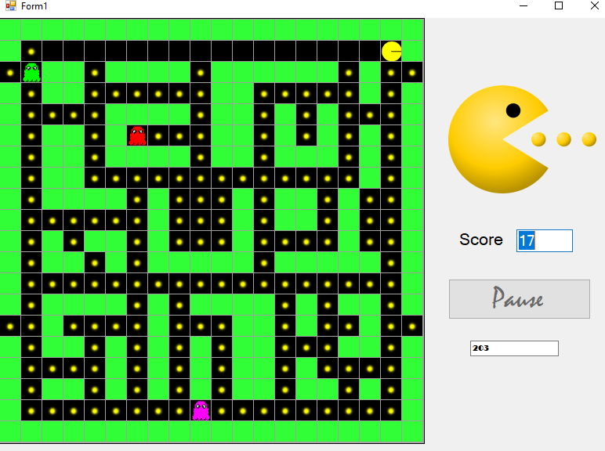
- What controls and components will you need?
- Button, label, textbox, picturebox, timer
- What will the user do? What events will be needed?
- Control arrow key, click button
- The key_down event and button_click event will be used.

Step 3: Abstraction

Identify the characteristics that distinguish one character from another:

- How many classes will be needed? What will each class be named?
- 7 classes. They are maze, character, pacman, ghouls, controller, direction,
- Form.
- What is the purpose of each class? This is your class comment.

Step 4: Encapsulation

Build your classes:

- For each class, list all the fields that will be needed.
- Parent character class: image: Bitmap; maze :Maze
- Sub class pacman: positon : Point; image1: Bitmap; mouseOpen Boolean;
- Direction: Direction
- Sub class ghouls: positon : Point; eaten Boolean; random Random
- GhoulDirection: Direction
- Maze class:map: string; nKibbles: int; wall: Bitmap; Kibble: Bitmap; blank Bitmap
- Controller class: pacman: Pacman; ghouls: List<Ghoul>; random: Random;
Score: int; Gameover: Boolean; Kibbles: int.
Form: random: Random; controller: Controller; maze:Maze.
- For each class, list all the methods that will be used. Keep in mind how the classes will interact with each other. What information needs to be passed in and out of the methods?
- Character: draw(); Move();HitWall()
- Pacman: Draw(); Move();HitWall(); PacmanEat(), return(kibbleEaten)
- Ghouls:Draw(); Move(); RandomDirection(); Bollean Hitwall(); Boolean PacmanDie().
- Controller: RunGame(); SetPacmanDirection();
- Maze: Draw(); KibbleToWall();
- Draw UML class diagrams.
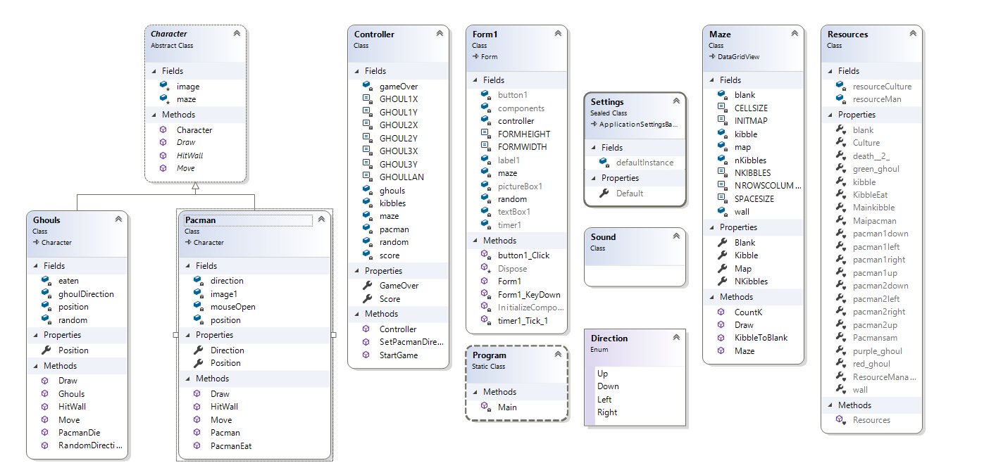
Show the relationships between your classes.

Step 5: Iterative Refinement

For each method:
- Name the method so that its purpose is obvious.
- State the purpose of this method in one statement. This is your method comment.
- Break each method down into sub tasks.
- Break each sub task down again....
- .... until they are single statements that can be translated into code.

Step 6: Now you can start coding!

Step 7: Identify extra functionality that will improve your solution.
- Sound
- Bonus points
- Pause button
- Multiple forms
- Menus
- Multiple lives
- Instructions, credits
- ………..

